Problem & Market Foundation

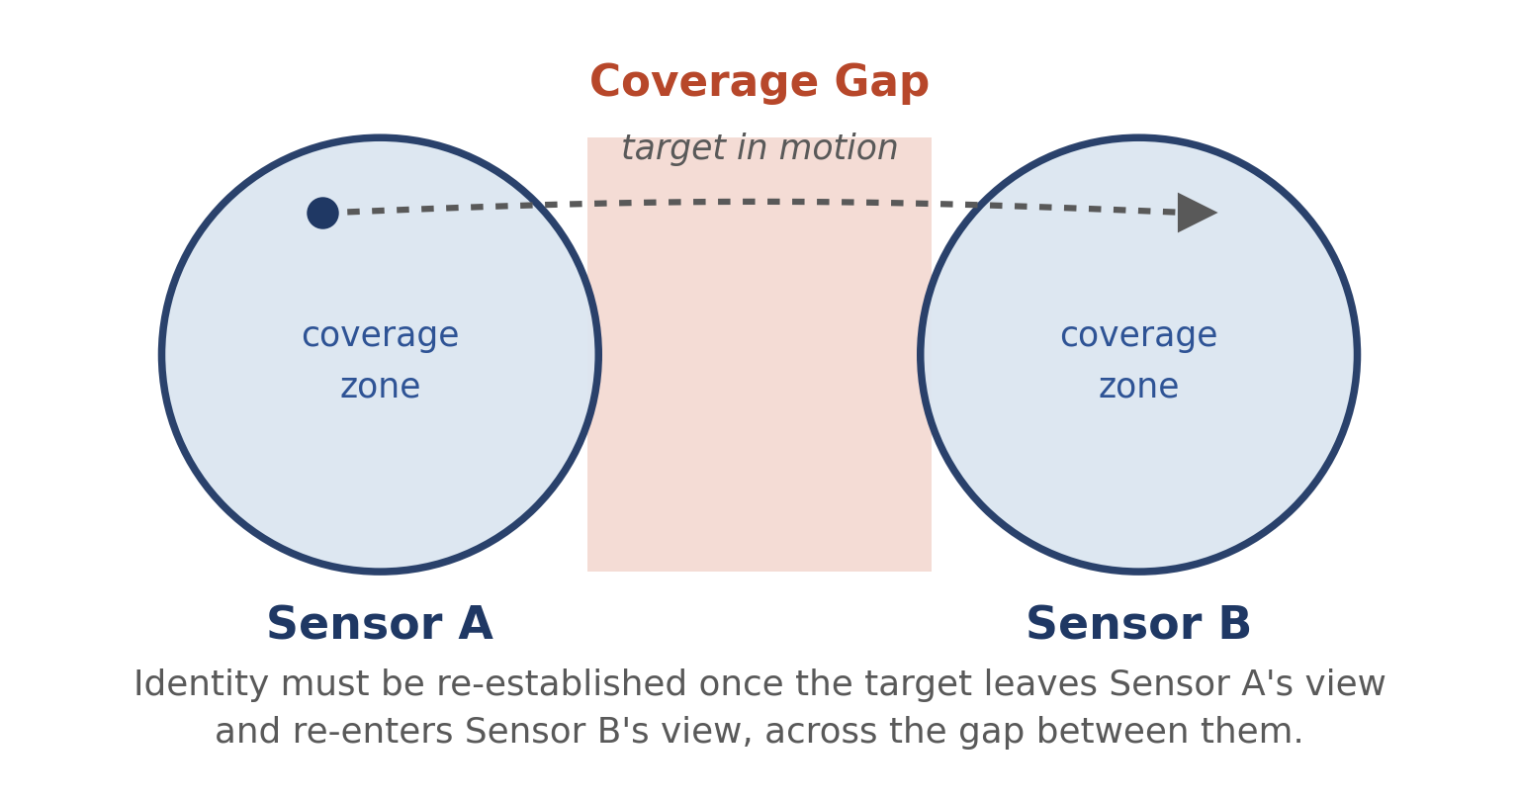
Figure 1. The recurring pattern examined in this analysis: identity must be re-established once a target crosses the gap between two independently operating sensors.

1. Executive Problem Summary
Organizations that rely on distributed camera or sensor networks to track people, vehicles, or mobile assets share a structural problem: no camera or sensor network economically achieves gap-free coverage of a physical area, so a tracked target periodically leaves the field of view of one sensor before entering another. Reconnecting “who this is” across that gap — re-identification — is difficult on two independent fronts. It is technically difficult because a target’s visual appearance changes with viewpoint, lighting, and occlusion, a challenge documented across two decades of computer-vision research. It is operationally difficult because the task of noticing a loss of track and re-establishing it today falls either to a centralized software match performed after the fact, or to a human operator who must notice the gap, recall the target’s appearance, and search other feeds manually. Human vigilance for sustained monitoring of this kind degrades measurably within roughly fifteen to thirty minutes of continuous attention, and no organization can economically staff one dedicated observer per camera at the ratios documented in the security-operations research literature.
The practical consequence, evidenced across five independent operational domains examined in this analysis — physical security, intelligent transportation, critical-infrastructure protection, search and rescue, and industrial/warehouse operations — is a recurring gap between what an organization believes it is watching and what it can actually keep track of. That gap is not evenly distributed. It is most consequential where an area is large, physically discontinuous, or crossed by many simultaneous moving targets — multi-building campuses, city street networks, long infrastructure perimeters, and wilderness search areas — and least consequential in small, densely covered spaces, or where the tracked entity can be reliably instrumented with a tag.
The underlying technical challenge (appearance-based re-identification across sensor gaps) and the underlying human/operational failure mode (vigilance decrement and staffing economics) are both well evidenced in independent, peer-reviewed and institutional sources. What is comparatively less evidenced is the size of a distinct market for a capability that specifically automates the handoff step, as opposed to the broader video-analytics, physical-security, or fleet-management markets it would sit inside; most available evidence addresses the underlying algorithmic problem (matching two appearances of the same target) or an adjacent but different problem (covering an area, or allocating tasks across a fleet) rather than continuity handoff in isolation. Real-world deployed practice, where documented, is still dominated by reactive, after-the-fact matching rather than proactive, pre-emptive handoff — the latter appears chiefly in research and benchmark settings. This document distinguishes throughout between what is established, what is a reasonable evidence-based inference, and what remains a hypothesis requiring further validation.

2. Problem Definition

2.1 Core Problem
What is actually going wrong: When a tracked person, vehicle, or mobile asset moves out of the coverage area of one sensor (a fixed camera, a mobile robot’s camera, or another point sensor) and into the coverage area of a different, independently operating sensor, the system loses the identity link between the two observations. The reappearing detection is treated as new and unrelated unless a separate, often manual or delayed, process re-establishes the connection.
Who experiences it: Personnel and automated systems responsible for maintaining continuous situational awareness of a moving subject: security-operations-center (SOC) operators and their managers; intelligent-transportation-system (ITS) and traffic-management engineers; critical-infrastructure security teams; search-and-rescue (SAR) coordinators and field teams; and industrial or warehouse robotics and fleet-operations engineers.
Where it occurs: In any physically distributed monitoring environment where full overlapping sensor coverage is not economically or physically achievable — multi-camera security networks, city-scale traffic-camera grids, long perimeters at critical-infrastructure sites, wilderness or disaster search areas, and multi-robot or multi-zone industrial facilities.
Under what conditions: The problem is dormant while a target remains inside a single sensor’s field of view and becomes active the moment a target crosses into a coverage gap. It worsens with sparse sensor placement (driven by cost), low light or adverse weather, occlusion-dense environments (crowds, foliage, structures), a high volume of simultaneous targets, and any requirement for real-time rather than after-the-fact response.
Why it occurs: Three independent, compounding causes recur in the literature: (1) full overlapping sensor coverage of large areas is economically and computationally prohibitive, so gaps are structural rather than accidental; (2) appearance-based matching across viewpoints, lighting, and occlusion is an intrinsically hard computer-vision problem, still an active research area after two decades of work; and (3) centralized architectures that stream raw sensor data to one location for matching are bandwidth-constrained, placing a further practical ceiling on how much of the coverage gap can be closed at scale.
What makes it difficult to handle: The problem sits at the intersection of a hard perception problem (recognizing that two different-looking observations are the same target), a hard systems problem (moving and processing enough information, fast enough, across a distributed network), and a hard human-factors problem (sustaining attention over a monitoring shift). Solving only one of the three does not resolve the operational failure.
How frequently it occurs: In busy environments — a security campus, a city intersection, a warehouse floor — a moving target can cross a coverage boundary many times per hour. In sparse environments such as long infrastructure perimeters or wilderness search areas, crossings are less frequent, but each one is comparatively more consequential.
What happens when it remains unresolved: The tracked entity’s history becomes fragmented or silently incorrect; response, when it happens at all, is reactive and delayed; and organizations compensate by adding cameras, adding staff, or accepting a lower standard of coverage than they believe they have.

Problem Statement
Operators and automated systems responsible for continuously tracking people, vehicles, or mobile assets across physically distributed sensor networks cannot reliably maintain identity continuity when a target passes through the coverage gap between independent sensors, because current re-identification methods are sensitive to appearance change and current operational workflows depend on human operators or after-the-fact algorithmic matching to bridge that gap. The result is intermittent, delayed, and error-prone situational awareness in security, public-safety, transportation, and industrial-tracking contexts.

2.2 Problem Context
The problem becomes relevant wherever an organization needs continuous awareness of a moving entity across an area too large, too irregular, or too costly to cover with a single sensor or a fully overlapping sensor array. Physically, it is most pronounced outdoors and across multi-structure sites, where weather, distance, and terrain further reduce effective sensor range. Operationally, it is shaped by staffing economics: shift-based monitoring, budget ceilings on camera or sensor density, and the use of multiple, often unintegrated vendor systems. A commonly cited risk in critical-infrastructure security assessments is exactly this kind of fragmentation — security systems that are not unified under a single command-and-control view, which compounds rather than resolves the coverage-gap problem. Technically, the problem is bounded by available network bandwidth and edge/cloud compute capacity: raw video at resolutions sufficient for reliable analytics is bandwidth-heavy (a single 1080p stream is of the order of 2 megabits per second, and a 4K stream 30–40 megabits per second), while typical uplinks at a given site are often an order of magnitude smaller. Organizationally, monitoring capability is frequently sized against fixed staffing ratios and budget cycles rather than against a measured rate of identity-continuity failure. Human factors compound all of the above: sustained visual monitoring is subject to a well-documented vigilance decrement, so the same coverage gap that a sensor network leaves open is not reliably closed by adding a human observer, either.

2.3 Root Causes, Contributing Factors, Symptoms, and Consequences
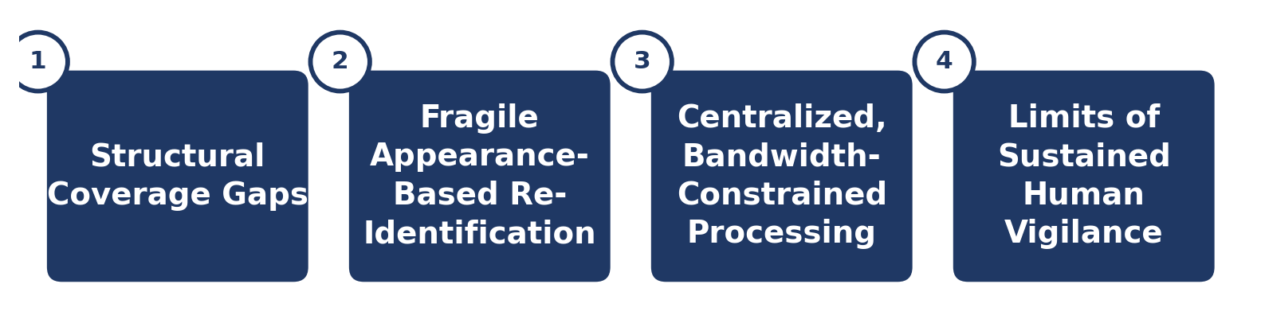
Figure 2. Four independent, compounding root causes underlie the identity-continuity problem.

Root cause 1 — Sensor coverage is structurally, not accidentally, incomplete
Full overlapping coverage of a large or irregular area is expensive in sensor count, installation, and processing load, so organizations deliberately deploy sparse or non-overlapping sensor layouts. The multi-camera tracking research literature treats non-overlapping fields of view as the practically necessary case for wide-area surveillance precisely because full overlap is cost- and computation-prohibitive. The observable symptom is a persistent “blind region” between sensor zones; the consequence is that the identity thread breaks every time a target enters one.

Root cause 2 — Appearance-based re-identification is intrinsically fragile
A target’s appearance changes with pose, viewpoint, illumination, and occlusion, and different individuals or vehicles can appear visually similar under the same conditions. Contributing factors documented across multiple independent surveys include cross-camera illumination variance, viewpoint and pose change, and occlusion — the last of these alone is broken down in the literature into four distinct sub-problems (position misalignment, scale misalignment, noisy information, and missing information). The observable symptom is a measurable rate of incorrect or failed matches; the consequence is either a missed reconnection (the same target is treated as new) or a false one (two different targets are merged into a single, now-incorrect, identity).

Root cause 3 — Centralized, bandwidth-constrained processing architectures
Where matching is performed centrally, all sensor data must first reach a central point, and that transport is constrained by available bandwidth. Concrete measurements from the video-analytics literature illustrate the scale of the constraint: detection accuracy for a standard detector has been shown to rise from roughly 61% to 92% when input resolution increases from 540p to 1080p, but this requires roughly 3.7 times more bandwidth; in a documented real-world deployment, eight 4K traffic cameras shared a single 35 Mb/s uplink costing $400 per month, an order of magnitude below what the cameras could produce natively. The observable symptom is processing backlog under load — one smart-city pedestrian-detection study explicitly reports that when hardware capacity is exceeded, detection can end up referencing images that are hours old. The consequence is that even a technically correct match may arrive too late to be operationally useful.
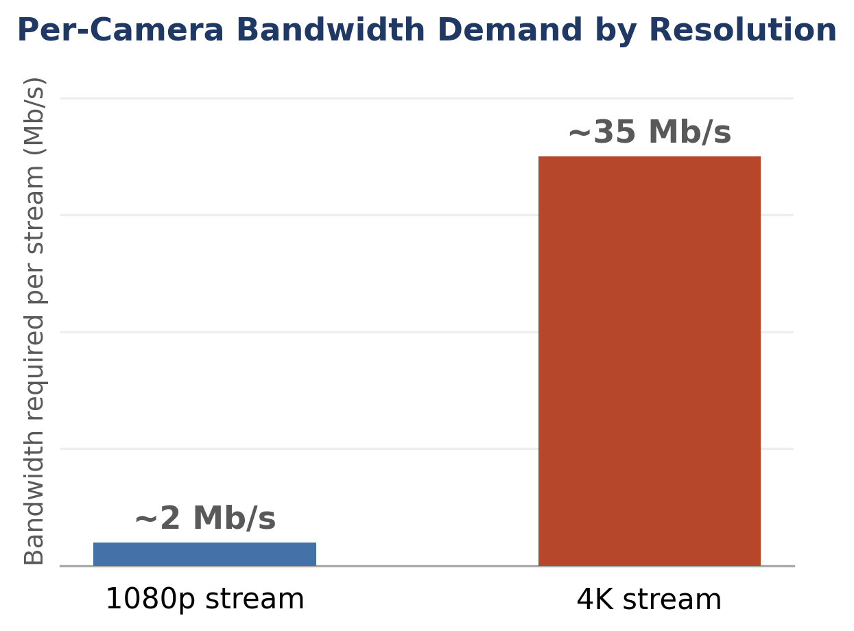
Figure 3. Bandwidth required per camera stream rises sharply with resolution (Scaling Video Analytics on Constrained Edge Nodes, arXiv 1905.13536).

Root cause 4 — Reliance on sustained human vigilance to bridge the gap
Where automated matching is absent or not trusted, the task of noticing a lost target and re-establishing it falls to a human operator. Peer-reviewed CCTV-monitoring research finds that operators in a 90-minute real-time surveillance task detected only about half of target behaviors, with high false-alarm rates, and that vigilance decrements (a measurable decline in detection performance over time) are a highly consistent finding across the vigilance-research literature more broadly, including specifically in CCTV settings. The number of camera feeds one operator can be expected to monitor effectively is widely discussed in the security industry, with commonly cited figures for full, unaided attention in the low single digits to around eight feeds, rising only when supplemented by motion or analytics triggers. The observable symptom is a documented decline in detection accuracy as either monitoring duration or the number of simultaneous feeds increases; the consequence is that a real, technically detectable event — including the reappearance of a target the operator was tracking — goes unnoticed until it is reviewed after the fact, if at all.

2.4 Consequences
- Operational: delayed response and operator/searcher time spent re-establishing awareness that a well-functioning system would have preserved automatically.
- Human: in time-critical contexts such as wilderness search and rescue, survival probability is documented to decline as search duration increases — for example, survival to 24 hours has been reported at roughly 38% for young children in one wilderness-SAR analysis — so delay introduced anywhere in the detection-to-confirmation chain has a measurable human cost.
- System-level: fragmented, non-integrated security systems are independently identified as one of the most common perimeter-security risks at critical-infrastructure sites, compounding rather than resolving the coverage-gap problem.
- Safety: undetected or delayed-detected intrusion at sensitive sites, and delayed location of missing or at-risk persons.
- Efficiency: duplicated search effort (ground or aerial assets re-covering areas already searched because a prior detection was not preserved and shared), and operator hours spent on after-the-fact video review rather than real-time response.
- Continuity and reliability: an identity switch — the system silently linking the wrong prior track to a new detection — produces a continuous-looking record that is factually wrong, which is more dangerous than an obviously broken one because downstream users may not know to question it.
- Resource implications: one of the few quantified data points available (a European perimeter-protection market assessment) reports that common perimeter-sensing technologies average roughly 40% false alarms and are 60–80% energy-inefficient because both sensors and cameras must run continuously to be ready for an intrusion — evidence that current mitigation approaches are resource-intensive without eliminating the underlying gap.
- Organizational: staffing estimates in the security-monitoring literature suggest that achieving continuous human coverage of a moderate-sized camera deployment can require a double-digit number of dedicated monitoring staff across shifts, an economic ceiling that limits how far the human-vigilance approach can scale.

2.5 Current Failure Modes

Failure mode 1 — Silent identity loss
A target exits a sensor’s field of view into a coverage gap; no automatic linkage is attempted, and the system treats the target’s reappearance elsewhere as a new, unrelated detection. This occurs because sensor nodes typically act independently, with no active mechanism anticipating or bridging the gap. The immediate effect is that continuity and prior context (where the target came from, what it had been doing) are lost; the operational consequence is that reconstructing the path requires a deliberate, manual review — and only happens if someone notices the loss occurred at all. The current response is, at best, retrospective review of adjacent camera archives once a reason to look arises.

Failure mode 2 — Identity switch (incorrect match)
The system or operator links a reappearing detection to the wrong prior track, typically because two targets are visually similar or because a matching threshold is tuned to favor recall (catching true matches) over precision (avoiding false ones). The immediate effect is a corrupted record that appears complete but is factually wrong; the operational consequence is that any downstream decision built on that record — an alert, a dispatch, an incident timeline — rests on a false premise. This failure mode is usually undetected unless independently cross-checked; it is also the specific reason the multi-object-tracking research field developed identity-focused metrics (IDF1, and later HOTA) distinct from simpler detection-only metrics, because those simpler metrics do not adequately penalize this kind of error.

Failure mode 3 — Operator attentional failure
The underlying detection is technically achievable, but the human responsible for acting on it does not notice, due to the documented vigilance decrement or to information overload from monitoring too many simultaneous feeds. The immediate effect is that a correctly generated alert or observation goes unactioned; the operational consequence is that no response is triggered even though the system “worked.” The current response is, again, retrospective: the miss typically surfaces only once a downstream consequence (a theft, an unresolved incident, a safety event) prompts a review.

Failure mode 4 — Backlog and latency failure
Correct processing eventually occurs, but too late to be operationally useful, because a centralized architecture receives frames faster than it can process them under load. The immediate effect is a delayed match or alert; the operational consequence is that the output is usable only as an evidentiary record after the fact, not as a trigger for preventive action. The current response is to invest in more hardware or bandwidth, or to reduce resolution or frame rate — a documented trade-off that itself reduces matching accuracy.

2.6 Problem Tree
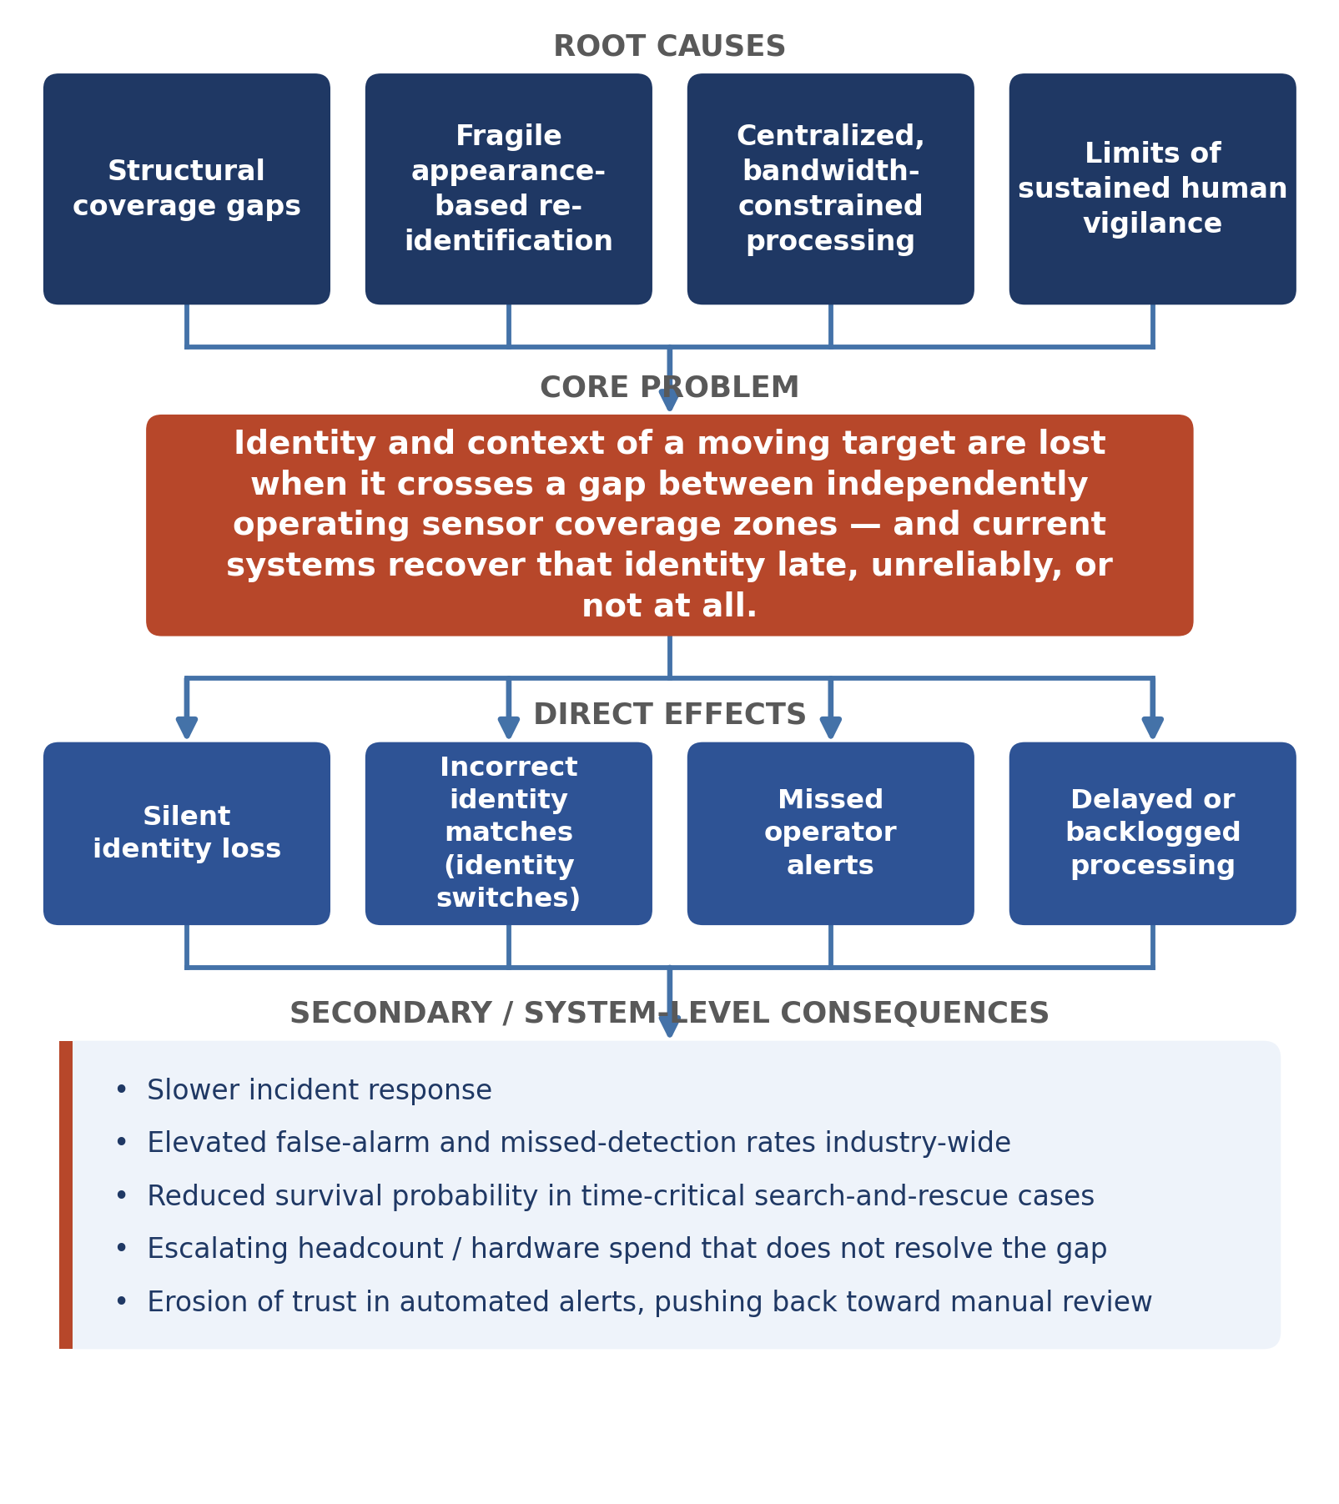
Figure 4. Causal structure from root causes through to system-level consequences.
ROOT CAUSES: economically limited sensor coverage → appearance-based re-identification fragility → centralized, bandwidth-constrained processing → reliance on sustained human vigilance
↓
CORE PROBLEM: identity and context of a moving target are lost when the target crosses a gap between independently operating sensor coverage zones, and current systems recover that identity late, unreliably, or not at all
↓
DIRECT EFFECTS: silent identity loss → incorrect identity matches (identity switches) → missed operator alerts → delayed or backlogged processing
↓
SECONDARY / SYSTEM-LEVEL CONSEQUENCES: slower incident response → elevated false-alarm and missed-detection rates industry-wide → reduced survival probability in time-critical search-and-rescue cases → escalating headcount and hardware spend that does not resolve the underlying continuity gap → erosion of trust in automated alerts, pushing organizations back toward manual review

4. Market Segmentation
The sectors below were investigated because each involves distributed sensor or robot coverage of a physical area and a documented need to track moving entities across that area. Two additional sectors named as starting points — general “robotics” and generic “logistics” — are folded into the industrial-operations segment below because the available evidence did not support treating them as independently distinct; they share the same operational pattern and the same dominant current solution (tagged-asset location systems). The evidence is strongest, and the problem most clearly unresolved by current practice, in physical security, intelligent transportation, critical-infrastructure protection, and search and rescue. It is present but structurally narrower in industrial operations, where an alternative technology (tag-based real-time location systems) already resolves continuity for the majority of tracked entities.

4.1 Physical Security & Surveillance
Concrete use case: A security operations center for a corporate campus, shopping center, hospital, or transit hub monitors dozens to hundreds of fixed cameras. When a subject of interest — a trespasser, a shoplifting suspect, a person exhibiting concerning behavior — moves between camera zones, particularly through uncovered corridors, stairwells, parking structures, or outdoor space, staff must reacquire visual custody of that person.
Customer / User / Beneficiary: The customer is typically a Director of Security or Chief Security Officer who owns the monitoring budget and vendor relationship. The user is the SOC operator or CCTV monitoring staff watching live and recorded feeds. The beneficiary is the broader organization — building occupants, loss-prevention teams, and, where relevant, law-enforcement liaisons — whose safety and liability position depends on effective monitoring.
Pain: Documented vigilance decrement (measurable detection-rate decline within roughly 15–30 minutes of continuous monitoring) combined with camera-to-operator ratios that make full manual coverage of every feed uneconomical at scale.
Current approach: Predominantly reactive: full-time human monitoring of a subset of “important” feeds, supplemented where budget allows by motion or video-analytics triggers, with after-the-fact recorded-video review once an incident is reported.
Severity / Frequency / Operational relevance: Severity ranges from moderate to high depending on site risk profile, escalating sharply at high-security or high-crime sites. Frequency is high — a busy site can generate many camera-to-camera transitions per hour. Operational relevance is direct: loss prevention, workplace-violence prevention, liability exposure, and, at sensitive sites, life safety.

4.2 Smart Cities / Intelligent Transportation Systems
Concrete use case: City-scale traffic-camera grids are used for congestion management, incident detection, and, in some jurisdictions, public-safety support. A specific vehicle or pedestrian must be tracked across a city’s non-overlapping traffic-camera network to reconstruct a route or respond to an incident.
Customer / User / Beneficiary: The customer is a municipal transportation department or public-safety agency. The user is the traffic-management-center operator or ITS engineer. The beneficiary is the traveling public, through faster incident response and better congestion management, and, in safety-relevant use, law enforcement or emergency responders.
Pain: Cross-camera vehicle and pedestrian tracking is described in the transportation-research literature as one of the core open problems in intelligent transportation systems, and remains an active, competitively benchmarked research area.
Current approach: Research-grade multi-target multi-camera tracking pipelines are evaluated on benchmark datasets and city-scale competitions; in live deployment, cross-camera correlation is typically performed manually by operators, or not attempted at all outside dedicated pilot systems.
Severity / Frequency / Operational relevance: Severity is moderate in routine congestion management and high in incident response or public-safety-adjacent use. Frequency is very high — thousands of vehicle and pedestrian transitions occur per hour across a city camera network. Operational relevance covers congestion reduction, faster incident response, and, where used for public safety, investigative continuity.

4.3 Critical Infrastructure Protection
Concrete use case: Utilities, energy sites, data centers, and other high-value facilities protect perimeters that can extend for miles, using sparse, long-range sensors. An intruder or vehicle moving along or through the perimeter passes between the coverage envelopes of individual sensors.
Customer / User / Beneficiary: The customer is the infrastructure operator’s security or risk-management function, often under regulatory obligation. The user is the on-site or remote security team monitoring perimeter alerts. The beneficiary is the facility, its personnel, and, for essential infrastructure, the public that depends on continuous service.
Pain: Documented top risks at these sites include the lack of real-time intrusion detection, fragmented and non-integrated security systems, and, for common perimeter-sensing technologies, an average false-alarm rate of roughly 40% together with substantial energy inefficiency, since sensors and cameras must remain continuously active.
Current approach: Long-range thermal, microwave, or fiber-optic perimeter sensors, supplemented by camera verification once an alert fires; gaps between individual sensor zones remain a documented, known vulnerability.
Severity / Frequency / Operational relevance: Severity is high: a missed or fragmented detection at this class of site carries safety, security, or large-scale service-continuity consequences. Frequency of individual crossing events is lower than in urban security contexts, but each event is higher-stakes. Operational relevance covers regulatory compliance and incident prevention; one available data point sizes the broader perimeter-protection-systems market at roughly €4.12 billion, growing at approximately 7.1% annually, cited here as a single indicative figure rather than a comprehensive market study.
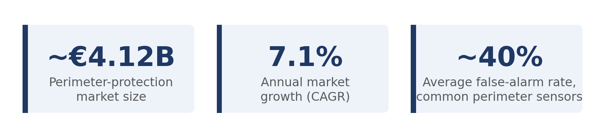
Figure 5. Indicative scale of the perimeter-protection segment (CORDIS / European Commission, project 783977).

4.4 Search & Rescue / Emergency Response
Concrete use case: Wilderness or disaster search teams — ground personnel, aircraft, and increasingly drones — search an area for a missing or injured person. When one asset detects a possible subject and then loses visual or sensor contact (the aircraft moves on, a drone reaches its range or battery limit, terrain obstructs the view), a later-arriving asset must determine whether what it is now observing is the same subject or an unrelated lead.
Customer / User / Beneficiary: The customer is an emergency-management agency, park service, or SAR-team organization, frequently volunteer-supported. The user is the SAR incident commander and field teams, and increasingly drone or UAV-swarm operators. The beneficiary is the missing or injured person and their family.
Pain: A ten-year U.S. national-park review recorded 65,439 SAR missions; a separate ten-year window recorded 46,609 lost individuals at a cost of roughly $51.4 million. Survival probability is well documented to decline with search duration. Autonomous and aerial search assets additionally face documented communication-latency, line-of-sight, and coordination challenges that make it difficult to maintain a consistent target identity across multiple independently operating assets.
Current approach: Predominantly human-coordinated search methodology (investigation, containment, hasty search, probability-of-area methods), with growing but still largely research-stage use of drones and thermal sensing; persistent, structured handoff of a specific detected subject from one asset to the next is not yet a mature, widely deployed capability.
Severity / Frequency / Operational relevance: Severity is the highest of the segments examined, since outcomes are measured in survival probability rather than efficiency. Individual incidents are comparatively less frequent than in urban security contexts but occur regularly in aggregate and are acutely time-critical. Operational relevance is direct: search efficiency and, ultimately, survival outcomes.
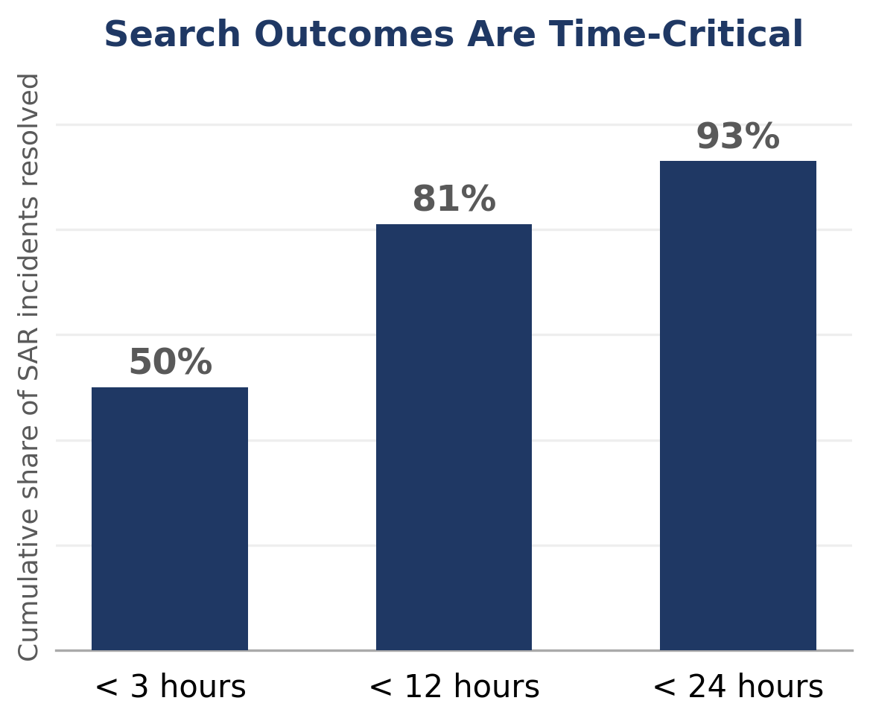
Figure 6. Share of U.S. national-park SAR incidents resolved by elapsed time (Heggie & Amundson, 2009; Koester, 2008).

4.5 Industrial Operations & Logistics
Concrete use case: Warehouses, distribution centers, ports, and manufacturing sites deploy fleets of autonomous mobile robots (AMRs) and use real-time location systems (RTLS) to track equipment, inventory, and personnel across zones.
Customer / User / Beneficiary: The customer is warehouse or plant operations and supply-chain leadership. The user is the fleet-operations engineer and warehouse-execution-system administrator. The beneficiary is the broader operation — throughput, safety, and inventory accuracy.
Pain and current approach — the key finding: The dominant current solution in this segment is not vision-based re-identification but active instrumentation: RFID, UWB, or BLE tags on the tracked entity, aggregated by fixed anchors, combined with centralized fleet-management software. This reliably solves continuity for any asset that can be tagged. The identity-continuity problem examined in this document therefore remains materially present but structurally narrower here: it applies chiefly to untagged actors and objects — unauthorized personnel, third-party vehicles, incoming or outgoing goods before tagging, or outdoor stockyard material impractical to tag individually — and to the general vision-based perception needs of AMR fleets operating safely around such untagged obstacles and people.
Severity / Frequency / Operational relevance: Severity is moderate and concentrated in the untagged-actor subset rather than the whole operation. Frequency depends heavily on how much of a given operation involves untaggable entities. Operational relevance centers on safety around robot fleets and on security against unauthorized access, rather than on core inventory accuracy, which RTLS and RFID already address.

Market Segmentation Matrix
Cells are intentionally terse for scanability; the narrative preceding this table carries the full detail and evidentiary support for each entry.
Segment | Concrete Use Case | Customer | User | Beneficiary | Pain | Current Approach | Severity | Frequency | Operational Relevance
Physical Security & Surveillance | SOC monitors many cameras; subject moves between camera zones through uncovered space | Security Director / CSO | SOC / CCTV operator | Occupants, loss prevention, liability posture | Vigilance decrement; uneconomical camera:operator ratios | Human monitoring of key feeds + motion triggers + after-the-fact review | Moderate–High | High (many/hr) | Loss prevention, violence prevention, liability
Smart Cities / ITS | Vehicle/pedestrian tracked across non-overlapping traffic-camera grid | Municipal transport / public-safety agency | Traffic-management-center operator / ITS engineer | Traveling public; emergency responders | Cross-camera tracking is an unresolved core research problem | Benchmark research pipelines; manual correlation in live deployment | Moderate–High | Very high (1000s/hr, city-wide) | Congestion, incident response, investigative continuity
Critical Infrastructure Protection | Intruder/vehicle crosses long perimeter between sparse long-range sensors | Infrastructure operator security/risk function | On-site / remote security team | Facility, personnel, dependent public | ~40% false-alarm rate; fragmented systems; no real-time detection | Long-range thermal/microwave/fiber sensors + camera verification | High | Lower, but high-stakes | Regulatory compliance, incident prevention
Search & Rescue / Emergency Response | Search asset detects possible subject, loses contact; next asset must confirm identity | Emergency-management agency / park service / SAR org | Incident commander; field & drone teams | Missing/injured person and family | Survival probability drops with search duration; swarm comms/LOS limits | Human-coordinated search method; limited, research-stage drone/thermal use | Highest (life/death) | Lower per-incident, frequent in aggregate | Search efficiency, survival outcomes
Industrial Operations & Logistics | AMR fleets and RTLS track tagged assets/personnel; untagged actors are the residual gap | Warehouse / plant operations leadership | Fleet-operations engineer | Overall operation (throughput, safety) | RTLS already solves continuity for tagged assets; gap is untagged actors | Centralized fleet management on RFID/UWB/BLE tag data | Moderate (narrow scope) | Depends on share of untaggable entities | Safety around fleets, unauthorized-access security

4.6 Segment Comparison
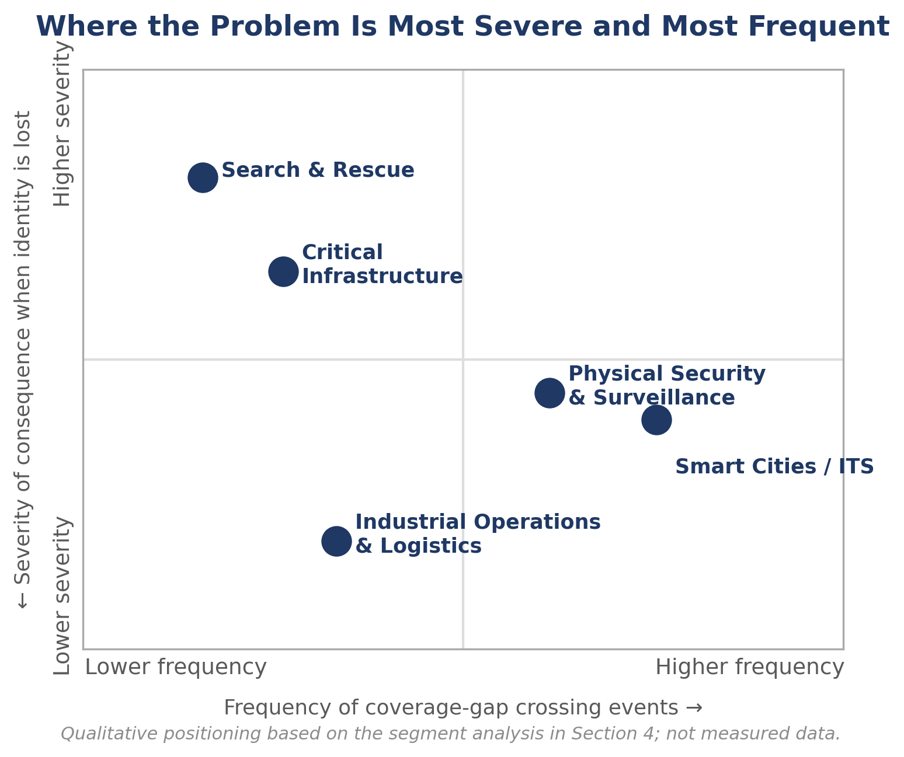
Figure 7. Segments positioned by the frequency and severity of coverage-gap crossing events, synthesized from Section 4.
Severity and frequency do not move together across these segments. Search and rescue shows the lowest frequency of individual crossing events but the highest severity per event, since outcomes are measured in survival probability rather than efficiency or cost. Physical security and intelligent transportation show the opposite pattern: very high frequency, with severity that is real but generally lower per individual event, escalating only at high-risk sites or during active incidents. Critical infrastructure sits between the two — comparatively infrequent crossing events, but each one carries safety, security, or continuity-of-service stakes that place it closer to search and rescue on severity than to routine security monitoring.
Continuity is most operationally central where the tracked entity cannot practically be instrumented with a tag or transponder — people (including uncooperative subjects), third-party vehicles, and wildlife or environmental hazards. This is precisely why industrial operations and logistics is the weakest fit among the segments examined: its dominant tracked population (owned assets, inventory, and fleet vehicles) can be tagged, and RTLS/RFID already provides reliable continuity for that population. The residual, vision-dependent problem there is real but narrow. Search and rescue and physical security, by contrast, are defined by tracking people who are, by the nature of the task, not carrying a cooperative tag.
Current workflows are most constrained in search and rescue, where field connectivity is frequently degraded or absent and where the search organizations themselves are often volunteer-supported and resource-constrained — a real adoption constraint independent of whether a technical solution exists. Critical infrastructure and intelligent transportation are constrained differently: by regulatory and procurement cycles, and, for any system that resembles person-tracking, by an active and evolving body of privacy and biometric-surveillance regulation (addressed further in Section 5).

5. User & Customer Research
The roles below were identified from the operational literature underlying each segment in Section 4, not from direct interviews or surveys; no statements attributed to a named individual, and no quotation, appears anywhere in this document. Distinctions between user, customer, and beneficiary are preserved throughout: the person who watches a screen, the person who approves a budget, and the person or organization who benefits from a correct outcome are frequently different people with different incentives.

5.1 Security Operations Center (SOC) / CCTV Monitoring Operator
Role & responsibility: Front-line staff who watch live camera feeds and respond to or escalate what they observe, responsible for detecting and reporting events — intrusions, incidents, persons of interest — in near real time from an assigned set of camera feeds.
Environment: Shift-based work, frequently overnight or extended hours, in a monitoring room with multiple screens; workload varies with site activity level.
Job: Maintain continuous, accurate awareness of who and what is on the monitored premises.
Current workflow: Watch assigned camera views individually or in a tiled layout, respond to analytics-triggered alerts where available, and manually search other camera feeds when someone of interest disappears from view.
Pain & consequence: Documented vigilance decrement (a measurable detection-rate decline within roughly 15–30 minutes of continuous monitoring) combined with camera-to-operator ratios that make full manual coverage uneconomical; the consequence is that real events — including the reappearance of a subject the operator was tracking — are missed or delayed.
Desired outcome: A subject who exits one camera’s view is reliably and quickly linked to their reappearance elsewhere, without the operator manually searching.
Current workaround: Motion-triggered alerting and analytics that reduce the number of feeds needing constant attention, plus after-the-fact recorded-video review once an incident is reported.
Adoption barrier: Deployment cost, integration with existing video-management systems, false-alarm fatigue, and the operator’s need to trust an automated match enough to act on it.

5.2 Physical Security Director / Chief Security Officer
Role & responsibility: Owns the security budget, vendor selection, and organizational risk posture for a site or portfolio of sites; ensures adequate coverage and response capability within budget and staffing constraints.
Environment: Works across corporate, retail, healthcare, or campus settings, balancing capital spend (cameras, sensors) against staffing spend (operators).
Job: Demonstrate that the organization can detect and respond to relevant incidents, and defend that claim to leadership, insurers, or regulators.
Current workflow: Sets camera density and staffing levels based on budget and general monitoring-effectiveness guidance, rather than a measured, data-driven view of actual identity-continuity performance.
Pain & consequence: Persistent uncertainty about how much true continuous coverage the organization has, given known human-vigilance and camera-ratio limits; coverage gaps are typically discovered only after an incident, when a post-hoc review reveals a subject was “lost” between cameras.
Desired outcome: A monitoring capability whose continuity does not depend on adding headcount at a rate that scales with camera count.
Current workaround: Layering additional cameras, more aggressive analytics rules, and after-the-fact footage review — none of which changes the underlying continuity gap.
Adoption barrier: Capital cost; uncertain return on investment given the difficulty of quantifying “coverage gaps avoided”; integration risk with incumbent video-management platforms; and, increasingly, exposure to privacy and biometric-tracking regulation for anything that resembles automated person-tracking (documented, evolving, and jurisdiction-specific as of 2026).

5.3 Search & Rescue Incident Commander
Role & responsibility: Coordinates search assets — ground teams, aircraft, drones — and search strategy for a missing-person or disaster-response incident; allocates limited search resources and time to maximize the probability of locating a subject alive.
Environment: Field-based command post, often with degraded or absent cellular and data connectivity, variable terrain and weather.
Job: Convert every partial detection — a sighting, a thermal signature, a track — into confirmed location information as quickly as possible.
Current workflow: Standard SAR methodology (investigation, containment, hasty search, expanding probability-of-area search), coordinated primarily through radio and, increasingly, shared mapping tools; detections from different assets are correlated manually by command staff.
Pain & consequence: Search assets, particularly drones operating in a swarm, face documented communication-latency, line-of-sight, and coordination challenges; a detection made by one asset is not automatically preserved and handed to the next asset covering that area, which risks wasted search effort or a genuine lead that is not followed up quickly enough.
Desired outcome: Any detection made by any asset is retained and available to whichever asset next covers that location, without depending on radio-relayed verbal description.
Current workaround: Verbal or radio relay of subject description between teams, and shared paper or digital mapping of search sectors.
Adoption barrier: Field connectivity constraints, ruggedization and power requirements for any additional hardware, and the volunteer, resource-constrained nature of many SAR organizations, which limits capital available for new equipment.

5.4 Intelligent Transportation Systems (ITS) Operations Engineer
Role & responsibility: Operates and maintains a city or regional traffic-camera and sensor network from a traffic management center; manages congestion, detects and responds to incidents, and, where mandated, supports public-safety camera requests.
Environment: Control-room setting overseeing a citywide, non-overlapping camera grid at intersections and along corridors.
Job: Understand where vehicles and pedestrians are moving across the city in close to real time, particularly during an active incident.
Current workflow: Single-camera analytics (counts, speeds, incident detection) at each intersection, with cross-camera correlation performed manually, or not attempted, outside of dedicated research and benchmark pipelines.
Pain & consequence: Cross-camera vehicle and pedestrian tracking is described in the transportation-research literature as a core unsolved challenge, driven by non-overlapping fields of view, appearance variation, and the scale of camera counts in a city network; incident response and route reconstruction therefore rely on manual, after-the-fact video pulls rather than a live, continuous citywide track.
Desired outcome: Continuous cross-camera tracking of a specific vehicle or pedestrian during an active incident, without a human manually reviewing every intersection camera in sequence.
Current workaround: Requesting and manually reviewing footage from multiple intersection cameras after an incident is reported.
Adoption barrier: Municipal procurement cycles; data-retention and privacy-policy constraints, particularly for pedestrian tracking; and integration with legacy, multi-vendor traffic-management infrastructure.

5.5 Warehouse / Industrial Robotics Fleet Operations Engineer
Role & responsibility: Manages the day-to-day operation of a fleet of autonomous mobile robots and the fleet-management software that coordinates them; keeps the fleet productive, safe around people and untagged obstacles, and integrated with the warehouse-execution system.
Environment: Dynamic warehouse or plant floor shared with human workers and forklifts, and, at facility boundaries, external vehicles and visitors.
Job: Ensure the fleet can navigate and coordinate safely and efficiently, including around entities that are not part of the tagged, instrumented asset base.
Current workflow: Centralized fleet-management software aggregates location data primarily from tagged assets (RFID, UWB, BLE), while each robot’s own onboard perception handles immediate obstacle avoidance; there is little persistent cross-robot tracking of untagged people or objects beyond a momentary encounter.
Pain & consequence: The continuity problem here is narrower than in other segments because RTLS/RFID already solves it for taggable assets; the residual pain is specific to untagged actors and to any use case requiring persistent, not just momentary, awareness of them across multiple robots’ fields of view. Incidents or inefficiencies involving untagged people, third-party vehicles, or unprocessed material are handled reactively.
Desired outcome: Where relevant, persistent awareness of untagged but relevant entities as they move between the fields of view of different robots or fixed cameras in the facility.
Current workaround: Local, per-robot obstacle detection and avoidance without cross-robot identity linkage, supplemented by fixed CCTV covering high-traffic zones.
Adoption barrier: This is the segment where the core problem is least central to daily operations, so any new capability must justify itself against an already-effective RTLS baseline for the majority of tracked entities.

Persona Matrix
As with the segmentation matrix, cells are condensed for scanability; full detail and evidentiary support appear in the persona narratives above.
Stakeholder | Responsibility | Environment | Job | Current Workflow | Pain | Consequence | Desired Outcome | Current Workaround | Adoption Barrier
SOC / CCTV Operator | Detect & report events from assigned camera feeds | Shift-based monitoring room | Continuous awareness of premises | Watch tiled feeds; respond to triggers; manual search on loss | Vigilance decrement; uneconomical feed ratios | Real events missed or delayed | Reliable auto-link on reappearance | Motion/analytics triggers; after-the-fact review | Integration, false-alarm fatigue, trust in match
Security Director / CSO | Own security budget, vendor choice, risk posture | Corporate / retail / healthcare / campus | Demonstrate adequate detect-and-respond capability | Set camera/staffing levels by budget & guidance | Unknown true coverage-gap rate | Gaps found only after an incident | Continuity that doesn't scale headcount with cameras | More cameras, stricter rules, after-the-fact review | Cost, unclear ROI, privacy/biometric regulation
SAR Incident Commander | Allocate search assets & strategy | Field command post, degraded connectivity | Convert detections into confirmed location fast | Standard SAR method; manual correlation via radio | Swarm comms/LOS limits; detections not preserved | Wasted search effort or missed follow-up | Detections persist & pass to next covering asset | Verbal/radio relay; shared sector maps | Field connectivity, ruggedization, volunteer budgets
ITS Operations Engineer | Operate citywide camera/sensor network | Traffic management center | Real-time citywide vehicle/pedestrian awareness | Single-camera analytics; manual cross-camera review | Cross-camera tracking is an unresolved research problem | Slow, manual incident/route reconstruction | Continuous cross-camera track during incidents | Manual multi-camera footage pulls | Procurement cycles, privacy policy, legacy integration
Warehouse Fleet Ops Engineer | Keep AMR fleet productive & safe | Dynamic warehouse/plant floor | Safe, efficient navigation incl. untagged entities | Centralized fleet mgmt on tagged-asset data | RTLS solves tagged assets; gap is untagged actors | Untagged incidents handled reactively, not persistently | Persistent awareness of relevant untagged entities | Per-robot local avoidance; fixed CCTV zones | Must beat an already-effective RTLS baseline

6. Jobs-to-Be-Done
Each job below is defined independently of any particular technology and reflects a genuine difference in situation, not a reworded repetition of the same underlying need.
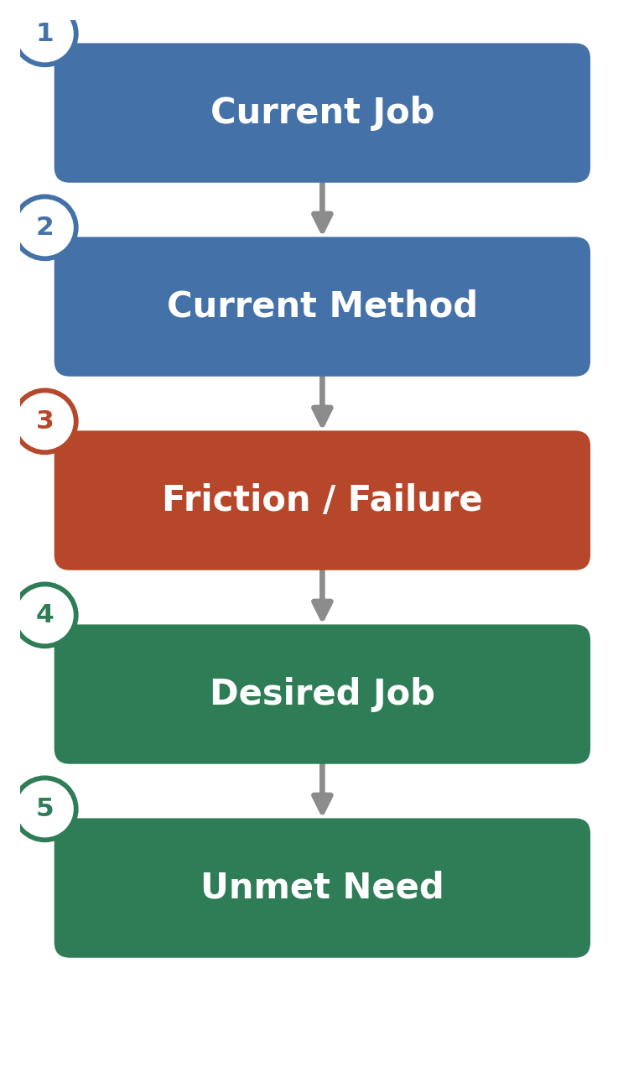
Figure 8. The analytical structure applied to each user group below.

6.1 SOC / CCTV Operator
When a person or vehicle of interest exits the field of view of one camera in a large facility, I want to know immediately, and with confidence, where they reappear, so that I can maintain continuous awareness without manually reviewing every other camera feed.
Current job / method: Watch assigned feeds and manually scan other cameras when a subject disappears from view.
Friction: Vigilance decrement and camera-count limits mean the loss itself may not be noticed, let alone resolved, in time.
Desired job / unmet need: Automatic, trustworthy re-linking of a subject across cameras; unmet because current tools require either a human to notice and search, or an offline match performed well after the fact.

6.2 Security Director / CSO
When I evaluate our monitoring capability, I want confidence that our system will not silently lose track of a subject moving through our site, so that I am not relying on staffing levels I cannot economically sustain.
Current job / method: Size camera density and staffing against budget and general industry guidance rather than a measured continuity rate.
Friction: There is no routine way to see how often continuity actually fails until an incident forces a retrospective review.
Desired job / unmet need: A monitoring capability whose reliability is demonstrable and does not degrade as camera count grows faster than headcount.

6.3 Search & Rescue Incident Commander
When search assets detect a possible subject and then lose contact as the subject moves out of range or behind terrain, I want that detection preserved and available to the next asset that covers the area, so that search effort is not wasted re-covering already-searched ground or re-establishing contact from scratch.
Current job / method: Detections are relayed verbally between teams and correlated manually by command staff.
Friction: Communication latency, line-of-sight limits, and the absence of a persistent shared record mean detections can be lost between assets.
Desired job / unmet need: Persistent, asset-to-asset preservation of a detection; unmet because most documented swarm-coordination work targets area coverage and task allocation, not continuity of a specific detected subject.

6.4 ITS Operations Engineer
When an incident requires tracing a specific vehicle or pedestrian across the city’s camera network, I want a continuous track rather than isolated single-camera clips, so that I can reconstruct events without manually pulling and reviewing footage from every intersection.
Current job / method: Single-camera analytics per intersection; cross-camera correlation performed manually or not at all.
Friction: Non-overlapping fields of view, appearance variation, and city-scale camera counts make manual correlation slow and incomplete.
Desired job / unmet need: A live, continuous, citywide track for a specific subject during an active incident; unmet in deployed practice, though addressed in benchmark research.

6.5 Warehouse Fleet Operations Engineer
When an untagged person, vehicle, or object needs to be tracked across zones not covered by a single robot’s or camera’s line of sight, I want continuity maintained without instrumenting every object with a tag, so that operations are not constrained to only what can be physically tagged.
Current job / method: Rely on RTLS/RFID for tagged assets and momentary, per-robot perception for everything else.
Friction: Untagged entities have no persistent identity across robots or cameras once they leave a single robot’s immediate field of view.
Desired job / unmet need: Persistent cross-robot awareness of untagged but operationally relevant entities; a narrow but real gap, since tagging already resolves the majority case.

7. AS-IS Workflow
The as-is workflow below represents the practice documented across the segments examined, generalized to the pattern common to all of them: independent sensor nodes, a transition point where coverage is lost, and a recovery step that is either manual or performed well after the fact.
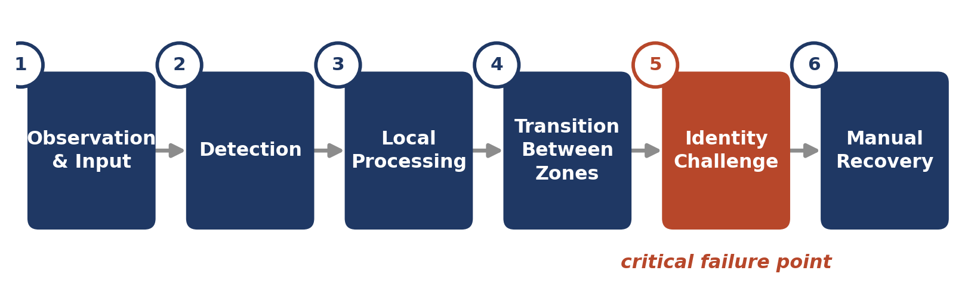
Figure 9. The as-is workflow, with the point at which continuity actually breaks highlighted.

Stage 1 — Observation / Input
What happens: a sensor — a fixed camera, a robot-mounted camera, or another point sensor — captures raw data of its coverage area. Who performs it: the sensor and, for video, an associated recording or streaming system. Information available: raw imagery or signal, without any cross-sensor context. Decisions made: none at this stage. Dependencies: sensor placement, power, and network connectivity. What can fail: coverage gaps by design (sparse placement), degraded conditions (light, weather, occlusion). After failure: the target simply is not observed until the next sensor picks it up, if any does.

Stage 2 — Detection
What happens: a person, vehicle, or object is identified within a single sensor’s feed, typically by a detection algorithm or a human operator. Who performs it: on-device or centrally run detection software, or a human watching the feed. Information available: a bounding location and, where analytics are used, a classification (person, vehicle, type). Decisions made: whether the detection is worth flagging. Dependencies: adequate resolution, lighting, and processing capacity. What can fail: missed detections under difficult conditions, or false detections. After failure: nothing is recorded, or an erroneous record is created.

Stage 3 — Local Processing / Tracking within a Sensor's View
What happens: the detected entity is followed continuously while it remains inside that sensor’s field of view, typically assigned a temporary, sensor-local identifier. Who performs it: single-sensor tracking software. Information available: a trajectory confined to the one sensor’s coverage. Decisions made: associating detections across consecutive frames into a single local track. Dependencies: consistent detection frame to frame. What can fail: the local track itself can be lost mid-view due to occlusion. After failure: even within a single sensor, the identity can already fragment before any handoff is attempted.

Stage 4 — Transition Between Observation Areas
What happens: the target moves out of the current sensor’s coverage and into a gap, then, potentially, into a different sensor’s coverage. Who performs it: this stage is not actively performed by anything in most current deployments — it simply happens. Information available: none, for the duration the target is in the gap. Decisions made: none. Dependencies: the size of the gap relative to how fast the target moves through it. What can fail: the entire continuity of the record. After failure: the target reappears, if at all, as an unlinked, apparently new detection.

Stage 5 — Identity / Continuity Challenge
What happens: this is the critical failure point identified throughout this analysis. A new detection appears in a different sensor’s feed, and the system (or a person) must decide whether it is the same target as one previously tracked elsewhere. Who performs it: either an appearance-matching algorithm run centrally, often offline, or a human operator relying on memory and manual comparison. Information available: the new detection’s appearance, and, if retained, a database or recollection of prior detections. Decisions made: match, no match, or uncertain. Dependencies: appearance similarity across viewpoint, lighting, and occlusion differences; for a human, recall and continued attention. What can fail: false non-matches (identity lost), false matches (identity switched), or simply no attempt being made. After failure: this is where failure modes 1 and 2 (Section 2.5) occur.

Stage 6 — Manual or Reactive Recovery
What happens: once a loss is noticed — sometimes immediately, often only after an incident prompts a review — a person manually searches other camera archives or asks other search assets, by radio or similar means, whether they have seen the subject. Who performs it: the operator, investigator, or incident commander. Information available: whatever institutional memory, recorded footage, or verbal description is available. Decisions made: where to look next, and whether the review is worth the time it takes. Dependencies: staff availability and footage retention. What can fail: the review may not happen at all, may happen too late to matter operationally, or may not find the correct match. After failure: the record remains permanently fragmented or wrong.

8. TO-BE Workflow
The desired workflow below is defined by the operational outcomes the as-is workflow fails to deliver — not by a specific technology. It describes what the process should accomplish, independent of how any particular implementation achieves it.
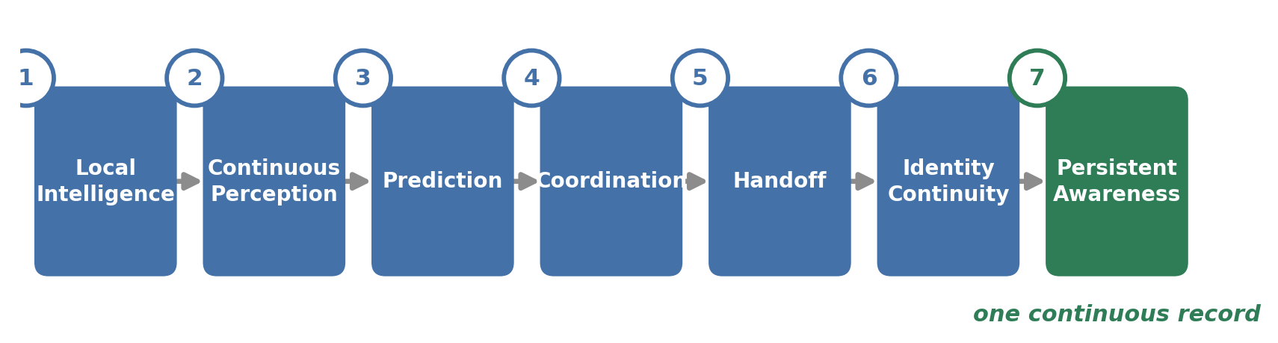
Figure 10. The to-be workflow, ending in one continuous record rather than fragmented clips.

Stage 1 — Local Intelligence
What happens: each sensor node processes what it observes at or near the point of capture, rather than requiring raw data to first travel to a central location before anything useful can be produced. Who performs it: the sensor node itself, or a compute unit closely associated with it. Information exchanged: none yet, beyond the sensor’s own processed output. Decision being made: what is present in this sensor’s view right now. Failure being prevented: the bandwidth and latency bottleneck documented in Section 2.3, where centralized processing of raw data becomes the constraint. What changes for the user: less dependence on network capacity and central-server load for basic detection to function. Outcome improved: faster, more resilient detection at the source.

Stage 2 — Continuous Perception
What happens: the target is tracked persistently while inside a given node’s coverage, maintaining a stable local identity. Who performs it: the same node-level processing as Stage 1. Information exchanged: none yet, beyond internal state. Decision being made: is this the same entity from one moment to the next within this node’s view. Failure being prevented: fragmentation of identity even before any handoff is needed (the failure noted in as-is Stage 3). What changes for the user: a more reliable starting point for whatever happens next. Outcome improved: fewer spurious identity fragments entering the system.

Stage 3 — Prediction
What happens: before the target actually leaves the node’s coverage, the system estimates that this is about to happen and roughly when and where. Who performs it: node-level processing, using the target’s recent trajectory. Information exchanged: none externally yet; this is anticipatory, internal to the node. Decision being made: is a handoff about to be needed, and if so, in which direction. Failure being prevented: the reactive, after-the-gap-occurs pattern of the as-is workflow, where nothing happens until continuity has already been lost. What changes for the user: the system has a head start on the problem instead of discovering it only once it has already occurred. Outcome improved: the transition (as-is Stage 4) becomes something the system prepares for, rather than something that simply happens to it.

Stage 4 — Coordination
What happens: the node anticipating a handoff communicates with the node(s) most likely to next observe the target. Who performs it: the originating and neighboring nodes, or a coordinating layer above them. Information exchanged: a compact description sufficient to recognize the same target — not the raw sensor feed itself. Decision being made: which neighboring node is best positioned to take over. Failure being prevented: the complete absence of any cross-node communication in the as-is workflow, and the bandwidth cost of transmitting full raw data to accomplish the same end. What changes for the user: the receiving point of observation is primed before the target arrives, rather than encountering it cold. Outcome improved: readiness at the point of reacquisition.

Stage 5 — Handoff
What happens: the compact identity description is transferred to the node(s) selected in Stage 4. Who performs it: the originating node, to the receiving node. Information exchanged: the identity description itself, plus relevant trajectory context. Decision being made: confirmation that the transfer is complete and the originating node can stand down from actively pursuing continuity for this target. Failure being prevented: duplicated or wasted effort continuing to track a target that is no longer in view, and loss of the description that would otherwise have to be manually reconstructed later. What changes for the user: the handoff itself becomes a discrete, observable event rather than an invisible gap. Outcome improved: a documented point of transfer exists, where none did before.

Stage 6 — Identity Continuity
What happens: the receiving node observes a new detection and evaluates whether it matches the identity description it was handed, using a matching approach that accounts for the appearance changes documented in Section 2.3 (viewpoint, lighting, partial occlusion) rather than a rigid, single-threshold comparison. Who performs it: the receiving node. Information exchanged: the match result. Decision being made: confirm, reject, or flag as uncertain for human review. Failure being prevented: both silent identity loss and incorrect identity switches (failure modes 1 and 2, Section 2.5). What changes for the user: reacquisition is attempted proactively, with context, instead of being left to chance or to a human’s memory. Outcome improved: higher-confidence, faster reconnection.

Stage 7 — Persistent Awareness
What happens: the confirmed, continuous record of the target’s path across multiple nodes is made available as a single thread. Who performs it: the system as a whole, presented to the human operator or downstream process. Information exchanged: the assembled trajectory and history. Decision being made: what, if anything, requires human attention or action. Failure being prevented: the burden on human vigilance to reconstruct continuity manually (root cause 4, Section 2.3), and the delay inherent in after-the-fact review (failure mode 4, Section 2.5). What changes for the user: the operator receives one coherent record instead of many disconnected clips. Outcome improved: faster, more reliable situational awareness with less demand on sustained human attention.

9. AS-IS vs TO-BE
Only dimensions genuinely relevant to the problem identified in this analysis are included. No numerical improvement figures are asserted; the table describes a qualitative shift in where and how each function is performed, which is what the available evidence supports.
Dimension | AS-IS | TO-BE
Observation | Independent sensors capture data with no shared context | Each node processes locally and is aware it is part of a network
Awareness / Continuity | Continuous only within a single sensor's view; breaks at every gap | Anticipated and actively maintained across gaps
Identity | Re-established late, if at all, by appearance matching or human memory | Carried forward via a compact description prepared before the gap is reached
Handoff / Transition | Invisible; simply happens with no active process | A discrete, coordinated, observable event between specific nodes
Failure Recovery | Manual, after-the-fact review once a loss is noticed or an incident occurs | Reacquisition attempted proactively at the point of transition
Human Intervention | Required continuously (vigilance-dependent) or investigatively (after the fact) | Reserved for genuinely uncertain matches or downstream decisions, not routine bridging
Responsiveness | Reactive; often delayed past the point of operational usefulness | Anticipatory; prepared before the gap is reached
Scalability | Bounded by camera-to-operator ratios and central-processing bandwidth | Bounded primarily by node-to-node coordination, not central throughput
Operational Visibility | Fragmented clips and records across independent sensors | One continuous, assembled record per tracked entity
Bandwidth / Infrastructure Load | Raw data often transmitted centrally at meaningful cost (documented Mb/s figures per stream) | Only compact descriptions and trajectory context cross the network
Privacy Exposure | Raw imagery is centralized, retained, and reviewable | Only minimized, purpose-limited metadata leaves the point of capture
Reading across any row shows the same underlying shift: the current state treats the gap between sensors as something to react to after the fact, while the desired state treats it as something to prepare for before it occurs. The improved operational state that follows is not faster processing for its own sake, but a continuous record that a human or downstream system can trust without having to reconstruct it manually.

10. Cross-Analysis

What is the actual underlying problem?
Organizations that must track a moving person, vehicle, or asset across a physically distributed sensor or robot network cannot reliably maintain that target’s identity when it passes through the coverage gap between independently operating sensors, because appearance-based re-identification is technically fragile, centralized processing is bandwidth-constrained, and human monitoring is subject to a well-documented vigilance decrement.

Who experiences it most strongly?
Search-and-rescue incident commanders and field teams experience the most severe consequences, since the cost of failure is measured in survival probability. Security operators and ITS engineers experience it most frequently, given the volume of crossing events in busy environments.

Under what conditions is it most severe?
When the area is large or physically discontinuous, when the tracked entity cannot be instrumented with a tag, when conditions are already degraded (low light, weather, occlusion, poor connectivity), and when the operational consequence of a missed or delayed reconnection is high (an active incident, a search for a missing person, an intrusion in progress).

Which environments experience it most clearly?
Physical security, intelligent transportation, critical-infrastructure protection, and search and rescue all show strong, independently sourced evidence of the problem as defined. Industrial operations and logistics shows the problem in a structurally narrower form, confined to untagged actors, because tag-based real-time location systems already resolve continuity for the majority of what is tracked in that segment.

What are the dominant failure modes?
Silent identity loss, incorrect identity matches (identity switches), operator attentional failure, and processing backlog or latency — detailed with their causes and consequences in Section 2.5.

What are users fundamentally trying to accomplish?
Not to watch more footage or generate more alerts, but to maintain one continuous, trustworthy account of where a specific person, vehicle, or asset has been and currently is, without that account depending on a human noticing and manually reconnecting fragments.

What are they doing today?
Relying on a combination of sparse sensor placement, centralized (often offline) appearance matching, and human operators or field personnel to notice losses and manually search, radio, or review footage to reconnect them — the as-is workflow described in Section 7.

Why is the current workflow insufficient?
Because it treats the loss of continuity as something to discover and repair after it has already happened, rather than something to anticipate; and because the two mechanisms it relies on to repair the loss — algorithmic appearance matching and human vigilance — both have well-documented, independent failure rates that compound rather than cancel each other out.

What would the desired workflow need to accomplish?
Anticipate an impending loss of coverage before it occurs, prepare the next relevant point of observation with enough information to recognize the same target under changed appearance conditions, and present the result as a single continuous record rather than a set of fragments requiring manual reassembly — the to-be workflow described in Section 8.

Which stakeholder groups have the strongest unmet need?
Search-and-rescue incident commanders and field teams, because the consequence of the unmet need is measured in survival outcomes and because, per the evidence gathered, persistent asset-to-asset handoff of a specific detection is not yet a mature, widely deployed capability even in that safety-critical setting. Security operators and ITS engineers follow closely, given the sheer frequency of unresolved crossing events they face.

Which market contexts appear genuinely relevant?
Physical security and surveillance, intelligent transportation systems, and critical-infrastructure protection show the strongest combination of frequency, severity, and clearly identifiable customers and users. Search and rescue shows the highest severity and a clear beneficiary but a resource-constrained customer base and real field-deployment constraints (connectivity, ruggedization, budget) that a purely technical solution does not resolve on its own.

Which initially plausible contexts appear weak or poorly aligned?
Industrial operations and logistics, treated as a general category, is the weakest fit: RTLS and RFID already deliver reliable continuity for the majority of what these operations track, so the residual, vision-dependent problem is real but narrow. Relatedly, a general “robotics” segment, and specifically a scenario in which mobile robots (rather than fixed cameras or a mix of both) hand a target to one another, is not independently evidenced as an established commercial category; the strongest, most consistently documented instantiation of the underlying problem in the literature is fixed or mixed camera-network surveillance, not robot-to-robot handoff in isolation. This distinction matters: the identity-continuity problem itself is well evidenced, but the specific architecture of robots handing a target to other robots is one possible way to address it, not a separately validated market need in its own right.

11. Evidence / Sources
Sources are listed with the type of evidence they support. “Verified” denotes findings drawn from peer-reviewed research, institutional/government publications, or directly documented technical measurements. “Industry / inference” denotes findings drawn from industry commentary, vendor documentation, or discussion-forum consensus, which are directionally informative but not peer-reviewed and, in the case of camera-to-operator ratios, vary considerably across sources; these are treated as evidence-based inference rather than settled fact. No statistic, quotation, or finding in this document was invented, and no persona in Section 5 represents a real, named individual or an actual interview.
Source | Publication / Organization, Year | Type | Relevant Finding
Donald, F.M. & Donald, C. | Applied Ergonomics, 2011 (and related 2015 follow-up) | Verified | CCTV operators in a 90-minute real-time task detected ~50% of target behaviors with high false alarms; vigilance decrements found for novices/generalists after ~30 min, not specialists.
Sandia National Laboratories | SAND2014-17929, 2014 | Verified | Vigilance decrement is described as the most pervasive finding across the vigilance-research literature, including CCTV-specific operator studies.
Security-industry operator forums & commentary | IPVM and related industry sources, 2013–2026 | Industry / inference | Widely cited (though non-uniform) guidance that effective unaided camera monitoring is limited to roughly 4–9 simultaneous feeds, rising when supplemented by analytics; figures vary substantially by source.
Multiple person re-identification surveys | ResearchGate / ACM / ScienceDirect, 2018–2025 | Verified | Person re-ID across cameras is fundamentally limited by pose, viewpoint, and illumination variation and by occlusion, which alone decomposes into four documented sub-problems.
Multi-camera non-overlapping tracking / handoff literature | Springer, arXiv, USPTO patent literature, 2003–2018 | Verified | Non-overlapping camera fields of view are treated as the practical norm for wide-area surveillance because full overlapping coverage is cost- and computation-prohibitive; handoff/handover mechanisms are an established research sub-field.
Distributed Multi-Target Tracking in Camera Networks | ResearchGate (decentralized smart-camera tracking), n.d. | Verified | Decentralized camera networks can identify neighboring sensors and distribute detection, tracking, and handoff without full central coordination.
“Scaling Video Analytics on Constrained Edge Nodes” | arXiv 1905.13536 | Verified | Concrete bandwidth figures: 1080p H.264 ≈ 2 Mb/s per stream; 4K ≈ 30–40 Mb/s; documented deployment of eight 4K cameras sharing one 35 Mb/s uplink.
BiSwift: Bandwidth Orchestrator for Multi-Stream Video Analytics | arXiv 2312.15740 | Verified | Detector accuracy rises from ~61% to ~92% between 540p and 1080p input, requiring ~3.7x more bandwidth — illustrating the accuracy/bandwidth trade-off in centralized architectures.
YOLOv5-MS smart-city pedestrian detection study | PMC10604626, 2023 | Verified | Under-provisioned hardware can cause detection backlog severe enough to reference imagery hours old, undermining real-time use.
Multi-target multi-camera vehicle tracking research (AI City Challenge / CityFlow / RoundaboutHD) | arXiv 2405.11345, 2507.08729, 2301.07805 | Verified | Cross-camera vehicle tracking (MTMCT) remains an active, competitively benchmarked research problem due to non-overlapping views, appearance variability, and unknown target/camera counts.
EU-funded perimeter-protection project record (WARDIAM) | CORDIS, European Commission, project 783977 | Verified (single data point) | Perimeter-protection-systems market for critical infrastructure valued at ~€4.12 billion, ~7.1% CAGR; common perimeter sensors average ~40% false alarms and are 60–80% energy-inefficient from continuous operation.
CNI perimeter-security risk commentary | Industry source, 2026 | Industry / inference | Lists lack of real-time detection and fragmented, non-integrated systems among the most common perimeter-security risks at critical-national-infrastructure sites.
Heggie & Amundson (2009); Koester (2008), via wilderness-SAR geospatial research | Applied research / capstone literature review | Verified | 65,439 SAR missions in U.S. national parks, 1992–2007; ~50% of searches resolve within 3 hours, 81% within 12 hours, 93% within 24 hours; survival probability declines sharply thereafter.
Hashimoto, Heintzman, Koester & Abaid | PMC8990012 (agent-based lost-person model) | Verified | 46,609 individuals reported lost in U.S. national parks, 2004–2014, at a cost of ~$51.4 million.
“Take Me Home, Wi-Fi Drone” | arXiv 2604.09115 | Verified | Missing-person incidents grew ~11% annually in England and Wales since 2016; subjects frequently cannot call for help due to weak or absent connectivity in remote terrain.
SAR drone-swarm coordination literature | arXiv / Nature / PMC, multiple, 2023–2026 | Verified | Multi-UAV SAR deployments face documented communication-latency, line-of-sight, and coordination challenges; existing swarm implementations are described as lacking real-time coordination in dynamic, obstacle-rich environments.
AMR fleet-management practice | Vendor technical documentation (Swisslog, KUKA, Interlake Mecalux) and peer-reviewed AMR review literature | Verified (as description of current practice) | Centralized fleet-management software coordinates AMR fleets primarily via tagged/instrumented location data integrated with warehouse-execution systems.
RTLS technology-comparison sources | Litum, WiserSystems, PMC3408320 | Verified | RTLS (UWB, BLE, active RFID) requires the tracked entity to carry a tag; it is explicitly a tagged-entity solution, not a general vision-based re-identification solution.
HOTA / IDF1 / MOTA tracking-metrics literature | Luiten et al., 2020, and related surveys | Verified | Identity-focused metrics (IDF1, HOTA) were developed specifically because simpler detection-only metrics do not adequately penalize identity-continuity failures — indirect evidence that the field treats identity continuity as the harder, more consequential sub-problem.
Facial-recognition / biometric-surveillance regulatory sources | CSIS; Congress.gov CRS Report R48935; Privacy International / EU AI Act analysis; state-law trackers, 2026 | Verified | As of 2026, an expanding, jurisdiction-specific body of state, federal, and EU rules restricts real-time and retrospective facial-recognition or biometric tracking in public spaces, including explicit prohibitions in some jurisdictions on real-time tracking of an identified individual's movement.

Stated Limitations
- No verified market-sizing, customer-count, or revenue data specific to a stand-alone “handoff” or “proactive re-identification” product category was located. The €4.12 billion figure cited above describes the broader perimeter-protection-systems market, not this narrower capability. Any claim about the total addressable market for a dedicated continuity solution is a hypothesis, not verified evidence, and would require dedicated primary market research to establish.
- No operational deployment data was found for real-time, proactive (prediction-based, pre-emptive) sensor handoff outside of research and benchmark settings. Documented real-world practice is dominated by reactive, after-the-fact re-identification and manual operator recovery. This is treated as an evidence-based inference about the current state of practice, not a verified statement about any particular technology's readiness.
- Camera-to-operator monitoring-effectiveness figures vary considerably across sources and were not independently replicated for this analysis; they are reported as industry-consensus ranges rather than a single verified number.
- The regulatory findings on facial recognition and biometric tracking describe a fast-moving, jurisdiction-specific landscape as of 2026; they should be treated as a snapshot of an evolving area rather than a stable baseline, and appearance-based re-identification (clothing, gait, non-facial features) does not necessarily fall under the same legal definitions as facial recognition specifically — this distinction is unresolved in the sources reviewed and is noted here as an open question rather than a settled conclusion.

Competitive & Research Intelligence Report
Decentralized Edge-AI Framework for Proactive Multi-Robot Target Handoff and Cross-Node Re-Identification
Competitive landscape, adjacent solution space, and research-gap validation
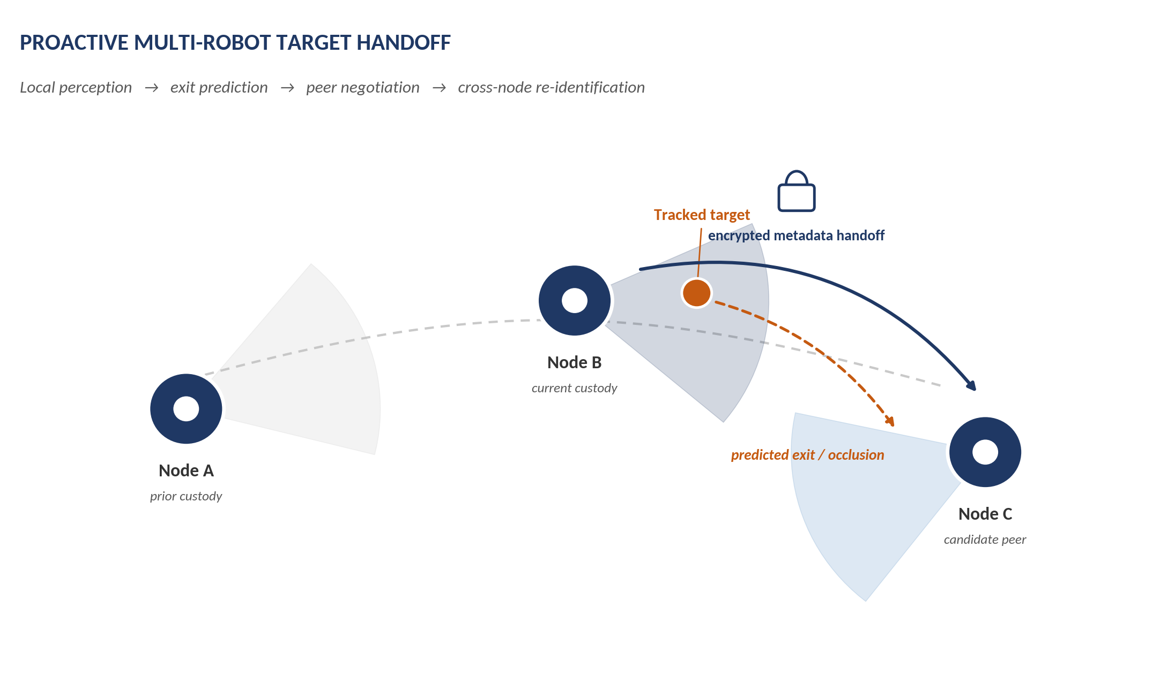
Proactive multi-robot target handoff: local perception, exit prediction, peer negotiation, and cross-node re-identification.

1. Competitive Landscape Overview
This report investigates the competitive, substitute, and research landscape surrounding a decentralized edge-AI framework for proactive multi-robot target handoff and cross-node target re-identification. In this architecture, mobile robotic nodes each perform local visual perception and tracking, predict when a tracked target is about to leave their field of view or become occluded, negotiate with peer robots to select the node best placed to continue tracking, exchange compact metadata describing the target rather than raw video, and re-establish a persistent identity for the target once a receiving robot acquires it.
The investigation was scoped around the underlying operational problem — maintaining reliable target identity and continuity across spatially separated, mobile observation nodes while reducing dependence on centralized raw-video processing and shifting from reactive to proactive handoff — rather than around the specific vocabulary used to describe the proposed system. This is deliberate: as the analysis below shows, the closest precedents in both industry and academia rarely use the same terminology, and several of the strongest matches were found under labels such as "camera handover," "cross-camera analytics," "collaborative perception," or "appearance search" rather than "target handoff."
The overall landscape is best described as fragmented across three maturity clusters that have developed largely independently of one another:
- A commercial cluster built around fixed-camera video management systems (VMS) with cross-camera appearance search. This cluster is mature, well-funded, and widely deployed, but is architecturally centralized, camera-only (no mobile robots), and mostly retrospective/investigative rather than live and proactive.
- An academic cluster on predictive or proactive camera handoff for fixed, non-overlapping camera networks. This cluster has produced several close conceptual precedents in the last one to two years, but every system found operates on static cameras, not mobile robots, and none couples the prediction step to a peer-to-peer robot negotiation or an encrypted metadata protocol.
- An academic/robotics cluster on multi-robot cooperative target tracking, task allocation, and collaborative perception (including the adjacent, much larger vehicle-to-everything collaborative-perception literature). This cluster is mature on coordination theory, consensus estimation, and communication-efficient feature sharing between mobile agents, but it is generally built around continuous joint sensing or fusion of a target that remains observable to the team, not around discrete custody handoff of an identity when a target disappears from one agent's view and must be proactively reacquired by another.
No commercial product or published research system was found that combines all five defining elements of the target architecture — mobile robot nodes, proactive exit/occlusion prediction, peer-to-peer candidate-agent selection, lightweight encrypted metadata exchange, and cross-node re-identification into a persistent global identity — in a single demonstrated system. Each individual element, however, has meaningful and in some cases mature precedent elsewhere, detailed in the sections that follow. The central analytical question this report addresses is therefore not "does anything like this exist," to which the answer is a qualified no, but "which specific pieces of this architecture are already solved, which are partially solved, and which remain genuinely open" — addressed directly in the Gap Analysis and Novelty Check sections.
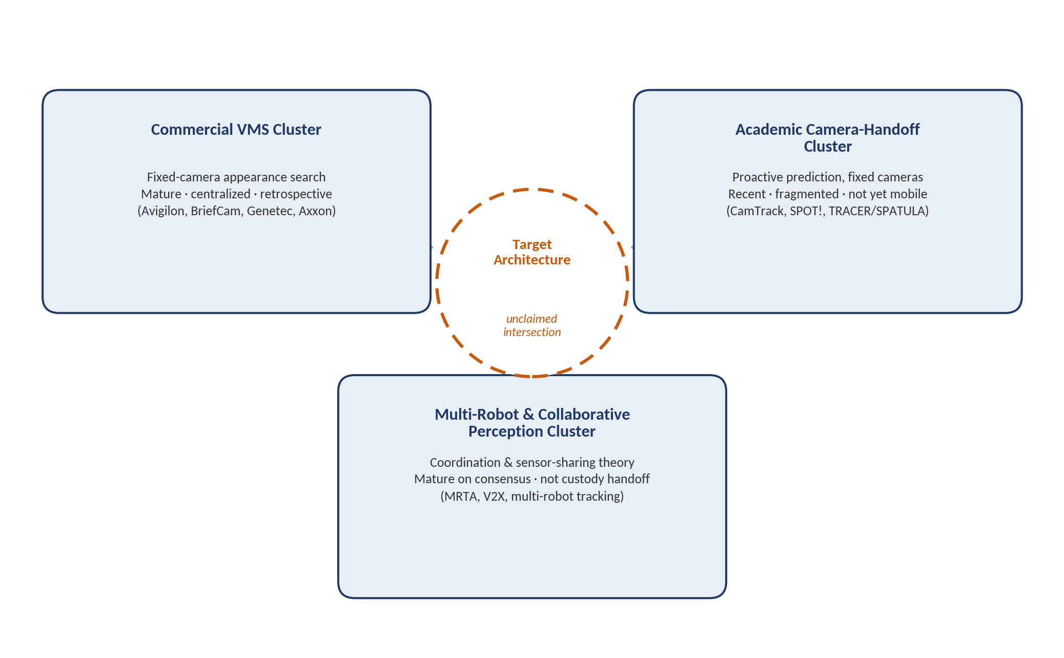
Figure 1 — The competitive and research landscape is fragmented across three maturity clusters that developed independently; the target architecture sits in the unclaimed intersection between them.

2. Direct Competitors
Direct competitors are grouped into three tiers by functional and architectural closeness to the reference architecture, following the open-ended discovery principle: relevance is judged by functional overlap with the underlying problem, not by whether a system is marketed using the same terms.
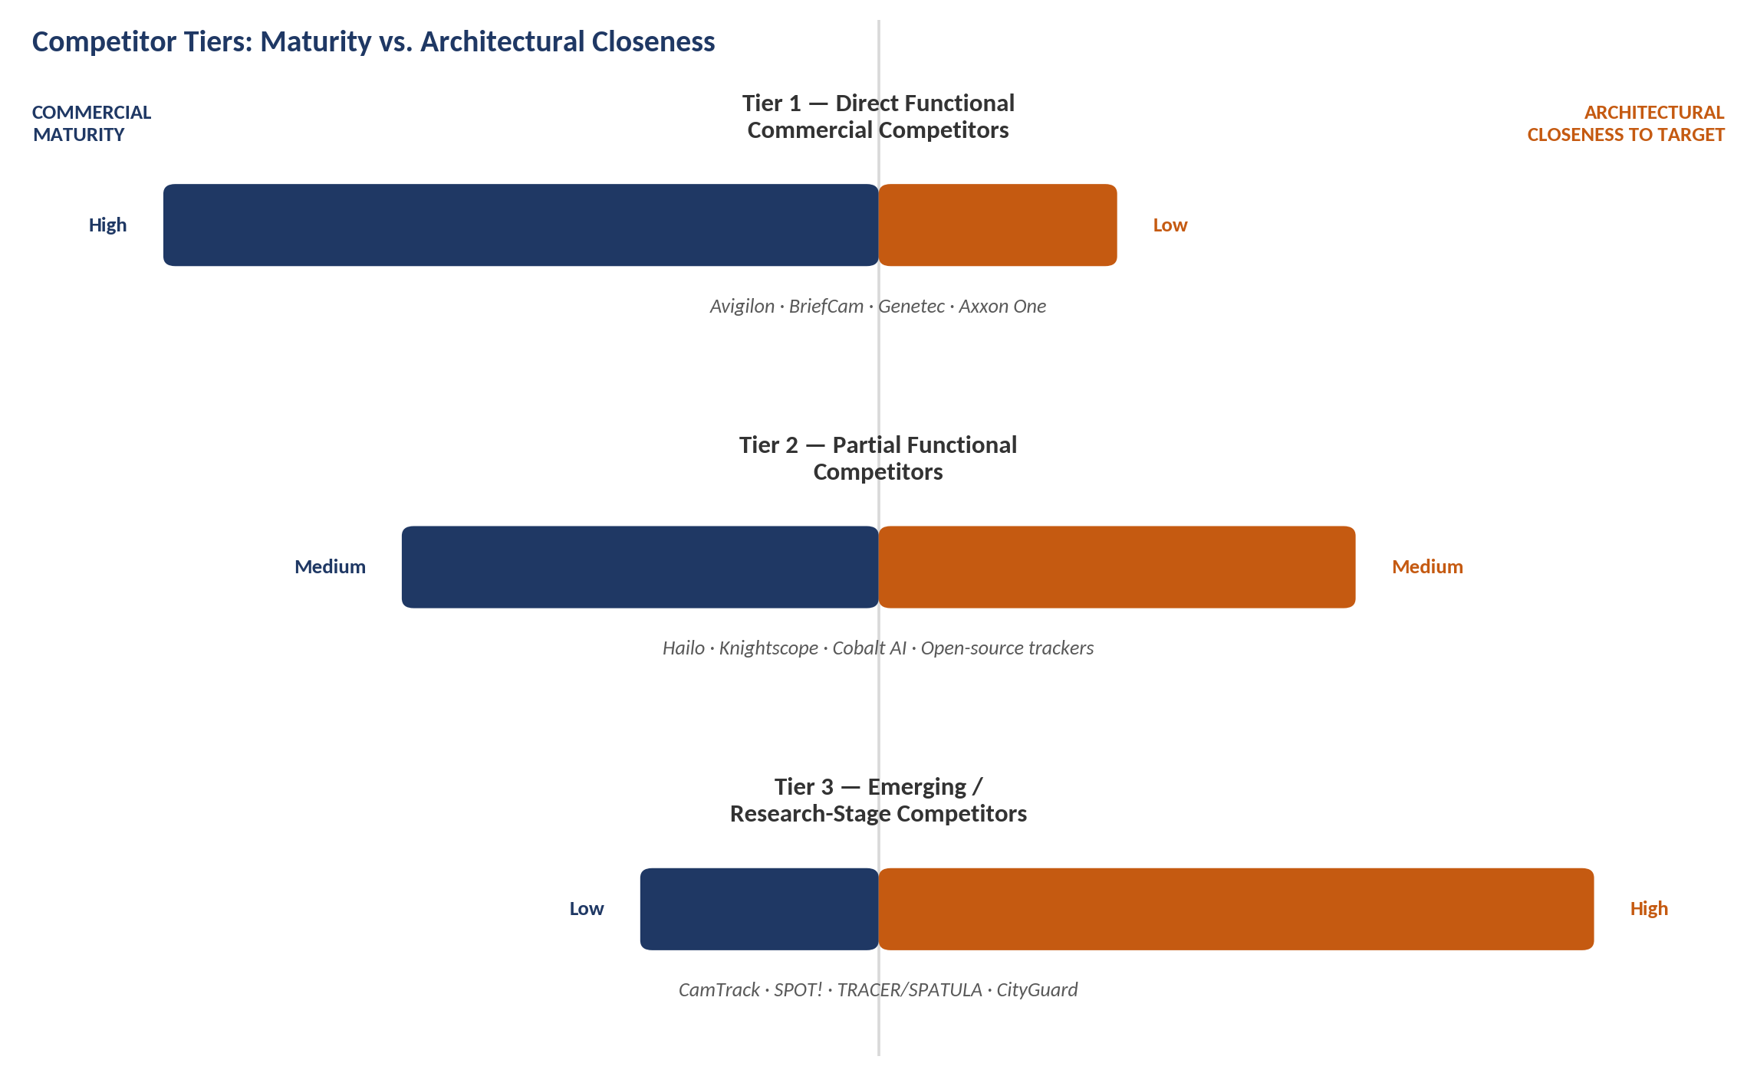
Figure 7 — Commercial maturity and architectural closeness to the target move in opposite directions across the three competitor tiers.

2.1 Tier 1 — Direct Functional Commercial Competitors
These are mature, commercially deployed systems that solve cross-camera identity continuity for fixed camera networks. They compete directly with the re-identification and handoff layers of the target architecture, but none involves mobile robots, proactive prediction before exit, or peer-to-peer coordination.

Avigilon Appearance Search (Motorola Solutions)
Provider: Motorola Solutions / Avigilon. Primary purpose: retrospective cross-camera search for a person or vehicle of interest by visual appearance (clothing color, gender/age categorization, facial characteristics), returning similarity-ranked matches across cameras and time. Deployment model: centralized, tied to Avigilon Control Center software and Avigilon-branded cameras/NVRs with GPU-accelerated appearance-matching hardware. Strengths: mature, widely deployed, strong appearance-matching accuracy within a single vendor's hardware stack. Limitations: single-vendor lock-in, investigative/retrospective search rather than live proactive handoff, no cross-organization or cross-site continuity beyond matching ACC software versions, no mobile-node or robot component. Evidence: vendor documentation and independent industry testing (IPVM) describing the search-only, non-alerting nature of the feature and its hardware dependency.

BriefCam (Canon; now integrated into Milestone XProtect)
Provider: Canon / BriefCam, distributed as a VMS-integrated analytics layer, notably within Milestone XProtect after Canon's 2024 consolidation move. Primary purpose: video synthesis and appearance/face-based watchlist search across multiple camera feeds. Deployment model: centralized VMS plug-in architecture, camera-agnostic to the extent the host VMS supports it. Strengths: broad VMS compatibility (works with many rival VMS platforms, not just Canon's own), mature face/appearance watchlist tooling. Limitations: centralized processing of raw video, investigative rather than proactive, no mobile or robotic sensing nodes, no predictive exit/occlusion modeling. Evidence: IPVM reporting on the Milestone consolidation and BriefCam's cross-VMS compatibility; EFF analysis of the BriefCam user manual describing its watchlist and confidence-scoring mechanics.

Genetec Security Center (Object/Appearance Search)
Provider: Genetec. Primary purpose: unified physical security platform with object/appearance search layered onto its VMS. Deployment model: centralized, on-premise or hybrid-cloud server processing. Strengths: broad camera-hardware compatibility (does not require a single camera vendor), large existing installed base. Limitations: independent testing (IPVM discussion threads) indicates Genetec's native object search historically operates per-camera rather than as an automatic cross-camera continuity feature comparable to Avigilon's, requiring add-on modules or third-party analytics (frequently BriefCam) for full cross-camera appearance search. No mobile-node component. Evidence: IPVM practitioner discussion and company reporting.

Axxon One Multi-Camera Tracking (AxxonSoft)
Provider: AxxonSoft. Primary purpose: real-time human detection and tracking across multiple cameras, showing a person's current location on an interactive map as they move between camera views. Core approach: neural-network appearance-matching to link detections between camera views and continue a track. Deployment model: centralized VMS/PSIM software running the matching pipeline. Strengths: real-time (not purely retrospective) cross-camera tracking with a live map display, closer in spirit to "live handoff" than most VMS appearance-search tools. Limitations: fixed camera infrastructure only, centralized processing, no predictive occlusion/exit modeling described in vendor documentation, no mobile robot integration. Evidence: vendor product documentation.

2.2 Tier 2 — Partial Functional Competitors
These systems address a significant sub-part of the underlying problem — either the edge/re-identification layer or the mobile-patrol layer — but not the full proactive multi-robot handoff architecture.

Hailo-8 Edge AI Processor for Multi-Camera Re-Identification (Hailo)
Provider: Hailo. Primary purpose: an edge AI accelerator chip marketed explicitly for real-time, on-device multi-person re-identification across camera streams for retail and security use cases. Relevant capabilities: edge inference, privacy-by-architecture (processing stays on-device rather than being sent to a central server), real-time multi-camera re-ID. Limitations: a hardware/inference enabler, not a system — it provides no handoff logic, no multi-robot coordination, and no metadata protocol of its own; a builder would still need to implement all of the coordination and prediction layers on top of it. Evidence: vendor technical blog and product documentation.

Knightscope Autonomous Security Robots (K5, K7)
Provider: Knightscope, Inc. (Nasdaq: KSCP). Primary purpose: autonomous physical-presence patrol robots for outdoor/perimeter security (parking lots, campuses, fence lines, logistics yards), equipped with 360-degree cameras, thermal imaging, license-plate recognition, and radiation/weapon detection sensors. Deployment model: single robots (or an uncoordinated fleet) patrolling pre-mapped routes and streaming video/alerts to a centralized security operations center ("Signals" platform); Knightscope's own marketing describes coordination through one human-supervised operations layer, not peer-to-peer robot negotiation. Relevant capabilities: mobile edge sensing, autonomous navigation, live streaming and anomaly alerting. Limitations: no evidence of robot-to-robot target handoff, proactive occlusion prediction, or persistent cross-robot identity; tracking and identity resolution, where they exist, are performed by the centralized platform and human analysts rather than negotiated between robots. Evidence: company product pages, CNN and trade-press coverage, and a November 2025 K7 product launch announcement.

Cobalt AI / Cobalt Robotics Security Robots
Provider: Cobalt AI. Primary purpose: indoor autonomous patrol robots for offices, hallways, and facilities, with environmental-sensor and building-management-system integration. Deployment model: centralized dispatch and human-in-the-loop remote operations, similar in structure to Knightscope. Relevant capabilities: mobile indoor patrol, anomaly detection correlated against building systems. Limitations: same structural gap as Knightscope — no published robot-to-robot handoff or distributed candidate-selection mechanism; comparative industry analysis explicitly frames Cobalt and Knightscope as alternatives to, not orchestrators of, camera-network appearance search. Evidence: industry buyer's-guide comparison reporting (Robotomated, 2026) and vendor materials.

Open-Source Multi-Camera People-Tracking Projects
Representative example: a public GitHub project combining YOLOv4-tiny detection with an Omni-Scale re-identification model to link people across multiple camera feeds. Primary purpose: hobbyist/research-grade demonstration of cross-camera tracking. Limitations: single-machine, offline-oriented, no distributed or edge deployment model, no predictive handoff, no robot integration; illustrates that the base building blocks (detection + re-ID) are commodity-level open-source technology, which is itself relevant to the novelty assessment in Section 13. Evidence: public repository documentation.

2.3 Tier 3 — Emerging / Research-Stage Competitors
These are the architecturally closest precedents found in this investigation. All are recent (2020–2026) academic systems; none is commercially deployed at scale, and each solves a meaningful subset of the target architecture rather than the whole.

CamTrack (Sou, Huang & Wu, 2026)
Published in Neural Computing and Applications (Springer), May 2026, by researchers at National Cheng Kung University, Taiwan. Primary purpose: assistive navigation for visually impaired users, but the underlying mechanism is a general predictive camera-handover framework. Core approach: fuses a smartphone's IMU (inertial) and Bluetooth Low Energy data with YOLOv7 detection and a ResNet50-CBAM re-identification model; a hybrid ReID+SORT tracker maintains identity within a camera, and a predictive handover algorithm uses the user's velocity and yaw angle to select and pre-activate only the most likely next camera before the user leaves the current camera's field of view. The paper also contributes an analytical Markov-chain model of handover success probability as a function of camera density and a tunable "handover expiry timer." Deployment: real-world validation on an operational smart-campus network of over 500 cameras and 69 NVRs. Relevant capabilities: proactive/predictive handoff (very close to the target's exit-prediction concept), cross-camera re-identification, quantified resource-efficiency gains (a 58% latency reduction from combining IMU sensing with smart camera selection, versus a vision-only baseline). Limitations relative to the target architecture: cameras are fixed infrastructure, not mobile robots; the architecture is centralized (a campus server coordinates via SSH tunnels into the camera network) rather than edge/decentralized; the predictive signal comes from a wearable device carried by the tracked person, not from autonomous onboard perception of the tracking nodes themselves; no encrypted inter-node metadata protocol is described. Evidence: peer-reviewed, open-access publication with full methodological detail.

SPOT! — Map-Guided LLM Agent for Multi-CCTV Blind-Spot Tracking (Noh, Park & Hwang, 2025–2026)
A conference paper (Kwangwoon University and the Gwangju Institute of Science and Technology, South Korea). Primary purpose: predicting which camera a vehicle will next appear in after leaving the field of view in a non-overlapping multi-CCTV network, including through blind spots with no camera coverage at all. Core approach: converts road/waypoint and camera field-of-view geometry into structured text documents retrieved via a spatial-plus-semantic (R-tree and MinHash) index; a physics-based perception agent estimates the target's exit velocity, heading, and acceleration; a neuro-symbolic planning agent runs a beam search over the road graph, periodically calling a large language model at ambiguous intersections to weight candidate paths, and finally simulates the geometric dwell time of the predicted trajectory inside each camera's field-of-view polygon to choose the next hand-off camera. Deployment: validated only in a CARLA driving-simulator environment, not in the physical world. Relevant capabilities: this is the most direct research precedent found for "prediction of future visibility/occlusion" and "proactive handoff" as literally named in the target architecture, including explicit next-node candidate selection based on predicted dwell time. Best configuration (DeepSeek-chat V3.2) achieved 70% top-1 and 78% top-k next-camera prediction accuracy against a heuristic-only baseline of 27%/28%. Limitations relative to the target architecture: tracks vehicles, not people; operates over fixed CCTV, not mobile robots; relies on external LLM API calls for its core reasoning step rather than fully on-device/edge inference, which cuts against the target's edge-AI and lightweight-communication goals; no metadata encryption or robot negotiation mechanism; simulation-only validation. Evidence: full preprint with algorithms, ablations, and quantitative results.

TRACER and SPATULA — Adaptive Cross-Camera Re-Identification Query Processing (Chunduri, Lu & Arulraj, 2025; Jain et al., 2020)
TRACER (Georgia Institute of Technology and the National University of Singapore) is a video-database system for efficiently answering "where else does this object appear" queries across a camera network; it builds on SPATULA (Microsoft Research/UC Berkeley-affiliated authors, IEEE/ACM Symposium on Edge Computing, 2020), the prior state of the art. Core approach: both represent the camera network as a graph and predict the most probable next camera to search rather than exhaustively processing every feed; SPATULA uses localized historical transition frequency, while TRACER trains a recurrent neural network on long-term trajectory history and combines it with a probabilistic exploration-exploitation search that adaptively re-weights candidate cameras as evidence accumulates. Reported results: TRACER answers re-identification queries 3.9× faster than SPATULA and 4.7× faster than a naive graph-search baseline, with prediction accuracy roughly 25% higher than SPATULA's local-correlation model, and the advantage widens as camera-network size grows. Relevant capabilities: this is a close precedent for the "distributed candidate selection" concept in the target architecture, i.e., intelligently narrowing which node should be queried/activated next rather than broadcasting to all nodes. Limitations relative to the target architecture: explicitly an offline, investigative query system operating over centrally recorded video on a central server, not a live, proactive, on-device handoff mechanism; no mobile robots; no metadata encryption; the "prediction" is of where to search after the fact, not a proactive pre-exit handoff during live tracking. Evidence: peer-reviewed conference-style preprints with full experimental detail and open discussion of the SPATULA baseline it improves upon.

CityGuard — Graph-Aware Private Descriptors for Identity Search Across Urban Cameras (Fu et al., 2026)
A February–March 2026 preprint from a multi-institution team (University of Macau, Tsinghua University, Renmin University of China, Shanghai AI Laboratory, HKUST, and others). Primary purpose: privacy-preserving, bias-resilient person identity retrieval across a distributed, city-scale camera network, explicitly framed as operating under data-protection regulations that prohibit sharing raw imagery. Core approach: a topology-aware transformer whose attention mechanism is conditioned on coarse camera geometry (a spatial adjacency graph of cameras, not survey-grade calibration); a dispersion-adaptive metric-learning loss for more compact per-identity clustering; and a differentially private embedding-release mechanism (a calibrated Gaussian noise mechanism) that allows compact, privatized descriptors — rather than raw images or uncalibrated features — to be indexed and searched at scale. The paper explicitly targets edge compatibility and "decentralized surveillance" as a design goal. Relevant capabilities: this is the closest research precedent found for the target architecture's "compact encrypted target metadata" and privacy-preserving cross-node re-identification concept, and it explicitly uses a camera-topology graph analogous to the target's inter-robot coordination graph. Limitations relative to the target architecture: cameras, not mobile robots; no described mechanism for proactive exit/occlusion prediction or peer-to-peer candidate-agent negotiation; privacy is achieved through differential-privacy noise addition to embeddings rather than an encrypted communication protocol between autonomous agents. Evidence: preprint with full architectural and privacy-accounting detail (arXiv, February 2026, revised March 2026).

Camera-Network Topology Inference for Re-Identification (Makris et al.; Cho et al.; distance-based topology inference)
A long-running research line (dating to early unsupervised topology-inference work by Makris and colleagues, extended by Cho et al.'s joint re-identification-and-topology approach and later distance-based topology-inference methods) that automatically learns the inter-camera transition graph — which camera pairs are connected, and with what transition-time distribution — directly from re-identification results or event correlation, without requiring manual site surveying. Relevant capabilities: this is a foundational precedent for the graph/topology layer the target architecture's distributed candidate-selection step would need, whether that graph connects fixed cameras or mobile robot rendezvous points. Limitations relative to the target architecture: developed and validated exclusively for static, fixed cameras; time-based topology models are known in this literature to degrade when subjects (or, by extension, robots) move at heterogeneous speeds, a limitation distance-based topology inference was specifically designed to address. Evidence: multiple peer-reviewed and preprint papers spanning roughly a decade of incremental improvement.

Federated and Privacy-Preserving Person Re-Identification (FedUReID; FedKLPR; Fed-Protoid; Spatial-Temporal Federated Re-ID)
A cluster of papers (FedUReID, Zhuang, Wen & Zhang, SenseTime/Nanyang Technological University, 2021; FedKLPR, Yu, Tseng & Chien, 2026; Fed-Protoid, 2024; and a spatial-temporal federated re-ID variant, 2022) that train or adapt re-identification models across distributed edge devices/cameras without centralizing raw images, addressing both data-privacy regulation and communication-bandwidth constraints. Relevant capabilities: directly relevant precedent for keeping raw visual data local to each node (edge-resident perception) while still achieving cross-node identity matching — conceptually close to what the target architecture would need for its edge nodes to avoid raw-video transmission. Limitations relative to the target architecture: this line of work addresses model training/adaptation across distributed cameras, not live operational handoff of a specific tracked target; none of these papers involves mobile robots, proactive prediction, or a handoff protocol. Evidence: peer-reviewed and preprint papers with reported accuracy/communication-overhead trade-offs.

2.4 Direct Competitor Matrix
Competitor / System | Organization | Primary Purpose | Architecture | Strengths | Key Limitations vs. Target
Avigilon Appearance Search | Motorola Solutions | Retrospective cross-camera appearance search | Centralized, single-vendor VMS | Mature, accurate within its hardware stack | Not proactive/live; camera-only; no robots
BriefCam | Canon / Milestone | Watchlist & video-synthesis search | Centralized VMS plug-in, cross-vendor | Broad VMS compatibility | Retrospective; centralized; no robots
Genetec Security Center | Genetec | Unified VMS with object search | Centralized, hardware-agnostic | Large installed base | Per-camera search, not automatic cross-camera handoff
Axxon One Multi-Camera Tracking | AxxonSoft | Real-time cross-camera human tracking + map | Centralized VMS/PSIM | Live (not just retrospective) tracking | No predictive exit modeling; no robots
Hailo-8 Edge Re-ID | Hailo | Edge chip for on-device re-ID | Edge hardware component | Real-time, privacy-by-architecture | Hardware enabler only; no system-level logic
Knightscope K5 / K7 | Knightscope, Inc. | Autonomous outdoor security patrol robot | Centralized SOC dispatch | Proven mobile autonomy, sensor suite | No robot-to-robot handoff or negotiation
Cobalt AI Security Robot | Cobalt AI | Autonomous indoor patrol robot | Centralized dispatch, BMS integration | Indoor autonomy, building-system fusion | No robot-to-robot handoff or negotiation
CamTrack | NCKU (academic) | Predictive camera handover for assistive nav. | Centralized server, fixed cameras | Real deployment; quantified handover model | Fixed cameras; relies on user's phone IMU
SPOT! | Kwangwoon Univ./GIST (academic) | LLM-based predictive next-camera selection | Centralized/LLM-API, fixed CCTV | Strong blind-spot prediction accuracy | Simulation-only; vehicles; LLM-API dependent
TRACER / SPATULA | Georgia Tech, NUS / MSR-affiliated (academic) | Adaptive re-ID query search across cameras | Centralized VDBMS, fixed cameras | 3.9–4.7× faster than baselines | Offline/investigative; no robots; no live handoff
CityGuard | Multi-university (academic) | Privacy-preserving identity search across cameras | Decentralized-capable, edge-compatible | Differential privacy; topology-aware | No prediction or robot negotiation; cameras only
Camera Topology Inference (Makris/Cho et al. line) | Multiple academic groups | Auto-learn inter-camera transition graph | Fixed-camera graph learning | Removes need for manual site survey | Fixed cameras only; degrades with speed variance
Federated Re-ID (FedUReID/FedKLPR/etc.) | SenseTime/NTU and others (academic) | Privacy-preserving distributed re-ID model training | Federated/edge | Keeps raw images local to device | Model training focus, not live handoff operation
Table 2.1 — Direct competitors and research precedents, tiered by architectural closeness to the target system.

3. Indirect Competitors
Indirect competitors solve the same underlying operational need — maintaining awareness of a moving subject across a monitored area — through a fundamentally different architecture or technology stack, rather than a variant of the same cross-camera/cross-robot handoff approach.

Human-Operator-Centric CCTV Monitoring
Underlying mechanism: trained human operators watch live camera feeds (or robot video feeds) and manually correlate a subject's movement across views, as is still standard in many facilities and as remains the fallback layer even for Knightscope- and Cobalt-style robot deployments. Advantages: requires no re-identification model, adapts instantly to novel situations and edge cases, carries lower up-front technical risk. Disadvantages: does not scale with the number of camera/robot feeds, subject to operator fatigue and attention limits, labor-cost-intensive around the clock (industry ROI analyses of robot-versus-guard deployments put a single additional 24/7 guard position at roughly $60,000–$80,000 per year). Operational fit: works well at small scale or where liability/judgment considerations make full automation undesirable. Scaling limitation: becomes economically and cognitively infeasible beyond a handful of simultaneous feeds. Residual problem: identity continuity across a wide area still depends on an individual operator's memory and attention, which the target architecture is explicitly designed to remove.

Centralized Cloud/Server Video Analytics (send-everything-to-the-center)
Underlying mechanism: every camera or robot streams raw or lightly compressed video to a central server or cloud service, which performs all detection, re-identification, and cross-camera correlation — the architecture used by Avigilon, BriefCam, Genetec, Axxon One, TRACER, and SPATULA alike. Advantages: simpler to build and reason about than a distributed system; a single model/database sees the whole picture, which allows more accurate long-term correlation and easier auditing. Disadvantages: bandwidth-intensive, creates a single point of failure, introduces network latency that undercuts real-time proactive handoff, and concentrates privacy risk in one location (a significant regulatory concern that motivated CityGuard and the federated re-ID literature). Operational fit: works well where reliable high-bandwidth connectivity exists and centralization of data is acceptable or required for a single site. Scaling limitation: becomes impractical exactly in the scenarios the target architecture is aimed at — outdoor/wide-area, bandwidth-constrained, or mobile-node deployments. Residual problem: the target architecture's whole rationale (edge inference, lightweight metadata, decentralization) is a direct response to this approach's weaknesses, making it the most important indirect competitor to benchmark against.

Static/Fixed-Camera VMS With No Handoff Automation
Underlying mechanism: many organizations simply deploy fixed cameras with a conventional VMS and no cross-camera automation at all, relying on manual, after-the-fact video review when an incident occurs. Advantages: lowest cost and complexity, well-understood technology, no re-identification accuracy risk. Disadvantages: no live tracking or continuity whatsoever; entirely reactive. Operational fit: adequate for low-risk sites or where the primary need is evidentiary record-keeping rather than active tracking. Scaling limitation: none in the technical sense — the limitation is functional, not scaling. Residual problem: complete absence of the live-tracking capability the target system provides.

Dense Fixed-Camera Coverage Instead of Smart Handoff ("just add more cameras")
Underlying mechanism: rather than building predictive/proactive handoff logic, increase physical camera density and overlap so that gaps between fields of view shrink and simple appearance matching suffices. Advantages: avoids the complexity, latency, and failure modes of predictive algorithms entirely; CamTrack's own published results quantify this trade-off directly — increasing active cameras from six to nine improved tracking-success probability by up to 39% in sparsely covered zones and 13% in densely covered zones. Disadvantages: linear or worse cost scaling with area covered, does not eliminate blind spots entirely, does not help in genuinely mobile/outdoor/unstructured settings where robots (rather than fixed infrastructure) are being proposed specifically because fixed cameras cannot cover the space. Operational fit: strong substitute wherever a site can physically and economically accommodate denser fixed infrastructure. Scaling limitation: cost and physical/regulatory limits on camera placement. Residual problem: does not address scenarios where the whole premise for using mobile robots — terrain, cost of fixed infrastructure, or the need for the sensing platform itself to move — holds.

3.1 Indirect Competitor Matrix
Alternative Approach | How It Solves the Problem | Advantages | Limitations | Best-Fit Context | Residual Problem
Human-operator CCTV monitoring | Manual visual correlation across feeds | No model risk; flexible judgment | Does not scale; fatigue-limited; costly 24/7 | Small facilities; liability-sensitive sites | Continuity depends on operator attention
Centralized cloud/server analytics | All video sent to one server for processing | Simpler architecture; global view | Bandwidth-heavy; latency; single point of failure | High-bandwidth, single-site deployments | Fails exactly where edge/mobile is needed
Static VMS, no automation | Manual after-the-fact review only | Lowest cost/complexity | No live tracking at all | Low-risk, evidentiary-only sites | No live continuity capability
Dense fixed-camera overlap | Shrink blind spots with more cameras | Avoids algorithmic complexity/latency | Cost scales with area; doesn't fit outdoor/unstructured sites | Sites that can afford dense fixed infrastructure | Doesn't address mobile/terrain-driven use cases
Table 3.1 — Indirect (architecturally different) competitors to the proposed system.

4. Substitute Solutions
Substitute solutions change the surrounding system rather than replicating the proposed approach, and in some cases eliminate the need for the target capability entirely rather than competing with it directly.

Infrastructure Substitution
Increasing fixed-camera density and overlap (Section 3) is the primary infrastructure substitute, with CamTrack's published data providing direct quantitative evidence of how much tracking-continuity improvement additional fixed cameras buy in practice.

Compute Substitution
Routing all sensing to a stronger centralized GPU server — the architecture used by every Tier 1 commercial competitor and by TRACER/SPATULA — substitutes for the target's distributed edge-inference design. Where connectivity and bandwidth budgets allow it, this is a mature, lower-engineering-risk substitute for edge/decentralized inference specifically.

Human Substitution
Deploying additional security personnel instead of automation. Cobalt AI and Knightscope's own published economics (e.g., an approximately $2.34–$2.5 million annual all-human cost for round-the-clock coverage of a 60-acre, 6-building campus versus a lower hybrid robot-plus-guard cost in the same case study) show this substitute is well quantified in the existing patrol-robot industry, and by extension applies to the target architecture's use cases as well.

Software Substitution
Adopting an existing VMS with built-in or add-on appearance search (Genetec, Milestone/BriefCam, Avigilon, Axxon One) substitutes for building custom cross-node re-identification and handoff software from scratch, at the cost of the centralization and camera-only limitations described in Section 2.

Sensor Substitution
Replacing or supplementing vision-based re-identification with non-visual sensing that avoids the re-identification problem altogether — for example, Bluetooth Low Energy and IMU-based positioning (as CamTrack itself fuses in), RFID, or Wi-Fi/UWB indoor positioning of a tag carried by the tracked subject. This class of substitute sidesteps the entire computer-vision re-identification challenge but requires the tracked subject to carry a cooperating device, which is a fundamentally different (and more restrictive) operating assumption than the target architecture's vision-only, non-cooperative tracking design.

Workflow Substitution
Redesigning the operational workflow so that continuous tracking is not required at all — for example, fixed checkpoints with access control/badge verification instead of continuous visual tracking between checkpoints, or accepting coverage gaps as a matter of policy for lower-risk assets.

Architectural Substitution
Adopting a fully centralized, cloud-native computer-vision pipeline (a generic AWS- or Azure-hosted video AI service, for instance) rather than any bespoke edge/robot architecture at all is the most fundamental architectural substitute: it treats the whole "decentralized edge, proactive handoff" premise as unnecessary engineering complexity for use cases where connectivity is reliable and latency requirements are modest.

4.1 Substitution Analysis
Substitute | What It Avoids / Solves | Required Change | Advantages | Limitations | Residual Gap
Denser fixed cameras | Cross-node handoff logic | More cameras/overlap | Simpler; quantified gains | Cost scales with area; unstructured terrain unaddressed | No mobility for the sensing platform itself
Centralized GPU compute | Edge/decentralized inference | Reliable, high-bandwidth link | Mature, lower engineering risk | Bandwidth, latency, single point of failure | Fails in constrained-connectivity settings
Additional guards/operators | Automated tracking algorithms entirely | Increase headcount | No model risk; flexible judgment | High recurring labor cost; scales linearly with coverage | Continuity still human-attention-limited
Existing VMS + appearance search | Custom re-ID/handoff software | License/integrate a VMS | Fast to deploy; vendor-supported | Centralized; camera-only; vendor lock-in | No mobile-robot or proactive-prediction capability
Non-visual tagging (BLE/RFID/UWB) | Vision-based re-identification itself | Subject must carry a device | Sidesteps re-ID accuracy problem | Requires cooperative subject; different privacy profile | Doesn't work for non-cooperative tracking
Cloud-native generic CV pipeline | Any bespoke distributed architecture | Adopt a cloud AI vendor service | Fast to stand up; well-supported | Same centralization drawbacks as compute substitution | Not purpose-built for handoff or robot mobility
Table 4.1 — Substitute solutions and what residual problem each leaves unaddressed.
Across all six substitute categories, the consistent pattern is that each substitute avoids the target architecture's engineering complexity by accepting one of its core premises as unnecessary — mobility, decentralization, bandwidth efficiency, non-cooperative subjects, or full automation — rather than by solving the same problem in a genuinely equivalent way. None of the substitutes fully eliminates the need for the target capability in the specific scenario the architecture targets (outdoor/unstructured, mobile, bandwidth-constrained, non-cooperative-subject tracking); each is a reasonable choice only when one of those constraints does not actually hold for a given deployment.

5. Research Landscape
This section surveys the academic research directions most relevant to the target architecture, followed by paper-level analysis of the most influential and directly relevant works identified in this investigation.

Multi-Object and Multi-Camera Tracking (MOT/MCMT)
Established methods: Detection-then-association pipelines (YOLO-family detectors feeding Kalman-filter/Hungarian-algorithm trackers such as SORT/DeepSORT/ByteTrack/StrongSORT), extended across cameras via appearance-based re-identification and spatio-temporal constraints.
Active research directions: Transformer-based re-identification backbones (e.g., TransReID), joint detection-and-tracking models (FairMOT), and multi-camera extensions benchmarked on datasets such as CityFlow, WildTrack, and MOTChallenge.
Known limitations: Non-overlapping, wide-baseline camera views remain harder than overlapping-view setups; performance degrades under occlusion, viewpoint change, and domain shift between training and deployment scenes.
Practical/deployment gap: Most MOT/MCMT research assumes fixed cameras and centrally available video; adapting these techniques to mobile, resource-constrained robot platforms with intermittent connectivity is comparatively under-explored.
Relevance to the target system: Forms the perception and short-term tracking backbone the target architecture's "local visual perception" and "target tracking" stages would sit on.

Person / Object Re-Identification (Re-ID)
Established methods: Deep global-feature and part-based CNN/transformer embeddings (ResNet-CBAM, TransReID) trained with metric-learning losses on benchmarks such as Market-1501 and MARS; a comprehensive 2021 IEEE TPAMI survey (Ye et al.) catalogs the field's evolution and open problems.
Active research directions: Occlusion-robust and partial re-ID, cross-modality (RGB-infrared) matching, federated/privacy-preserving re-ID training (Section 2's federated cluster), and bias-resilient, privacy-preserving descriptor learning (CityGuard).
Known limitations: Domain shift between training data and a new deployment site remains a persistent accuracy drag; privacy regulation increasingly constrains the raw-image-sharing assumptions of classical re-ID pipelines.
Practical/deployment gap: Re-ID robust to the specific viewpoint and motion characteristics of a robot-mounted (rather than fixed, elevated) camera is comparatively less studied than fixed-CCTV re-ID.
Relevance to the target system: Directly underlies the target architecture's "target re-identification representation" and "cross-node re-identification" stages.

Edge AI and Distributed/On-Device Inference
Established methods: Purpose-built edge accelerators (e.g., Hailo-8, NVIDIA Jetson-class devices) run compressed detection and re-identification models on-device rather than streaming raw video to a server.
Active research directions: Model compression/pruning for federated and edge deployment (FedKLPR's pruning-aware aggregation is a direct example), communication-efficient federated learning more broadly.
Known limitations: On-device compute and power budgets constrain model size and update frequency; federated aggregation introduces convergence-stability challenges under non-identically-distributed data across nodes (explicitly documented in FedKLPR).
Practical/deployment gap: Real-time federated or fully decentralized model adaptation for mobile (not just fixed-edge) camera nodes remains comparatively immature.
Relevance to the target system: Directly underlies the target architecture's edge-computing model and its goal of reducing dependence on centralized raw-video processing.

Multi-Agent Systems and Multi-Robot Task Allocation (MRTA)
Established methods: Market-based/auction algorithms (Gerkey & Mataric; Dias, Zlot, Kalra & Stentz's 2006 survey of market-based multi-robot coordination) and consensus-based bundle algorithms remain the dominant paradigm for distributing tasks among robots with only local or partial global state.
Active research directions: ROS2/DDS-based distributed implementations combining auction algorithms with publish/subscribe messaging for scalable, low-latency coordination; recent work integrating large language models into multi-robot task allocation and reasoning.
Known limitations: Classical optimal task assignment is NP-hard in the general case, so most practical systems use sub-optimal but computationally tractable heuristics; performance under intermittent or degraded communication remains an active research concern.
Practical/deployment gap: Auction/market-based allocation has been applied extensively to generic task allocation (who fetches which item, who explores which region) but rarely to the specific, time-critical decision of "which peer robot should take over tracking this exact target right now," which has different latency and information requirements.
Relevance to the target system: Directly underlies the target architecture's "distributed candidate selection" stage.

Distributed / Collaborative Perception (including the V2X literature)
Established methods: In the autonomous-driving domain, vehicle-to-everything (V2X) collaborative perception is a large, well-funded, and mature research area; multiple 2023–2026 surveys (Liu et al.'s V2X-focused survey; Song et al.'s 2025 survey framing wireless communication itself as an "information sensor"; Yazgan et al.'s 2024 dataset survey) catalog data-level, feature-level, and object-level information-sharing schemes between multiple mobile agents under bandwidth and latency constraints.
Active research directions: Adaptive feature-fusion transformers robust to channel impairments (e.g., AFFormer, 2026); large-scale real-world V2X datasets combining vehicles and roadside infrastructure (V2X-Real); simulation platforms for full-stack cooperative-perception evaluation (V2Xverse on CARLA).
Known limitations: The V2X literature is overwhelmingly oriented toward 3D object detection for driving safety (avoiding collisions, seeing around occlusions) rather than identity-preserving handoff of a specific tracked subject between agents; communication-channel robustness and bandwidth efficiency remain active problems even within its home domain.
Practical/deployment gap: Techniques for compressing and sharing perceptual information between mobile agents are mature in V2X, but have not, in the systems found in this investigation, been adapted specifically to the target-handoff/re-identification problem this report investigates.
Relevance to the target system: The single most transferable adjacent research field for the target architecture's "lightweight metadata exchange" and "sensor fusion" goals, despite the different application domain.

Multi-Robot Cooperative Target Tracking
Established methods: A mature robotics sub-field (surveyed in Robin & Lacroix's 2016 taxonomy in Autonomous Robots and the 2019 ACM Computing Surveys review of cooperative heterogeneous multi-robot systems) covering distributed Kalman-consensus filtering, active-sensing control, and resilience to communication/sensing failures (e.g., 2024–2025 work on tracking under sensing and communication “danger zones”, and self-triggered communication schemes that reduce bandwidth use while preserving tracking accuracy).
Active research directions: Resilient/robust coordination under adversarial or unreliable communication; mixed human-robot teams for multi-target tracking (a 2026 Cornell-affiliated paper on this appears in the same research programme as several of the resilience papers above); LLM-integrated multi-robot systems.
Known limitations: Much of this literature assumes the target remains within the collective sensing footprint of the robot team (a joint-estimation problem) rather than a target that fully exits observation and must be proactively reacquired by a specific peer — a "custody handoff" framing that is less common than a "continuous joint tracking" framing.
Practical/deployment gap: Explicit robot-to-robot custody handoff (as opposed to continuous joint multi-robot sensing/fusion of a still-visible target) is a comparatively under-represented framing within this otherwise mature literature.
Relevance to the target system: Directly underlies the target architecture's multi-robot setting, communication model, and resilience requirements.

Predictive / Proactive Camera and Node Handoff
Established methods: Until roughly 2019–2020, handoff between cameras was largely reactive (search after the subject disappears) or based on manually configured, calibration-heavy field-of-view overlap constraints (an approach traceable to foundational work by Kettnaker & Zabih and Javed et al. in the early-to-mid 2000s on consistent labeling across overlapping fields of view).
Active research directions: Since roughly 2020, a cluster of systems has begun predicting handoff proactively: SPATULA and TRACER predict the most probable next camera before exhaustively searching; CamTrack predicts the next camera before the subject leaves the current field of view using kinematic (IMU) cues; SPOT! predicts the next camera through blind spots using a beam search plus LLM reasoning over road/camera topology. An adjacent and conceptually parallel body of work exists in telecommunications, where camera-derived visual data is used to proactively predict signal blockage and trigger handoff between wireless base stations before a link degrades.
Known limitations: Every system identified in this cluster operates on fixed cameras; none couples proactive prediction to a mobile sensing platform or to peer-to-peer negotiation between autonomous agents.
Practical/deployment gap: This is the most active and most directly relevant emerging research direction for the target architecture, and also the clearest illustration of a partial precedent: the *prediction* problem is being actively and successfully solved for fixed cameras, but not yet demonstrated for mobile robot nodes.
Relevance to the target system: Directly and closely underlies the target architecture's "prediction of future visibility/occlusion" and "proactive handoff" stages — the single closest research cluster to the system's core novelty claim.

5.1 Paper-Level Analysis
The following table collects the papers judged most influential or most directly relevant to establishing the state of the art and the remaining gaps, rather than an exhaustive bibliography (the full source list appears in Section 15).
Title | Authors / Venue / Year | Core Contribution | Key Result | Relevance & Limitation
CamTrack: Multi-sensor fusion for user matching and continuous tracking leveraging camera handover | Sou, Huang & Wu; Neural Computing and Applications; 2026 | Predictive IMU-driven camera handover + Markov-chain handover-probability model | 6→9 cameras improved success 13–39%; 58% latency cut vs. vision-only baseline | Closest precedent for proactive handoff; fixed cameras only, centralized server, IMU-driven not autonomous-perception-driven
SPOT!: Map-Guided LLM Agent for Unsupervised Multi-CCTV Dynamic Object Tracking | Noh, Park & Hwang; preprint; 2025–2026 | Neuro-symbolic beam search + LLM reasoning for blind-spot next-camera prediction | 70% top-1 / 78% top-k next-camera accuracy (best config) vs. 27%/28% heuristic baseline | Closest precedent for occlusion/exit prediction; simulation-only, vehicles not people, LLM-API dependent
TRACER: Efficient Object Re-Identification in Networked Cameras through Adaptive Query Processing | Chunduri, Lu & Arulraj; preprint; 2025 | RNN-based long-term camera-transition prediction + adaptive exploration-exploitation search | 3.9× faster than SPATULA, 4.7× faster than graph-search baseline | Precedent for predictive candidate-node selection; offline/investigative, centralized, no robots
Spatula: Efficient Cross-Camera Video Analytics on Large Camera Networks | Jain et al.; IEEE/ACM Symposium on Edge Computing; 2020 | Localized spatio-temporal filtering for cross-camera query acceleration | Prior state of the art later outperformed by TRACER | Establishes the baseline predictive-filtering approach TRACER and, by extension, this investigation's handoff-prediction comparisons build on
CityGuard: Graph-Aware Private Descriptors for Bias-Resilient Identity Search Across Urban Cameras | Fu et al.; preprint; Feb.–Mar. 2026 | Topology-aware transformer + differentially private embeddings for decentralized identity search | Tunable privacy-utility trade-off with rigorous differential-privacy accounting | Closest precedent for encrypted/private metadata exchange; cameras only, no proactive prediction or robot negotiation
Cooperative Heterogeneous Multi-Robot Systems: A Survey | Multiple authors; ACM Computing Surveys; 2019 | Systematic taxonomy of heterogeneous multi-robot cooperation including target tracking | Establishes the field's coordination and communication taxonomy | Foundational context for the target's multi-robot setting; predates the recent proactive-handoff cluster
Multi-robot target detection and tracking: taxonomy and survey | Robin & Lacroix; Autonomous Robots; 2016 | Foundational taxonomy of multi-robot detection/tracking approaches | Widely cited baseline taxonomy still referenced by 2024–2025 papers | Shows continuous joint-sensing framing has long dominated over discrete custody-handoff framing
Resilient Multi-Robot Target Tracking with Sensing and Communication Danger Zones | Li et al.; preprint; 2024, revised 2025 | Chance-constrained optimization for tracking robustness under probabilistic communication/sensing failure | Validated in real-world multi-robot experiments, not simulation alone | Directly relevant to the target's resilience/communication-model requirements under unreliable links
Wireless Communication as an Information Sensor for Multi-agent Cooperative Perception: A Survey | Song, Xie, Wen & Li; preprint; 2025 | Categorizes data-, feature-, and object-level cooperative perception information sharing | Comprehensive taxonomy of communication-constrained multi-agent perception | Most transferable adjacent field for the target's lightweight metadata-exchange design
FedUReID: Federated Unsupervised Person Re-identification | Zhuang, Wen & Zhang; SenseTime/NTU; 2021 | Federated, label-free re-ID training kept on edge devices with cloud aggregation | Higher accuracy and 29% lower computation cost vs. non-personalized federated baseline | Precedent for edge-resident re-ID training without raw-image centralization
FedKLPR: KL-Guided Pruning-Aware Federated Learning for Person Re-Identification | Yu, Tseng & Chien; preprint; 2026 | Communication-efficient, pruning-aware federated re-ID addressing non-IID convergence instability | Reduced communication overhead in resource-constrained edge settings | Shows federated re-ID is an active 2026 research direction directly relevant to edge-resident cross-node re-ID
Deep Learning for Person Re-Identification: A Survey and Outlook | Ye, Shen, Lin, Xiang, Shao & Hoi; IEEE TPAMI; 2021 | Comprehensive survey of deep re-ID methods, benchmarks, and open problems | Widely cited reference survey for the re-ID sub-field | Establishes re-ID state of the art and open problems underlying the target's re-identification stage
Distance-based Camera Network Topology Inference for Person Re-identification | Multiple authors; preprint / peer-reviewed; 2017–2019 | Unsupervised inference of inter-camera transition graphs without manual survey | Improves on time-based topology inference under heterogeneous walking speeds | Foundational precedent for the graph/topology layer the target's candidate-selection step needs
Auction-Based Task Allocation for Multi-robot Teams in Dynamic Environments; Market-based multirobot coordination: A survey and analysis | Various (incl. Dias, Zlot, Kalra & Stentz, Proc. IEEE, 2006) | Establishes market-based/auction task allocation as the dominant MRTA paradigm | Long-validated approach, still the basis of 2025–2026 ROS2 distributed-allocation implementations | Directly relevant precedent for the target's distributed candidate-agent selection mechanism
Table 5.1 — Paper-level analysis of the most influential and directly relevant research identified.
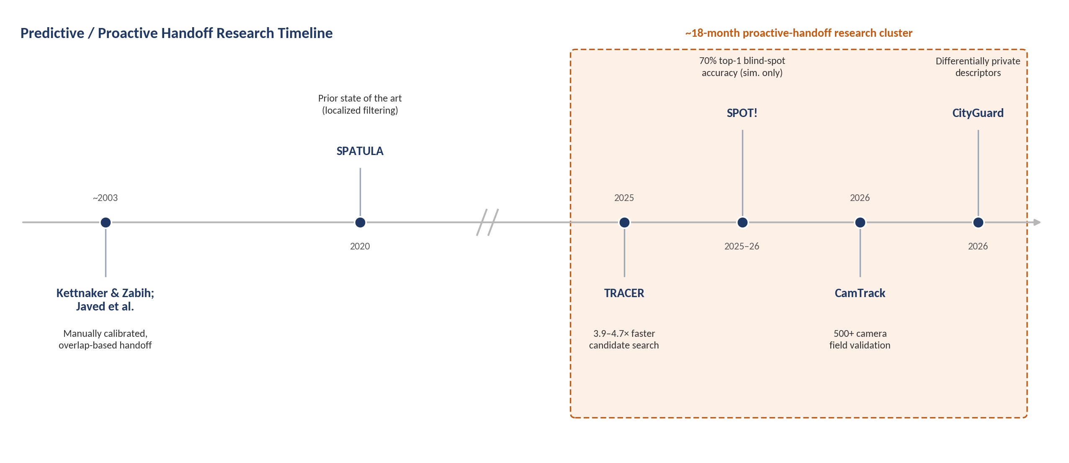
Figure 2 — Predictive and proactive camera-handoff research has clustered sharply within an eighteen-month window, after a long period of comparatively little activity since early calibration-based handoff work.

6. Research Landscape Map
The research areas surveyed above relate to one another and to the target architecture as follows. Rather than force a single linear map, the structure below reflects what the investigation actually found: two converging streams (a fixed-camera stream and a mobile-robot stream) that have not yet merged in a published or commercial system.

Stream A — Fixed-camera predictive handoff and re-identification
Problem Domain (cross-camera identity continuity) → Research Areas (MOT/MCMT, Re-ID, camera-topology inference) → Established Approaches (appearance embeddings, Hungarian/Kalman association, learned transition graphs) → Current Capabilities (live cross-camera tracking with a map display — Axxon One; retrospective appearance search — Avigilon/BriefCam/Genetec; predictive next-camera selection — TRACER, SPATULA, SPOT!, CamTrack) → Known Limitations (centralized processing; fixed infrastructure; investigative rather than fully proactive in the commercial tier) → Emerging Directions (privacy-preserving/decentralized descriptors — CityGuard; federated re-ID — FedUReID/FedKLPR) → Unresolved Problems (none of these systems generalizes to a mobile sensing platform).

Stream B — Mobile multi-robot coordination and perception sharing
Problem Domain (cooperative multi-agent sensing under mobility and bandwidth constraints) → Research Areas (MRTA/auction algorithms, multi-robot cooperative target tracking, V2X collaborative perception) → Established Approaches (market-based task allocation, Kalman-consensus filtering, feature/object-level V2X information sharing) → Current Capabilities (resilient tracking under communication failure; bandwidth-efficient inter-agent feature sharing; auction-based real-time task reassignment) → Known Limitations (target-tracking work assumes continuous joint sensing more often than discrete handoff; V2X sharing is optimized for collision-avoidance perception, not identity-preserving handoff) → Emerging Directions (LLM-integrated multi-robot reasoning; resilience under adversarial/degraded communication) → Unresolved Problems (no published system uses this coordination machinery specifically to hand off custody of a re-identified target between mobile robots).

Where the streams would need to converge
The target architecture sits precisely at the unpublished intersection of Stream A's prediction/re-identification techniques and Stream B's mobile-agent coordination/communication techniques:
MOT + Re-ID + Edge AI (Stream A perception layer)
+
MRTA + Multi-Robot Tracking + V2X-style Collaborative Perception (Stream B coordination layer)
↓
Proactive, Privacy-Preserving, Mobile-Robot Target Handoff and Persistent Cross-Node Identity (the target architecture — not found as a demonstrated combination in this investigation)
This combination diagram should not be read as proof that the combination is impossible or unattempted elsewhere — only that no commercial product or published paper found in this investigation demonstrates it end-to-end. Section 13 (Novelty Check) treats this distinction carefully.
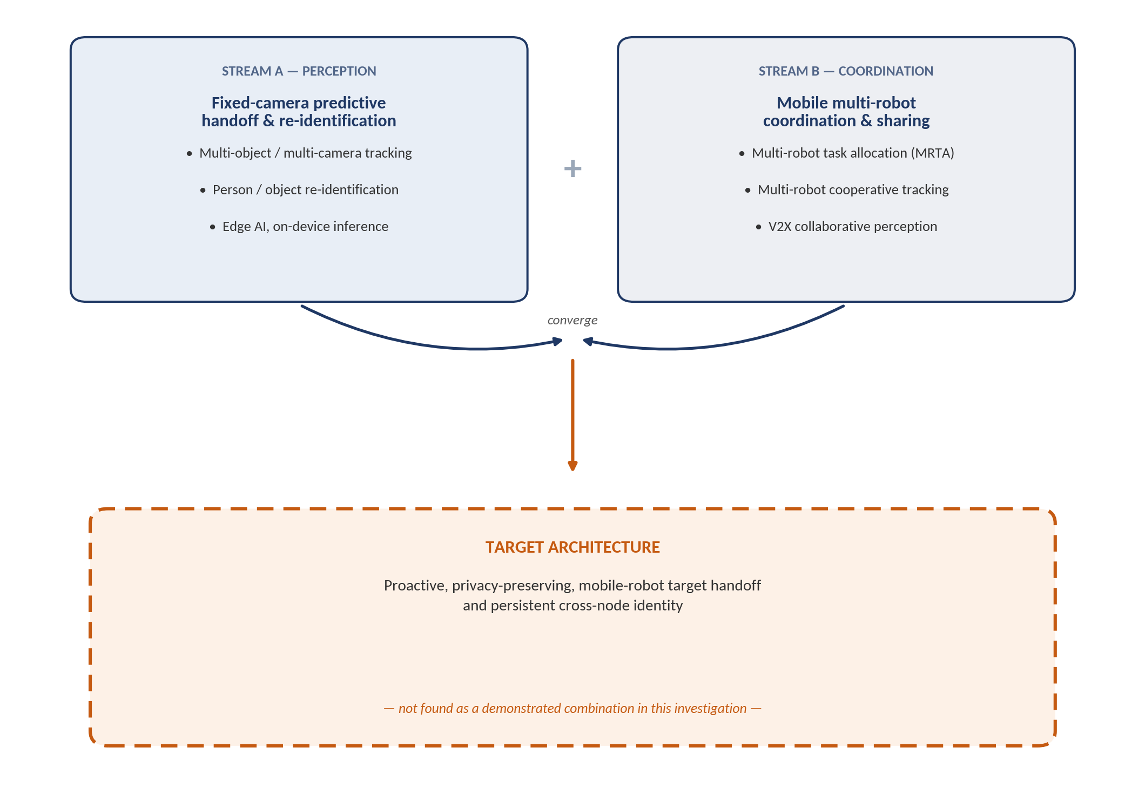
Figure 3 — The target architecture requires the convergence of two research streams — fixed-camera perception/re-identification and mobile multi-robot coordination — that have so far developed on separate tracks.

7. State-of-the-Art Assessment

Already technically mature
- Single-camera multi-object tracking (detection + Kalman/Hungarian association) — commodity technology, available open-source.
- Deep-learning person re-identification on benchmark datasets — mature, with well-established backbones (ResNet-CBAM, TransReID) and public benchmarks (Market-1501, MARS).
- Market-based/auction task allocation for multi-robot teams — studied since the early 2000s, with production-grade ROS2/DDS implementations available today.
- Fixed-camera cross-camera appearance search for retrospective investigation — multiple mature commercial products (Avigilon, BriefCam, Genetec).

Experimentally demonstrated but not yet operationally mature
- Proactive/predictive camera handoff before a subject exits the field of view — demonstrated with strong quantitative results (CamTrack, SPOT!, TRACER) but only in single real-world campus deployments or pure simulation, not at broad commercial scale.
- Differentially private, topology-aware identity descriptors for decentralized camera networks (CityGuard) — published within the last several months of this report's writing, with no known commercial deployment yet.
- Federated/edge-resident re-identification training (FedUReID, FedKLPR) — promising accuracy/communication trade-offs in controlled experiments, not yet shown at large real-world edge-device fleet scale.

Works only under controlled conditions
- SPOT!'s LLM-based blind-spot prediction has been validated exclusively in the CARLA driving simulator with synthetic traffic; its authors explicitly flag real-world validation as future work.
- Most V2X collaborative-perception results are reported on simulation platforms (CARLA-based V2Xverse) or on datasets gathered in specific, favorable geographic test areas, with channel-impairment robustness (AFFormer, 2026) still an active rather than solved problem.

Remains unreliable in dynamic, real-world environments
- Cross-camera and cross-robot re-identification generally degrades under domain shift (different lighting, camera angle, or crowd density than training data) — a persistent limitation flagged across the re-ID survey literature and directly motivating CityGuard's dispersion-adaptive, bias-resilient design.
- Communication-constrained multi-robot coordination remains fragile under adversarial or intermittent connectivity; this is precisely why “resilient multi-robot target tracking under sensing/communication danger zones” is still an active 2024–2025 research topic rather than a solved problem.

Fundamentally difficult problems vs. primarily engineering problems
Fundamentally difficult: re-identification robustness under severe domain shift and long time gaps; guaranteeing bounded-latency coordination decisions under adversarial or degraded wireless links; formally verifying privacy guarantees (e.g., differential-privacy budgets) under a live, evolving multi-agent metadata stream rather than a static released dataset.
Primarily engineering integration problems: combining an existing edge re-identification model (e.g., a Hailo-class chip) with an existing auction-based task-allocation stack (e.g., ROS2/DDS) and an existing proactive-handoff prediction module (of the kind demonstrated by CamTrack or SPOT!) into one coherent robot-to-robot pipeline. Each component exists with public reference implementations or published methodology; no single component identified in this investigation appears to require fundamentally new science to adapt to a mobile-robot context, though the integration itself is non-trivial and unproven at system level.

Apparent gaps already addressed in recent research
- "Proactive rather than reactive handoff" — addressed for fixed cameras by CamTrack, SPOT!, and TRACER/SPATULA within the last one to two years.
- "Metadata-based rather than raw-video-based coordination" — addressed conceptually by CityGuard's differentially private descriptors and by the broader V2X feature/object-level sharing literature.
- "Distributed candidate-node selection" — addressed generically by decades of market-based multi-robot task allocation research, and specifically for camera networks by TRACER's learned camera-prediction model.

Gaps that remain genuinely unresolved (in what this investigation found)
- A demonstrated system in which the proactive-handoff prediction step operates using a mobile robot's own onboard perception of the target's motion (rather than a wearable device on the tracked subject, as in CamTrack, or a simulated vehicle with known kinematics, as in SPOT!).
- A demonstrated peer-to-peer negotiation protocol in which candidate robots bid or vote specifically on taking over custody of a re-identified target, as distinct from generic task allocation or continuous joint-sensing consensus filtering.
- End-to-end field validation (outside simulation or a single fixed-camera campus deployment) of the full pipeline described in the target architecture.
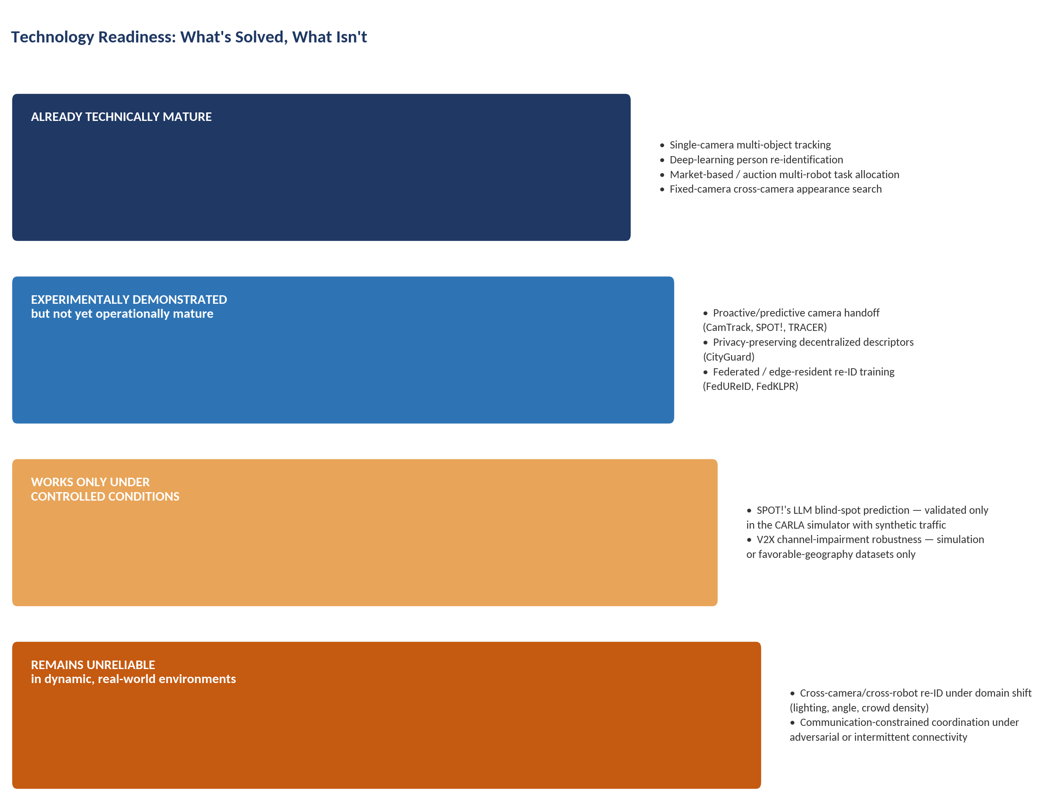
Figure 8 — Individual technologies span the full readiness spectrum, from commodity-mature to unreliable in the field; no single element of the target architecture is itself unsolved research — only their combination.

8. Competitor Capability Matrix
Capabilities were selected for their direct correspondence to stages of the target architecture. Values are Yes / Partial / No / Research-only / Unclear, and are traceable to the evidence presented in Sections 2 and 5; nothing is marked "Yes" on the strength of product-name similarity alone.
Capability | Avigilon/BriefCam/Genetec (Tier 1) | Knightscope/ Cobalt | CamTrack | SPOT! | TRACER/ SPATULA | CityGuard | Multi-Robot Tracking Research | V2X Collab. Perception
Multi-camera / multi-node tracking | Yes | No (single node) | Yes | Yes | Yes | Yes | Partial (sim. sensor) | Yes
Mobile (robot) sensing nodes | No | Yes (uncoordinated) | No | No | No | No | Yes | Partial (vehicles)
Proactive exit/occlusion prediction | No | No | Yes | Yes | Partial | No | Research-only | Partial
Cross-node re-identification | Yes | No | Yes | Partial (vehicle ID) | Yes | Yes | Partial | No
Distributed / peer-to-peer candidate selection | No | No | No | No | Partial | No | Partial | Partial
Edge / on-device inference | No | Partial | No | No | No | Yes | Partial | Partial
Lightweight metadata exchange (not raw video) | No | Unclear | No | No | No | Yes | Partial | Yes
Encrypted / privacy-preserving exchange | Unclear | Unclear | No | No | No | Yes | No | Unclear
Persistent global identity after handoff | Partial | No | Yes | Partial | Yes | Yes | No | No
Real-world field validation (not simulation-only) | Yes | Yes | Yes | No | Partial | No | Partial | Partial
Table 8.1 — Capability matrix across the strongest identified competitors and research systems.
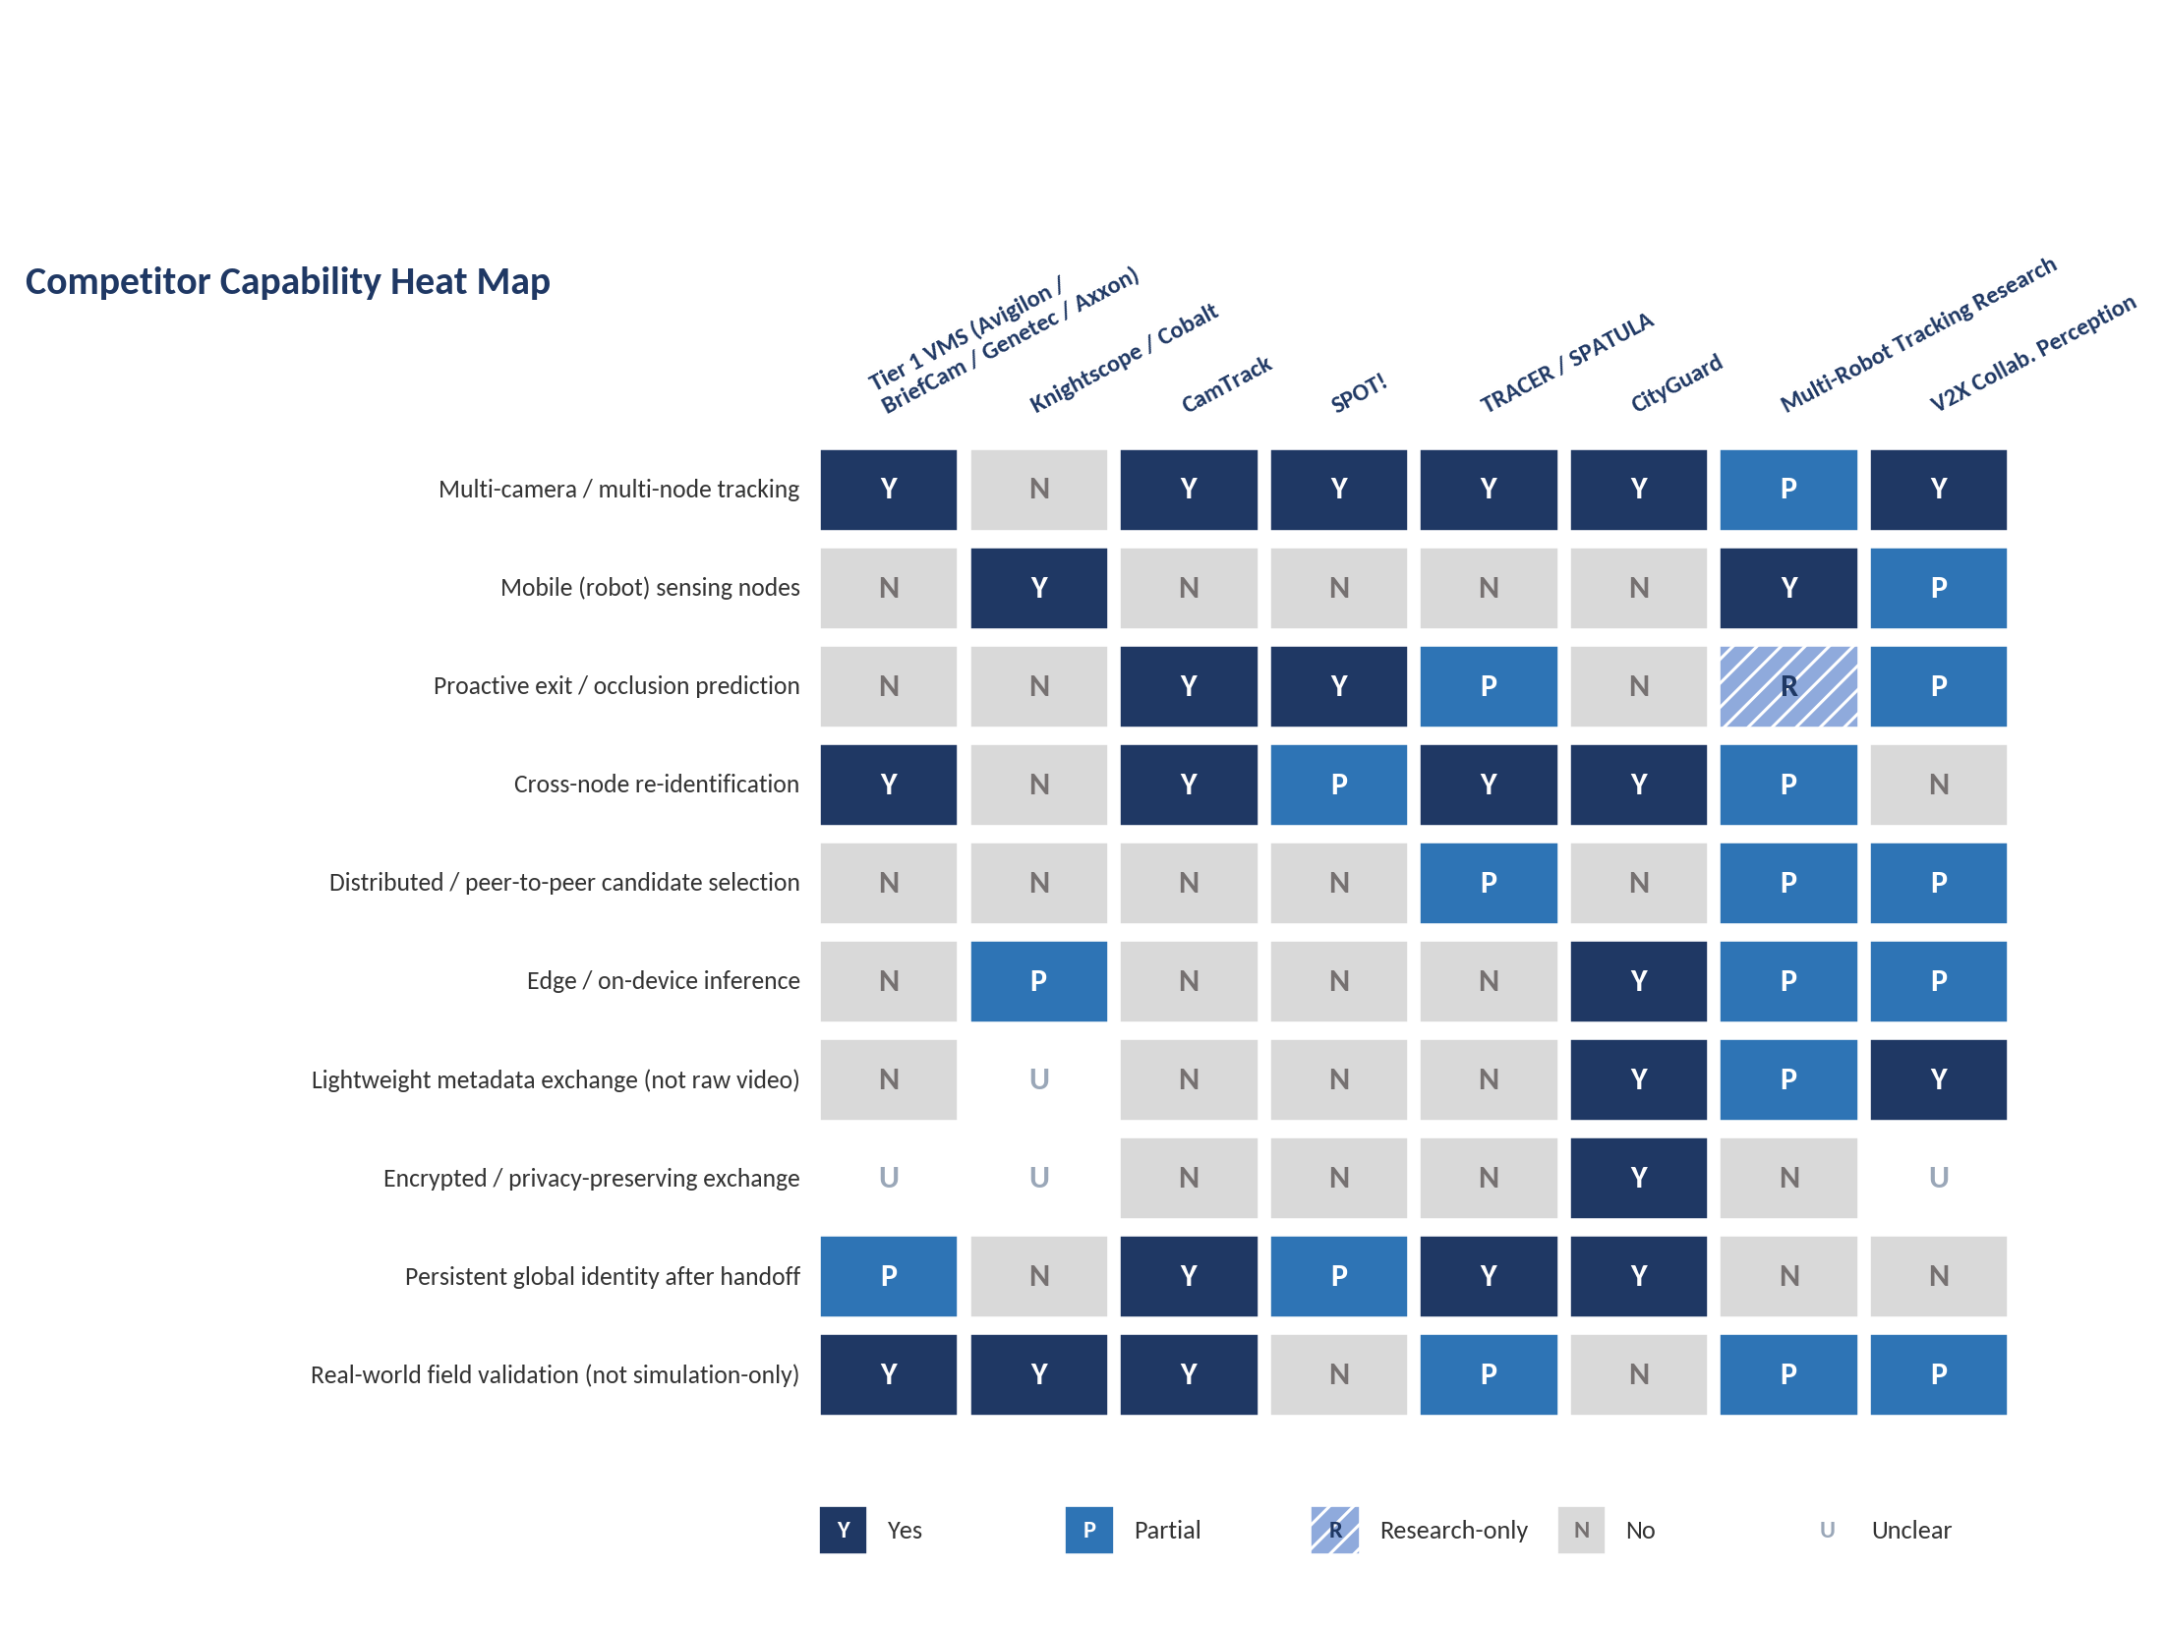
Figure 4 — Visual summary of Table 8.1. No competitor or research system covers more than five of the ten capability rows, and none combines mobile sensing nodes with proactive exit/occlusion prediction.
Read across each row, no single competitor or research system covers more than five of the ten capability rows, and no system covers both "mobile sensing nodes" and "proactive exit/occlusion prediction" simultaneously — the clearest matrix-level confirmation of the integration gap identified qualitatively in Sections 6 and 7.
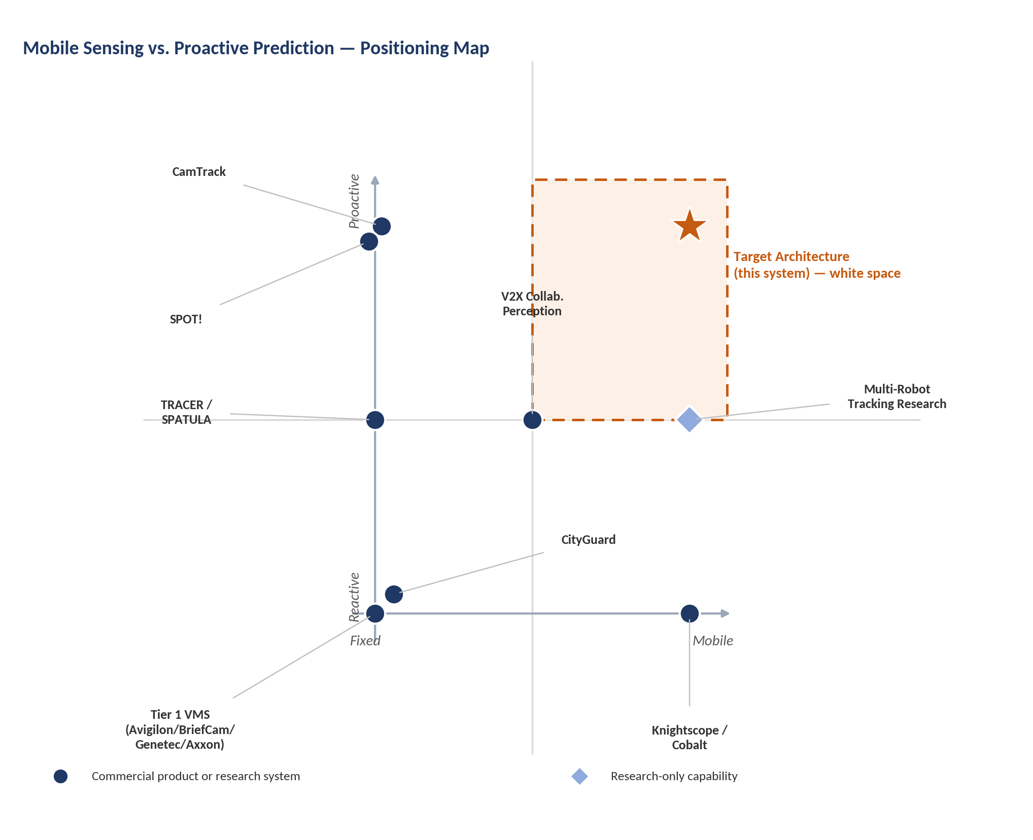
Figure 5 — Plotting sensing-platform mobility against handoff proactivity, every identified system anchors to at least one axis; the mobile-and-proactive quadrant remains white space.

9. Competitive Positioning

Functional Overlap
The commercial Tier 1 cluster (Avigilon, BriefCam, Genetec, Axxon One) covers the largest share of the target's downstream value proposition — "know where a person of interest is across a monitored area" — for the specific case of fixed-camera, single-site deployments. Functional overlap with the target's full scope (proactive, mobile, edge, privacy-preserving) is low for this cluster and high only for isolated pieces of the target's five-stage pipeline scattered across different research systems (Section 2.3).

Architectural Overlap
Architectural overlap is low across the board. Every commercial competitor and nearly every research precedent identified is centralized (server- or cloud-based processing of feeds collected from fixed cameras). CityGuard and, to a lesser degree, Hailo's edge chip and the federated re-ID literature are the only precedents with a genuinely edge/decentralized architecture, and none of them involves mobile robots or a handoff protocol.

Operational Overlap
Operationally, Knightscope and Cobalt's mobile security robots are the closest real-world analogue to "a mobile sensing node patrolling a physical space," but their operational model routes all meaningful decision-making through a centralized, human-supervised operations center rather than through autonomous peer-to-peer robot negotiation, which is a fundamentally different operational pattern from the target architecture's design.
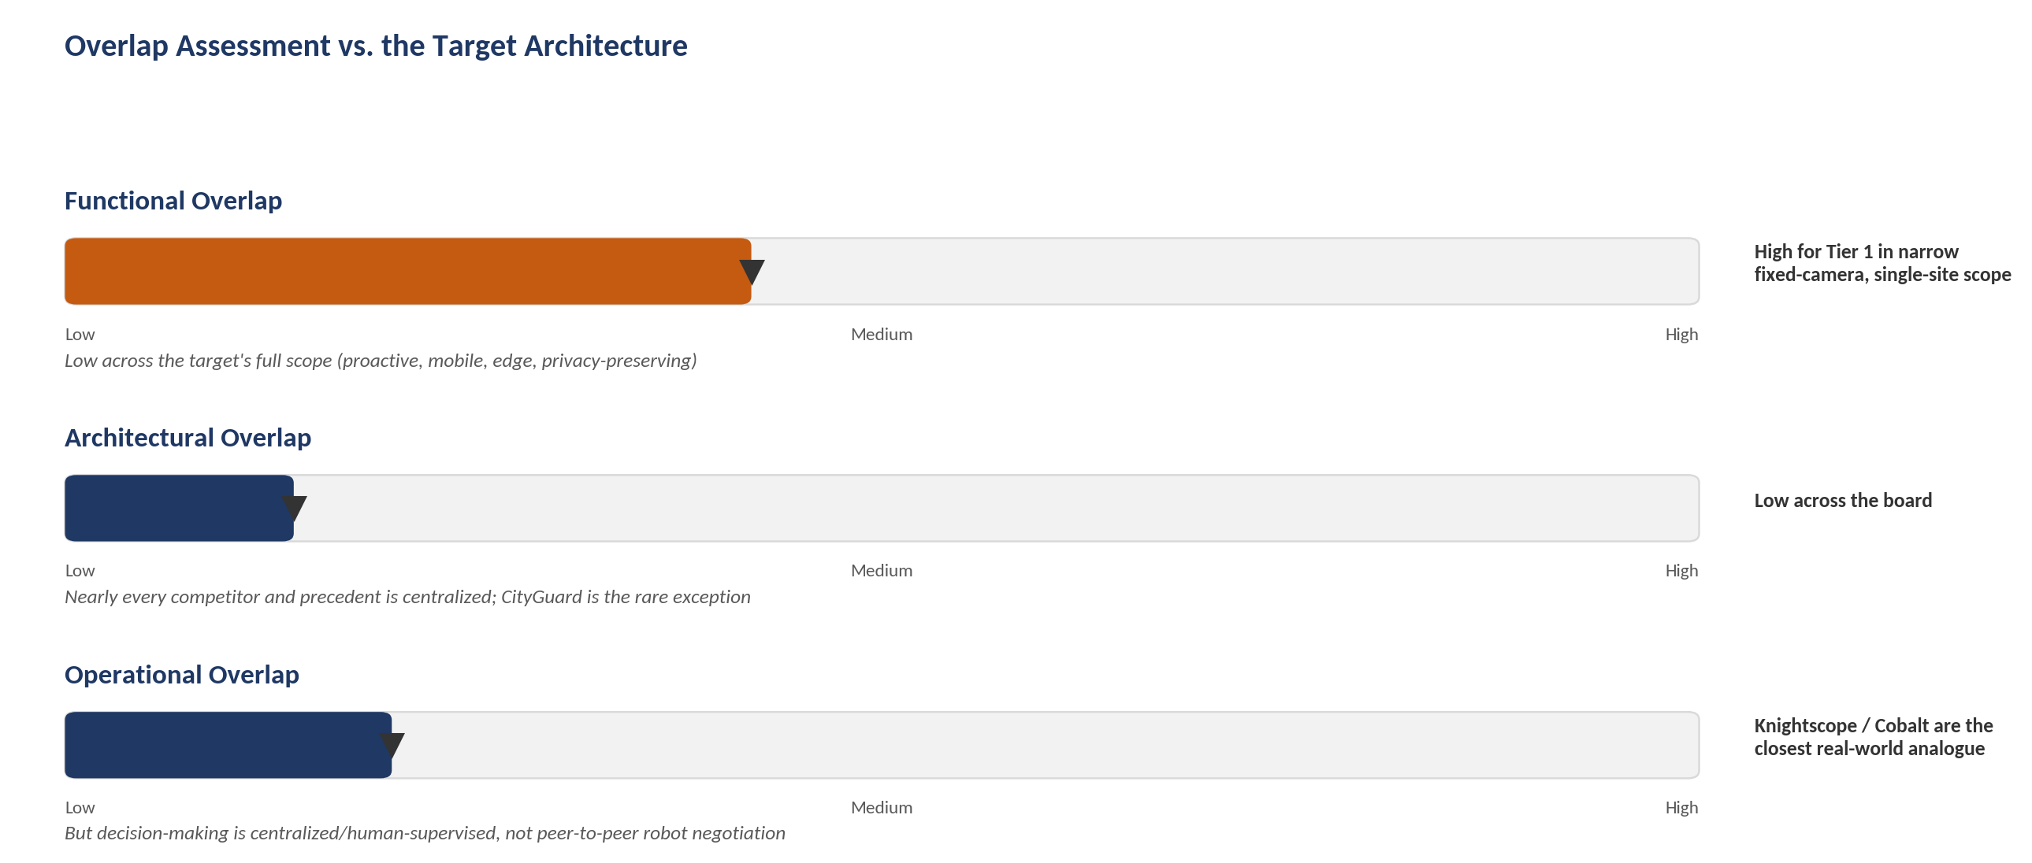
Figure 9 — Functional, architectural, and operational overlap with the target architecture are each low outside of narrow, isolated cases.

Performance / Deployment Strength by Approach
- Tier 1 commercial VMS competitors: strongest on accuracy and reliability within a single fixed-camera vendor ecosystem, and on ease of procurement/support.
- CamTrack: strongest on real-world, quantified, large-scale (500+ camera) deployment validation among the research precedents.
- SPOT!: strongest on blind-spot (zero-camera-coverage) prediction accuracy, a scenario closely analogous to a robot losing line-of-sight on a target.
- TRACER/SPATULA: strongest on computational efficiency of predictive candidate-node search at query time.
- CityGuard: strongest on privacy-preserving, topology-aware descriptor design for decentralized deployment.
- Multi-robot tracking / MRTA research: strongest on formal coordination and resilience guarantees under communication or sensing failure.

Limitation Surface by Approach
- Tier 1 commercial VMS competitors: centralization, single-vendor lock-in, no mobility, largely retrospective rather than proactive.
- Patrol robots (Knightscope/Cobalt): no peer-to-peer coordination or handoff logic; identity resolution is human-mediated.
- Fixed-camera predictive-handoff research (CamTrack/SPOT!/TRACER): no mobility, no robot-to-robot negotiation, and in SPOT!'s case, no real-world validation and a dependency on external LLM inference that cuts against edge/lightweight-communication goals.
- Multi-robot tracking/MRTA research: usually assumes continuous joint sensing rather than discrete custody handoff; rarely integrates a modern deep re-identification model.

Unaddressed Requirements
Across the entire landscape surveyed, three requirements of the target architecture were not found addressed together, or in several cases not found addressed at all, by any single system: (1) proactive occlusion/exit prediction driven by a mobile robot's own onboard perception of the target rather than a wearable device or simulated ground truth; (2) a peer-to-peer negotiation protocol specifically for target-custody handoff, as distinct from generic task allocation; and (3) encrypted, bandwidth-light metadata exchange between robots validated in a real (non-simulated) multi-robot field deployment.

10. Market Gap Analysis
Gap validation is applied rigorously below rather than assumed; each candidate gap is tested against the ten validation questions from the research brief.

Candidate Market Gap: Mobile, infrastructure-light tracking continuity for sites that cannot economically deploy dense fixed-camera coverage
What exactly is missing: A commercially available system that provides cross-node tracking continuity using mobile robots rather than fixed cameras, for sites (large outdoor perimeters, unstructured terrain, temporary/event sites) where dense fixed-camera coverage is impractical or uneconomical.
Who experiences the missing capability: Operators of large, irregular, or temporary sites — the same customer segment Knightscope and Cobalt already sell single-robot patrol into, but who currently receive human-mediated (not automated peer-to-peer) continuity when a robot's own view is insufficient.
Why it matters: Patrol-robot vendors' own published ROI cases (Section 4) show fixed-camera-equivalent coverage of large sites is expensive; a mobile-node alternative that can proactively hand off tracking to a peer robot would extend the value proposition robot vendors already sell.
Which existing systems attempt to solve it: Knightscope and Cobalt solve the mobile-sensing half; CamTrack/SPOT!/TRACER solve the proactive-handoff half, but only for fixed cameras.
Why those systems are insufficient: Neither half has been demonstrated combined with the other in a shipping product; patrol robots do not negotiate handoff with each other, and predictive-handoff research has not been validated on mobile platforms.
Nature of the limitation: Primarily an integration/engineering gap rather than a fundamental market gap in the sense of “no one wants this” — the adjacent market (patrol robots, VMS appearance search) is demonstrably large and funded (Knightscope is a public company; Milestone/Canon and Motorola Solutions are large incumbents), suggesting demand exists for the constituent capabilities separately.
Has recent research addressed it: Not directly; the closest research (CamTrack, SPOT!) addresses the prediction problem but not on a mobile robot, and no patrol-robot vendor's public material describes robot-to-robot handoff.
Genuinely unresolved or under-researched: Best characterized as under-integrated rather than under-researched — the constituent research areas (Section 5) are active and well-funded; their combination for this specific use case is what is missing from the public record.
Strength of evidence: Moderate. The absence of a combined product across an extensive, multi-angle search (commercial VMS vendors, patrol-robot vendors, and recent academic literature) is reasonably strong negative evidence, but the search cannot rule out non-public internal R&D at large incumbents (Motorola Solutions, Canon, Knightscope) who have both the component technology and the customer relationships to build this.
What would disprove the gap: A product announcement or patent filing from an existing patrol-robot or VMS vendor describing robot-to-robot or camera-to-robot proactive handoff; or a research paper (missed by this search) demonstrating the same combination.

11. Technical Gap Analysis

Candidate Technical Gap: Proactive exit/occlusion prediction driven by a mobile robot's own onboard perception of a target's motion, feeding a peer-to-peer handoff negotiation
What exactly is missing: A demonstrated technique for a mobile robot to predict, from its own onboard sensing of a moving target (not a wearable device on the target, and not a simulator's ground-truth kinematics), that the target is about to leave its field of view or become occluded, in time to proactively initiate a handoff to a specific peer robot.
Who experiences the missing capability: Any multi-robot system attempting live, low-latency custody handoff of a non-cooperative (no wearable, no known kinematics in advance) target.
Why it matters: This is the specific mechanism that distinguishes "proactive" from "reactive" handoff, and reactive handoff is well known (in the CamTrack paper's own words, describing conventional approaches) to cause tracking-continuity loss during the gap between a subject leaving one field of view and being reacquired in the next.
Which existing systems attempt to solve it: CamTrack (via wearable IMU/BLE, not autonomous perception of the target); SPOT! (via simulator-provided vehicle kinematics, not real-world autonomous perception); the broader pedestrian/vehicle trajectory-prediction literature (Social LSTM, Social GAN, Trajectory++, cited within the SPOT! paper's own reference list), which predicts future motion from purely visual observation but has, in the systems found here, not been coupled to a live camera/robot handoff decision.
Why those systems are insufficient: CamTrack and SPOT! each substitute an external, non-vision information source (a wearable device or simulator ground truth) for the harder problem of predicting exit/occlusion from vision alone, in real time, from a moving observer's own perspective.
Nature of the limitation: Partially technical (robust real-time trajectory prediction from a moving, resource-constrained platform's own camera is genuinely harder than from a fixed camera or a wearable sensor) and partially a research-attention gap (the trajectory-prediction literature exists but has not, in what this investigation found, been integrated into a live handoff decision loop).
Has recent research addressed it: Adjacently: pedestrian trajectory prediction from a moving platform is well studied in the autonomous-driving literature; the specific coupling of that prediction to a proactive camera/robot handoff decision is what appears absent from the public record surveyed here.
Genuinely unresolved or under-researched: Under-researched as an integrated pipeline, though the individual sub-problems (trajectory prediction; handoff decision logic) each have separate mature literatures (Section 5).
Strength of evidence: Moderate-to-strong for the specific combination (vision-only, robot-perspective, autonomous prediction feeding live peer-to-peer handoff); weak as a claim that any of the underlying sub-components (trajectory prediction, handoff decision modeling) is itself unsolved, because each sub-component individually is well precedented.
What would disprove the gap: A paper or product coupling onboard robot-perspective trajectory prediction directly to a live inter-robot or inter-camera handoff trigger — the specific combination this section could not find in the literature or product landscape searched.

Candidate Technical Gap: Encrypted, bandwidth-light metadata protocol specifically for target-custody handoff between autonomous agents
What exactly is missing: A validated protocol and message format for exchanging compact, encrypted target-descriptor metadata (as opposed to raw video, and as opposed to the differentially-private but not encryption-focused descriptors of CityGuard) directly between mobile robot peers as part of a handoff transaction.
Who experiences the missing capability: Any deployment where bandwidth is constrained (outdoor, wide-area, or many-robot deployments) and where regulatory or organizational policy requires that raw imagery of tracked individuals not be transmitted between nodes or off-device.
Why it matters: Both the bandwidth constraint and the privacy/regulatory constraint are independently well documented as active concerns in adjacent fields — V2X collaborative perception explicitly optimizes for bandwidth-constrained feature sharing, and CityGuard explicitly cites data-protection regulation (GDPR/CCPA-type constraints) as a design driver for privacy-preserving descriptors.
Which existing systems attempt to solve it: CityGuard (differential privacy on embeddings, not encryption per se, and for fixed cameras); V2X feature/object-level sharing schemes (bandwidth-efficient, but for driving-safety perception, not identity handoff); federated re-ID (keeps raw images local during training, not during live operational handoff).
Why those systems are insufficient: None combines encryption or formal privacy guarantees, bandwidth efficiency, and a live operational (not training-time) handoff transaction between mobile peers in the way the target architecture specifies.
Nature of the limitation: Primarily an integration gap: differential privacy (CityGuard), bandwidth-efficient feature compression (V2X literature), and secure communication protocols are each independently mature technical areas; their combination into a single lightweight handoff-metadata standard was not found demonstrated.
Has recent research addressed it: Partially and very recently — CityGuard (February–March 2026) is the closest precedent found, published within months of this report, indicating this is an active rather than dormant research direction.
Genuinely unresolved or under-researched: Actively being researched (CityGuard's recency is itself evidence of this), but not yet resolved for the specific mobile-robot, live-handoff case.
Strength of evidence: Moderate. Given how recently CityGuard was published, it is plausible that closely related unpublished or very recent work exists that this investigation's search did not surface.
What would disprove the gap: A follow-on paper or product from the CityGuard authors or a comparable group extending the approach to mobile agents and live handoff transactions rather than static camera indexing.

12. Deployment, Integration, and Scalability Gaps

Deployment Gap
The strongest research precedents for the target's core novelty (SPOT!, and to a lesser extent TRACER/SPATULA) have been validated only in simulation (CARLA) or in an offline/investigative setting, not in a live, real-world, multi-agent field deployment. CamTrack is the notable exception with genuine large-scale field validation, but on fixed infrastructure. This represents a broad, evidenced deployment gap: the specific proactive-prediction techniques most relevant to the target architecture are demonstrated capabilities in research settings, not yet operationally proven capabilities in the field, for anything resembling the target's mobile, multi-robot context.

Integration Gap
This is the dominant gap type identified throughout this report. Individually mature or near-mature components — edge re-identification inference (Hailo), auction-based multi-robot task allocation (decades of MRTA research and production ROS2 implementations), proactive fixed-camera handoff prediction (CamTrack/SPOT!/TRACER), and privacy-preserving descriptor exchange (CityGuard) — have not, in the systems surveyed, been integrated into a single pipeline. The capability matrix in Section 8 shows no system covering more than half of the target architecture's ten capability dimensions. This is consistent with an engineering-integration gap rather than a set of unsolved scientific problems, though the integration work itself (particularly real-time performance on resource-constrained robot hardware) should not be assumed trivial.

Scalability Gap
Where scalability has been explicitly measured, results are mixed and instructive. TRACER's advantage over baseline camera-prediction methods widens as the camera network grows, suggesting the predictive-candidate-selection approach scales favorably. CamTrack's Markov-chain model explicitly quantifies a coverage-density/success-probability trade-off that becomes less favorable in sparsely covered areas — directly relevant to any deployment where robot density (analogous to camera density) is low relative to the area covered. No source found in this investigation reports results for a robot team beyond the tens-of-agents scale typical of MRTA benchmark literature; behavior at large fleet scale (hundreds of robots) for the specific target-handoff use case is unvalidated in either direction.

Communication / Infrastructure Gap
The V2X collaborative-perception literature's own open challenges — robustness to channel impairments (explicitly the subject of the 2026 AFFormer paper), bandwidth-latency trade-offs, and degraded-connectivity resilience (the subject of the 2024–2025 “danger zones” multi-robot tracking papers) — apply directly to the target architecture's reliance on inter-robot communication for both coordination and metadata exchange. These are documented as open, active problems in the adjacent literature rather than solved prerequisites the target architecture can simply assume away.
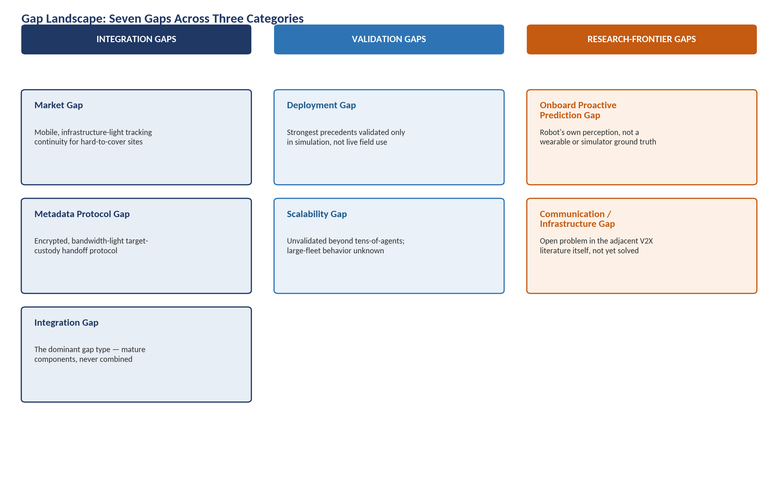
Figure 10 — The seven gaps identified across Sections 10–12 cluster into integration gaps, validation gaps, and research-frontier gaps; integration gaps are the dominant type.

13. Novelty Check
Each element of the reference architecture is classified independently. The combination is assessed separately from the individual elements, consistent with the principle that a combination can be commercially valuable without being academically novel, and a component can be academically novel without being commercially differentiated.
Architecture Element | Classification | Basis
Local visual perception & tracking (single-node MOT) | Already Commercially Available | Commodity detection/tracking pipelines (YOLO + SORT-family trackers) are open-source and widely deployed.
Target re-identification representation | Already Commercially Available / Already Demonstrated in Research | Mature commercial (Avigilon, BriefCam) and academic (Re-ID survey literature) state of the art.
Trajectory / state prediction of a target | Already Demonstrated in Research | Mature autonomous-driving pedestrian/vehicle trajectory-prediction literature (Social LSTM, Social GAN, Trajectory++, etc.).
Prediction of future visibility / occlusion (proactive exit prediction) | Partially Demonstrated | Demonstrated for fixed cameras (CamTrack, SPOT!) with strong quantitative results; not demonstrated from a mobile robot's own onboard perception.
Distributed candidate-agent selection for handoff specifically | Partially Demonstrated / Emerging | Generic MRTA auction methods are mature; camera-specific predictive candidate selection (TRACER) is demonstrated; the specific “who should take custody of this target” framing is not found demonstrated end-to-end.
Proactive handoff execution (as opposed to reactive/retrospective) | Partially Demonstrated | Demonstrated for fixed cameras (CamTrack, SPOT!, TRACER/SPATULA) within the last one to two years; not demonstrated for mobile robot nodes.
Lightweight metadata exchange (object/feature-level, not raw video) | Already Demonstrated in Research | Mature in the V2X collaborative-perception literature and in cross-camera analytics systems (TRACER/SPATULA) that avoid raw-video transmission.
Encrypted / privacy-preserving metadata exchange | Emerging | CityGuard (Feb.–Mar. 2026) is a very recent, closely related precedent for fixed cameras; not yet demonstrated for live mobile-robot handoff transactions.
Cross-node re-identification after handoff | Already Demonstrated in Research | Directly demonstrated by CamTrack, TRACER, and CityGuard for camera networks.
Persistent global identity across the whole session | Partially Demonstrated | Demonstrated within single deployments (CamTrack's campus system); long-horizon, large-team persistence at scale is not separately validated in the sources found.
Full end-to-end combination on mobile multi-robot nodes | Apparently Unresolved (in public sources found) | No commercial product or published paper found in this investigation demonstrates all elements above combined on mobile robot platforms.
Table 13.1 — Novelty classification by architectural element.
The overall picture is one of high component-level maturity and low combination-level precedent. This is a common and defensible pattern for applied systems research and should not, on its own, be read as either a strong or a weak novelty claim: it means the differentiating value of the target architecture would need to rest on the quality and real-world validation of the integration — particularly the two elements classified as “partially demonstrated” or “emerging” rather than “already demonstrated” (proactive exit prediction from a robot's own onboard perception, and encrypted metadata exchange for live mobile handoff) — rather than on inventing any single component from first principles.
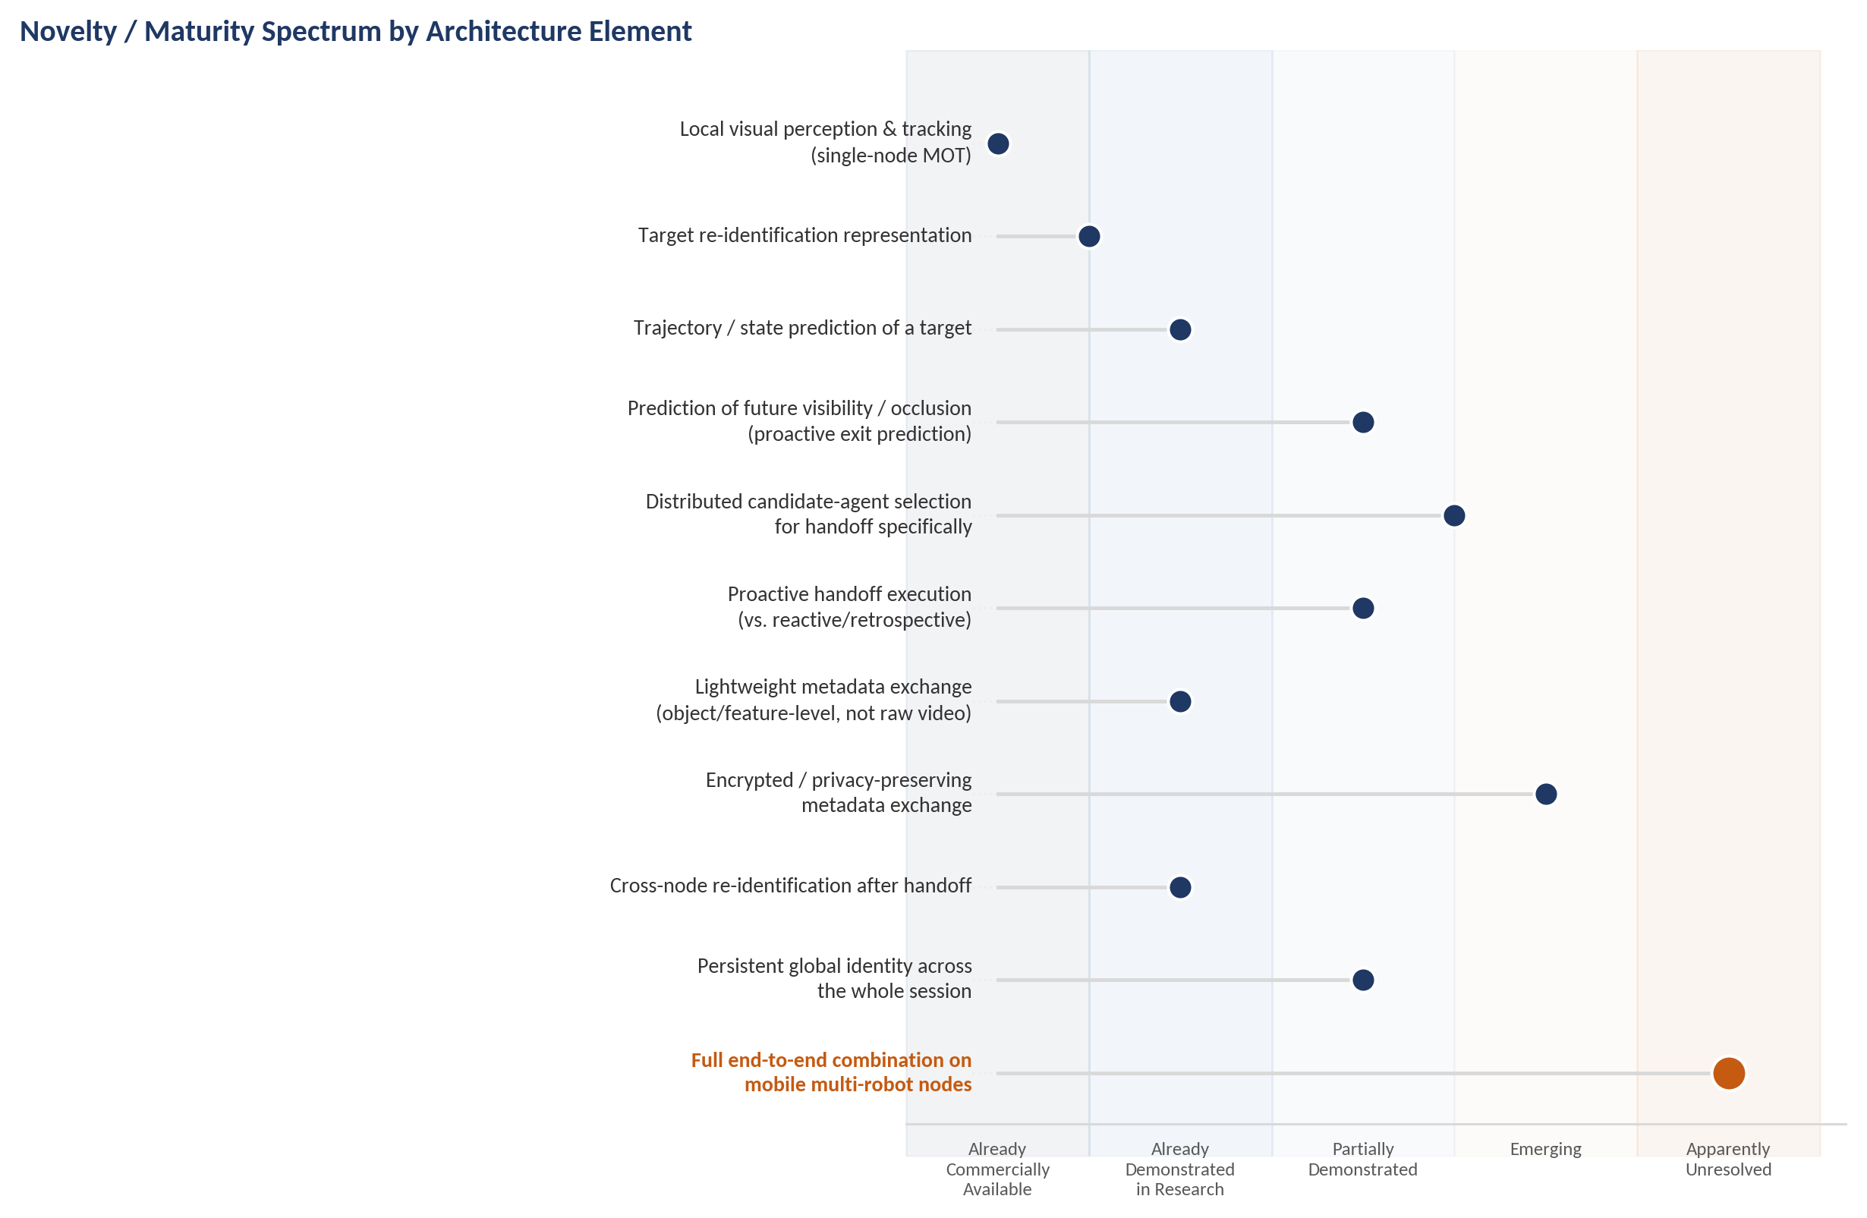
Figure 6 — Individual architecture elements skew toward high maturity; only the full end-to-end combination on mobile multi-robot nodes remains apparently unresolved.

14. Competitive & Research Synthesis

What already exists
A mature commercial market for fixed-camera, cross-camera appearance search (Avigilon, BriefCam, Genetec, Axxon One), a mature and separate commercial market for single-robot mobile security patrol (Knightscope, Cobalt AI), and a fast-moving academic literature (concentrated in the last one to two years) on proactive, predictive handoff for fixed cameras (CamTrack, SPOT!, TRACER/SPATULA) and privacy-preserving decentralized identity search (CityGuard).

What works well
Appearance-based re-identification is a solved problem at the model level; predictive next-camera selection has moved decisively from reactive/exhaustive search to learned, proactive prediction within fixed-camera research in just the past few years, with CamTrack's real 500-camera campus deployment providing the strongest field evidence in this entire landscape that proactive handoff delivers measurable latency and continuity benefits.

What is commercially mature vs. research-only
Commercially mature: fixed-camera appearance search and retrospective investigation tooling; single-robot autonomous patrol. Research-only: proactive/predictive handoff itself, privacy-preserving decentralized descriptor exchange, and (almost entirely) any robot-to-robot custody-handoff mechanism.

What can be substituted by infrastructure, people, or existing systems
A meaningful share of the target's value proposition can be approximated, in specific deployment contexts, by denser fixed-camera coverage (quantifiably, per CamTrack), by additional human security staff (quantifiably, per patrol-robot vendors' own ROI case studies), or by simply adopting an existing VMS's appearance-search feature and accepting its centralization and camera-only limitations.

Where current approaches break down
Every commercial approach breaks down as soon as fixed-camera infrastructure is impractical (large, unstructured, or temporary sites) or as soon as full automation without human-in-the-loop review is required at wide-area scale. Every closely related research approach breaks down as soon as the sensing platform must itself move, since none was found validated on a mobile perception platform.

Which limitations are fundamental vs. implementation-specific
Fundamental: re-identification accuracy under severe domain shift; formally bounded coordination latency under adversarial/degraded communication; rigorous privacy accounting under a live, evolving (not static, released) metadata stream. Implementation-specific (i.e., addressable engineering integration rather than open science): the absence of a system combining edge re-ID, proactive robot-perspective prediction, peer-to-peer handoff negotiation, and encrypted metadata exchange — each of the four exists with credible reference implementations or published methodology individually.

Which gaps appear genuine vs. not genuine
Genuine (evidenced by an extensive, purpose-directed search finding no combined precedent): the specific end-to-end combination of mobile-robot proactive handoff with encrypted metadata exchange and persistent cross-node identity. Not genuine, or at minimum significantly overstated if claimed as novel: any individual component in isolation — re-identification, edge inference, market-based task allocation, or metadata-based (as opposed to raw-video) coordination each has substantial and, in most cases, very recent prior art, some of it (CityGuard, FedKLPR) published within the months immediately preceding this report.

Where the landscape is crowded
Fixed-camera cross-camera appearance search is crowded and largely a commodity feature among VMS vendors; single-robot autonomous security patrol has at least two well-funded, publicly traded or venture-backed competitors (Knightscope, Cobalt AI) with multi-year track records.

Where the landscape is fragmented
Proactive/predictive handoff research is fragmented across at least three independent research groups (Taiwan/CamTrack, South Korea/SPOT!, Georgia Tech-NUS/TRACER) publishing within roughly the same eighteen-month window without, based on their reference lists, building directly on one another — evidence of a genuinely active but not yet consolidated research direction.

Where there is meaningful whitespace
The most defensible whitespace identified is the specific combination of (a) proactive exit/occlusion prediction driven by a mobile robot's own onboard perception rather than a wearable device or simulator ground truth, (b) a peer-to-peer negotiation protocol purpose-built for target-custody handoff rather than generic task allocation, and (c) encrypted, bandwidth-light metadata exchange validated in a real (not simulated) multi-robot deployment. Each of the three sub-elements individually is close to, but not fully at, the state of the art demonstrated elsewhere; their combination, validated in the field, was not found demonstrated by any commercial product or published paper identified in this investigation.
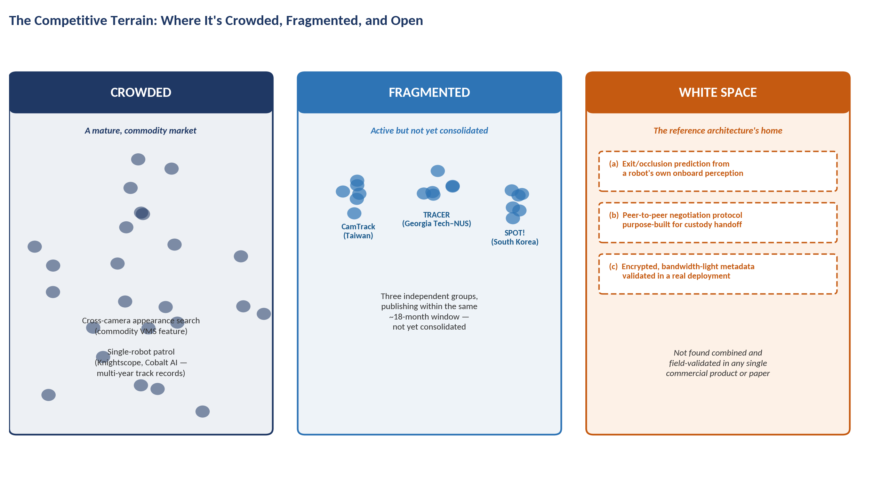
Figure 11 — The competitive terrain in one view: mature markets are crowded, active research is fragmented across independent groups, and the specific combination the target architecture requires remains open.

15. Sources

15.1 Commercial Systems
Organization | Product / System | Year / Status | Source
Motorola Solutions / Avigilon | Appearance Search | Current product; feature since c. 2016 | Vendor documentation; IPVM independent testing
Canon / Milestone | BriefCam | Current product; Milestone integration 2024 | IPVM reporting; EFF user-manual analysis
Genetec | Security Center Object/Appearance Search | Current product | IPVM company reporting and practitioner discussion
AxxonSoft | Axxon One Multi-Camera Tracking | Current product | Vendor product documentation
Hailo | Hailo-8 edge AI processor | Current product | Vendor technical blog
Knightscope, Inc. (Nasdaq: KSCP) | K5 / K7 Autonomous Security Robots | Current; K7 launched Nov. 2025 | Company site; BusinessWire/RoboticsTomorrow coverage; Wikipedia; CNN
Cobalt AI | Cobalt indoor security robot | Current product | Robotomated industry comparison report (2026); vendor materials
Open-source community | YOLOv4-tiny + Omni-Scale multi-camera tracker | Public repository | GitHub project documentation

15.2 Research Papers
Title | Authors | Venue | Year
Multi-sensor fusion for user matching and continuous tracking leveraging camera handover in surveillance systems (CamTrack) | Sou, S.-I., Huang, Y.-C., Wu, C.-L. | Neural Computing and Applications (Springer) | 2026
SPOT!: Map-Guided LLM Agent for Unsupervised Multi-CCTV Dynamic Object Tracking | Noh, Y., Park, I. J., Hwang, C. | Preprint (arXiv) | 2025–2026
TRACER: Efficient Object Re-Identification in Networked Cameras through Adaptive Query Processing | Chunduri, P., Lu, Y., Arulraj, J. | Preprint (arXiv) | 2025
Spatula: Efficient Cross-Camera Video Analytics on Large Camera Networks | Jain, S., Zhang, X., Zhou, Y., et al. | IEEE/ACM Symposium on Edge Computing (SEC) | 2020
CityGuard: Graph-Aware Private Descriptors for Bias-Resilient Identity Search Across Urban Cameras | Fu, R., Zhang, W., Meng, Y., et al. | Preprint (arXiv) | 2026
Cooperative Heterogeneous Multi-Robot Systems: A Survey | Multiple authors | ACM Computing Surveys | 2019
Multi-robot target detection and tracking: taxonomy and survey | Robin, C., Lacroix, S. | Autonomous Robots | 2016
Resilient Multi-Robot Target Tracking with Sensing and Communication Danger Zones | Li, P., et al. | Preprint (arXiv) | 2024, rev. 2025
Active Target Tracking with Self-Triggered Communications in Multi-Robot Teams | Multiple authors | Preprint (arXiv) | 2017
Wireless Communication as an Information Sensor for Multi-agent Cooperative Perception: A Survey | Song, Z., Xie, T., Wen, F., Li, J. | Preprint (arXiv) | 2025
Towards Vehicle-to-everything Autonomous Driving: A Survey on Collaborative Perception | Multiple authors | Preprint (arXiv) | 2023
Collaborative Perception Datasets in Autonomous Driving: A Survey | Yazgan, M., et al. | Preprint (arXiv) | 2024
V2X-Real: A Large-Scale Dataset for Vehicle-to-Everything Cooperative Perception | Xiang, H., et al. | Preprint (arXiv) | 2024
AFFormer: Adaptive Feature Fusion Transformer for V2X Cooperative Perception under Channel Impairments | Zhou, X., Huang, T., et al. | Preprint (arXiv) | 2026
FedUReID: Federated Unsupervised Person Re-identification | Zhuang, W., Wen, Y., Zhang, S. | Preprint (arXiv) | 2021
FedKLPR: KL-Guided Pruning-Aware Federated Learning for Person Re-Identification | Yu, P.-H., Tseng, Y.-S., Chien, S.-Y. | Preprint (arXiv) | 2026
Privacy-Preserving Adaptive Re-Identification Without Image Transfer (Fed-Protoid) | Multiple authors | ECCV workshop chapter (Springer) | 2024
Spatial-Temporal Federated Learning for Lifelong Person Re-identification on Distributed Edges | Multiple authors | Preprint (arXiv) | 2022
Deep Learning for Person Re-Identification: A Survey and Outlook | Ye, M., Shen, J., Lin, G., Xiang, T., Shao, L., Hoi, S. C. H. | IEEE Transactions on Pattern Analysis and Machine Intelligence | 2021
Multi-Camera Multi-Object Tracking: A Review of Current Trends and Future Advances | Amosa, T. I., et al. | Neurocomputing | 2023
Distance-based Camera Network Topology Inference for Person Re-identification | Multiple authors | Preprint / ScienceDirect | 2017–2019
Joint Person Re-identification and Camera Network Topology Inference in Multiple Cameras | Multiple authors | Preprint (arXiv) | 2017
Market-based multirobot coordination: A survey and analysis | Dias, M. B., Zlot, R., Kalra, N., Stentz, A. | Proceedings of the IEEE | 2006
Optimal Market-based Multi-Robot Task Allocation via Strategic Pricing | Multiple authors | Robotics: Science and Systems (RSS) | 2013
A ROS2-based Distributed Task Allocation Framework for Unmanned Vehicles | Multiple authors | International Journal of Control, Automation and Systems | 2025
Distributed Control of Mixed Human-Robot Teams (MHRT) for Cooperative Multi-target Tracking | Surve, S., et al. | Springer conference proceedings | 2026
Additional supporting sources consulted for context (industry buyer's guides, patent filings on early camera-handoff systems, and vendor-neutral practitioner reporting) are cited inline within Sections 2–4 where directly relevant.

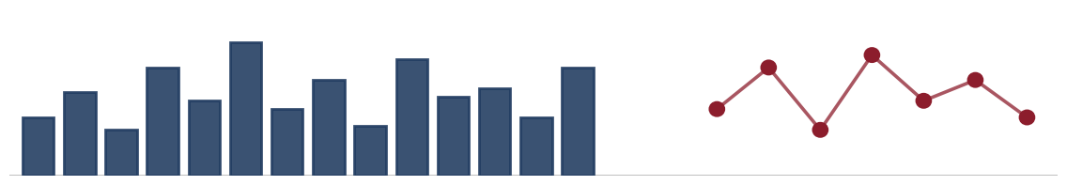
Egypt/MENA + Field Validation Report
Regional Relevance, Infrastructure Readiness, and Deployment Feasibility of a Decentralized Edge-AI Framework for Multi-Robot Target Handoff and Re-Identification
Evidence-based assessment — Egypt, Saudi Arabia, United Arab Emirates, Qatar, Morocco
Prepared September 2026
Status: Desk research and secondary-source analysis. No primary field interviews or surveys have been conducted as part of this report. Section 6 sets out the protocol proposed for that primary validation.

1. Regional Relevance Overview
This report examines whether the problem addressed by a decentralized, edge-AI multi-robot system — maintaining continuous identity of a moving target as it crosses the non-overlapping fields of view of multiple cameras or robots — is a genuine, evidenced operational need in Egypt and the wider MENA region, and whether the region's existing infrastructure, regulatory environment, and institutional practice would support real deployment. It does not evaluate the underlying computer-vision or robotics architecture itself; it evaluates the ground the architecture would have to stand on.
The short answer, developed in detail below, is regionally uneven and condition-dependent rather than uniformly positive or negative. Three findings recur across the sectors and countries examined:
- The underlying operational problem — losing visual continuity of a person, vehicle, or asset as it moves between separated camera or patrol zones — is real and independently documented across Egyptian and Gulf security, port, and industrial environments. It is not a problem invented to justify the technology.
- Camera and sensor density is high in the specific environments where the problem matters most (new-capital surveillance grids, container terminals, airports), but this density has been built almost entirely around a centralized command-and-control philosophy, not a decentralized, peer-negotiating one. That is a genuine architectural mismatch the project will have to address, not a minor implementation detail.
- Deployment readiness diverges sharply by country and by sector within a country. The strongest infrastructure and applied-robotics research base for this specific technical problem sits in the UAE (Khalifa University, MBZUAI) and, for capital intensity, Saudi Arabia — not in Egypt, despite Egypt having the largest number of candidate physical environments (ports, industrial zones, universities) and the most directly relevant new legal exposure (a 2025 licensing requirement for visual surveillance analytics).
Research integrity note: all quantitative figures in this report are sourced, dated, and geographically scoped in the Quantitative Evidence Table (Section 6) and in-line citations. No interviews, surveys, or field observations were conducted for this report. Every claim about stakeholder needs, adoption willingness, or operator sentiment that is not attributed to a published source is explicitly labelled a hypothesis to be tested, not a finding.
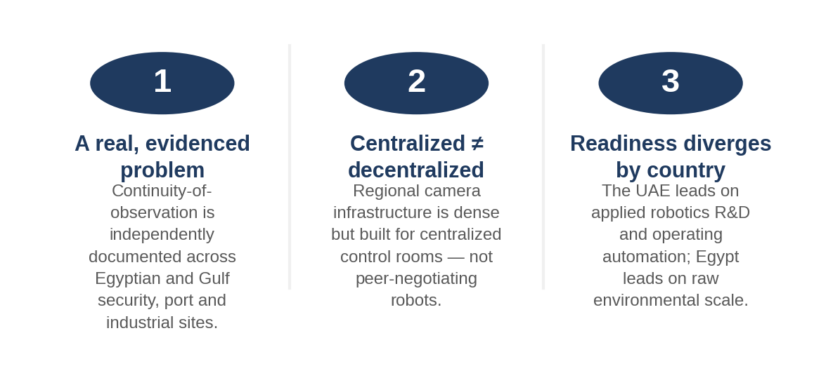
Figure 1. Three findings that recur across the regional evidence.

2. Egypt Market Analysis
Egypt was investigated across nine starting-point environments (security and surveillance, airports, ports, universities, industrial zones, smart cities, warehouses, transportation, and critical infrastructure) plus two environments that emerged as materially relevant during research but were not in the original starting list: last-mile e-commerce logistics hubs, and the national security command-and-control apparatus itself, which functions as a distinct institutional environment rather than simply a customer for CCTV hardware.

2.1 What is actually happening on the ground
Egypt has spent roughly a decade building wide-area, camera-dense environments — the New Administrative Capital, Cairo's commercial districts, the Suez Canal Economic Zone, and its airport network — but almost all of that build-out has been procured and licensed as centralized surveillance, not as an environment designed for autonomous multi-node coordination. This is the single most important regional-specificity finding for this project: the infrastructure exists, but its institutional logic is the opposite of the system's decentralized design.
Since April 2015, a Permanent National Committee for Security Coordination of the Video Surveillance Camera System, chaired by the Assistant Interior Minister for Communication Systems and Information Technology and including Military Intelligence and General Intelligence representatives, has coordinated the installation of CCTV across Egyptian provinces and linked feeds into a single national grid jointly accessed by security services (Rosa Luxemburg Stiftung, 2023, Egypt). Law and ministerial decree have progressively mandated camera installation in shops, workplaces, educational institutions, and mosques. In 2025–2026, state media coverage of the Ministry of Interior's new Security Operations Center (SOC) describes a centralized command-and-control hub using AI-based facial recognition, reportedly built on infrastructure similar to the Huawei-linked National Network for Emergency and Public Safety inaugurated in 2022 (3arabawy, January 2026, Egypt).
The commercial deployments follow the same centralized pattern at smaller scale: the New Administrative Capital's surveillance system, installed under a 2018/2019 agreement with Honeywell worth a reported $31 million, connects more than 6,000 IP cameras to a single Integrated Command and Control Centre (ICCC) running video analytics for crowd monitoring, traffic congestion, theft detection, and automated alarms (Egyptian Streets, February 2019, Egypt; independently corroborated at 6,000+ operational cameras by Context/Thomson Reuters Foundation, January 2023, Egypt).

2.2 Egyptian sector analysis

2.2.1 Security & Surveillance (state and commercial)
- Concrete environment: national CCTV grid coordinated by the Ministry of Interior; New Administrative Capital ICCC (6,000+ cameras); mandated commercial and institutional CCTV (shops, mosques, workplaces, schools).
- Use case: identifying and following a person or vehicle of interest as they move between camera zones with no overlapping coverage — precisely the continuity-of-observation problem the project addresses.
- Operational context: human operators in a centralized control room watch multiplexed feeds; AI-assisted facial recognition has been publicly acknowledged by the Ministry of Interior only very recently (SOC media coverage, 2025–2026) and only in the context of a single centralized system, not distributed robotic agents.
- Problem relevance: high. Loss of visual continuity across camera boundaries is the explicit design rationale for the ICCC-style command centers Egypt has already built, and it is the reason large integrated contracts (Honeywell, Huawei-linked systems) were commissioned in the first place.
- Scale: 6,000+ cameras in the New Administrative Capital alone; camera mandates extend nationally across shops, mosques, and institutions, implying a camera count in the hundreds of thousands nationally, though no single authoritative national count was found in public sources — flagged as an evidence gap (Section 10).
- Existing infrastructure: dense fixed CCTV, a national command-and-control network, and (as of 2025–2026) an AI-enabled central facial-recognition capability. Edge/robotic sensing platforms were not found in any Egyptian security deployment identified in this research.
- Regional specificity: procurement, licensing, and operational authority are concentrated in Ministry of Interior-linked bodies; a decentralized system in which peer robots autonomously negotiate a handoff without central command sits outside this institutional model and would likely require a fundamentally different customer relationship (private integrators and facility operators, not the security state) to be deployable at all in the near term.
- Evidence quality: strong for the existence and scale of centralized CCTV; weak-to-absent for any distributed/robotic security deployment, and largely indirect (investigative journalism, NGO research) rather than official disclosure for the AI/facial-recognition capability specifically, because the Ministry of Interior does not publish technical specifications.

2.2.2 Airports
- Concrete environment: Cairo International Airport (CAI) — Egypt's primary hub, four terminals; 18 further airports of varying scale (Egypt Tours Portal count of 19 notable airports); newly built Sphinx International Airport near the Grand Egyptian Museum.
- Use case: continuity of tracking for a flagged individual, unattended object, or vehicle moving between landside, terminal, and airside camera zones that do not overlap.
- Operational context: biometric e-gates (facial recognition, fingerprint) have been present at CAI since at least 2015 and have been progressively expanded, most recently with digital visa-on-arrival and further e-gate rollouts reported in 2025; these are static identity-verification checkpoints, not moving-target tracking systems.
- Problem relevance: moderate-to-high in large multi-terminal hubs like CAI, lower at smaller regional airports where a single control room can cover the whole facility with overlapping coverage.
- Scale: CAI handled 30.9 million passengers in 2025; Egyptian airports overall handled 9.4 million passengers and 70,700 flights in the first four months of 2026 alone (Ahram Online, 2026, Egypt).
- Existing infrastructure: dense fixed CCTV and biometric checkpoints; no public evidence of edge-robotic or autonomous ground-vehicle tracking infrastructure at any Egyptian airport.
- Regional specificity: airport security in Egypt sits under the Ministry of Civil Aviation and national-security-linked bodies, with an active privatization drive for airport operations underway (EgyptAir fleet expansion, airport privatization reported 2026) that could plausibly open a commercial procurement channel distinct from Ministry of Interior security procurement.
- Evidence quality: strong for passenger/flight volumes and biometric checkpoint presence; no field data on operator pain points around losing track of a target between zones.

2.2.3 Ports
- Concrete environment: 15 commercial ports and 29 specialized ports (5 tourist, 6 mining, 12 petroleum, 6 fishing) (Egypt Tours Portal); the five major commercial ports are Alexandria/El Dekheila, Damietta, Port Said, Suez (including Adabiya), and Ain Sokhna; the Suez Canal itself is 193.5 km including approaches.
- Use case: tracking cargo-handling vehicles, personnel, or intruders across large, visually segmented port yards and along canal approaches where fixed cameras cannot maintain unbroken coverage.
- Operational context: port authorities (Alexandria Port Authority, Damietta Port Authority, Port Said Port Authority, etc.) each control their own facilities and lease terminal operations to state and private companies, including the Suez Canal Container Terminal (SCCT, operational since 2004).
- Problem relevance: high in principle — ports are exactly the kind of large, non-overlapping, security-and-safety-critical environment the project targets — but Egyptian ports were not found, in public sources, to have deployed autonomous ground robotics or edge-AI tracking of the kind operating at UAE's Jebel Ali (Section 4.2).
- Scale: the eleven main seaports handled over 8.9 million TEU in 2024 (ShipHub, 2026); Port Said ranked 47th globally among container ports in Lloyd's List's 2025 ranking with 4.439 million TEU, up from 64th in 2024; Damietta Container Terminal ranked 90th globally with 1.8 million TEU (Ahram Online, 2026, Egypt).
- Existing infrastructure: modern cranes and transshipment equipment at major terminals; no public evidence of autonomous internal terminal vehicles, autonomous security craft, or edge-robotic tracking comparable to DP World's Jebel Ali deployment.
- Regional specificity: heavy DP World involvement in SCZone logistics (the Prime Minister's tour of the DP World logistics zone at Sokhna is documented — Daily News Egypt, 2025) creates a plausible transfer channel for UAE-proven port-automation practice into Egypt, but no evidence that transfer has occurred for robotic tracking specifically.
- Evidence quality: strong for cargo/throughput scale; no direct evidence, positive or negative, on whether Egyptian port operators currently lose track of moving assets across yard zones — this is a genuine field-validation gap (Section 10).

2.2.4 Industrial Zones (Suez Canal Economic Zone and similar)
- Concrete environment: the Suez Canal Economic Zone (SCZone), spanning Sokhna, East Port Said, Ismailia, and other sub-zones, plus the separate China-backed TEDA Suez Economic and Trade Cooperation Zone.
- Use case: monitoring movement of people, vehicles, and goods across sprawling, multi-operator industrial campuses where a single factory's perimeter is only one part of a much larger zone.
- Operational context: SCZone is a rapidly expanding multi-tenant industrial park model — investors from more than 28 countries operate within a shared authority-managed zone with common infrastructure (power, water, telecoms) but individually operated facilities.
- Problem relevance: moderate-to-high for zone-wide security and asset tracking, but the fragmented, multi-tenant ownership structure (many independent factory operators within one zone) is a genuine deployment complication: a decentralized system would need either a zone-wide authority customer (SCZone's General Authority) or dozens of individual facility-level sales, which are very different go-to-market paths.
- Scale: SCZone operational factories grew from 43 (roughly three and a half years before late 2025) to 205 by May 2026, with 172 more under construction; total investment reached $16 billion over roughly the same period, and $7.1 billion in the current fiscal year alone; 387 companies are established in the zone (Daily News Egypt, 2025–2026, Egypt). The separate TEDA cooperation zone hosts close to 200 companies and $3.8 billion in investment as of end-2025, on a site expanding from 7.34 km² to over 10 km² (People's Daily, January 2026).
- Existing infrastructure: SCZone explicitly advertises "power, water and telecommunications networks to support integrated development" as part of its infrastructure pitch to investors, but no public evidence of a zone-wide camera or sensor network comparable to a smart-city ICCC was found.
- Regional specificity: the zone's growth rate (roughly 5x factory count in 3.5 years) means any infrastructure assessment made today is likely to be stale within 12–18 months — a genuine characteristic of Egyptian industrial development that differs from the more mature, slower-growing Gulf industrial cities.
- Evidence quality: strong and recent for investment and factory-count figures (multiple corroborating 2025–2026 sources); no evidence located on security-camera density or existing tracking-continuity pain points within the zone specifically.

2.2.5 Smart Cities
- Concrete environment: the New Administrative Capital (the flagship case); New Alamein and other planned new cities represent a broader Egyptian pattern of building greenfield, camera-instrumented cities, though public infrastructure detail was found only for the New Administrative Capital.
- Use case: the New Administrative Capital's own stated design goal — video analytics that "monitor crowds and traffic congestion, detect incidents of theft, observe suspicious people or objects" (Honeywell contract description, Egyptian Streets, 2019) — is functionally a continuity-of-observation problem at city scale.
- Operational context: single ICCC, Honeywell/MTI-integrated system, WiFi-enabled lampposts, keycard building access, and a resident-facing mobile app for utilities and services, reflecting a highly centralized "one city, one control room" design philosophy.
- Problem relevance: high by design intent, but the city's own architecture (a single command center, not distributed agents) is the clearest Egyptian illustration of the centralized-vs-decentralized mismatch noted in Section 2.1.
- Scale: 6,000+ cameras for a first-phase population target of 6.5 million residents (Context/TRF, 2023; Japan Times, 2023).
- Existing infrastructure: purpose-built, high-end (city was designed with surveillance infrastructure from inception, unlike retrofitted older cities).
- Regional specificity: because the city was built from scratch, it lacks the legacy-system integration problem that complicates deployment in older Egyptian cities — but its centralized ICCC contract (Honeywell/MTI, already installed) is itself a legacy system a new decentralized layer would need to interoperate with, not replace.
- Evidence quality: good for physical description and camera count; no independent verification of operational effectiveness (rights groups and residents quoted in the Reuters Foundation piece raise concerns about surveillance scope rather than performance) (Context/TRF, 2023, Egypt).

2.2.6 Warehouses & E-Commerce Logistics
- Concrete environment: last-mile delivery and sortation hubs operated by companies such as Bosta, Jumia Egypt, Aramex Egypt, and Amazon Egypt; Egypt's freight and logistics market overall.
- Use case: tracking parcels, vehicles, and personnel across large automated sortation facilities and multi-hub delivery networks — a related but distinct continuity problem (asset/parcel identity across processing stages rather than person/vehicle identity across camera zones).
- Operational context: Bosta opened a $5 million automated sorting center in Cairo in January 2026, built by Egyptian manufacturer Simplex, processing 11,000 parcels per hour and over 250,000 parcels per day across more than 50 operational hubs nationwide; the company handled 37 million parcels in 2025 and targets 80 million in 2026 (Disrupt Africa; LogUpdate Africa, 2026, Egypt).
- Problem relevance: moderate. The automation appetite and capital investment are real and recent, but the specific technical problem here (conveyor/parcel sortation) is closer to industrial machine vision than to the project's person/vehicle Re-ID and multi-robot handoff use case; it is a weaker fit than security, ports, or industrial zones.
- Scale: Egypt's freight and logistics market was valued at over $19.76 billion in 2024 (Appicial, 2025, Egypt), with e-commerce logistics growing quickly enough that a 2023 Ministry of Transport regulation now mandates automated inventory management and real-time tracking in the sector.
- Existing infrastructure: modern, newly built automated sortation equipment exists at scale (Bosta's facility is described as the largest automated sorting machine in the Middle East); this indicates local capital and appetite for automation capital expenditure, a positive adoption signal even though the specific use case is a weaker technical fit.
- Regional specificity: fast-growing, founder-led private logistics sector (Bosta was founded in 2017) is structurally more agile and faster to adopt new technology than state security procurement — a genuinely different adoption pathway from the security-sector environments above.
- Evidence quality: strong and recent (2025–2026) for automation investment; weaker on whether continuity-of-tracking (rather than throughput/sortation accuracy) is an operator pain point in these facilities.

2.2.7 Transportation (metro, rail, roads)
- Concrete environment: Cairo Metro, national rail network (with an announced automation initiative for the Assiut–Sohag–Nagaa Hammadi line), urban road networks with mandated intersection CCTV since at least 2015.
- Use case: tracking a suspect or lost individual across metro stations, or a vehicle across a road-camera network with gaps in coverage.
- Operational context: turnstile and access-control vendors explicitly market high-throughput biometric turnstiles "for Cairo metro, stadiums & airports," indicating an active, if fragmented, commercial market for station-level security hardware (Mairs Turnstile, Egypt vendor listing, 2026).
- Problem relevance: moderate. Real but not clearly differentiated from the general urban-security case already covered under Security & Surveillance.
- Scale: not independently quantified in this research; flagged as an evidence gap.
- Existing infrastructure: fixed CCTV and access control at major stations; automation investment is proceeding on rail operations (ticketing, dispatch) faster than on camera-based tracking specifically.
- Regional specificity: none identified beyond the general national CCTV-mandate pattern already described.
- Evidence quality: weak — this sector was investigated but did not yield sector-specific quantitative evidence beyond general urban CCTV mandates; retained in the matrix for completeness rather than as a priority sector.

2.2.8 Critical Infrastructure (power, water, pipelines)
- Concrete environment: national electricity grid and substations, the SUMED (Suez–Mediterranean) pipeline connecting Ain Sokhna and Sidi Kerir, LNG terminals at Damietta and Idku.
- Use case: perimeter monitoring of unmanned, geographically distributed infrastructure nodes (substations, pipeline sections) where no human operator is normally present — arguably the strongest theoretical fit for autonomous robotic patrol anywhere in the sector list, since these sites are unmanned by design rather than merely camera-monitored.
- Operational context: this research did not locate public information on the current monitoring technology used at Egyptian substations or pipeline sections; this is a genuine and significant evidence gap given the theoretical strength of the use case.
- Problem relevance: potentially high, but unverified — labelled Unverified / Requires Primary Validation.
- Scale: not available from public sources within the scope of this research.
- Existing infrastructure: unknown from public sources.
- Regional specificity: unknown from public sources.
- Evidence quality: weak. This sector illustrates the report's instruction not to force speculative sectors into the matrix merely to enlarge it — it is retained because the theoretical fit is strong enough to warrant flagging for primary research, not because current evidence supports a conclusion either way.
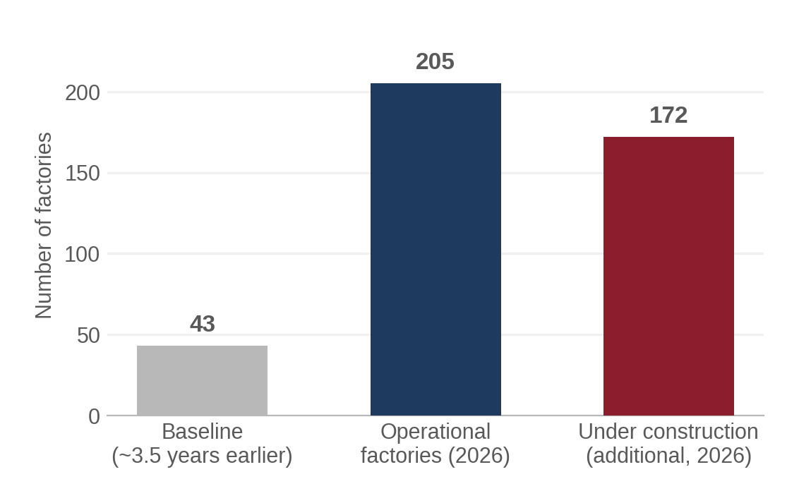
Figure 2. Suez Canal Economic Zone factory growth, baseline vs. 2026.
Source: Daily News Egypt, 2025–2026, Egypt.

2.3 Egypt sector matrix
Sector | Problem Relevance | Existing Infrastructure | Evidence of Scale | Key Regional Characteristic
Security & Surveillance (state) | High | National CCTV grid; central AI/facial-recognition SOC | 6,000+ cameras, New Capital alone | Centralized command-and-control model; decentralized robotics is an institutional mismatch
Airports | Moderate–High | Biometric e-gates; dense fixed CCTV | CAI: 30.9M pax (2025) | Privatization drive may open a non-security-state procurement channel
Ports | High (theoretical) | Modern terminal equipment; no known robotics/edge-AI tracking | 8.9M TEU, 11 main ports (2024) | DP World's SCZone presence is a plausible tech-transfer channel from the UAE
Industrial Zones (SCZone) | Moderate–High | Shared power/water/telecom infrastructure; camera density unknown | 205 factories, $16bn investment | Multi-tenant ownership complicates a single-buyer deployment model
Smart Cities (New Capital) | High (by design) | Purpose-built ICCC, 6,000+ cameras | 6.5M planned residents | Built-from-scratch, but centralized architecture already installed (Honeywell)
Warehouses / E-commerce | Moderate | New automated sortation (Bosta), 50+ hubs | 37M parcels handled 2025 | Fast, founder-led adoption culture; weaker technical fit (parcels, not people)
Transportation | Moderate | Station CCTV/turnstiles; rail automation underway | Not independently quantified | Fragmented vendor market; no sector-specific evidence found
Critical Infrastructure | Unverified | Unknown | Not available | Strong theoretical fit (unmanned sites) but no public evidence either way

2.4 Egypt priority analysis
Ranking is based on the convergence of three factors documented above: (a) independently evidenced scale, (b) an existing centralized system the project would need to interoperate with or displace, and (c) a plausible non-state commercial buyer, since state security procurement in Egypt is opaque, centralized, and — per the drone-permitting precedent (Section 8.4) — slow and security-cleared rather than open to standard commercial sales cycles.
- Most tangible and frequent: the New Administrative Capital and similar new-city surveillance grids, because the continuity-of-observation problem is explicit in the system's own stated design brief, and the physical camera density already exists.
- Highest consequence of failure: critical infrastructure and ports, where a missed handoff could mean an undetected intrusion at an unmanned or safety-critical site — but this is the sector with the weakest public evidence, so the conclusion is directional, not confirmed.
- Best infrastructure fit today: the Suez Canal Economic Zone and Bosta-style logistics hubs, because both are growing so fast that new technology can be designed in from the start rather than retrofitted, and both sit outside the most sensitive, security-cleared procurement channel.
- Weakest fit on closer inspection: national transportation (metro/rail) and general commercial CCTV — real problems, but not clearly differentiated from the general urban-security case, and not supported by sector-specific scale evidence in public sources.
- Most severe infrastructure limitation: any deployment that depends on the Ministry of Interior's centralized SOC as a customer or integration partner, because that system's institutional logic (single control room, state-controlled facial recognition) is structurally opposed to a decentralized, peer-negotiating robotic architecture, and because the system's technical specifications are undisclosed.
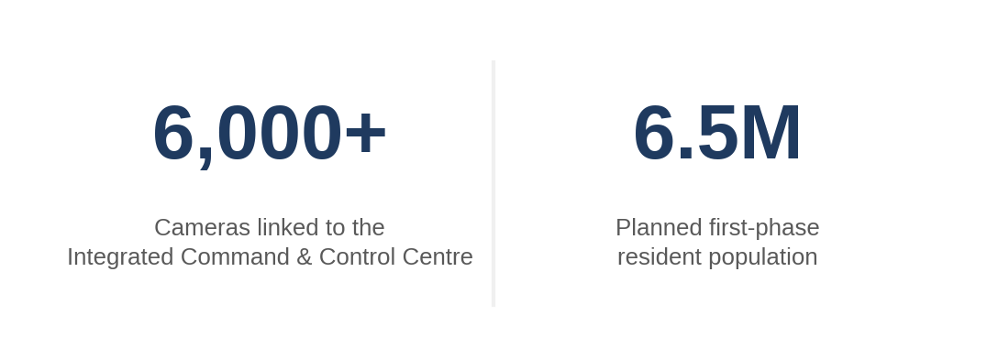
Figure 3. The New Administrative Capital's surveillance grid, by the numbers.
Source: Egyptian Streets, 2019; Context/Thomson Reuters Foundation, 2023, Egypt.

2.5 Regional ecosystem analysis (Egypt)
The real operational ecosystem around this problem in Egypt has at least four distinct actor types, and they do not currently talk to each other in ways that would make a single go-to-market approach work across all of them:
- Government security bodies (Ministry of Interior, National Security Sector, General Intelligence Service) — control the largest camera networks and the SOC, but procurement is opaque, security-cleared, and oriented toward centralized systems from large integrators (Honeywell, and reportedly Huawei-linked infrastructure).
- Zone and infrastructure authorities (SCZone's General Authority, port authorities, the Suez Canal Authority, airport holding companies) — control large, multi-tenant physical environments and could plausibly act as a single buyer for zone-wide deployment, but their core mandate is investment attraction and logistics throughput, not security technology procurement.
- Private system integrators — a fragmented market of companies (examples found in this research include Golden Technology, EGITS, and multiple turnstile/access-control vendors) that already sell and install CCTV and access-control hardware to Egyptian commercial and institutional clients; these firms are a plausible channel-partner layer rather than an end customer.
- Universities and research centers (American University in Cairo, Nile University, Zewail City, German University in Cairo) — active in computer vision and robotics research and increasingly linked to pan-African CV research collaborations, but operate at a smaller scale and with less applied-robotics infrastructure than the leading Gulf institutions (Section 4).
This ecosystem description is built from publicly available organizational and contractual information (procurement announcements, vendor listings, university program pages). It does not represent verified deployment practices or internal decision-making processes at any named organization, which would require direct primary contact.

3. Egypt Sector & Use-Case Analysis — Summary
Section 2 above constitutes the full sector-by-sector and use-case analysis required by the research scope; this section summarizes the cross-sector pattern rather than repeating it. Three use-case categories emerge, not the single undifferentiated "surveillance" category a generic market report would apply:
- State-security continuity-of-observation (New Capital ICCC, Ministry of Interior SOC, airports): high evidenced relevance, but locked to a centralized institutional model and opaque procurement.
- Commercial/industrial-zone asset and perimeter tracking (SCZone, ports, logistics hubs): moderate-to-high relevance, faster-moving and more accessible procurement, but thinner public evidence of the specific continuity-of-observation pain point versus general automation appetite.
- Unmanned critical-infrastructure monitoring (substations, pipelines): theoretically the strongest fit for autonomous multi-robot patrol, but essentially undocumented in public Egyptian sources — the clearest candidate for primary field research (Section 6) rather than desk conclusions.

4. MENA Analysis
Beyond Egypt, this research examined Saudi Arabia, the United Arab Emirates, Qatar, and Morocco, as instructed, and did not find sufficient distinct, materially relevant evidence to justify adding further countries within the scope of this report (Bahrain, Kuwait, Oman, and Jordan were briefly considered but yielded no comparable public infrastructure or research-ecosystem evidence during this research pass and are not included as separate entries).
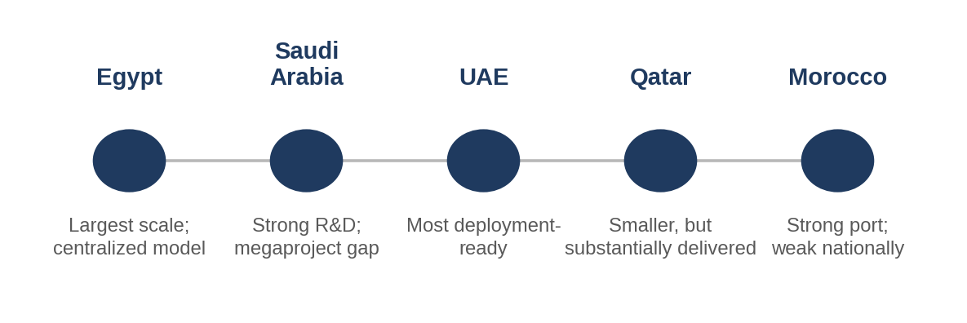
Figure 4. Regional snapshot — not a geographic map, a summary of the five countries examined.

4.1 Saudi Arabia
- Country: Saudi Arabia. Relevant sectors: giga-project smart cities (NEOM, Red Sea Project, Qiddiya), applied robotics research.
- Concrete use case: perimeter and public-safety surveillance embedded into greenfield city design from inception, plus applied robotics R&D that includes exactly the technical building blocks (autonomous navigation, UAV tracking simulation) the project depends on.
- Infrastructure environment: Vision 2030 has directed a stated $500 billion toward giga-projects since 2017; the Saudi smart-cities market was valued at $14.4 billion in 2025 and is projected to reach $32.3 billion by 2034 (8.91% CAGR); the Saudi video-surveillance-systems market was $780.9 million in 2025, projected to reach $2.24 billion by 2034 (IMARC Group data via Futurism, 2026, Saudi Arabia).
- Technology readiness: KAUST operates a dedicated 1,000 m² Robotics Bay and an active robotics research program covering autonomous navigation, marine and agricultural robotics, and UAV-based tracking simulation (the Sim4CV simulator explicitly supports "autonomous UAV-based tracking of moving objects") (KAUST, 2026, Saudi Arabia).
- Operational relevance: high on paper, but Section 4.1.1 below shows a significant gap between announced investment and confirmed built capacity.
- Deployment conditions: SDAIA's Personal Data Protection Law reached full enforcement on 14 September 2024, explicitly classifies facial-recognition/biometric data as sensitive personal data requiring heightened consent, and had already issued 48 enforcement decisions by 2025–2026 (SGC Consulting, 2026, Saudi Arabia) — a materially more active enforcement posture than Egypt's regulator, which only became operational in November 2025.
- Distinctive regional factor: Saudi Arabia is currently the only country in this study where a flagship megaproject (NEOM) has been publicly and explicitly scaled back for cost and revenue reasons — a directly relevant caution against assuming announced investment equals deployable capacity (Section 4.1.1).
- Evidence strength: strong for research infrastructure (KAUST) and regulatory maturity; mixed-to-weak for giga-project build-out claims, which require independent verification project-by-project.

4.1.1 NEOM: a case study in theoretical possibility versus operational deployability
NEOM illustrates the report's required distinction between technically possible, operationally deployable, and practically adoptable more clearly than any other single case examined. The original 2017 budget figure was $500 billion; an internal audit reported by the Wall Street Journal in 2024 put full 55-year build-out cost as high as $8.8 trillion, a figure the Public Investment Fund has not endorsed. Cumulative spending through late 2025 is independently estimated at approximately $50 billion — roughly 10% of the original headline figure and a much smaller fraction of the higher estimate (Vision2030.ai encyclopedia entry, 2026, Saudi Arabia). Population targets for The Line have been revised down from 1 million residents by 2030 to a reported 300,000 by decade's end. In 2026, Saudi Arabia signaled it would scale back NEOM and explore repurposing it as an AI data-center hub rather than the originally envisioned linear city (Britannica, 2026, Saudi Arabia). At the same time, a concrete and specific capital commitment does exist within NEOM: a $5 billion, 1.5-gigawatt AI data center agreement between DataVolt and NEOM's Oxagon industrial zone, announced February 2025. The lesson for this project is not that Saudi Arabia is a weak market — its research infrastructure and surveillance-market spending are real and growing — but that any Saudi giga-project reference in a pitch or plan should be sourced to a specific, dated, funded contract, not to the headline vision figure.
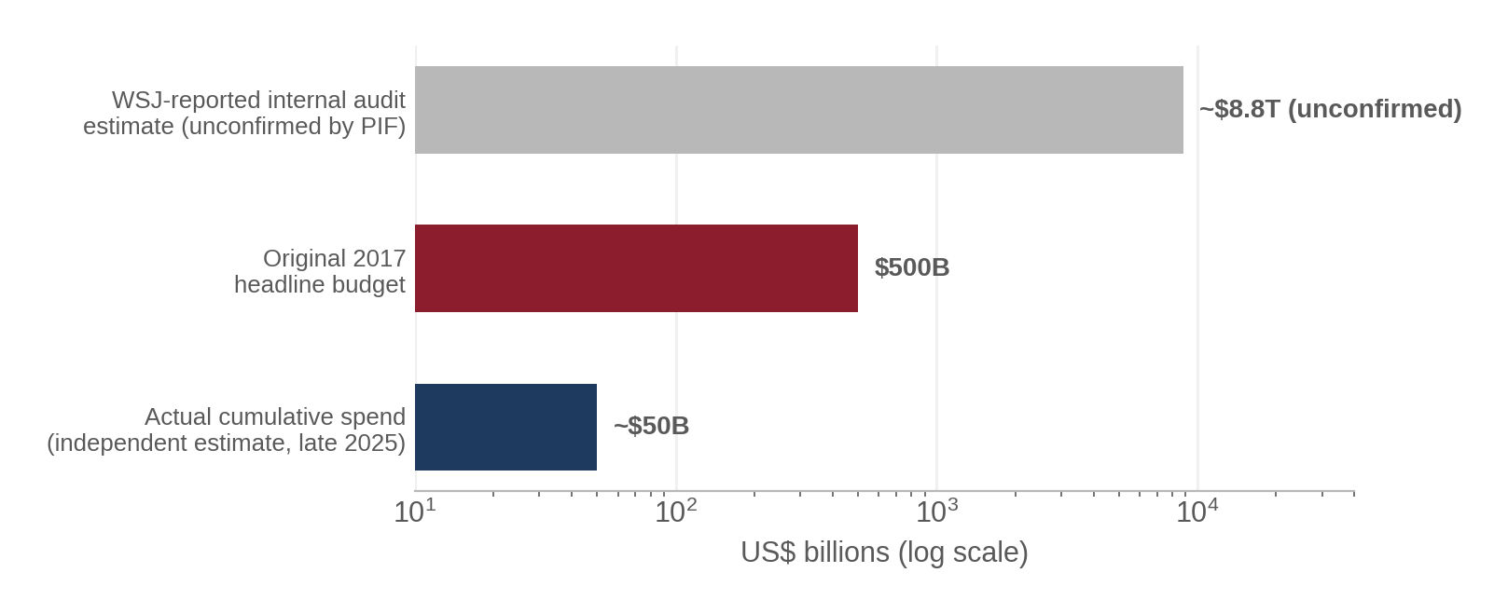
Figure 5. NEOM: headline budget, disputed audit estimate, and actual spend — three very different numbers.
Source: Vision2030.ai; Britannica, 2026, Saudi Arabia. Log scale — note the order-of-magnitude gaps.

4.2 United Arab Emirates
- Country: UAE. Relevant sectors: container-port automation, applied computer-vision and robotics research, public-safety surveillance.
- Concrete use case: this is the one country in the study with confirmed, currently operating autonomous systems directly analogous to the project's own domain — autonomous internal terminal vehicles and autonomous security patrol craft at a working container port, not a rendering or an announcement.
- Infrastructure environment: DP World's Jebel Ali Port already operates remotely operated quay cranes and automated gantry cranes and gates; World Security (a DP World subsidiary) deployed autonomous security boats across Jebel Ali, Mina Rashid, and Mina Al Hamriya from 2021; DGWorld has supplied Autonomous Internal Terminal Vehicles (AITVs) to Jebel Ali in phases since a 2020 agreement (The National, 2021; Ship Technology / Port Technology International / Business Wire, 2020, UAE).
- Technology readiness: Khalifa University's Center for Autonomous Robotic Systems (KUCARS) in Abu Dhabi conducts multi-object tracking and Re-Identification research directly in the project's own technical subfield — a 2026 paper on "object-centric appearance estimation for multi-object tracking" is co-authored by KUCARS-affiliated faculty (arXiv preprint, 2026). The Mohamed bin Zayed University of Artificial Intelligence (MBZUAI) operates a dedicated Computer Vision Research Department covering robotic vision, multi-sensor fusion, and biometrics with PhD and MSc programs (MBZUAI, 2026, UAE). UAE-based Micropolis Robotics unveiled an Autonomous Logistics Platform (400V architecture, 4–5 ton payload, 18-hour mission endurance) for industrial-zone logistics at UMEX 2026.
- Operational relevance: high and, unlike Saudi Arabia's giga-projects, substantially confirmed by operating systems rather than announcements alone.
- Deployment conditions: UAE's Federal Decree Law No. 45 of 2021 (PDPL) has been in force since January 2022, is GDPR-modeled with extraterritorial reach, and explicitly treats biometric data — including facial recognition used for identification — as sensitive personal data requiring heightened consent and, for high-risk processing such as large-scale surveillance or biometric analysis, a Data Protection Impact Assessment (DataSpot Infra, 2026; IBA, 2026, UAE). Free zones (DIFC, ADGM) layer additional, stricter rules on top of the federal law.
- Distinctive regional factor: the UAE combines the region's highest surveillance-camera density (reporting around the COP28 summit described roughly 12,000 cameras linked to the event specifically, with the UAE more broadly described as having one of the highest surveillance-camera concentrations globally — Euronews, 2023, UAE) with its most applied and academically serious computer-vision/robotics research base. This combination — dense sensing infrastructure plus a functioning applied-research pipeline in the exact relevant subfield — is not replicated elsewhere in the countries studied.
- Evidence strength: strong. Multiple independent trade-press and academic sources corroborate both the operational port automation and the research infrastructure.

4.3 Qatar
- Country: Qatar. Relevant sectors: smart-city infrastructure (Lusail, Msheireb Downtown Doha), integrated transport monitoring.
- Concrete use case: a single, centrally managed AI platform coordinating traffic, lighting, buildings, and (per system-integrator marketing material) CCTV-linked environmental and safety response across an entire new city.
- Infrastructure environment: Qatar's TASMU Smart Qatar program targets $5.7 billion in digital investment by 2026 (Invest Qatar, 2024); the national smart-cities market was valued at $3.31 billion in 2025, projected to reach $10.9 billion by 2034 (14.14% CAGR, IMARC data, 2026, Qatar).
- Technology readiness: ST Engineering was awarded a contract (reported at S$60 million, roughly $44 million) to build Lusail City's AI-powered urban operating system, integrating traffic, lighting, and building management on one platform, running Q4 2024 to 2027 (SmartCitiesWorld, 2024, Qatar); a November 2025 TASMU expansion adds a National Digital Twin hosted in sovereign data centers.
- Operational relevance: moderate. Qatar's smart-city investment is real and dated, but it is explicitly centralized-platform-first ("Lusail's Control Center manages everything"), the same architectural pattern seen in Egypt's New Administrative Capital, and there is no public evidence of distributed/robotic tracking deployment.
- Deployment conditions: Doha ranked 33rd globally and 3rd regionally in the IMD Smart City Index 2025, reflecting genuinely high-quality general urban infrastructure (IMD/Business Year, 2025, Qatar).
- Distinctive regional factor: Qatar's smart-city build-out is smaller in absolute scale than Saudi Arabia's or the UAE's but more evenly and verifiably delivered — Lusail and Msheireb are substantially built, not merely announced, which is a meaningful distinction after the NEOM case study above.
- Evidence strength: moderate — good on investment figures and the flagship contracts, but no evidence located on Qatar's applied robotics research capacity (no Qatari analogue to KAUST or MBZUAI was identified in this research) or on any camera-continuity pain point specifically.

4.4 Morocco
- Country: Morocco. Relevant sector: port and automotive-industrial automation (Tanger Med).
- Concrete use case: perimeter and yard tracking at one of the world's largest container ports and an adjoining automotive manufacturing/logistics cluster.
- Infrastructure environment: Tanger Med has an 11-million-container handling capacity, ranks among the world's top 25 container ports, and is the largest port in Africa and the Mediterranean, hosting roughly 1,100 companies across its industrial platform and connecting to 180 ports in 70 countries (Wikipedia/Tanger Med Group corporate material, cross-checked, 2025–2026, Morocco). The adjoining Tangier automotive cluster includes Renault's Tangier plant, its second-largest by volume globally, producing 394,000 vehicles in 2025 with 87 tier-1 suppliers co-located in the free zone (Renault Group, 2026, Morocco).
- Technology readiness: the University Mohammed VI Polytechnic (UM6P) and Tanger Med Group launched an "AI Tanger Med" industrial-AI partnership in July 2025, alongside a separate national push (a Casablanca-Settat AI/data excellence center targeting 500 trained engineers over four years, and a Morocco Digital 2030 strategy) (Morocco World News, 2025, Morocco).
- Operational relevance: moderate. Tanger Med and the automotive cluster are a strong physical-fit environment, but Morocco's national digital infrastructure lags meaningfully behind Egypt and the Gulf states: Morocco ranked 76th of 139 countries on the 2025 Network Readiness Index, with roughly 60% internet penetration nationally (TechBehemoths, 2026, Morocco) — well below Egypt's reported 74.8–81.9% (Section 6) and far below near-universal Gulf penetration.
- Deployment conditions: this is the clearest example in the study of the report's required caution against generalizing from one facility to an entire country. Tanger Med itself is world-class, heavily automated port infrastructure; the national digital-infrastructure base it sits within is not. A deployment at Tanger Med specifically could be well-supported; a deployment predicated on "Morocco's" general infrastructure readiness would not be.
- Distinctive regional factor: Morocco's automation strength is concentrated and industrial-export-driven (ports, automotive) rather than security-state-driven, a different institutional pattern from Egypt, Saudi Arabia, and Qatar.
- Evidence strength: strong for Tanger Med's physical scale and automotive-cluster automation; strong for the national connectivity gap; no evidence located on any camera-continuity or tracking pain point specifically within Moroccan facilities.
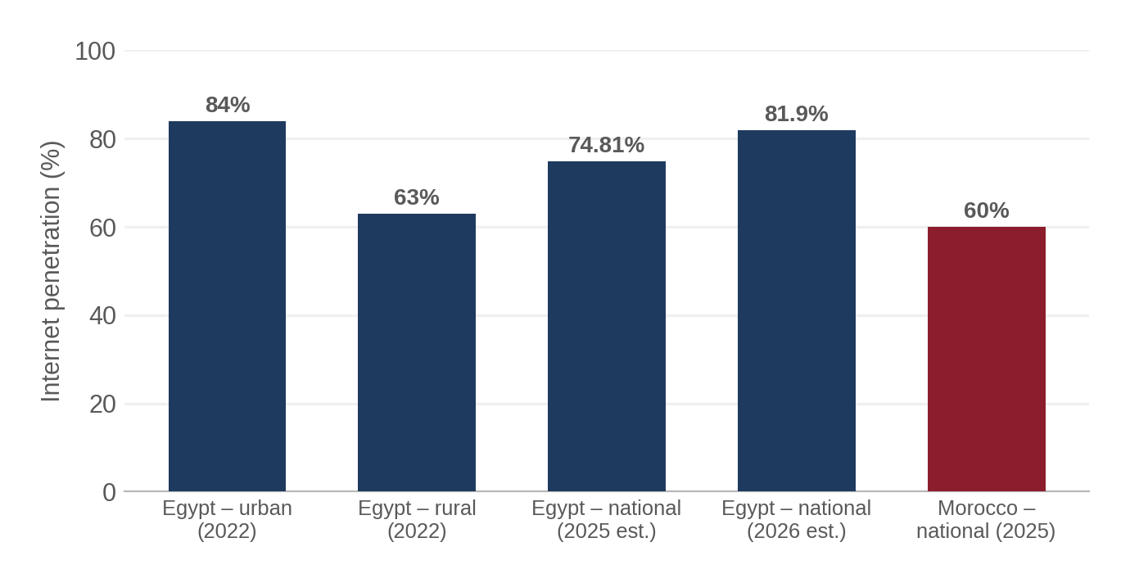
Figure 6. Internet penetration: Egypt's urban/rural split vs. Morocco's national rate.
Source: Internet Society Pulse, 2022; NAOS Solutions, 2025; Omdia/Informa, 2025; TechBehemoths, 2026.

4.5 MENA comparison table
Country | Key Use Cases | Infrastructure Readiness | Distinctive Factor | Evidence Strength
Egypt | New-capital surveillance; SCZone industrial; ports | High camera density; centralized architecture; nascent 5G/data centers | 2025 licensing requirement for visual surveillance analytics | Strong on scale; weak on operator pain points
Saudi Arabia | Giga-project public safety; applied robotics R&D | Real R&D infrastructure (KAUST); giga-project build-out overstated vs. spend | NEOM scale-back shows a gap between announcement and delivery | Strong on R&D; mixed on megaproject claims
UAE | Port automation (Jebel Ali); CV/robotics research | Confirmed operating autonomous port systems; dense camera coverage | Only country with operating systems directly analogous to the project | Strong — multiple corroborating sources
Qatar | Centralized smart-city platforms (Lusail) | Smaller but substantially delivered (not just announced) | High urban-infrastructure quality (Doha, IMD rank 33) | Moderate — no robotics-research analogue found
Morocco | Port/automotive automation (Tanger Med) | World-class at Tanger Med; weak nationally (NRI rank 76/139) | Strongest example of facility-vs-country generalization risk | Strong on the gap itself; weak on tracking-specific evidence
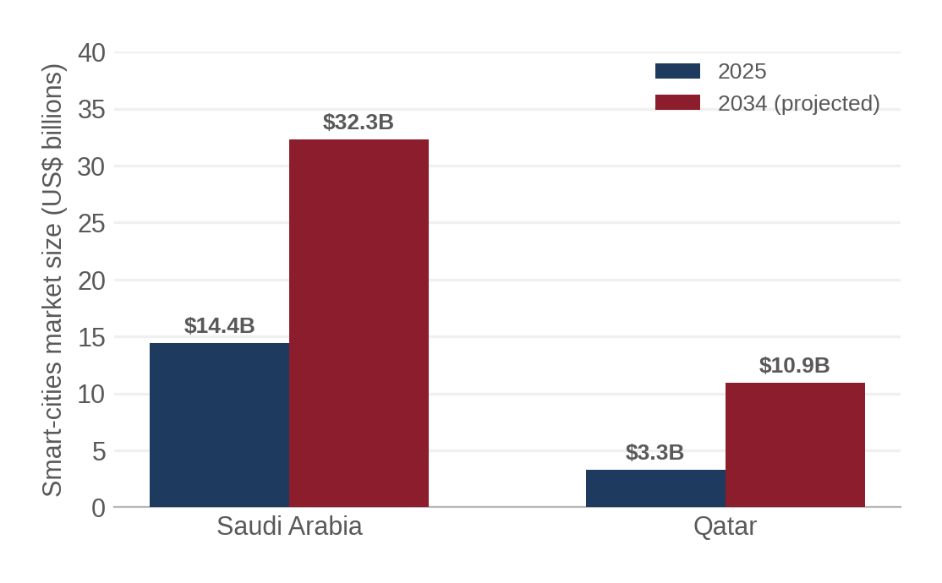
Figure 7. Smart-cities market size: 2025 vs. 2034 (projected).
Source: IMARC Group data via Futurism, 2026, Saudi Arabia / Qatar.

4.6 Regional comparative analysis
- Strongest infrastructure readiness for this specific technology: UAE, on the strength of confirmed operating autonomous port systems and a directly relevant academic research base (KUCARS, MBZUAI) — not the largest or wealthiest market by headline investment (that is Saudi Arabia), which is itself a useful corrective to assuming scale of announced investment predicts deployment readiness.
- Strongest operational need by evidenced scale: Egypt, on sheer count and density of candidate environments (ports, SCZone factories, airports, the New Capital) and the most immediate new regulatory trigger (the November 2025 licensing requirement for visual surveillance systems, which affects any deployment regardless of whether this specific technology is involved).
- Largest deployment barriers: Saudi Arabia's giga-projects (announcement/delivery gap) and Morocco nationally (connectivity gap outside flagship facilities) — for different reasons in each case.
- Markets where the underlying problem appears already adequately handled by centralized alternatives: Qatar's Lusail and Egypt's New Administrative Capital both show that the region's default answer to "we need to track something across camera zones" has so far been a bigger centralized control room, not distributed autonomy — meaning the project's core value proposition (decentralization, bandwidth reduction, no continuous raw-video transmission) needs to be argued for explicitly rather than assumed as an obvious upgrade path.

5. Quantitative Evidence
Every figure below follows the required Value + Source + Year + Geography + Context format. Figures are grouped by category and kept explicit about geographic scope; none are extrapolated beyond what the source states, and reporting inconsistencies found in the underlying sources (for example, two different Egyptian internet-penetration figures for similar dates) are shown rather than silently reconciled.
Metric | Value | Geography | Year | Context | Source
Surveillance cameras | 6,000+ | New Administrative Capital, Egypt | 2023 | City-wide ICCC, first-phase residents | Context/TRF; Japan Times
Commercial + specialized ports | 15 + 29 | Egypt (national) | 2025 | 5 tourist, 6 mining, 12 petroleum, 6 fishing specialized ports | Egypt Tours Portal
Container throughput, main seaports | 8.9 million TEU | Egypt (11 main seaports) | 2024 | Total across 11 main seaports | ShipHub
Port Said global container-port rank | 47th (4.439M TEU) | Port Said, Egypt | 2025 | Up from 64th in 2024, Lloyd's List ranking | Ahram Online
Cairo Int'l Airport passengers | 30,944,269 | Cairo, Egypt | 2025 | Full-year passenger count | Wikipedia/airport statistics
Egyptian airport traffic | 9.4M passengers / 70,700 flights | Egypt (national) | Jan–Apr 2026 | Four-month period | Ahram Online
SCZone operational factories | 205 (172 more under construction) | Suez Canal Economic Zone, Egypt | 2026 | Grown from 43 factories ~3.5 years earlier | Daily News Egypt
SCZone total investment | $16 billion (28 countries) | SCZone, Egypt | 2025–26 | Cumulative over ~3 years 9 months | Daily News Egypt
TEDA cooperation zone companies | ~200 (≈$3.8bn invested) | SCZone (TEDA zone), Egypt | end-2025 | Site expanding 7.34km² → 10km²+ | People's Daily
Nationwide 5G launch | All 4 operators, $2.7bn combined spend | Egypt (national) | June 2025 | Spectrum + infrastructure investment | Futurism / DCD
Internet penetration (higher estimate) | 81.9% (96.3M users) | Egypt (national) | 2026 | Reported alongside 42% YoY data-use growth | Futurism data-center report
Internet penetration (lower estimate) | 74.81% | Egypt (national) | April 2025 | Independent telecom-regulation review; shown alongside the figure above due to source discrepancy | Omdia/Informa
Rural vs urban internet use | 84% urban / 63% rural | Egypt (national) | 2022 | ≈24.5M rural Egyptians offline vs. ≈8M urban | Internet Society Pulse, via NAOS Solutions
Telecom towers | 37,000 (2024), +3,000 planned 2026, +9,000 over 3 yrs | Egypt (national) | 2024–26 | Over $6bn invested in fixed/mobile infrastructure since 2019 | NAOS Solutions; Middle East Observer
Local data-center market value | $278 million | Egypt (national) | 2024 | New entrants: Africa Data Centres, Khazna | NAOS Solutions
Submarine cable connections | 17 existing (+5 planned) | Egypt (national) | 2024 | Connecting Middle East, Africa, Europe | ResearchAndMarkets/BusinessWire
Bosta parcel volume | 37 million parcels (target 80M in 2026) | Egypt (national) | 2025 | Last-mile e-commerce logistics | Disrupt Africa; fwdstart.me
Bosta automated sorting capacity | 11,000 parcels/hour, 250,000/day | Cairo, Egypt | Jan 2026 | $5M facility, 50+ hubs nationwide | LogUpdate Africa; Disrupt Africa
Egypt freight & logistics market size | $19.76 billion | Egypt (national) | 2024 | Overall market valuation | Appicial
Saudi smart-cities market | $14.4bn → $32.3bn (2034 est.) | Saudi Arabia (national) | 2025 | 8.91% projected CAGR | IMARC Group via Futurism
Saudi video-surveillance market | $780.9M → $2.24bn (2034 est.) | Saudi Arabia (national) | 2025 | 12.44% projected CAGR | IMARC Group via Futurism
NEOM cumulative spend vs. headline budget | ~$50bn spent vs. $500bn–$8.8tn cited budget range | NEOM, Saudi Arabia | late 2025 | PIF has not endorsed the $8.8tn WSJ-reported audit figure | Vision2030.ai; Britannica
NEOM/Oxagon AI data-center deal | $5bn, 1.5GW capacity | Oxagon, NEOM, Saudi Arabia | Feb 2025 | DataVolt–NEOM agreement | Malay Mail (AFP/SPA)
KAUST Robotics Bay | 1,000 m² facility | KAUST, Saudi Arabia | 2026 | Dedicated robotics/autonomy research space | KAUST
Saudi PDPL enforcement actions | 48 decisions | Saudi Arabia (national) | 2025–26 | SDAIA enforcement committee rulings | SGC Consulting
Tanger Med capacity | 11 million containers/year | Tanger Med, Morocco | 2025–26 | Among world's top 25 container ports | Wikipedia; Tanger Med Group
Tanger Med industrial platform | ~1,100 companies | Tanger Med, Morocco | 2020 baseline, still cited 2025–26 | €8bn annual export business (2020 figure) | Wikipedia (flagged as needing update)
Renault Tangier production | 394,000 vehicles | Tangier, Morocco | 2025 | 2nd-largest Renault plant globally by volume; 87 tier-1 suppliers | Renault Group
Morocco Network Readiness Index rank | 76th of 139 | Morocco (national) | 2025 | Internet penetration ≈60% | TechBehemoths
Qatar smart-cities market | $3.31bn → $10.9bn (2034 est.) | Qatar (national) | 2025 | 14.14% projected CAGR | IMARC Group via Futurism
Lusail City AI platform contract | ≈S$60m (≈$44m) | Lusail, Qatar | 2024–2027 | ST Engineering Agil Smart City OS | SmartCitiesWorld
Doha IMD Smart City Index rank | 33rd globally, 3rd regionally | Doha, Qatar | 2025 | Scores well on safety, mobility, governance | IMD via The Business Year
UAE COP28-linked camera count | ≈12,000 cameras (event-linked reporting) | UAE (Dubai, COP28 context) | Dec 2023 | Reported in context of surveillance-concern coverage, not a national census | Euronews
DP World Jebel Ali AITV/automation | Autonomous terminal vehicles, cranes, security boats — operational | Jebel Ali, UAE | 2020–2021 (ongoing) | Multi-phase rollout; not a pilot announcement | The National; Port Technology Int'l
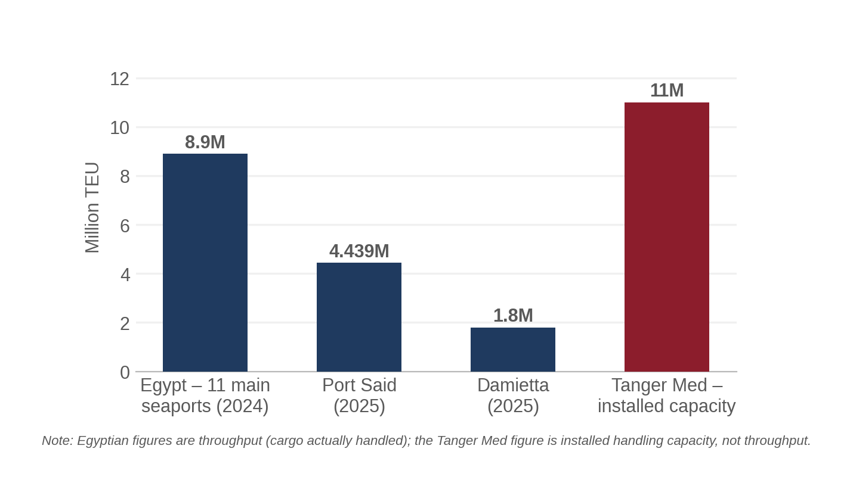
Figure 8. Regional port scale: Egyptian throughput vs. Tanger Med capacity.
Source: ShipHub; Ahram Online, 2026; Tanger Med Group, 2025–26.

5.1 Data quality notes
- Two Egyptian internet-penetration figures (74.81% for April 2025 and 81.9% undated-but-recent) come from different methodologies and providers and are shown side by side rather than reconciled into a single number — a direct application of the instruction not to replace missing precision with invented certainty.
- The Tanger Med "1,100 companies / €8bn exports" figure is sourced to a Wikipedia page flagged by its own editors as needing an update since 2021; it is retained because no more recent authoritative company count was located, but it should be treated as a 2020-era baseline, not a current figure.
- NEOM's headline $500 billion–$8.8 trillion budget range spans an order of magnitude and is explicitly not endorsed by the Public Investment Fund at the higher end; only the independently estimated ~$50 billion cumulative spend figure should be treated as reasonably reliable evidence of actual deployed capital.
- The UAE "12,000 cameras" figure is specific to COP28-linked reporting, not a national or even city-wide census, and is presented here only as illustrative of reporting on UAE camera density, not as a national statistic.

6. Field Validation Framework
No interviews, surveys, or field observations were conducted for this report. Everything in this section is Research Proposed / Research Needed, clearly separated from the Research Conducted (desk research) that constitutes Sections 2–5 above. Where this report references stakeholder needs, adoption willingness, or operational pain points without a citation to a published source, that content should be read as a hypothesis the protocol below is designed to test — not as a finding.

6.1 Why primary research is necessary before proceeding
The desk research in this report can establish that camera-dense, non-overlapping-zone environments exist at scale in Egypt and the Gulf, and that centralized systems are the current default answer. It cannot establish, from public sources alone, whether the specific operators who run those systems currently experience continuity-of-observation as a significant, costly, or frequent failure mode — as opposed to a theoretical gap the system's architects have not prioritized. That is a field question, not a desk-research question, and the report treats it as unresolved.

6.2 Participant groups
Starting-point participant groups, selected to represent the distinct institutional environments identified in Sections 2 and 4 rather than a generic "security professionals" category:
- Control-room / SOC operators at a large camera-dense facility (New Capital-style ICCC, port authority, or airport) — the people who would personally experience a lost handoff.
- Port and industrial-zone facility security or operations managers (SCZone, or a Gulf port comparator) — represent the multi-tenant, zone-wide deployment model discussed in Section 2.2.4.
- Private security-system integrators who currently sell and install CCTV/access-control hardware in Egypt (the vendor layer identified in Section 2.5) — represent the channel through which a new system would likely have to be sold.
- Robotics and computer-vision researchers at regional universities (AUC, Nile University, Khalifa University/KUCARS, MBZUAI, KAUST) — represent the technical-feasibility and Re-ID/handoff-specific perspective, and can speak to whether regional benchmark datasets or test environments exist.
- Logistics/warehouse operations managers (e.g., at an automated sortation facility) — represent the weaker-fit but fast-adopting commercial-logistics environment identified in Section 2.2.6.
- Data-protection / compliance officers at organizations newly subject to Egypt's November 2025 visual-surveillance licensing requirement, or the UAE/Saudi equivalents — represent the regulatory-adoption-barrier perspective specifically.

6.3 Interview design principles
Questions are built to reveal unexpected information while remaining comparable across participants, following the brief's explicit instruction to avoid leading questions such as "would you like a system that solves this problem?" in favor of open, workflow-anchored questions.

6.3.1 Current process
- Walk me through how your team currently keeps track of a person or vehicle of interest as they move through your site.
- What tools, screens, or systems are involved at each stage of that process?
- At which points does a human operator have to intervene manually rather than the system handling it automatically?

6.3.2 Failure
- Walk me through what happens when the current system loses continuity of observation — when the person or object you were tracking moves out of one camera's view before the next camera picks them up.
- How often does that happen, as best you can estimate?
- Which specific failure patterns cause the most disruption — camera gaps, lighting changes, crowd occlusion, something else?
- What is the recovery process when that happens? Who re-acquires the target, and how long does it typically take?

6.3.3 Impact
- What is the operational consequence when a handoff like this fails — what happens next?
- Which situations are hardest to handle with your current setup?
- Where does this problem consume the most staff time or attention relative to its actual importance?

6.3.4 Existing infrastructure
- What camera, sensor, network, and compute infrastructure do you already have in place at the site?
- What other systems would a new tracking or handoff capability need to work alongside, rather than replace?
- Where are the current limitations — network coverage, bandwidth, on-site compute, something else?

6.3.5 Adoption
- What would stop your organization from deploying a new system like this, even if it worked technically?
- What would make a new system trustworthy enough to rely on operationally?
- Who inside your organization would need to approve a deployment like this, and what would they need to see first?
- What would justify the cost or the operational change involved?

6.3.6 Privacy and security
- What privacy, data-protection, or facial-recognition restrictions currently affect what you can do with camera data?
- Has your organization gone through, or started, the licensing process for visual surveillance systems under [the applicable national data-protection law]? What has that involved?

6.3.7 Desired state
- If you could redesign how tracking and handoff works at your site from scratch, what would that look like?

6.4 Sampling
A small exploratory study in the 10–20 participant range, drawing across the six participant groups above rather than concentrated in one, would likely surface the diversity of operational context needed to distinguish sector-specific findings from general patterns — but this range is a starting estimate, not a requirement, and should be adjusted based on how quickly responses converge or continue to diverge across interviews.

6.5 Survey design (if broader quantitative validation is pursued)
A structured survey, if pursued after exploratory interviews, should measure — using neutral wording that tests the problem rather than advertises a solution — the following, without presupposing that a decentralized robotic system is the desired answer:
- Frequency and severity of continuity-of-observation failures at the respondent's site.
- Current workaround (additional cameras, additional staff, accepted loss of coverage, something else).
- Estimated time and operational cost impact of those failures.
- Confidence in and current use of existing centralized systems.
- Familiarity with, and attitude toward, distributed/autonomous alternatives to centralized control rooms.
- Awareness of and readiness for applicable data-protection licensing requirements.
- Existing network, compute, and edge-device infrastructure at the respondent's site.

6.6 Field validation analysis plan
Once primary data exists, it should be analyzed for frequency, severity, and — critically — consistency and contradiction across stakeholder groups and sectors, not aggregated into a single regional average. A state-security SOC operator and a private logistics-hub manager are answering from different institutional worlds (Section 2.5); if their answers diverge, that divergence is itself a finding, not noise to be averaged away. Negative and disconfirming findings (a control room that reports the problem is rare, or already well-handled by adding cameras) should be reported with the same weight as confirming findings.

7. Existing Infrastructure & Deployment Readiness

7.1 Sensing infrastructure (CCTV / cameras)
Dense fixed-camera infrastructure is well evidenced in the specific Egyptian and Gulf environments profiled above (New Capital, Jebel Ali, Lusail, Egyptian national CCTV mandates). This is a genuine asset: the project's Re-ID and handoff logic depends on cameras existing in the first place, and in the highest-priority environments they already do. What is not evidenced anywhere in this research is camera infrastructure designed for edge inference (on-camera or near-camera compute) rather than simple video capture feeding a centralized control room — the existing infrastructure is built to move video toward a center, not to process it at the edge.

7.2 Network availability
Egypt's network picture is one of rapid but uneven recent improvement: nationwide 5G launched in June 2025 across all four operators with $2.7 billion in combined investment, but NTRA's own 2026 commentary (via Opensignal) describes current 5G experience as "patchy," contingent on a further ~420MHz spectrum allocation expected in phased agreements from January 2026 through 2030 (Opensignal, 2026, Egypt). There is also a substantial urban/rural divide (84% vs. 63% internet use), which matters directly for any deployment outside Cairo, Alexandria, or a handful of major metropolitan areas. Gulf countries generally have more mature, denser network coverage, though this research did not locate directly comparable 5G-quality benchmarking for Saudi Arabia, the UAE, or Qatar to place alongside the Egyptian data.

7.3 Edge computing
Egypt's data-center market is real but nascent: approximately $278 million in 2024, with new entrants (Africa Data Centres, Khazna) and a first government cloud/AI data center (23,500 m²) opened in April 2024. This is centralized cloud/data-center capacity, not distributed edge-compute infrastructure at the individual camera or robot level. No public evidence was located, for any country in this study, of an existing regional edge-computing layer purpose-built for real-time multi-agent robotic coordination — every edge-computing reference found in this research (Egypt's data-center market reports, NEOM's Oxagon AI data center) describes centralized or near-centralized hyperscale/AI-training infrastructure, not the low-latency, distributed, per-node compute the project's architecture (VisionSERVICE, PredictionSERVICE, NegotiationSERVICE running per edge node) requires.

7.4 Centralized infrastructure and legacy-system risk
Every high-priority environment identified in this report — the New Administrative Capital, the Ministry of Interior's SOC, Lusail's Control Center — already has a substantial, recently procured, centralized command-and-control system in place (Honeywell/MTI in Cairo; ST Engineering in Lusail; a Huawei-linked system reportedly underpinning the Egyptian SOC). A new decentralized system would not be arriving into a greenfield environment in any of these cases; it would need an explicit integration or coexistence story with an existing, recently paid-for centralized system, which is a substantially harder sale than deploying into an unserved environment. This is the single most consistent "do not assume compatibility" finding across the entire regional analysis.

7.5 Deployment model analysis
Model | Regional compatibility | Basis
Centralized | High — matches existing regional procurement and institutional norms | New Capital ICCC, Ministry of Interior SOC, Lusail Control Center all follow this model
Edge | Low — infrastructure gap; no evidenced regional edge-compute layer at camera/robot level | Data-center evidence is centralized/hyperscale, not distributed edge nodes
Distributed (peer-to-peer, project's own architecture) | Low institutional fit today, though technically the project's design intent | No regional precedent found for peer-negotiating autonomous security agents; closest analogue (Jebel Ali AITVs) still reports into a centralized terminal operating system
Hybrid (edge sensing + centralized oversight/audit) | Moderate-to-high — most consistent with both existing infrastructure and regional security-governance norms | Preserves the centralized audit/control layer regulators and security bodies currently require while allowing the project's edge logic to operate underneath it
A hybrid model — in which the project's decentralized handoff logic operates as the real-time mechanism, but a centralized system retains an audit trail, override capability, and single point of regulatory accountability — is not a technologically fashionable choice; it is the model most compatible with what this research found about how Egyptian and Gulf security governance actually operates today. This is a genuine finding, not a hedge: every deployed or heavily-invested regional system found in this research reports into a single control center, and Egypt's new licensing regime for visual surveillance explicitly requires a licensed controller/processor structure that a fully peer-to-peer, no-central-record architecture would sit awkwardly against.
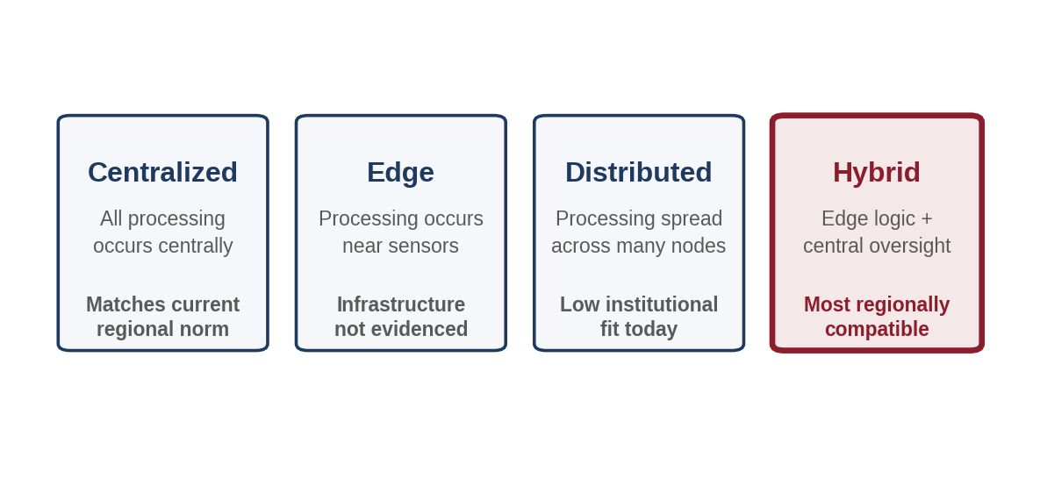
Figure 9. Four deployment models, and which one fits the region today.

8. Adoption & Deployment Barriers

8.1 Regulatory / governance barriers (the strongest and most immediate finding)
This is the single most concrete, evidenced adoption barrier identified anywhere in this report, and it applies specifically and directly to this project's domain — not to technology deployment in general.
- Egypt: the Executive Regulations to the Personal Data Protection Law (Decree No. 816 of 2025), in force since 1 November 2025 with full enforcement from 1 November 2026, require a standalone license or permit specifically for "the use of visual surveillance systems in public places," subject to "strict conditions relating to transparency, data security, and limitations on processing, including restrictions on facial recognition technologies except where expressly permitted by law" (Shand Partners, 2026, Egypt). Any deployment of this project's Re-ID technology in a public place in Egypt would need to navigate this licensing process — and because it was only just activated, there is no established precedent yet for how it will be applied to a Re-ID/tracking system specifically, as opposed to conventional CCTV.
- Egypt (a partial mitigant): the PDPL explicitly excludes data held by national-security and intelligence agencies (Presidency, Defense, Interior, General Intelligence) from its scope (Record of Law, 2026, Egypt) — meaning a deployment sold directly to the security state may sit outside this licensing regime, while the same deployment sold to a commercial port operator or industrial zone would not. This materially changes which regulatory path applies depending on the customer, and should be treated as a design input, not an afterthought.
- UAE: Federal Decree Law No. 45/2021 treats biometric/facial-recognition data as sensitive personal data requiring heightened consent, and requires a Data Protection Impact Assessment for high-risk processing such as large-scale surveillance or biometric analysis — a process, not a blanket prohibition, but a real compliance cost and timeline.
- Saudi Arabia: SDAIA's PDPL reached full enforcement in September 2024 and had issued 48 enforcement decisions by 2025–2026, indicating an active, not merely nominal, regulator.

8.2 Institutional/architectural barrier (from Section 7)
The region's dominant deployed pattern is a single centralized control room. A fully decentralized, peer-negotiating multi-robot system is a genuine institutional and cultural mismatch with how the highest-priority regional customers (state security bodies, large integrated smart-city control centers) currently operate and are regulated. This is not a hypothetical concern raised for balance — it is the most consistent pattern across every high-evidence-quality deployment examined in this report.

8.3 Cost, infrastructure, and skills barriers
- Infrastructure: edge-compute infrastructure of the kind the project requires (VisionSERVICE, PredictionSERVICE, NegotiationSERVICE running per node) is not evidenced as existing today anywhere in this study; the region's data-center and 5G investment is real but is oriented toward centralized cloud/AI training capacity, not distributed low-latency edge nodes.
- Network: Egypt's own regulator describes current 5G experience as "patchy," and this is Egypt's most advanced current network technology — a genuine binding constraint on any application (like real-time inter-robot negotiation) that depends on consistent low-latency connectivity, as distinct from applications that can tolerate occasional degradation.
- Skills/operations: this research did not locate direct evidence of a shortage or sufficiency of operational skills for maintaining autonomous multi-robot systems specifically in Egypt or the Gulf; this is flagged as an evidence gap rather than assumed in either direction (Section 10).
- Procurement: Egyptian state-security procurement (evidenced by the drone-permitting process, Section 8.4 below) is slow, security-cleared, and not designed for iterative commercial sales cycles; the multi-tenant SCZone and private-logistics channels identified in Section 2.5 are structurally faster.

8.4 A directly relevant regulatory precedent: Egypt's UAV permitting regime
Because this project's system includes ground robots (UGVs) rather than aerial drones, Egypt's extensive and strict UAV/drone regulatory regime (Executive Regulation No. 931 of 2018, overseen primarily by the Ministry of Defense rather than a civilian aviation authority) does not directly apply — but it is the closest evidenced regional precedent for how Egyptian authorities regulate autonomous mobile platforms, and it is instructive. Key features: only institutions (companies, scientific institutions, sports clubs), not individuals, may apply; applicants need security-clearance approval from National Security Authority, Military Intelligence, and General Intelligence sectors in addition to civil-aviation sign-off; review is meant to take 30 days but defaults to refusal if unanswered; universities and government research institutes are exempted from security clearance only when operating within campus boundaries for scientific research (Lexology, 2022; Masaar, 2021, Egypt). A 2026 update introduced a formal Commercial Drone Operator Certificate, mandatory liability insurance (minimum EGP 5 million), and geofencing requirements, while indicating that further liberalization for autonomous flight may not arrive before 2027 (Swissmena, 2026, Egypt).
This report did not locate any published Egyptian legal framework specifically addressing autonomous ground robots (UGVs) operating in public, commercial, or industrial spaces, as distinct from aerial UAVs. This is flagged as a significant open regulatory question (Section 10) rather than assumed to be either permissive or restrictive — the honest position is that it is currently undefined in public sources, and the drone precedent above is the best available analogue, not a confirmed answer.

9. Regional Deployment Compatibility
For the two strongest regional use cases identified in this report — Egyptian industrial-zone/port environments (commercial customer path) and UAE port/logistics environments (most technically ready) — the requirement-by-requirement picture is as follows. Only dimensions with actual evidence are populated; where evidence is absent, the gap is stated as such rather than filled with a plausible-sounding guess.

9.1 Egypt — industrial zone / port environment
Requirement | Existing Situation | Gap | Deployment Implication
Sensors / CCTV | Dense in flagship sites (New Capital); unknown at SCZone/port yard level | No public evidence of camera density at SCZone or port yards specifically | Site survey required before any deployment plan is credible
Networking | Nationwide 5G launched June 2025 but described by regulator as "patchy"; fiber/submarine cable base is strong nationally | Contiguous mid-band spectrum still pending (agreements expected from Jan 2026) | Real-time inter-node negotiation may be network-constrained outside major metro areas
Compute (edge) | No evidenced edge-compute layer; data-center market is nascent ($278M, 2024) and centralized | Distributed low-latency compute at camera/robot level not evidenced anywhere | Edge/distributed deployment model likely requires new infrastructure investment, not reuse of existing capacity
Integration | SCZone advertises shared power/water/telecom infrastructure; no evidence of a shared security/camera platform | Unknown whether a zone-wide integration point exists or each tenant is independent | May require dozens of separate facility-level integrations rather than one zone-wide deployment
Human operations | Not evidenced for SCZone/ports specifically; general Egyptian CCTV operations are centralized control-room-based | No field data on SCZone/port operator workflows | Primary research required (Section 6)
Privacy | Nov 2025 licensing regime for visual surveillance in public places, with facial-recognition restrictions | Unclear how the licensing regime applies to a private industrial zone (arguably not fully "public") | Legal opinion needed on SCZone's regulatory classification before deployment
Procurement | Multi-tenant zone; SCZone General Authority vs. individual factory operators | No public evidence of which entity would be the buyer | Go-to-market strategy (zone authority vs. individual tenants) needs to be decided, not assumed

9.2 UAE — port / logistics environment (Jebel Ali)
Requirement | Existing Situation | Gap | Deployment Implication
Sensors / CCTV | High density, event-linked reporting (COP28) suggests very high concentration in Dubai generally | No terminal-specific camera-density figure located | Likely favorable but unconfirmed at Jebel Ali specifically
Networking | Not independently benchmarked in this research | No 5G-quality data for UAE located | Evidence gap — flagged, not assumed favorable purely by reputation
Compute (edge) | DP World already operates automated cranes, gates, and AITVs — implying some existing operational-technology compute at the terminal | Unclear whether that compute is accessible/extensible for a new third-party system | Integration conversation with DP World's existing technology stack (and DGWorld, its automation partner) would be the realistic entry point
Integration | DGWorld already supplies autonomous vehicle/robotics technology in phases to DP World | Unknown whether DP World's architecture is open to additional third-party autonomous systems | A partnership or channel relationship with an existing automation vendor is more plausible than a direct, first-of-its-kind sale
Human operations | Terminal already operates with autonomous systems in production (cranes, gates, AITVs, security boats) | Operator familiarity/trust levels not evidenced | Primary research would likely find a more receptive operational culture than in Egypt, but this is not yet confirmed
Privacy | UAE PDPL requires DPIA for high-risk/biometric processing | Unclear how DP World's existing systems have satisfied this requirement, if at all | Legal review of UAE PDPL compliance pathway required
Security | Federal PDPL is GDPR-modeled and in force since 2022 | No public data on cybersecurity incident history for these systems | Standard vendor security-assurance process would apply
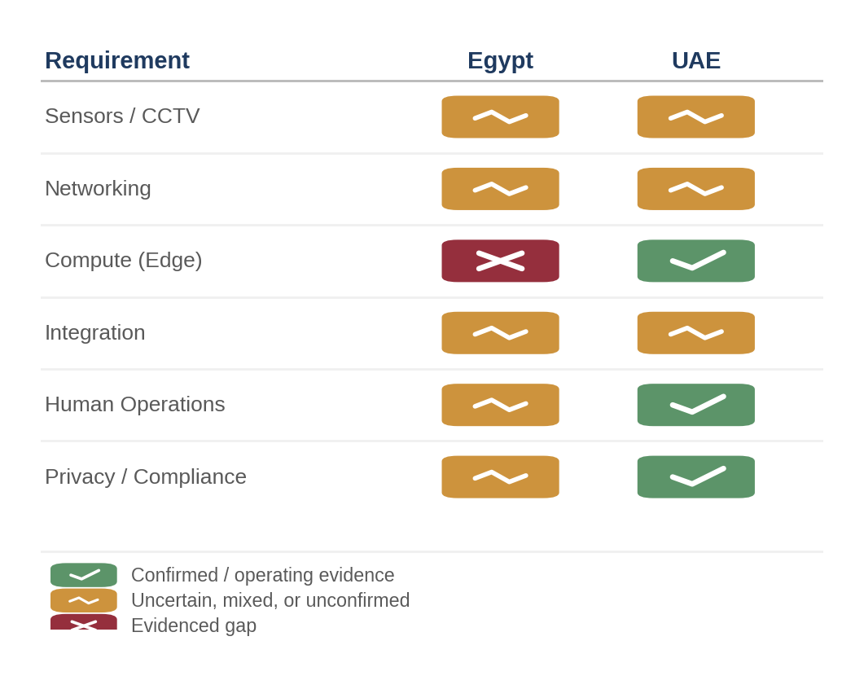
Figure 10. Egypt vs. UAE, side by side — a qualitative synthesis of Section 9's two compatibility tables (not an independently scored index).

10. Evidence Gaps & Uncertainties
Maintained here as an explicit register, consistent with the instruction to record unresolved questions rather than let them disappear into confident-sounding prose elsewhere in the report.

10.1 Do Egyptian/Gulf CCTV control-room operators actually experience continuity-of-observation as a frequent, costly failure — or has the region's centralized-control-room model already absorbed most of this problem operationally, even if imperfectly?
- Why it matters: This is the core premise of the entire project's value proposition; if operators do not perceive this as a live pain point, willingness to adopt a new, architecturally unfamiliar system drops sharply regardless of infrastructure readiness.
- Current evidence: None (desk research cannot answer this)
- Missing evidence: Direct interview data from control-room operators (Section 6 protocol)
- Validation method: Structured interviews per Section 6.3.2

10.2 What is the current legal status of autonomous ground robots (UGVs) — as distinct from aerial drones — operating in Egyptian public, commercial, or industrial spaces?
- Why it matters: The project's core deliverable is a UGV-based system; if no framework exists, deployment could face indefinite regulatory uncertainty rather than a defined, if slow, approval path (as exists for drones).
- Current evidence: Detailed UAV regulatory precedent (Section 8.4); no UGV-specific framework located
- Missing evidence: Direct confirmation from Egyptian Civil Aviation Authority, Ministry of Interior, or qualified local counsel
- Validation method: Legal consultation; potentially a direct regulatory inquiry

10.3 Does an edge-computing layer suitable for real-time multi-agent robotic coordination exist anywhere in the region today, even in a pilot form not covered by public market reports?
- Why it matters: The entire deployment-model analysis (Section 7.5) depends on this; if such infrastructure exists in an unreported pilot, the 'infrastructure gap' finding would need revision.
- Current evidence: Public data-center/5G market reports, all describing centralized or hyperscale capacity
- Missing evidence: Direct technical inquiry with regional telecom operators (Telecom Egypt, Etisalat, du) and DP World's technology partners
- Validation method: Vendor/operator technical briefings; not achievable through public search alone

10.4 What camera and sensor density actually exists inside SCZone factories and port yards specifically (as opposed to the well-documented New Capital flagship case)?
- Why it matters: SCZone is identified as one of the two strongest regional use cases, but its internal security infrastructure is essentially undocumented in public sources.
- Current evidence: General infrastructure marketing material (power/water/telecom) from SCZone's own promotional material
- Missing evidence: Site-level camera/sensor inventory
- Validation method: Direct site visit or interview with SCZone General Authority

10.5 How will Egypt's November 2025 visual-surveillance licensing regime actually be applied to a Re-ID/multi-camera-tracking system, as opposed to conventional single-camera CCTV?
- Why it matters: The regime is brand new (in force under a year at the time of this report) and untested; its practical scope for this specific technology category is unknown even to Egyptian compliance professionals writing about it in early 2026.
- Current evidence: The regulation's text and general legal commentary (Section 8.1)
- Missing evidence: A specific regulatory ruling, licensing precedent, or direct guidance from the Personal Data Protection Centre
- Validation method: Direct engagement with the Personal Data Protection Centre or specialized Egyptian technology counsel

10.6 What monitoring technology, if any, currently protects unmanned Egyptian critical infrastructure (power substations, pipeline sections)?
- Why it matters: This sector has the strongest theoretical fit (unmanned by design) of any sector examined, but is entirely undocumented in this research.
- Current evidence: None located
- Missing evidence: Basic sector description, let alone technology detail
- Validation method: Direct inquiry with the Ministry of Electricity and Renewable Energy or pipeline operators; likely requires security clearance

11. Real-World Validation Findings
Because no primary field research has been conducted, this section reports only what the evidence chain in Sections 2–9 actually supports, organized by the required Problem → Operational → Infrastructure → Stakeholder → Adoption → Remaining Uncertainty structure, for the two highest-priority use cases.

11.1 Egyptian industrial-zone / port use case
- Problem evidence: strong. Egypt's own flagship smart-city contract (New Capital ICCC) is explicitly designed around exactly this continuity-of-observation problem, and ports/industrial zones share the same non-overlapping-camera-zone structure by nature.
- Operational evidence: weak. No field data on how SCZone or Egyptian port operators currently handle target loss between camera zones.
- Infrastructure evidence: moderate. General power/telecom/network infrastructure is documented and improving quickly; camera density and edge-compute capacity specifically are not documented.
- Stakeholder evidence: absent. No interviews conducted.
- Adoption evidence: mixed. A new, specific licensing requirement (Nov 2025) is a documented adoption cost; a plausible non-state commercial buyer path (SCZone authority, private operators) is documented as existing but untested for this technology.
- Remaining uncertainty: substantial, concentrated in operator-level pain-point validation and site-level infrastructure detail (Section 10).

11.2 UAE port / logistics use case (Jebel Ali)
- Problem evidence: strong, and reinforced by the fact that DP World has already invested in autonomous solutions (AITVs, security boats) for adjacent problems at the same facility — indicating the operator already believes automation is worth paying for in this environment.
- Operational evidence: moderate. DP World's public statements describe automation as core to its operating strategy, but do not specifically describe continuity-of-tracking as a named pain point.
- Infrastructure evidence: moderate-to-strong relative to Egypt, given confirmed operating automated systems at the terminal, though specific edge-compute and network-quality data was not located.
- Stakeholder evidence: absent. No interviews conducted.
- Adoption evidence: favorable relative to other cases examined — an existing automation vendor relationship (DGWorld) suggests a plausible channel, and UAE's PDPL, while requiring a DPIA for high-risk processing, is a defined, navigable compliance process rather than a brand-new, untested regime.
- Remaining uncertainty: whether DP World's existing technology architecture is open to additional third-party systems, and whether its automation appetite extends to security/tracking specifically rather than only cargo-handling efficiency.
Both use cases show the same shape: real, evidence-supported problem existence; genuinely uncertain operational and stakeholder validation; and adoption pathways that are more clearly mapped in the UAE than in Egypt, despite Egypt having greater raw environmental scale. Neither conclusion should be read as final — both are contingent on the primary research proposed in Section 6.

12. Regional Synthesis

12.1 Regional opportunity map
The clearest evidence convergence in this study follows this chain for the two priority cases:
- Egypt / SCZone & ports → Industrial & logistics → Multi-tenant industrial zone / port yard → Continuity-of-observation across non-overlapping camera zones (evidenced by New Capital's own design brief, extrapolated to similar environments) → General infrastructure present, security-specific infrastructure undocumented → Stakeholder need unverified → New licensing regime as of Nov 2025 is a defined but untested constraint → Validation status: desk-research-supported, field-validation-pending.
- UAE / Jebel Ali → Port & logistics → Container terminal → Automation already proven valuable by the operator's own investment pattern → Infrastructure confirmed at the level of operating systems, though specific edge/network data is missing → Stakeholder need unverified but circumstantially supported → Established PDPL compliance pathway and existing automation-vendor relationship → Validation status: desk-research-supported, most field-ready of the cases examined.
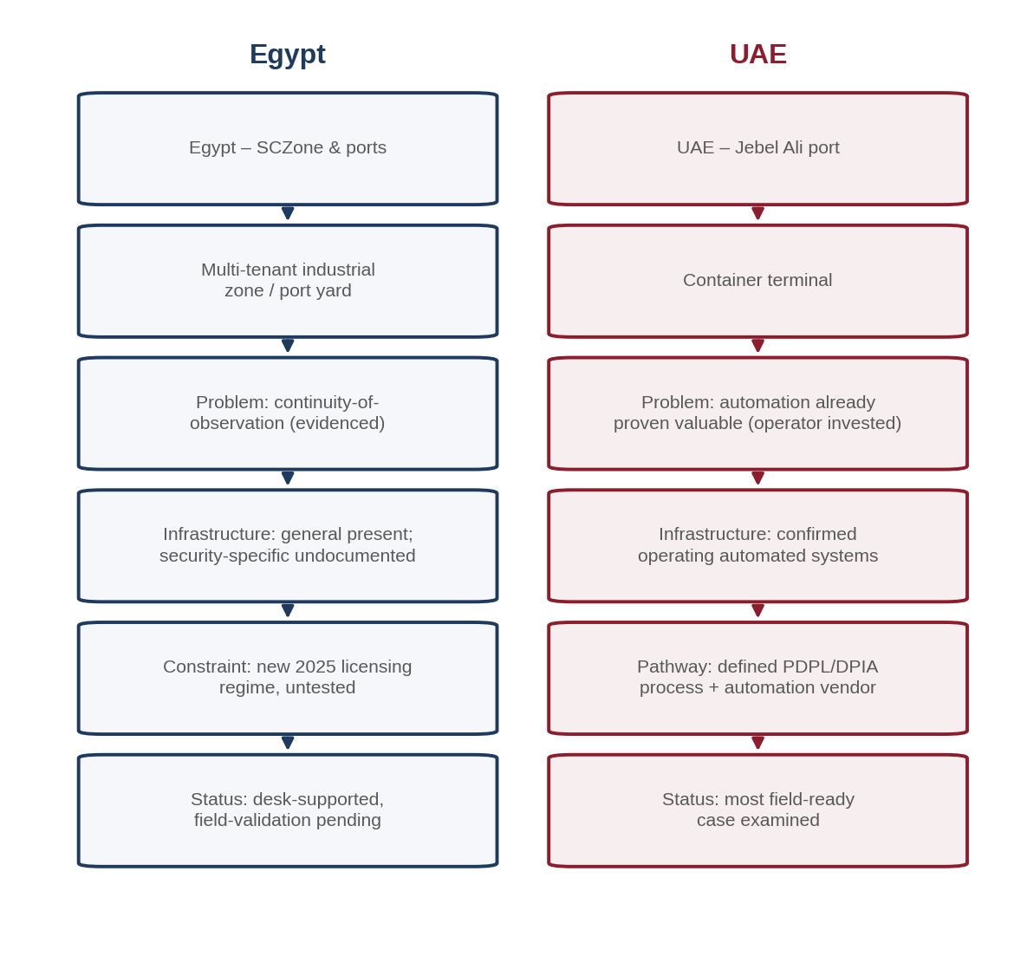
Figure 11. The two priority-case evidence chains, side by side.

12.2 What the evidence changes about the project's assumptions
- The problem is real and regionally grounded — this is not a case of a solution in search of a problem. Multiple governments and private operators have independently spent real, verifiable money (Honeywell's $31M New Capital contract, DP World's automation investment, Saudi Arabia's $780M+ surveillance market) trying to solve versions of exactly this continuity-of-observation problem.
- But the region's dominant existing answer is more centralization, not decentralization. Every well-evidenced deployment found in this research — Egypt's New Capital, the Ministry of Interior's SOC, Lusail's Control Center — doubles down on a single control room rather than moving toward distributed autonomous agents. The project's core architectural bet (decentralization, peer negotiation, minimized raw-video transmission) runs against the regional grain and will need to be explicitly justified to potential adopters, not assumed as an obviously superior upgrade.
- Infrastructure readiness and research readiness are not the same thing, and they are not concentrated in the same country. Egypt has the largest number of candidate physical environments; the UAE has the most directly relevant applied-research base (KUCARS, MBZUAI) and the only confirmed operating analogue system (Jebel Ali). A regional strategy built only around Egypt's raw scale, or only around Gulf capital availability, would each miss half of the picture.
- The single most concrete near-term constraint uncovered in this entire research pass is regulatory, not technical: Egypt's November 2025 visual-surveillance licensing requirement is new, applies specifically to this category of technology, and is entirely untested — which is both a genuine barrier and, potentially, an opportunity to help define regional norms early if approached deliberately.
- Ground-robot (UGV) legal status is an open question, not a solved one, in Egypt specifically. This is a genuine gap between what the project needs (clarity on where and how its physical robots can legally operate) and what currently exists in public Egyptian law.

12.3 What remains genuinely unresolved
This report has deliberately not converted its strongest circumstantial patterns into firm conclusions where primary evidence is missing. The single largest open question is whether the operators who would actually use this system — not the governments and companies that fund the surrounding infrastructure — experience the problem it solves as significant enough to justify adopting an unfamiliar, decentralized architecture. That question can only be answered in the field, using the protocol in Section 6, and every conclusion in this report about priority sectors and countries should be treated as provisional until that field validation occurs.

13. Sources
All sources consulted during this research, in the order referenced through the report. Web sources were accessed in searches conducted in early September 2026; publication dates, where shown by the publisher, are noted in-line throughout the report.
- Context / Thomson Reuters Foundation — "Egypt's new high-tech capital: Smart city or surveillance trap?" (Jan 2023) — context.news
- The Japan Times — "CCTV cameras will watch over Egyptians in new high-tech capital" (Jan 2023)
- Egyptian Streets — "City-Wide Security Cameras to Cover Egypt's New Capital" (Feb 2019)
- Ahram Online — "Egyptian ports' container traffic" and Egyptian airport traffic reporting (2026)
- ShipHub — "Seaports in Egypt – The Top 5 Container Ports" (2026)
- Egypt Tours Portal — Egypt ports and airports overviews (2024–2026)
- Wikipedia — Suez Canal Container Terminal; Cairo International Airport; Suez Canal Economic Zone; Tanger Med; Tangier Exportation Free Zone; National Security Sector; Ministry of Interior (Egypt); State Security Investigations Service; Egyptian Integrated Soldier System (various)
- CIA World Factbook (via theodora.com) — Egypt Transportation (2024)
- Egypt Ministry of Transport / mts.gov.eg — Egyptian Ports Capacity
- Daily News Egypt — Suez Canal Economic Zone investment and factory-count reporting (2025–2026)
- EgyptToday — SCZone factory reporting (2026)
- People's Daily Online — TEDA Suez cooperation zone reporting (Jan 2026)
- Propertyfinder.eg; Wikipedia (Nile University); AUC (Robotics, Control and Smart Systems MSc); Zewail City; GoToUniversity — Egyptian university profiles
- arXiv 2401.11617 — "The State of Computer Vision Research in Africa" (Egyptian co-authors: Al-Azhar University, German University in Cairo, Nile University)
- Futurism (vocal.media, citing IMARC Group) — Egypt Data Center Market Outlook (2026); Saudi Arabia video-surveillance, security, and smart-cities market reports; Qatar smart-cities market report (2026)
- Opensignal — "Egypt 5G Journey: Readiness, Launch, and Early Performance" (Jan 2026)
- NAOS Solutions — "Egyptians And Digital 2025 Report" (Apr 2025)
- The Middle East Observer — "The Internet Has a Physical Economy: Who Will Build Egypt's Next Digital Highway?" (Aug 2026)
- Omdia / Informa — "Egypt: Country Regulation Overview – 2025"
- DCD (datacenterdynamics.com) — News: Egypt (2024–2026)
- DC Market Insights — "Egypt Data Center Market Size, Growth and Forecast Report 2035"
- BusinessWire / ResearchAndMarkets — Egypt Data Center Market Investment Analysis (2024)
- Legal500 — "Overview of the Executive Regulations of the Egyptian Personal Data Protection Law" (2026)
- Shand Partners — "The Executive Regulations of the Data Protection Law in Egypt" (2026)
- Kennedys Law — "Egypt's Personal Data Protection Law – the compliance countdown has begun" (2026)
- ACC.com — Law No. 151 of 2020 (English translation excerpt)
- DLA Piper Data Protection Laws of the World — Egypt; Saudi Arabia; UAE
- CADE (Civil Society Alliances for Digital Empowerment) — Egypt data protection implementation reporting (2025)
- Record of Law — "Digital Privacy Rights in Egypt" (2026)
- Trade.gov Market Intelligence — Egypt Data Protection
- Clyde & Co — "Egypt regulatory update on data privacy" (Jan 2026); "Saudi Arabia's PDPL becomes enforceable" (2024)
- Lexology; Masaar — Egyptian drone/UAV legal analysis (2021–2022)
- UAV Systems International; drone-laws.com; Flying Glass; DroneSGator; Brussels Morning; TS2.tech — Egypt drone-law consumer/commercial guides (2025–2026)
- Swissmena — "New Regulations for the Use of Drones in Business in Egypt in 2026"
- Ken Research — Egypt E-Commerce Logistics Market; Egypt Smart Logistics and E-Commerce Warehousing Market (2025)
- Appicial — "How to Start a Logistics Business in Egypt" (2025)
- fwdstart.me; Disrupt Africa; LogUpdate Africa — Bosta reporting (2026)
- 3arabawy (Substack) — "Inside the Surveillance Apparatus" (Jan 2026)
- Rosa Luxemburg Stiftung — "Cairo's Panopticon 2.0" (Aug 2023)
- Privacy International — "State of Privacy: Egypt"
- Britannica — "Neom" (2026)
- Vision2030.ai encyclopedia — "NEOM: Saudi Arabia's Giga-Project Reality Check 2026"
- Arab Urban Development Institute — NEOM project overview
- Bayut Saudi Blog — "Robots in NEOM Projects" (2026)
- Malay Mail (AFP/SPA) — DataVolt–NEOM AI data center (Feb 2025)
- KAUST — Robotics research and Robotics Bay pages; DSA/CS/ECE/CEMSE/IVUL/AMCS/Mechatronics Computer Vision pages
- MBZUAI — Computer Vision Research Department
- arXiv (2606.23604) — "Polycepta: Object-Centric Appearance Estimation for Multi-Object Tracking" (Khalifa University / KUCARS co-authors)
- The National — "DP World launches autonomous security boats at UAE ports" (2021)
- Ship-Technology; Port Technology International; BusinessWire; Seatrade Maritime; Gulf News — DP World / DGWorld Jebel Ali AITV reporting (2020–2024)
- Robotics and Automation News — "The Desert Digitalises: How Dubai is Engineering a Global Hub for Robotics and Automation" (2026)
- UPPERSETUP (news.uppersetup.com) — "Artificial Intelligence in the UAE" (2025)
- Signzy; PECB; DataGuidance; SGC Consulting; VerifyWise; CMS Law; IAPP — Saudi PDPL/SDAIA compliance reporting (2024–2026)
- DataSpot Infra — "CCTV Analytics & Privacy UAE" (2026)
- IBA (International Bar Association) — "Data protection laws in the UAE: a closer look" (2026)
- Martin Kubler (Substack) — "Data Protection in the UAE: PDPL? PDPL!"
- Euronews — UAE surveillance-camera / COP28 reporting (2023)
- UAE Legislation portal (uaelegislation.gov.ae) — Federal Decree Law on Data Protection
- The Business Year — "Smart Cities & Qatar in 2025"
- Araburban.org (Arab Urban Development Institute) — Lusail City project page
- Futurism (via IMARC Group) — Qatar Smart Cities Market report (2026)
- Ministry of Transport and Communications, Qatar (motc.gov.qa) — Smart cities initiative
- Qatar Tribune — "Qatar builds a smarter, greener transport future" (2026)
- SmartCitiesWorld — "ST Engineering to provide smart city platform for Lusail City" (2024)
- Atech-tc.com — "System Integration: Powering Qatar's Smart Cities" (2025)
- Wikipedia — Lusail Tram
- Tanger Med Special Agency / Tanger Med Group — Industrial Clusters pages
- Renault Group — "Tangier factory, the industrial and logistics hub" (2026)
- TechBehemoths — "Top 10+ Robotics Companies in Morocco (2026)"
- Morocco World News — "UM6P, Tanger Med Launch AI Program" (2025)
- North Africa Smart Infrastructure Summit — Smart Ports & Logistics Transformation (conference program, 2026)
- The Cooperative Logistics Network (blog) — "Tanger Med Port: How Morocco Built Africa's Largest Logistics Hub" (2025)
- Biometric Update — Cairo International Airport ePassport gates (2015)
- M2SYS — Egypt airport biometric equipment
- Ahram Online — Cairo International Airport biometric equipment reporting
- Egyptian iVisa — Cairo Airport digital immigration rules (2025)
- Mairs Turnstile; Dolink Egypt; Hikvision-EG; Egypt Yellow Pages; itqanbs; EGITS; noon.com; ibcegypt.com — Egyptian security-hardware vendor listings (used only as evidence of an existing commercial CCTV/access-control vendor market, Section 2.5)
- Gulf News — "Cairo shops ordered to install security cameras" (archival)
- Model Diplomat — ITC-Egypt'2026 conference listing

Real-World Use Cases, Operational Value & Technology Adoption Analysis
A Decentralized Edge-AI Framework for Proactive Multi-Robot Target Handoff and Re-Identification

1. Executive Overview
This analysis examines where a decentralized, edge-AI multi-robot framework for proactive target handoff and re-identification could create genuine operational value, and what would have to be true for that value to materialize. The system under review distributes detection (YOLO), short-term tracking (DeepSORT), trajectory forecasting (Kalman-filter-based time-to-occlusion estimation), inter-node negotiation, and cross-node re-identification across edge nodes — fixed cameras in early deployment phases, mobile UGVs in later phases — connected by a lightweight MQTT metadata layer rather than a centralized video feed.
The strongest real-world fit is in large, multi-zone outdoor or semi-outdoor facilities where a moving target of interest must be followed across a site faster than a human operator can manually correlate footage, and where full fixed-camera coverage is either impractical or defeated by sightline obstructions. Distribution and logistics campuses, container terminals, and large open institutional campuses meet this description most directly. Airports and generic industrial-inspection settings are weaker or conditional fits, and search and rescue — despite appearing on the brief's own list of candidate environments — is the weakest fit of all: the system is built to preserve continuity of a target that has already been detected and is about to leave a covered zone, whereas SAR's central operational problem is usually initial detection across terrain with no existing sensor coverage.
Where the fit is strong, the plausible value is real but narrower than a “bandwidth efficiency” framing suggests on its own. Raw HD video runs roughly 2–4 Mbps per stream at 1920×1080/30fps under H.264 compression, while a JSON metadata payload carrying an identifier, an appearance embedding, and a short trajectory is on the order of a few kilobytes — a large, calculable reduction per handoff event, but one that only translates into economic or operational benefit where raw-video transmission was actually the bottleneck for that facility, which is not automatically true of a site already running on wired local infrastructure. The more defensible value driver is reacquisition time and operator workload, not bandwidth in isolation.
The underlying technology stack is unevenly mature. Edge inference, ROS 2/Nav2 navigation, and MQTT messaging are each commercially and operationally established on their own — Nav2 alone is reported in production use at over 300 companies. Cross-camera person and object re-identification, by contrast, remains a documented open research problem: published benchmarking work consistently shows accuracy dropping under real-world domain shift (illumination, viewpoint, clothing similarity, low resolution), even for state-of-the-art models. Multi-robot coordination for patrol and handoff specifically is even less settled: a frequently cited practical study found that tightly coordinated multi-robot patrol is often not practical in real deployments and is regularly matched or beaten by loosely coordinated or uncoordinated strategies — a direct caution against assuming the framework's negotiation logic automatically earns its complexity. In short: the individual building blocks are mature; their specific combination for live, proactive, appearance-based multi-agent handoff is not yet demonstrated at commercial scale.
Adoption is also constrained by factors outside the system's technical scope. Data protection regimes such as the EU GDPR treat data used to “uniquely identify” a person as special-category biometric data requiring a narrow legal basis; whether an appearance-based Re-ID embedding crosses that line is an open legal question rather than a resolved one — a materially different risk posture than an unqualified “zero visual data breaches” claim, which the project's own documentation has already revised toward a narrower “minimizes exposure of raw visual data” framing. A commercially available alternative also exists for the camera-coverage-rich version of this problem: VMS-integrated cross-camera re-identification products, already embedded in mainstream security platforms, deliver forensic and some real-time cross-camera person tracking for fixed-camera sites today — narrowing, without eliminating, the incremental case for a full decentralized multi-robot architecture wherever a facility could instead simply add more fixed cameras.

2–4 Mbps  Typical raw 1080p/30fps H.264 video stream | 300+  Companies running Nav2 in production | $35B  Est. annual U.S. cargo-theft losses (NICB) | $70–75K  Typical base price of a legged UGV unit

2. Real-World Use Cases and Use-Case Analysis
Each candidate environment below is assessed against the same causal chain — operational situation, existing problem, current approach, current limitation, system intervention, operational change, expected benefit — and is only carried forward as a serious candidate where the problem is real, material, and not already adequately solved by a simpler approach. Four environments are analyzed in full; three additional environments named in the source brief (airport, search and rescue, and generic industrial facility) are evaluated and found to be conditional or weak fits, with the reasoning given explicitly rather than omitted.
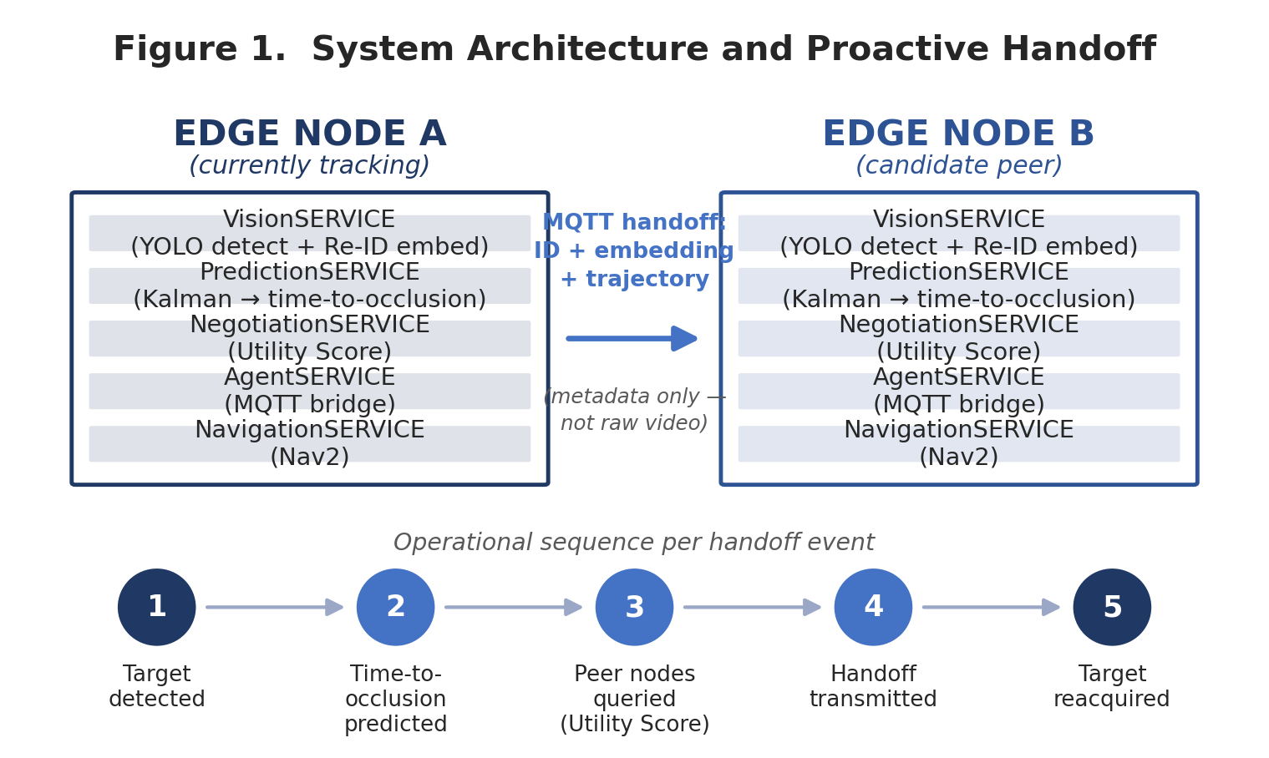

Use Case A — Distribution / Logistics Warehouse Campus
HIGH-VALUE CANDIDATE
Environment: A large distribution or logistics campus combining an indoor warehouse floor with an outdoor yard, loading docks, employee and truck parking, and perimeter fencing. Documented commercial deployments of a comparable scale include a 970,000-square-foot distribution center on roughly 19.5 acres (Knightscope, 2022).
Operational Situation: A person, vehicle, or piece of equipment (“target”) moves through the yard or between buildings — for example, an unescorted individual crossing from the parking lot toward a restricted dock area at night.
Actors: Existing patrol UGVs and/or fixed cameras at chokepoints (docks, gates), a remote or on-site security operations center (SOC), and a physical guard for dispatch where needed.
Objective: Maintain a continuous track of the target as it crosses zones with camera gaps, so the SOC or a responding unit can be directed instead of manually reconstructing the target's path after the fact.
Problem: Cargo theft and after-hours intrusion carry a documented cost: the National Insurance Crime Bureau's widely cited estimate puts annual U.S. cargo-theft losses at roughly $35 billion (cited in Knightscope, 2022). Existing systems generate disconnected per-camera clips; when a target crosses an uncovered zone, continuity is lost, and an operator must manually re-identify the same person later, often failing to do so at night.
Current Approach: Fixed CCTV managed through a VMS (e.g., Genetec, Milestone), frequently paired with a bolt-on analytics layer offering cross-camera face re-identification and forensic search (BriefCam, integrated with both platforms), plus, at a growing number of sites, independently patrolling autonomous security robots (Knightscope K1/K5) that record and alert but do not coordinate live handoffs with each other.
Current Limitation: Commercial cross-camera Re-ID products are built for centralized, largely forensic search over recorded footage from fixed cameras with reasonable overlap, and rely on facial recognition, which degrades at typical yard distances and lighting and introduces separate legal exposure under biometric-specific statutes (e.g., Illinois BIPA). Existing patrol robots operate as independent sensors reporting to a human rather than a coordinating fleet; genuine camera gaps (yard perimeters, inter-building corridors) have no live continuity at all today.
System Role: The PredictionSERVICE estimates time-to-occlusion for the node currently tracking the target; the NegotiationSERVICE queries peer nodes for a Utility Score (distance, line-of-sight probability, interception time) and hands off a compact Re-ID embedding and trajectory — not raw video — before the target leaves the current field of view; the receiving node matches the embedding using appearance rather than facial geometry.
Operational Improvement: Live, proactive handoff replaces after-the-fact manual correlation; the SOC receives a continuous track instead of disconnected alerts it must interpret itself; a UGV can be actively vectored to intercept rather than merely logging a passerby.
Expected Benefit: Faster reacquisition after a target leaves a node's field of view (the brief's own primary metric), fewer operator interventions to manually re-associate footage, and — because the approach is appearance-based rather than facial — potentially lower direct biometric-statute exposure than face-recognition-based alternatives (see Section 16), though this legal advantage is plausible rather than settled.
Preconditions: Sufficiently dense edge-node placement that gaps are measured in seconds rather than minutes; reliable local wireless coverage across the yard for MQTT traffic; UGVs rated for outdoor, uneven-terrain navigation (Nav2 is commercially mature for this, though off-road ruggedness is platform-, not framework-, dependent); night-time image quality adequate for reliable detection and embedding extraction — exactly the condition under which Re-ID benchmarks show their largest accuracy loss.
Failure / Risk: Illumination and viewpoint change are among the most consistently cited causes of Re-ID domain-shift failure; a mismatch here can produce either a missed handoff (target lost) or a false-positive handoff (a UGV vectored toward the wrong individual while the real target goes unmonitored). If a facility's actual inter-zone walking gaps run several minutes rather than seconds, the target may exit the operational area entirely before any peer node can respond, making the negotiation logic largely moot.

Use Case B — Port / Container Terminal Yard
CONDITIONAL — INFRASTRUCTURE-DEPENDENT
Environment: A container terminal or bulk-cargo port yard: a large paved or gravel outdoor area with container stacks several units high, perimeter fencing, vehicle gates, and quay cranes.
Operational Situation: An unauthorized vehicle, stowaway, or person deviates from a designated route inside the secured yard, repeatedly disappearing behind container stacks as it moves.
Actors: Fixed cameras at gates and main lanes, patrol UGVs where deployed, the terminal security operations center, and port authority or customs where an event is confirmed.
Objective: Maintain a continuous track of an anomalous target through a yard whose sightlines change dynamically as stacking operations proceed — unlike a warehouse, where camera gaps are mostly fixed by building geometry.
Problem: Ports are large (often hundreds of acres), operate continuously, and container stacking defeats static camera planning: a camera positioned to cover one aisle can be blocked within hours by a newly stacked row. This analysis did not independently verify current port-specific security-incident rates and flags that as an evidence gap (Section 20).
Current Approach: Fixed CCTV at chokepoints supplemented by patrol guards or vehicles and, at some advanced terminals, patrol UGVs or drones; cross-camera correlation is manual or performed after the fact through VMS forensic search.
Current Limitation: Because container stacking is itself operational and constantly changing, a camera plan adequate last week may have new blind spots today — a structural limitation of the environment, not merely a coverage-density problem that more fixed cameras alone would solve.
System Role: Because the framework assumes camera gaps rather than full coverage, and treats UGVs and fixed cameras as interchangeable edge nodes, it is structurally suited to an environment where blind spots move: a UGV that loses the target behind a stack can negotiate a handoff to whichever peer node currently has the best predicted line of sight, rather than requiring the yard to be re-surveyed each time stacking changes.
Operational Improvement: Converts a recurring camera re-planning problem into a routing problem — negotiate the best-positioned current node rather than adding cameras after each newly discovered gap.
Expected Benefit: Faster reacquisition after a target passes behind a stack (directly meaningful here); potentially lower cumulative fixed-camera capital expenditure for equivalent effective coverage — a calculated, not measured, benefit (Section 20).
Preconditions: Reliable outdoor wireless coverage across a yard containing large steel container stacks, which are a well-known source of RF multipath and shadowing — an infrastructure precondition this analysis flags as uncertain rather than assumed; ruggedized UGVs rated for port conditions (dust, weather, heavy vehicle traffic); a Re-ID model trained and validated on the port's specific appearance domain (high-visibility workwear, trucks, containers) rather than the pedestrian-surveillance benchmarks most Re-ID research uses.
Failure / Risk: Steel container stacks plausibly cause both the visual occlusion the system is designed to address and RF interference with the wireless mesh the system's own communication layer depends on — a risk specific to this environment. If the wireless layer degrades precisely in the densest, most occlusion-prone parts of the yard, the NegotiationSERVICE cannot function where it is needed most.

Use Case C — University or Corporate Campus, After-Hours Security
HIGH-VALUE CANDIDATE
Environment: A large, open, mixed indoor/outdoor campus with multiple buildings, walkways, and parking structures, typically with partial camera coverage in older buildings or along outdoor pathways.
Operational Situation: A person of interest — an intruder, a banned individual, or someone in crisis — is observed on one camera and must be tracked across campus toward another building, often at night when image quality and lighting are poor.
Actors: The campus SOC, existing fixed CCTV, campus safety patrol officers, and, at a growing number of institutions, patrol robots (e.g., a Knightscope K5 deployed on a Florida school campus, 2022); wellness or disability services where the situation involves a person in crisis rather than a security threat.
Objective: Give a small night-shift SOC — often one or two operators watching dozens of feeds — a continuous, low-effort track of a subject of interest rather than requiring manual comparison across cameras.
Problem: A single operator cannot reliably watch dozens of feeds and mentally re-associate a person across cameras separated by unmonitored walkway stretches — a workload and attention problem, not an absence of cameras.
Current Approach: Fixed CCTV reviewed live or after the fact by human operators, with growing but still limited use of patrol robots that operate as independent, camera-equipped units reporting to a human rather than a coordinating fleet.
Current Limitation: No public evidence was found of a live, coordinated, negotiated handoff approach deployed at any campus today; existing patrol robots do not hand off targets to each other or to fixed cameras, leaving the operator as the sole point of continuity — the exact bottleneck the system targets, though this specific solution to it remains unproven in this setting.
System Role: Automated appearance-based handoff between fixed cameras and any patrol UGVs present, surfacing one continuous track to the operator instead of a set of disconnected clips.
Operational Improvement: Shifts the operator's task from actively re-identifying a person across every camera to supervising and confirming a system-proposed track — plausible workload reduction, but only if the new supervisory task (validating handoffs) is smaller than the task it replaces (see Operator Workload Analysis, Section 10).
Expected Benefit: Reduced time-to-locate for a subject of interest; fewer missed detections during unmonitored gaps between buildings; a plausible reduction in the number of feeds one operator must actively watch simultaneously.
Preconditions: Campus wireless coverage adequate for MQTT traffic across outdoor walkways — nontrivial for older campuses; administrative and legal clearance for appearance-based tracking, including state biometric statutes such as Illinois BIPA, which this analysis does not resolve; night-time image quality sufficient for reliable Re-ID.
Failure / Risk: Re-ID accuracy is documented to degrade under low light and viewpoint change — precisely the conditions of a night-time campus incident — making night-time reliability the single most important open question for this use case. Campus security procurement also tends to be risk-averse (see Adoption Barriers), and is unlikely to accept an unvalidated Re-ID pipeline for safety-relevant tracking without extensive on-site testing.

Use Case D — Critical-Infrastructure Perimeter (substations, solar farms, water treatment, data-center campuses)
CONDITIONAL — WEAKEST READINESS
Environment: Large fenced perimeters, often remote, with intermittent or no continuous human presence.
Operational Situation: An intrusion or anomalous movement occurs along a long perimeter where fixed-camera density is limited by cost and, frequently, by the absence of grid power or connectivity at every point along the fence line.
Actors: A remote monitoring center, facility operations staff, and, where applicable, a sector-specific regulator (e.g., power-grid security frameworks in the relevant jurisdiction).
Objective: Detect and maintain track of an intruder along a perimeter too long to fully instrument with fixed cameras.
Problem: The structural logic mirrors the warehouse case — non-overlapping camera zones are common because remote perimeters are long and fixed-camera density is cost-constrained — but is compounded by a frequent lack of power and connectivity at every pole.
Current Approach: Sparse fixed cameras at key points, motion sensors, and periodic human patrol; gaps between sensors are effectively unmonitored.
Current Limitation: The same structural gap as the warehouse case, worsened by remoteness: adding more fixed cameras is often infeasible where power and backhaul are themselves unavailable.
System Role: A UGV or a small set of edge nodes could, in principle, extend coverage along the gap using the same negotiated-handoff mechanism described for Use Case A.
Operational Improvement: Would convert an instrumentation problem (no power/connectivity for more fixed sensors) into a mobile-coverage problem — but only where the UGV itself has adequate power and connectivity, which is the same limiting resource.
Expected Benefit: Potentially meaningful improvement in detection continuity along an otherwise unmonitored gap — a theoretical benefit not evidenced by any located deployment.
Preconditions: Reliable site connectivity and power for both fixed and mobile nodes (often the very resource the site lacks); in many jurisdictions, sector-specific security certification and regulatory approval before any new monitoring technology can be deployed on regulated critical infrastructure.
Failure / Risk: This is the use case where the two preconditions it needs most — reliable connectivity and a fast regulatory approval path — are the two most likely to be absent at a genuinely remote, regulated site.

Use Cases Evaluated and Downgraded
The source brief names three further candidate environments explicitly. Each was evaluated against the same causal chain and found to be a weaker fit than the four cases above; the reasoning is given rather than the cases simply omitted.

Airport (airside / landside)
CONDITIONAL — WEAK NEAR TERM
The core operational problem — tracking anomalous movement across a large secured area with coverage gaps — exists at airports too. However, airports already carry some of the densest fixed-CCTV and access-control infrastructure of any candidate environment, a well-documented feature of post-9/11 aviation-security regulation generally, though this analysis did not verify current per-airport camera-density figures. Security-critical infrastructure in this category typically requires lengthy vendor vetting and certification before any new monitoring technology is approved — a general and well-documented pattern in regulated critical-infrastructure procurement, not independently verified here for airports specifically — that a research-stage decentralized robotics framework is unlikely to clear in the near term. Verdict: plausible long-run fit, but it fails the Deployment Plausibility test in the near term, independent of the technology's own readiness.

Search and Rescue
WEAK — MECHANIC MISMATCH
This is the clearest mismatch. The system's entire mechanic — predict time-to-occlusion for a target currently in view, then negotiate a handoff to a peer node before the target leaves — assumes the target has already been detected and is moving through a zone with at least partial existing sensor coverage. SAR's central operational problem is usually the opposite: an unknown-location target, often stationary or moving unpredictably, in terrain with no existing camera or edge-node coverage at all, where the primary need is search coverage, not continuity of an existing track. Where the system's individual components could still help — for instance, if SAR robots are already deployed in a search grid and DeepSORT/Re-ID prevents double-counting the same person across robots — this is a narrow sub-case of a much larger SAR problem, not the flagship application the brief's own environment list implies. Verdict: weak fit; the system's core differentiator is largely irrelevant to SAR's actual bottleneck.

Industrial Facility (generic framing)
WEAK / REDUNDANT
If “industrial facility” means equipment or asset inspection — the dominant real-world use of industrial UGVs today, per the documented Nav2 deployments in power-plant and similar settings — the framework's core capability (re-identifying and handing off a moving target) is simply not exercised; inspection robots follow fixed routes and report on stationary equipment, not moving people or vehicles. If “industrial facility” instead means intrusion or security monitoring at a large industrial site, it collapses into the same structural case as the warehouse and critical-infrastructure use cases above and should not be counted as a distinct application. Verdict: weak or redundant as a separate use case.

3. Use-Case Comparison
Qualitative labels below are grounded in the evidence and reasoning presented in Section 2; where no direct evidence was located, the cell is marked accordingly rather than assigned an unsupported score.
Use Case | Problem Severity | Op. Frequency | Current Limitation | System Fit | Expected Value | Deploy Difficulty | Key Dependency | Evidence Confidence
Warehouse / logistics yard | Mod–High (documented cargo-theft cost) | Continuous site, intermittent incidents | Manual correlation; non-coordinating patrol robots | Strong | Moderate | Moderate | Wireless coverage; night Re-ID | Moderate
Port / container yard | Moderate (not independently verified) | Continuous | Static camera plans defeated by shifting stacks | Strong (structural) | Mod–High if wireless holds | High | RF-resilient mesh among steel stacks | Low–Moderate
Campus security | Moderate (safety-critical, lower frequency) | Low–Moderate | Single small operator team; disconnected feeds | Mod–Strong | Moderate | Moderate | Night Re-ID accuracy; legal clearance | Moderate
Critical-infra perimeter | High (regulated infrastructure) | Low (rare intrusions, continuous exposure) | Sparse cameras; remote power/connectivity | Strong (structural) | Potentially high, conditional | High | Site power/connectivity; certification | Low (analogical only)
Airport airside/landside | High | Low-incident, high-consequence | Marginal — already camera-dense | Moderate | Low–Moderate near term | Very High | Regulatory approval pathway | Low
Search & rescue | High (life-safety) | Rare / episodic | Wide-area initial detection, not continuity | Weak (mechanic mismatch) | Low, as specified | High (unstructured terrain) | N/A — problem mismatch | Moderate (reasoned judgment)
Industrial facility (generic) | Depends on framing | N/A | N/A | Weak / redundant | Low as distinct case | N/A | N/A | N/A (definitional)

4. Use-Case Prioritization
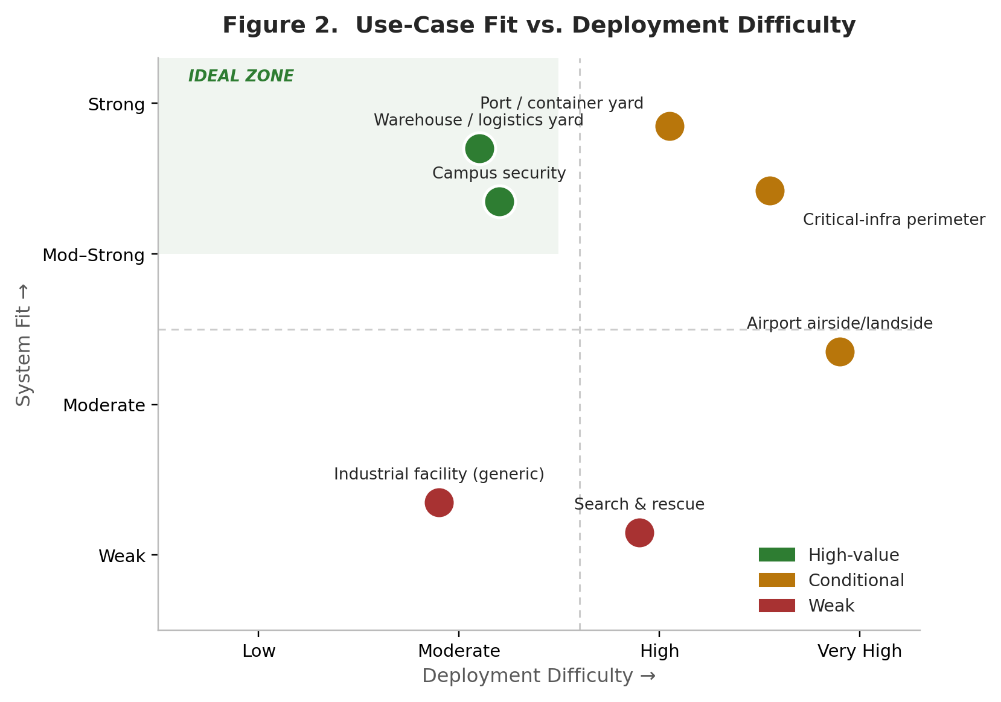

High-Value Use Cases
- Distribution / logistics warehouse yard — real, costed problem; strong structural system fit; moderate deployment difficulty; the weakest link is night-time Re-ID accuracy, which is testable before full commitment.
- University or corporate campus security — real workload problem with existing patrol-robot precedent; the coordinated-handoff element itself is unproven, but the underlying need is well evidenced.

Conditional Use Cases
- Port / container terminal yard — the strongest structural fit of any case (fixed cameras structurally cannot solve a moving-occlusion problem), but conditional on wireless resilience among steel stacks, which this analysis could not verify.
- Critical-infrastructure perimeter — strong structural logic, but conditional on the two resources (connectivity, regulatory approval) most likely to be scarce at a genuinely remote, regulated site.
- Airport airside/landside — plausible long-run fit, blocked in the near term by certification and vendor-vetting timelines rather than by the technology itself.

Weak Use Cases
- Search and rescue — the system's core mechanic does not address SAR's actual bottleneck (initial wide-area detection); listed on the original candidate list but does not survive the System Fit test.
- Generic industrial facility — either off-target (equipment inspection) or a restatement of the warehouse/perimeter case (security framing); not a distinct application.

5. Alternative-Solution Check
For the two high-value use cases, the operative question is whether the same operational outcome could be achieved more simply.
Additional fixed cameras: for a warehouse or campus with a fixed building layout — unlike the port case, where the occlusion pattern itself changes — simply adding fixed cameras to close coverage gaps is a well-understood, lower-complexity alternative that many facilities already partially pursue. Fixed cameras require no navigation stack, do not run out of battery, and introduce no moving-robot safety consideration. The marginal cost of an additional networked camera and cable run is typically far below the cost of an added UGV node; industry pricing estimates place a base legged UGV platform (Boston Dynamics Spot-class) at roughly $70,000–$75,000 per unit before payloads, a materially different capital profile than a camera.
Centralized processing via existing VMS analytics: BriefCam's cross-camera face re-identification, already embedded in Genetec Security Center and Milestone XProtect, addresses much of the “who is this person, where did they go” problem for fixed-camera sites today, without a decentralized negotiation protocol or mobile robots. Where a site's camera coverage is already reasonably dense, this existing commercial product is a lower-complexity substitute for the framework's fixed-node handoff function.
Human operators / simpler robotics: the Agmon-Stone finding that uncoordinated or loosely coordinated multi-robot patrol regularly matches tightly coordinated patrol in practice suggests it is worth testing whether a second human operator, or a simpler alert-only patrol robot with no inter-robot negotiation, achieves a comparable outcome before investing in the full Utility-Score negotiation logic.
Conclusion: for the warehouse and campus cases, a materially simpler alternative — more fixed cameras plus an existing VMS analytics layer — plausibly delivers a similar operational outcome wherever the coverage gap is fixed and plannable (building geometry does not change). The decentralized multi-robot approach's genuine incremental advantage concentrates in environments where the gap itself is dynamic and cannot be closed by adding fixed cameras — which points back to the port and critical-infrastructure cases as the settings where the added complexity is most defensible, even though those are also the settings with the weakest direct deployment evidence.

6. Economic / Operational Value
The framework's plausible value concentrates in four operational dimensions: network load per handoff event, reacquisition time after occlusion, operator workload, and coverage continuity across structurally gapped zones. Each is examined below with the evidence available; figures are labeled as measured, calculated from documented assumptions, or theoretical, per the evidence standard this analysis follows.

Value Chain Analysis

Chain 1 — Local processing
Edge inference at each node → only compact metadata (identifier, embedding, trajectory) needs to leave a node, not raw video → lower per-handoff network load compared with continuous raw-stream transmission → a potential reduction in bandwidth or infrastructure requirement, but only where raw-video transmission was the actual bottleneck for that site (see Baseline vs. Improved State, below).

Chain 2 — Proactive time-to-occlusion prediction
Forecasting occlusion before it happens → handoff negotiation begins before the target is actually lost → a shorter gap between the target leaving one node's view and being reacquired by another → faster reacquisition and reduced continuity loss, provided the negotiation completes before the target also leaves the receiving node's field of view — a timing race this analysis found no sizing evidence for in the source documentation.

Chain 3 — Appearance-based re-identification
Matching by appearance rather than facial geometry → cross-camera identity matching without transmitting or storing biometric-grade facial templates → lower direct exposure to face-recognition-specific statutes (e.g., Illinois BIPA, which specifically targets facial geometry) → a plausible reduction in legal and compliance risk relative to face-recognition-based competitors — though this is a claim for legal counsel to verify, since GDPR's broader “unique identification” test may still capture a sufficiently distinctive appearance embedding as biometric data. This analysis treats the compliance advantage as plausible, not settled.
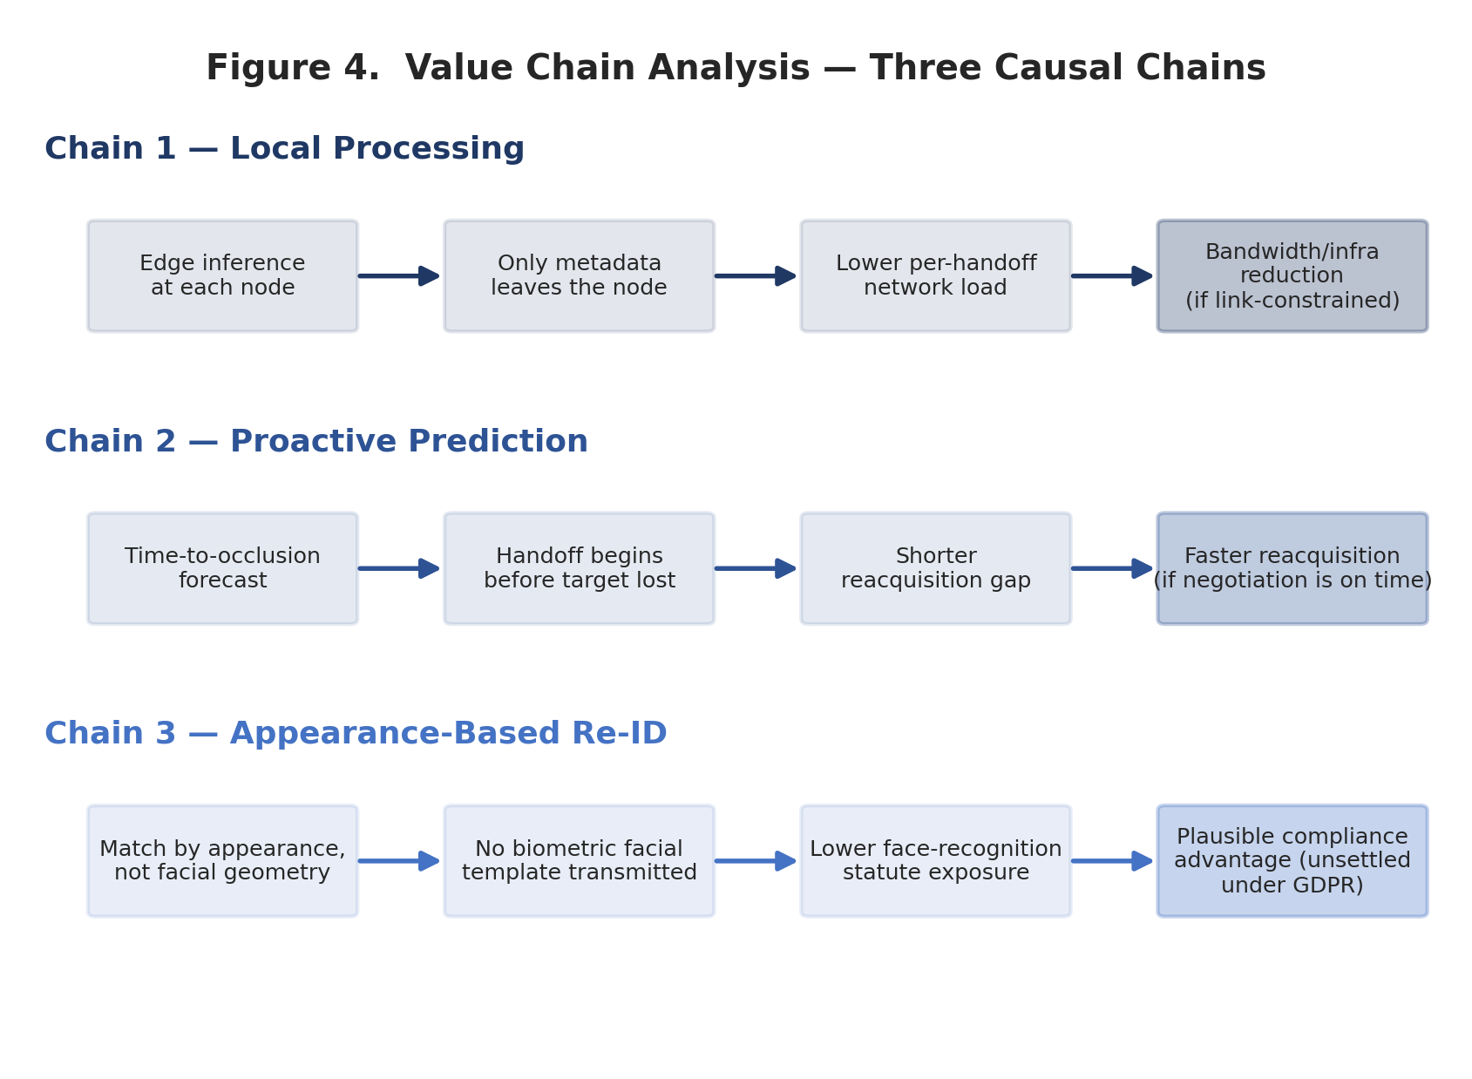

Baseline vs. Improved State
Dimension | Baseline (current approach) | System State | Measurable Difference | Operational Meaning
Network load per target-crossing event | Full raw video stream continues regardless of target activity (≈ 2–4 Mbps per 1080p/30fps H.264 stream) | A compact JSON payload (ID, embedding, trajectory) is sent at the handoff moment | Calculated: several orders of magnitude smaller payload per handoff event — not a claim about total site network load | Meaningful mainly where the inter-node link is itself bandwidth-constrained (wireless mesh, cellular backhaul); less decision-relevant on an already-adequate wired LAN
Continuity across a camera gap | Manual: an operator notices the same person minutes later on a different feed, if at all | Automated: a handoff is attempted before occlusion, based on predicted time-to-occlusion | Theoretical / calculated only — no field measurement of this architecture was located | Value depends entirely on Re-ID accuracy under the site's actual lighting and viewpoint conditions, which cannot be quantified without an on-site pilot
Operator task | Actively watch and compare multiple live feeds | Supervise and confirm a system-proposed track | Qualitative shift; not directly measured | Do not assume automation removes workload outright — supervising an imperfect system is a real, nonzero task (see Operator Workload Analysis)

Operator Workload Analysis
- Currently manual: continuous feed-watching and manual cross-camera correlation of the same individual over time.
- Failures requiring human intervention: a missed or incorrect handoff (wrong-person match) requires a human to notice and correct it — and given documented Re-ID domain-shift failure patterns, this is not a rare edge case in uncontrolled lighting.
- New responsibilities created by automation: someone must monitor the system's own handoff decisions, particularly early in deployment — a new task, not simply a subtraction from an old one.
- Conclusion: “more automation = less workload” should be treated as unproven until measured on-site; the more defensible claim is a shift in the nature of the task, not an unconditional reduction in it.

Bandwidth, Latency, and Continuity Analysis
Bandwidth: documented bitrate tables put a 1920×1080/30fps H.264 stream at roughly 2–4 Mbps depending on quality setting, versus a metadata payload of a few kilobytes per handoff — a calculated, order-of-magnitude difference, not a measured result from this system. Its operational significance depends on whether the deploying site's actual network link is bandwidth-constrained in the first place.
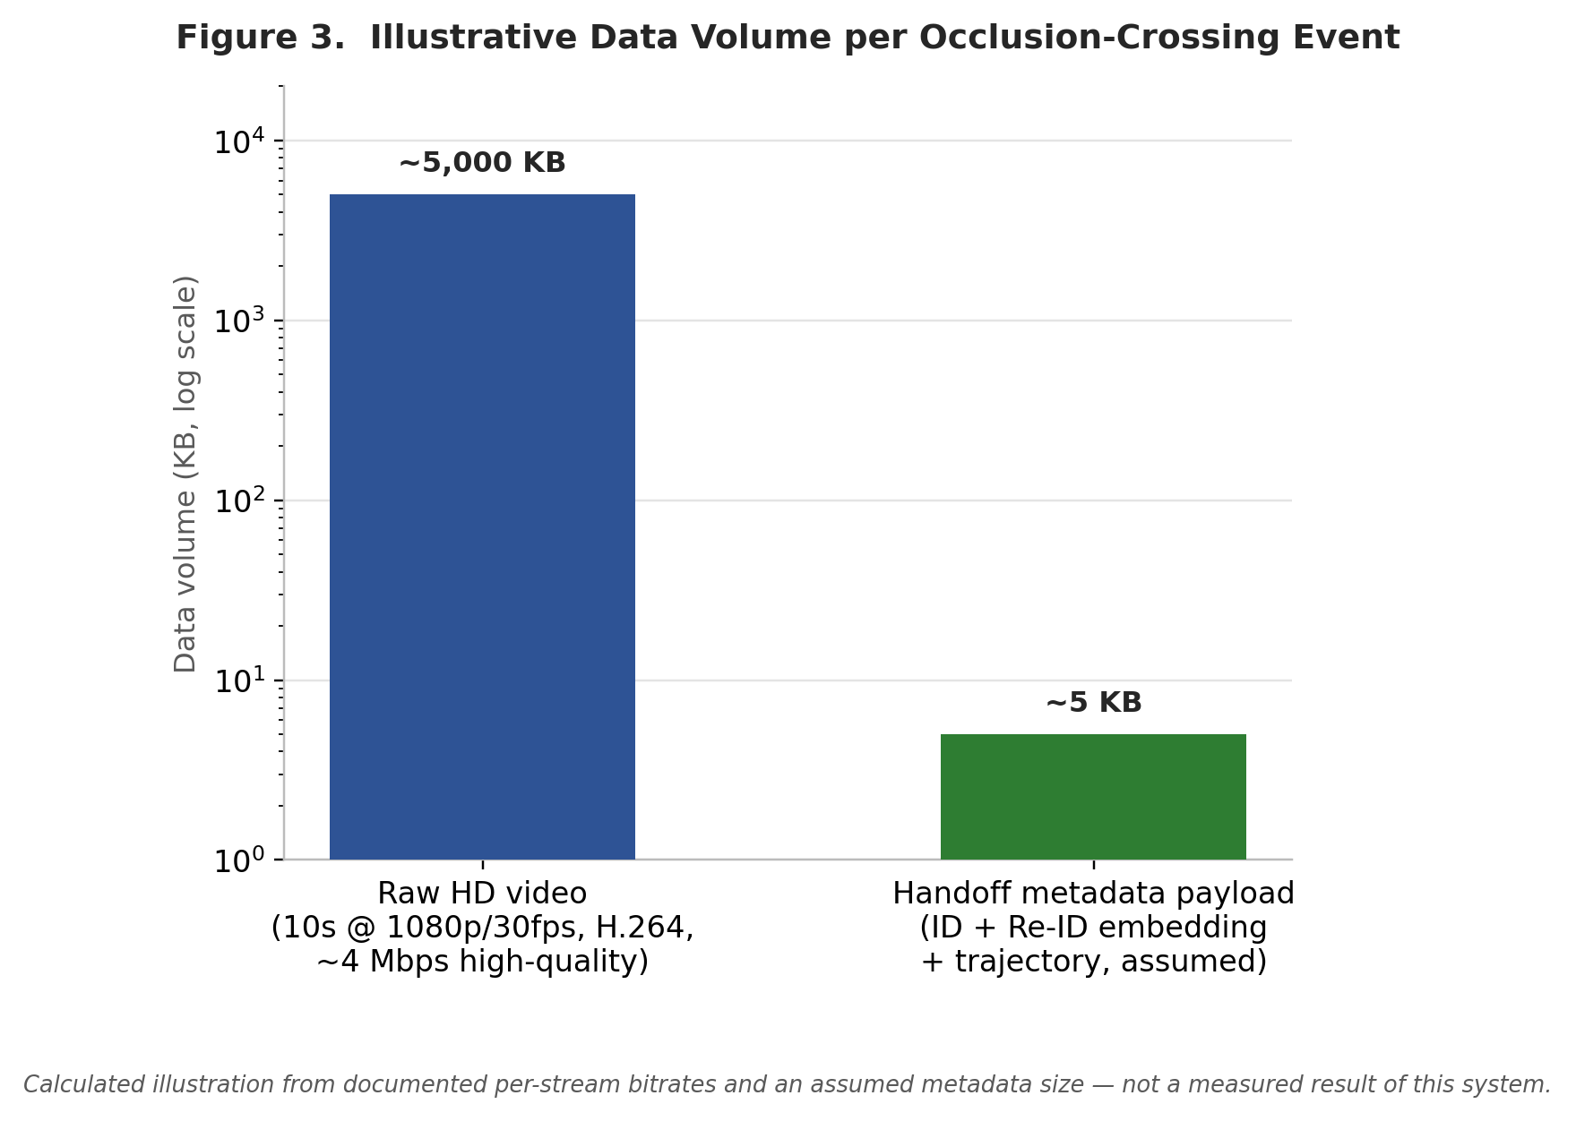
Latency: end-to-end latency runs from sensing through transmission, processing, decision, coordination, and handoff/reacquisition. The system's realistic influence concentrates in transmission (a small MQTT payload should move quickly under normal load — one academic model reports message queueing delay in the single-digit milliseconds under light load) and coordination (proactive rather than reactive negotiation). Sensing and processing latency are bounded by the underlying YOLO/DeepSORT pipeline and camera frame rate, which the system does not change. Critically, MQTT performance is documented to degrade materially as the number of concurrent clients grows — one empirical study found a 100-byte payload took roughly 61% longer to deliver on a 150-client network than a 50-client network — a real risk that a facility with many simultaneous edge nodes could see negotiation latency grow non-linearly, undermining the exact “before occlusion” timing budget the handoff mechanism depends on.
Continuity and recovery: identity continuity improves the operational objective only if Re-ID accuracy is high enough that false handoffs remain rare; faster handoff only matters where the target would otherwise genuinely be lost — i.e., in real non-overlap gaps, which the Alternative-Solution Check above suggests can sometimes be closed more simply by adding fixed cameras instead.

7. Value-to-Complexity Analysis
The central question is whether the value created is large enough to justify the technical and operational complexity required: five distinct services per node (Vision, Prediction, Negotiation, Agent, Navigation), a live wireless mesh, per-node UGV hardware cost, site-specific Re-ID validation, ongoing supervision of handoff accuracy, and multi-service software maintenance.
For fixed-camera-friendly environments with static building geometry — a typical warehouse or campus with an adequate camera budget — the value-to-complexity ratio is questionable: the Alternative-Solution Check suggests a simpler fixed-camera-plus-VMS-analytics approach may deliver comparable value at materially lower complexity. For environments where fixed cameras structurally cannot solve the problem — container yards with shifting occlusion, remote perimeters without power or connectivity for more sensors — the added complexity is more clearly justified because the simpler alternative does not exist. These are also, however, the environments with the least direct deployment evidence and the highest infrastructure risk, so the case remains conditional rather than proven.
The Agmon-Stone finding — tight coordination often impractical, loose or uncoordinated strategies frequently competitive — is a direct, specific caution against assuming the NegotiationSERVICE's full Utility-Score-based coordination automatically outperforms a simpler “nearest available node” or “broadcast, first responder” rule. This is precisely the kind of complexity the value-to-complexity test should require the project to justify empirically — for example, by benchmarking the negotiated approach against a simple baseline on the same test data — rather than assume by design.

8. Technology Adoption Landscape
This section evaluates whether the external technology ecosystem is moving toward conditions that support deployment of this category of system, and separates technological direction from actual adoption readiness — a distinction the evidence below shows is not the same thing.

Technology Maturity
Technology | Maturity | Real-World Deployment | Reliability / Integration Notes
Edge AI / on-device inference (vision) | Commercially established | Widespread for industrial visual inspection and mobile inference; described across 2026 industry commentary as the default pattern for latency-, privacy-, and connectivity-sensitive workloads | Generally reliable for well-scoped detection tasks; established frameworks (TensorRT, ONNX Runtime, TFLite) lower integration difficulty
ROS 2 / Nav2 navigation | Operationally mature | Open Navigation reports over 300 companies in production across warehouses, hospitals, hotels, agriculture, maritime, oil & gas, construction, and logistics; an earlier AWS RoboMaker demonstration logged 37 miles over 24 hours without a navigation failure | High for structured and semi-structured navigation; off-road ruggedness is a platform, not a Nav2, limitation; large, well-documented community
MQTT messaging | Operationally mature | Ubiquitous in industrial IoT; decades-old standard with defined QoS guarantees | High under normal load (single-digit-millisecond broker queueing reported in one 2023 study); documented latency growth as concurrent client count rises — relevant at scale
Appearance-based re-identification (cross-agent) | Technically established (research); not operationally mature | Commercial cross-camera Re-ID exists (BriefCam) but is face-based, on fixed cameras, in VMS platforms — not appearance-only, cross-robot re-ID as specified here | Multiple 2025 studies document accuracy loss under illumination, viewpoint, and resolution domain shift even for state-of-the-art models; requires site-specific validation
Multi-robot coordination for patrol/handoff | Emerging — minimal commercial deployment | No verified commercial deployment of live, negotiated, proactive inter-robot target handoff was located; commercial patrol robots (Knightscope, BOW) operate largely as independent units | A frequently cited 2012 field study (and subsequent literature) found tight coordination often impractical versus looser strategies; unproven at operational scale for this specific application
Collaborative / distributed perception (general) | Emerging (most mature in V2X) | Primarily research and autonomous-vehicle pilot programs; active 2024–2025 survey and dataset literature indicates a still-forming field | Communication-constraint sensitivity is an openly documented challenge across the surveyed literature

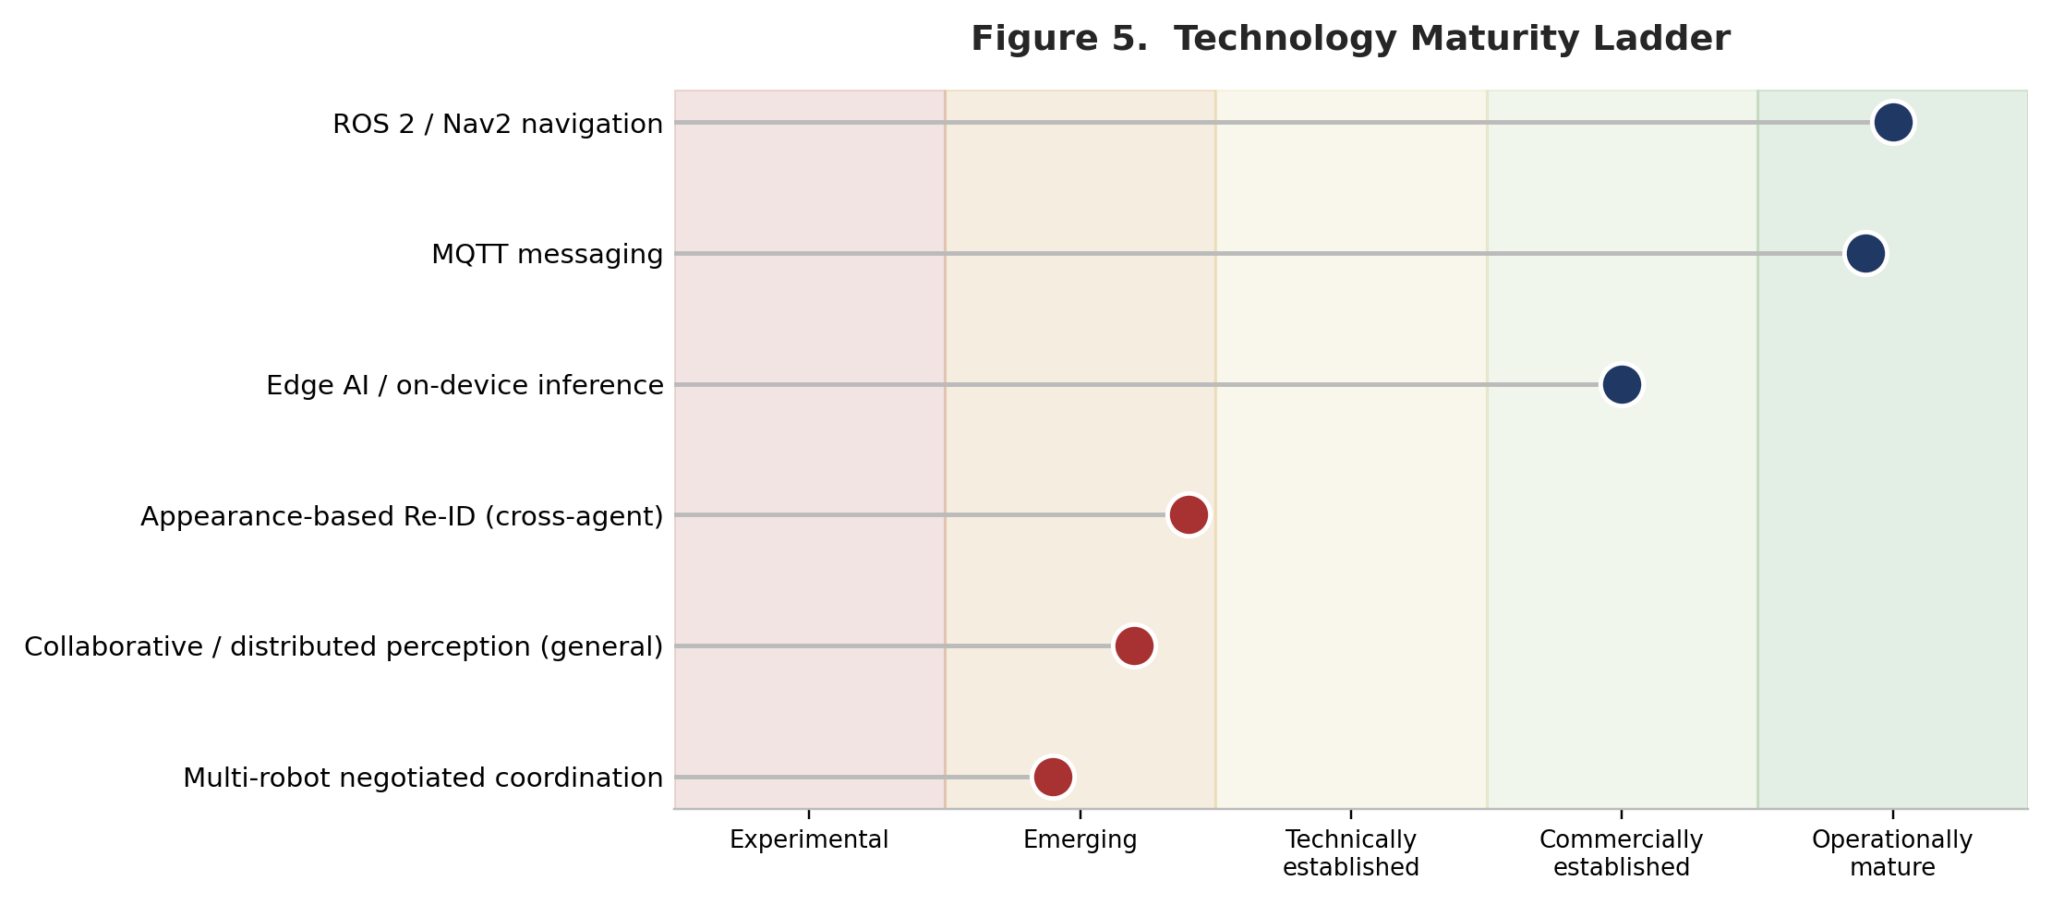
Compute: edge GPUs and NPUs (Jetson-class and comparable) are commercially available and increasingly power-efficient. Running five concurrent services per node is a heavier load than a single inference task, and this analysis did not locate a benchmark of this specific five-service pipeline on a cost-realistic embedded platform — an evidence gap, not a resolved point.
Networking: local wireless is broadly available in principle, but its reliability in outdoor, RF-obstructed, or remote settings is exactly where the strongest structural-fit use cases (port, critical infrastructure) are weakest on precondition evidence.
Robotics: Nav2 is production-grade and widely deployed (see maturity table); UGV hardware cost ranges from roughly $70,000–$75,000 per unit for legged platforms (industry pricing estimates) to lower, but still material, costs for wheeled platforms — a nontrivial capital outlay multiplied across a fleet.
Software: MQTT brokers, containerization, and ROS 2 middleware are mature, well-documented components; the integration risk sits in reliably orchestrating five custom services per node, not in the underlying infrastructure layer.

Technology Direction
The broad direction — more edge processing, more local inference, less dependence on centralized processing — is well supported by the 2026 edge-AI sources reviewed, which describe edge inference as an increasingly default deployment pattern for latency-, privacy-, and connectivity-sensitive workloads. Multi-agent and collaborative perception research volume is also trending upward, concentrated in the V2X/autonomous-driving literature. However, a favorable overall direction is not the same as near-term readiness for this specific architecture: the maturity table above shows the individual ingredients trending favorably while the specific combination — live inter-robot negotiation for appearance-based target handoff — remains evidenced almost entirely by academic literature rather than field deployment.

9. Adoption Barriers

Technical
- Re-ID accuracy loss under real-world domain shift (illumination, viewpoint, resolution, clothing similarity) is documented across multiple 2025 studies, even for state-of-the-art models.
- Multi-robot coordination for handoff/patrol is unproven at operational scale in practice, per the Agmon-Stone finding and the broader literature it sits within.
- MQTT latency degradation at higher concurrent-node counts directly threatens the “before occlusion” timing budget the handoff mechanism depends on.

Infrastructure
- Outdoor and remote wireless reliability, particularly where RF-obstructed (container yards) or genuinely remote (perimeters) — the two settings with the strongest structural fit for the system.
- Power provisioning for edge compute at remote nodes; per-unit UGV hardware cost is material when multiplied across a fleet.

Integration
- Existing VMS platforms (Genetec, Milestone) already carry their own analytics ecosystems (BriefCam); a new decentralized framework must integrate with or displace this installed base — a nontrivial commercial and technical problem independent of the underlying technology's own merits.

Operational
- New supervisory workload to validate system handoffs; training and monitoring of a five-service-per-node pipeline; failure recovery when a node goes offline mid-negotiation is not addressed in the source documentation and is flagged as an evidence gap.

Security
- An MQTT broker and inter-node negotiation protocol is itself an attack surface (device spoofing, message injection) distinct from the video-privacy question. The source brief's “encrypted metadata via MQTT” claim addresses confidentiality but not necessarily authentication and integrity of which node may claim a handoff — this analysis treats that as unaddressed rather than resolved.

Privacy
This is the single most consequential barrier category. Under the EU GDPR, data used to “uniquely identify” a natural person is special-category biometric data (Article 9), processable only on a narrow legal basis such as explicit consent. Whether an appearance-based Re-ID embedding meets that bar is a genuinely open legal question in the sources reviewed — not one this analysis can resolve — but it is squarely the kind of question a deploying organization's legal and compliance function must clear before rollout. The project's own documentation has already revised an earlier “zero visual data breaches” claim to the narrower “significantly minimizes exposure of raw visual data” framing; this analysis treats the narrower framing as the more defensible one.

Organizational
- Procurement in regulated or safety-critical settings (airports, critical infrastructure) typically requires vendor vetting and certification cycles — a well-documented general pattern in critical-infrastructure procurement, not independently verified here for these specific sectors.
- Internal ownership of “who watches the robots” (security team, IT, or facilities) is an unresolved organizational question for any first deployment.

Economic
- Per-node UGV hardware cost (tens of thousands of dollars for legged platforms) multiplied across a fleet is a material capital outlay relative to the marginal cost of an additional fixed camera.
- Ongoing maintenance of both hardware (battery, physical wear from outdoor operation) and the multi-service software stack adds recurring cost not quantified in the source brief.
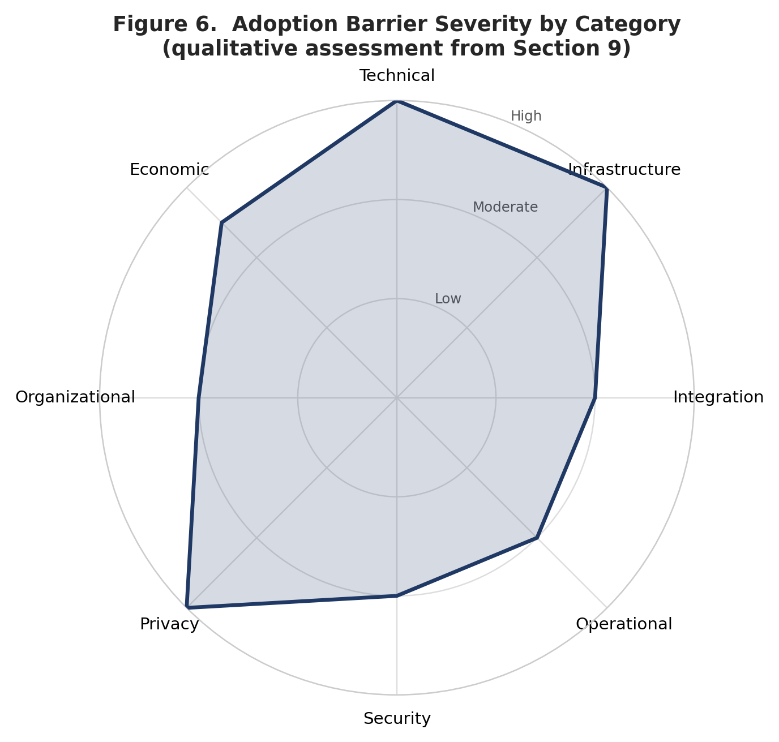

10. Deployment Readiness
Component | Readiness
Edge AI inference | Operationally mature
ROS 2 / Nav2 navigation | Operationally mature
MQTT messaging layer | Operationally mature
Appearance-based Re-ID (cross-agent) | Technically possible; deployable only with significant conditions (site-specific validation, controlled or well-characterized lighting)
Multi-robot negotiated coordination | Technically possible; operationally plausible only in narrow, tested conditions; not yet demonstrated at production scale for this application
Warehouse / campus deployment | Deployable with significant conditions (night Re-ID validation, wireless coverage)
Port / critical-infrastructure deployment | Operationally plausible in principle; not yet practical pending infrastructure and, for critical infrastructure, regulatory preconditions
Airport deployment | Not yet practical near term — certification barrier dominates, independent of the technology's own readiness
Search-and-rescue deployment | Not a good candidate as specified — a fit problem, not a readiness problem

11. Technology Dependencies
VisionSERVICE (detection + Re-ID embeddings) depends on: adequate camera resolution and frame rate at the target's actual distance and lighting, and a Re-ID model validated for the deployment's specific appearance domain. Availability of the underlying components (cameras, YOLO) is high; the required maturity of the Re-ID component specifically is not yet met for open, uncontrolled real-world domains; deployment risk is therefore high and concentrated exactly in the component most central to the system's value proposition.
NegotiationSERVICE depends on: reliable, low-latency messaging among all candidate peer nodes. MQTT as a transport is mature and available; coordination logic at production scale for this specific task remains unproven per the Agmon-Stone literature; deployment risk is therefore moderate and concentrated in the coordination logic rather than the transport.
NavigationSERVICE (Nav2) depends on: an accurate map and localization solution for the deployment terrain. Nav2/SLAM is mature for structured and semi-structured terrain, met for most candidate environments except deeply unstructured outdoor terrain; deployment risk is low for warehouse/campus, higher for port/outdoor perimeter, and high for SAR-type terrain (reinforcing the SAR fit assessment in Section 2).
AgentSERVICE (MQTT bridge) depends on: a functioning wireless network across the entire operational area. Availability varies by site; required maturity is high, since any dead zone breaks the handoff exactly where it is needed; deployment risk is directly proportional to the site's own wireless coverage quality, which this analysis cannot assess without a site survey.

12. Technology Risks
Risk | Cause | Impact | Likelihood | Mitigation
False handoff (wrong-person match) | Re-ID domain shift under lighting/viewpoint change | Target lost, or a UGV vectored toward the wrong individual | Moderate–High (real-world conditions) | Site-specific Re-ID validation before go-live; conservative confidence thresholds; human-in-the-loop confirmation before any physical UGV response
Negotiation latency growth at scale | MQTT broker queueing delay increases with concurrent client/node count | Handoff completes after the target has already left the receiving node's view | Unquantified (documented general effect) | Node-count-aware QoS tuning; local pre-filtering before broadcast; test negotiation latency at the target site's actual node density
Wireless coverage gaps | Container-stack RF shadowing; remote-site connectivity limits | AgentSERVICE cannot deliver the handoff payload | Moderate–High (site-dependent) | Site RF survey before deployment; fallback fixed-camera coverage in the weakest-signal zones
Legal/regulatory exposure (biometric classification) | GDPR Art. 9 and comparable regimes may classify unique-identification-capable embeddings as special-category data | Compliance liability; potential deployment halt or redesign | Uncertain (open legal question) | Legal review before deployment in any GDPR-applicable jurisdiction; consider non-persistent, on-device-only embedding storage and data-minimization design
Coordination underperformance vs. simpler alternatives | Prior research shows tight coordination can underperform loose/no coordination in practice | Wasted engineering investment relative to a simpler baseline | Moderate (evidenced by prior research) | Benchmark the negotiated approach against a simple “nearest node” or “broadcast” baseline before committing to the full Utility-Score design

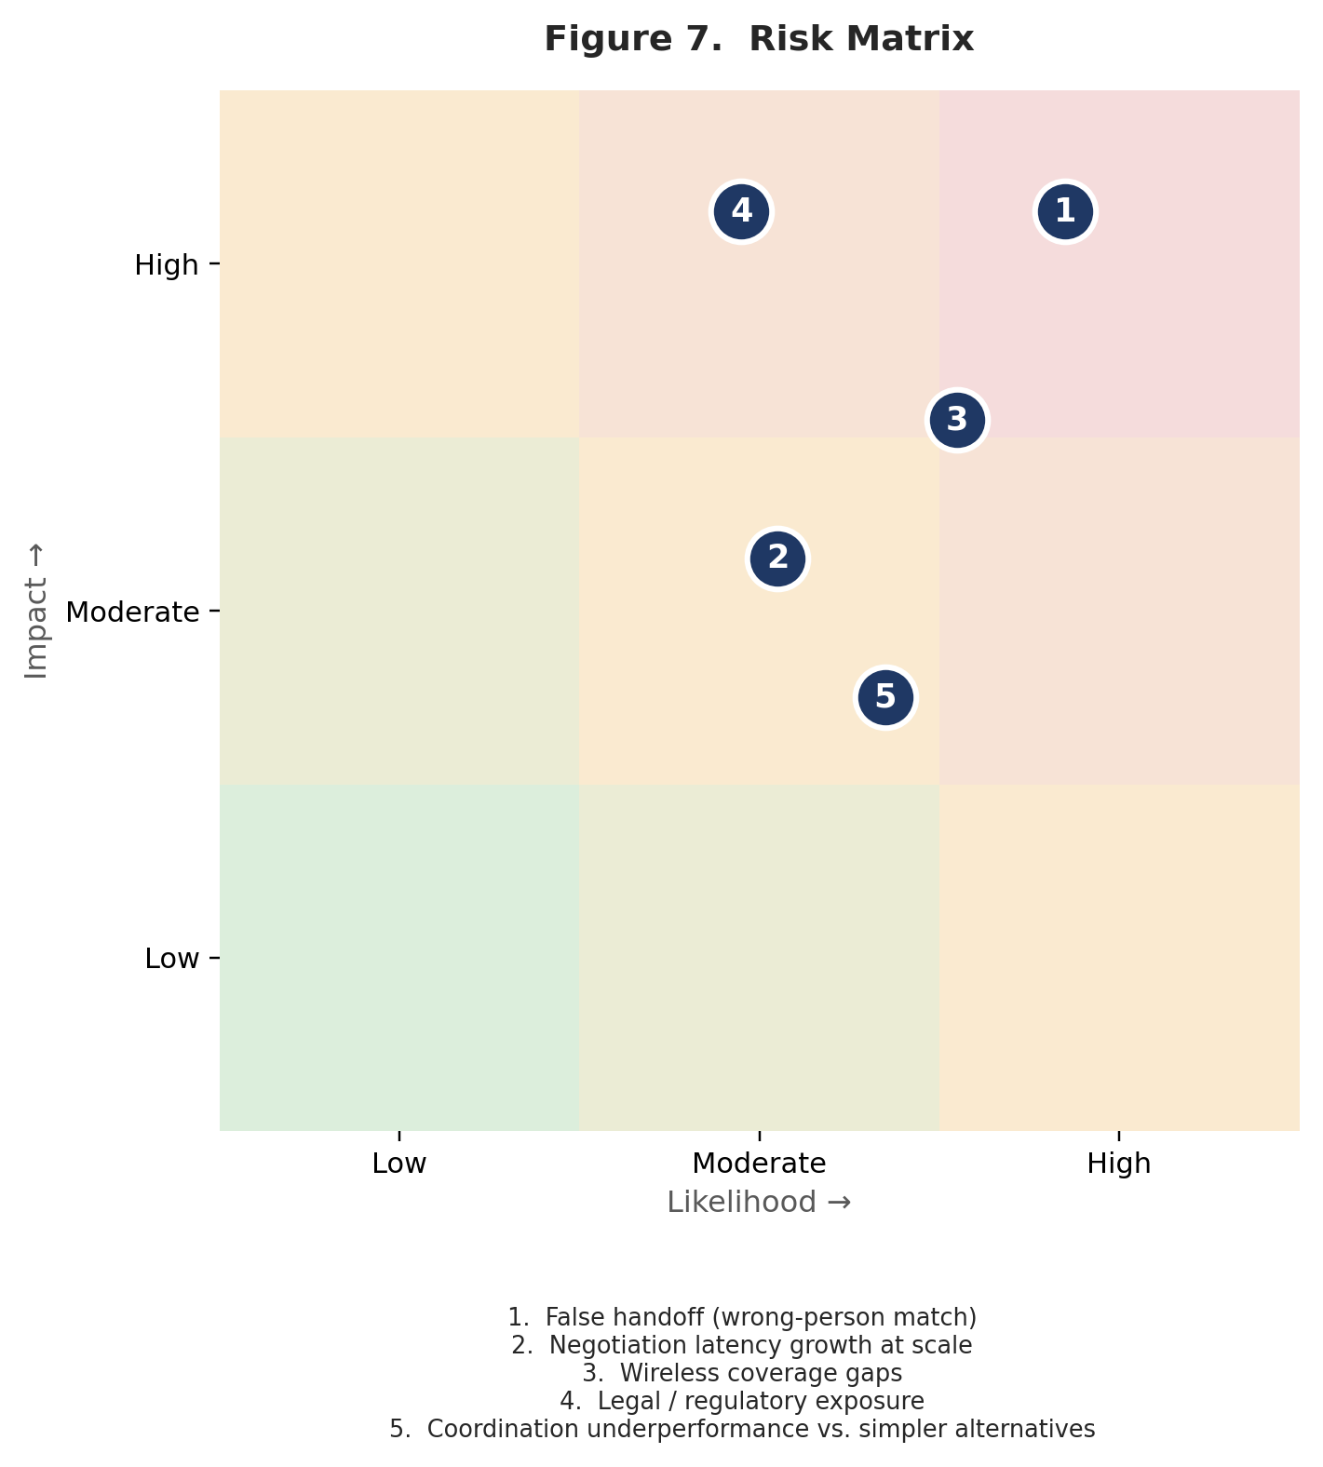

13. Evidence Gaps and Remaining Uncertainties
- No field-deployment evidence was found for a live, proactive, negotiated multi-agent target-handoff system of this specific kind (fixed and mobile edge nodes, appearance Re-ID, MQTT negotiation) at any of the candidate sites; all use-case assessments above are structural and analogical, not based on observed pilot results.
- Compute performance of the five-service pipeline (Vision, Prediction, Negotiation, Agent, Navigation) on a specific embedded platform was not benchmarked in the sources reviewed; whether it runs in real time on a cost-realistic edge device is unverified here.
- Port and critical-infrastructure RF/wireless conditions were reasoned from general engineering knowledge (steel shadowing, remote connectivity limits), not from site-specific measurements.
- The legal status of appearance-based Re-ID embeddings under GDPR's biometric-data definition is genuinely unsettled in the sources reviewed and should not be treated as resolved in either direction.
- Bandwidth savings are calculated from documented per-stream bitrate figures and typical metadata payload sizes, not measured on the actual system; their operational significance depends on whether a given site's network link is actually bandwidth-constrained, which this analysis could not determine in general.
- The primary multi-robot coordination evidence (Agmon, Fok, Stone et al.) dates to 2012; more recent coordination research may have shifted the practical picture, but this analysis did not locate a direct, current re-test of tight versus loose coordination specifically for target-handoff, as opposed to patrol, tasks.

14. Sources
- Knightscope, Inc. — “Knightscope K1 Autonomous Security Robot (ASR) Deployed in Southern California” and related releases (2022) — distribution-center deployment scale and National Insurance Crime Bureau cargo-theft estimate. ir.knightscope.com; businesswire.com
- Knightscope, Inc. — “Florida School Deploys Knightscope Autonomous Security Robot (ASR)” (2022) — campus/school patrol-robot deployment precedent. businesswire.com
- Agmon, N., Fok, C.-L., Emaliah, Y., Stone, P., Julien, C., Vishwanath, S. — “On Coordination in Practical Multi-Robot Patrol,” ICRA 2012 — finding that tight coordination is often impractical relative to loose/uncoordinated strategies. cs.utexas.edu
- Open Navigation — hiring/organizational post describing Nav2 production deployment scale (“over 300 companies,” 2025–2026). discourse.openrobotics.org
- AWS Robotics Blog — “AWS RoboMaker now supports ROS2 Foxy Fitzroy featuring Navigation2” — 37-mile, 24-hour Nav2 demonstration. aws.amazon.com/blogs/robotics
- Huaman, J., Sumari, F.O., Machaca, L., Clua, E., Guerin, J. — “Benchmarking Person Re-Identification Approaches and Training Datasets for Practical Real-World Implementations” — domain-shift accuracy loss in Re-ID deployment. paperswithcode.com; sotaverified.org
- Asperti, A., Naldi, L., Fiorilla, S. — “An Investigation of the Domain Gap in CLIP-Based Person Re-Identification,” Sensors, 2025 — measured domain-gap effects across Market-1501, DukeMTMC-reID, MSMT17, and Airport benchmarks. doi.org/10.3390/s25020363
- Baggam, R.L., Kumari, V.V. — “Advancements in Person Re-Identification Through Artificial Intelligence Techniques,” Defence Science Journal, 2025 — survey of Re-ID techniques including Kalman-filter-based tracking. publications.drdo.gov.in
- Nokia Bell Labs — “Camera Re-ID” research page — causes of Re-ID domain shift (illumination, viewpoint, occlusion, resolution). nokia.com/bell-labs
- BriefCam (Milestone Systems) — product materials on cross-camera face re-identification and VMS integration with Genetec Security Center and Milestone XProtect. briefcam.com
- Forasoft — “Re-identification” and “Biometric data” glossary entries — VMS-industry framing of cross-camera Re-ID and biometric-data classification. forasoft.com/learn/video-surveillance/glossary
- GDPRLocal — “Biometric Data GDPR Compliance Made Simple” (updated March 2026) — GDPR Article 9 special-category treatment of biometric data. gdprlocal.com
- Information Commissioner’s Office (UK) guidance on biometric recognition, as summarized in babl.ai coverage (2024, updated February 2026). babl.ai
- Fortinet / FortiRecorder documentation — H.264 bitrate table for IP video (1080p30 ≈ 2–4 Mbps by quality tier). help.fortinet.com
- Hikvision — “Bandwidth Requirement Chart for H.264, MPEG4 and MJPEG” technical bulletin. us-legacy.hikvision.com
- Cisco — “What is Message Queuing Telemetry Transport (MQTT)?” — MQTT architecture and QoS levels. cisco.com
- Ali, J., Zafar, M.H. — “Improved End-to-End Service Assurance and Mathematical Modeling of MQTT-Based Massively Deployed Devices in Smart Cities,” Alexandria Engineering Journal, 2023 — single-digit-millisecond MQTT queueing delay under modeled load. doaj.org
- “Internet of Things Network Performance: Impact of Message and Client Sizes and Reliability Levels”, ECTI-EEC — empirical MQTT latency growth with client count. ph02.tci-thaijo.org
- 360iResearch — “Indoor Security Patrol Robot Market” report summary (2025–2032 forecast) — market size and CAGR for indoor patrol robots. giikorea.co.kr
- IMARC Group — “Security Robots Market” report summary — global security robots market size (2024). imarcgroup.com
- Boston Dynamics Spot pricing — multiple industry pricing-estimate sources converging on a ≈ $70,000–$75,000 base price (2024–2025 estimates, not an official published price).
- Wang, N., Shang, D., Gong, Y., et al. — “Collaborative Perception Datasets for Autonomous Driving: A Review,” 2025 — maturity and scale of collaborative-perception research. arxiv.org/pdf/2504.12696v1
- Huang, T., Liu, J., Zhou, X., et al. — “Vehicle-to-Everything Cooperative Perception for Autonomous Driving,” Proceedings of the IEEE, 2025 — survey of V2X collaborative perception and open challenges. researchonline.jcu.edu.au
- Song, Z., Xie, T., Wen, F., Li, J. — “Wireless Communication as an Information Sensor for Multi-Agent Cooperative Perception: A Survey”, 2025 — communication constraints in collaborative perception. arxiv.org/pdf/2505.00747
- Industry commentary on 2026 edge-AI deployment trends (multiple sources, industry blogs and market commentary rather than peer-reviewed research; treated with appropriate caution) — general framing of edge inference as an increasingly default deployment pattern.

Market Need vs Technical Need & Final Market Validation
A Decentralized Edge-AI Framework for Proactive Multi-Robot Target Handoff and Cross-Node Re-Identification
Evidence-based alignment analysis and final validation verdict
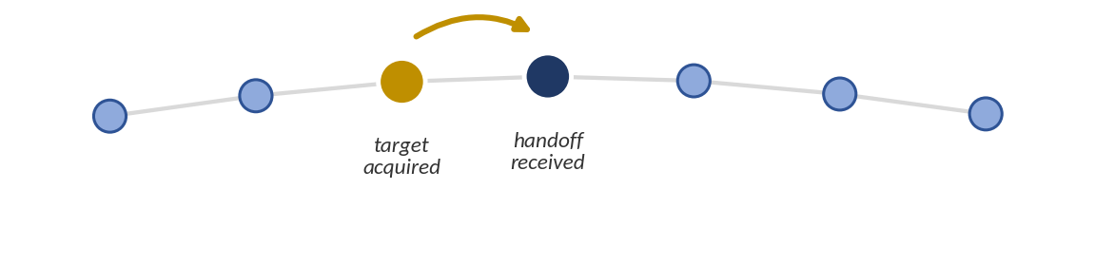

Introductory Note on Evidence Base
This analysis synthesizes the complete body of evidence developed across the preceding phases of this research program: the problem and market foundation, the competitive and research intelligence review, the Egypt/MENA regional field-readiness assessment, and the real-world use-case and technology-adoption analysis. No new primary research (interviews, surveys, or field observation) was conducted for this document. Where a claim rests on desk research, industry commentary, or reasoned inference rather than direct measurement, that distinction is preserved rather than smoothed over. Where the earlier phases of this program identified an evidence gap, that gap is treated as still open here, not silently resolved in the course of synthesis.
The system under review is a decentralized, edge-AI framework in which each observation node — a fixed camera in early deployment phases, a mobile ground robot in later phases — runs five coordinated services: a VisionSERVICE (detection, short-term tracking, and appearance-embedding extraction), a PredictionSERVICE (Kalman-filter-based forecasting of when a tracked target will become occluded or leave the node's field of view), a NegotiationSERVICE (a Utility-Score-based negotiation among peer nodes to select the best-placed receiving node), an AgentSERVICE (a lightweight MQTT messaging bridge carrying compact, encrypted target metadata rather than raw video), and a NavigationSERVICE (ROS2/Nav2-based mobility, relevant once nodes are mobile robots rather than fixed cameras). This description is drawn directly from the technical documentation supplied across the program and is treated as authoritative; nothing in this analysis adds, removes, or reinterprets a system capability beyond what that documentation specifies.
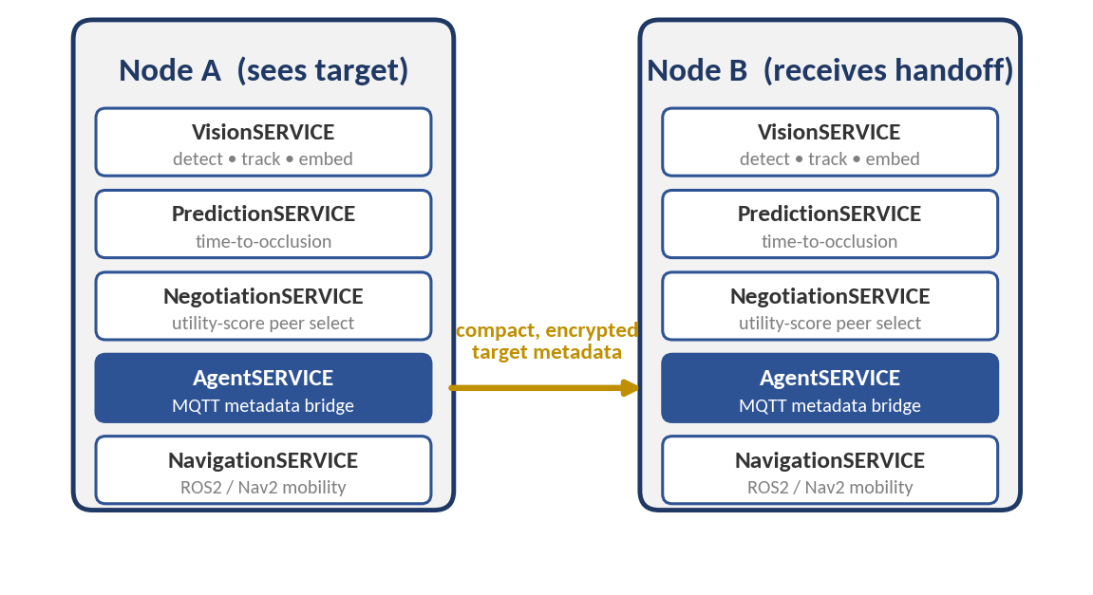
Figure 1 — Per-node service composition and the metadata handoff between two nodes.

Part I — Market Need vs Technical Need

1. Real-World Market / Operational Needs
The needs below are drawn from the operational literature and stakeholder analysis assembled in the problem-and-market-foundation phase and cross-checked against the use-case-level findings of the operational-value phase. Each is stated as an outcome, not as a technology.

N1 — Maintain a target's identity across a coverage gap
Context: Any environment where a person, vehicle, or asset must be tracked across an area no single sensor or node can fully cover.
Trigger: A target physically exits one node's field of view before entering another's, with a gap — spatial or temporal — in between.
Current problem: The reappearing detection is treated as new and unrelated unless something re-establishes the link.
Current method: Centralized, often offline, appearance matching, or a human operator noticing the loss and manually searching other feeds.
Current limitation: Appearance-based matching is measurably fragile under viewpoint, lighting, and occlusion change; human vigilance measurably declines within roughly fifteen to thirty minutes of sustained monitoring.
Importance: Without it, the record of where a target has been and currently is becomes fragmented or silently wrong.
Consequence if unaddressed: Delayed or absent response; in time-critical contexts, a documented decline in survival probability as search or response duration increases.

N2 — Reconnect a target quickly enough for the reconnection to be operationally useful
Context: Active-incident response, intrusion response, or any use case where the value of reconnection decays with time.
Trigger: A target has left a node's coverage and reconnection must occur before the operational window closes.
Current problem: Current reconnection is reactive: it begins only after the loss has already occurred and is often discovered only after the fact.
Current method: Manual, after-the-fact review of recorded footage once an incident prompts a search.
Current limitation: A technically correct match arriving after the operational window has closed is only useful as an evidentiary record, not as a trigger for action.
Importance: Timeliness, not just eventual accuracy, determines whether reconnection has any operational effect.
Consequence if unaddressed: Response becomes purely retrospective; duplicated search effort; missed intervention windows.

N3 — Reduce dependence on sustained human vigilance
Context: Any monitoring operation staffed below the ratio needed for full manual coverage of every feed — the normal condition, not the exception, per the camera-to-operator ratios documented in the security-industry literature.
Trigger: The number of feeds or nodes exceeds what a human can reliably watch without a measurable decline in detection accuracy.
Current problem: Detection quietly depends on an operator noticing something they are, on average, likely to miss as monitoring duration or feed count grows.
Current method: Motion-triggered alerts and analytics that reduce, but do not eliminate, the number of feeds requiring constant attention.
Current limitation: Even correctly generated alerts can go unactioned if the operator's attention has already lapsed.
Importance: This is a structural, not incidental, limitation — it does not improve by hiring marginally more staff, because the underlying vigilance decrement is a documented property of sustained human attention itself.
Consequence if unaddressed: Real, technically detectable events are missed until a downstream consequence forces a review.

N4 — Scale monitoring coverage without scaling headcount at the same rate
Context: Organizations whose camera or node count is growing faster than their monitoring budget.
Trigger: Camera/node density increases (for coverage or resolution reasons) while staffing levels are held roughly constant.
Current problem: Continuity currently depends on either more cameras, more staff, or both — the two levers organizations already pull, per the problem-foundation analysis, without resolving the underlying gap.
Current method: Layering additional cameras and stricter analytics rules; after-the-fact footage review.
Current limitation: Neither lever changes the underlying reactive nature of the process; both add cost without a corresponding, measured reduction in the continuity-failure rate.
Importance: An organization's true coverage is currently unknown to itself in a routine sense — gaps surface only after an incident forces a retrospective look.
Consequence if unaddressed: Escalating headcount and hardware spend that does not resolve the underlying continuity gap.

N5 — Reduce reliance on transmitting raw video where bandwidth is the binding constraint
Context: Sites where the link between an observation node and any central point is bandwidth-constrained — documented concretely in outdoor, wireless, or multi-camera-per-uplink deployments.
Trigger: Camera/node count or resolution requirements exceed available uplink capacity.
Current problem: Centralized architectures require raw sensor data to reach a central point before matching can occur, and that transport is bandwidth-bounded.
Current method: Reducing resolution or frame rate, or provisioning more bandwidth.
Current limitation: Reducing resolution measurably reduces detection accuracy; provisioning more bandwidth is a real, ongoing cost, and under load, processing can fall far enough behind that referenced imagery becomes hours old.
Importance: This need is real but conditional — it matters only where the link is actually the bottleneck, which is not automatically true of every site (an adequately provisioned wired LAN does not have this problem).
Consequence if unaddressed: Processing backlog; delayed, operationally useless matches.

N6 — Minimize exposure of biometric-grade personal data
Context: Any deployment tracking people (as opposed to vehicles or assets) in a jurisdiction with active biometric or facial-recognition regulation — an expanding set as of 2026.
Trigger: A tracking system captures, stores, or transmits data sufficient to uniquely identify a specific person.
Current problem: Facial-recognition-based identification carries direct, well-defined legal exposure under statutes that specifically target facial geometry (e.g., Illinois BIPA), and broader data-protection regimes (GDPR Article 9) treat any data usable to uniquely identify a person as special-category biometric data.
Current method: Where addressed at all, either avoiding facial recognition specifically or accepting the compliance burden of processing it lawfully.
Current limitation: Avoiding facial recognition specifically does not resolve whether a sufficiently distinctive non-facial appearance embedding still meets the broader 'unique identification' threshold — an unresolved legal question, not a solved one.
Importance: Regulatory exposure is a genuine deployment gate, not a secondary concern, in an expanding set of jurisdictions.
Consequence if unaddressed: Compliance liability, deployment delay, or forced redesign after the fact.

N7 — Maintain coverage where the occlusion pattern itself changes over time
Context: Environments where the physical layout that creates camera blind spots is not fixed — the clearest documented example being a container terminal, where newly stacked containers create new blind spots that a static camera plan cannot anticipate.
Trigger: Normal operations (stacking, vehicle movement, temporary structures) change what a fixed camera can and cannot see, faster than the camera plan can be revised.
Current problem: A camera plan adequate yesterday may have new blind spots today; adding more fixed cameras does not fully solve a moving-blind-spot problem, because the blind spot moves.
Current method: Periodic re-survey and camera-plan revision, or accepting the residual gap.
Current limitation: Re-surveying and revising a fixed-camera plan on an ongoing operational cadence is itself a real and recurring cost.
Importance: This is the one need identified across the program's evidence base where a structurally different (non-fixed-camera) approach has a genuine, non-substitutable rationale.
Consequence if unaddressed: Recurring, unpredictable coverage gaps that a static infrastructure investment cannot fully close.

N8 — Extend coverage where power and connectivity, not just camera count, are the limiting resource
Context: Long, remote perimeters (pipelines, substations, solar farms) where grid power and backhaul connectivity are not available at every point along the boundary.
Trigger: A perimeter exceeds the length that can be economically instrumented given the site's actual power/connectivity footprint.
Current problem: Adding more fixed cameras is infeasible specifically where power and backhaul are themselves unavailable, not merely expensive.
Current method: Sparse fixed sensors at powered points, motion sensors, and periodic human patrol, leaving the gaps between sensors effectively unmonitored.
Current limitation: A European perimeter-protection market assessment cited in the problem-foundation research reports that common perimeter-sensing technologies average roughly 40% false alarms and are 60–80% energy-inefficient, evidence that current mitigation is resource-intensive without eliminating the gap.
Importance: This is the other need in the evidence base with a genuine structural rationale for a non-fixed-camera approach, though it is also the need with the least direct deployment evidence anywhere in the program.
Consequence if unaddressed: Undetected or delayed-detected intrusion at sites that are, by design, unmanned.

2. Need Categories
- Continuity & Persistent Identity — N1, N2
- Reduced Manual/Vigilance Dependency & Scalability — N3, N4
- Infrastructure & Communication Efficiency — N5
- Privacy & Regulatory Exposure — N6
- Structural / Dynamic Coverage — N7, N8
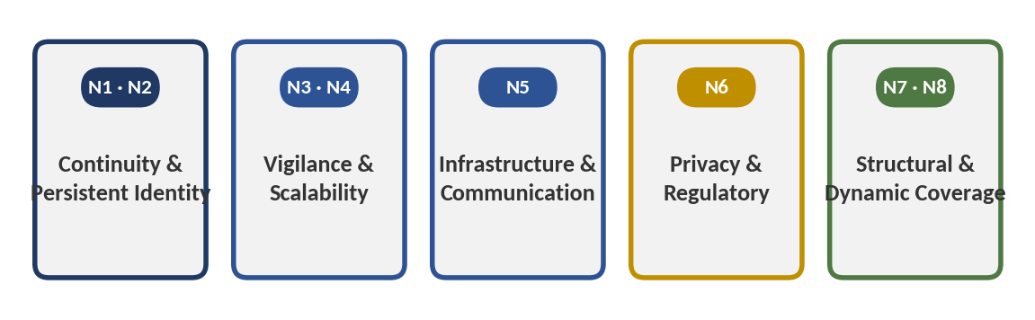
Figure 2 — The five need categories and the needs each groups.
These five categories, rather than the larger illustrative list in the originating brief, are the ones the evidence base actually supports as materially distinct. 'Resilience' and 'better situational awareness' were considered as separate categories but folded into Continuity & Persistent Identity, since every relevant piece of evidence found in the program's research treats them as effects of solving N1/N2 rather than as independent needs with their own distinct evidence.

3. Technical Requirements Derived from the Needs
For each need, the requirement below states the minimum that must be technically true, not the specific mechanism the system happens to use to satisfy it.
Need | Operational Problem | Technical Requirement | Why Required | Minimum Necessary Capability | Consequence if Missing
N1 — Continuity across a gap | Reappearing detections are treated as new/unrelated | Retain and re-apply target identity across separated observation points | Without it there is no continuity to speak of | Some form of appearance (or other) matching plus a retained description | Fragmented or silently incorrect records
N2 — Timely reconnection | Recovery is reactive, after the loss has occurred | Anticipate and act before, not after, the target leaves coverage | A correct match arriving too late has no operational effect | Trajectory-based prediction of an impending coverage loss | Reconnection becomes evidentiary only, not actionable
N3 — Reduced vigilance dependency | Human monitoring degrades measurably over time/feed count | Automate the noticing-and-searching step currently performed by a human | Vigilance decrement is a documented property of sustained attention, not a training gap | Automated detection of a loss-of-track event | Real events go unnoticed until a downstream consequence forces review
N4 — Scalable coverage | Coverage currently scales with headcount, not just camera count | Decouple continuity from a 1:1 (or better) camera-to-operator ratio | Headcount cannot economically scale indefinitely with camera/node count | Some automation of the matching step (N1) that does not require proportionally more human review | Escalating cost without a resolved continuity gap
N5 — Bandwidth-conditional efficiency | Centralized matching requires raw data at a central point | Perform enough processing locally that only compact information needs to cross the network | Only matters where the link is actually bandwidth-constrained | Local (edge) inference plus a compact metadata payload rather than continuous raw-stream transmission | Backlog and delay under load, specifically on constrained links
N6 — Reduced biometric exposure | Facial-recognition-based ID carries direct legal exposure; unique-identification embeddings may also qualify | Use the least identifying representation sufficient for the matching task, and minimize retention/exposure | Regulatory exposure is a deployment gate in an expanding set of jurisdictions | Non-facial appearance representation plus data-minimization design | Compliance liability or forced redesign after deployment
N7 — Dynamic-occlusion coverage | A fixed camera plan cannot track a blind spot that itself moves | Coverage capability must be reconfigurable, not fixed to a static camera plan | A structurally different problem from simply adding more fixed cameras | Some form of mobile or reassignable sensing node | Recurring gaps a static investment cannot close
N8 — Power/connectivity-constrained coverage | Fixed sensors cannot be added where power/backhaul do not exist | Coverage capability must not depend on fixed power/backhaul at every point | Distinct from N7 — the constraint here is energy/connectivity, not occlusion geometry | A mobile or self-powered sensing node with its own communication path | Undetected intrusion at unmanned, under-instrumented sites
Table 3.1 — Need-to-requirement mapping. One need can imply several capabilities; several needs converge on N1's core matching requirement.

4. Technical Capability → Need Mapping
The capabilities below are the five per-node services defined in the supplied technical documentation, plus the two design choices (appearance-based matching; metadata encryption) that recur across the program's evidence as distinct value claims in their own right.

VisionSERVICE — detection, short-term tracking, and Re-ID embedding extraction
Technical problem addressed: Producing, at each node, a reliable local track and a compact appearance representation of a target.
Operational need served: N1 (continuity), and the precondition for every other service.
Operational effect: A target has a stable local identity and a portable description before any handoff is attempted.
Practical value: Without this, none of the rest of the pipeline has anything to act on.
Evidence strength: Strong for the underlying detection/tracking components (YOLO, DeepSORT) individually, per the competitive-landscape review; weaker for Re-ID accuracy specifically under the real-world domain shift (lighting, viewpoint) the operational-value analysis documents as a persistent, unresolved research limitation.

PredictionSERVICE — Kalman-filter time-to-occlusion forecasting
Technical problem addressed: Estimating, before it happens, that a target is about to leave the current node's field of view.
Operational need served: N2 (timely, proactive rather than reactive reconnection).
Operational effect: Converts the moment of loss from something discovered after the fact into something anticipated.
Practical value: This is the specific mechanism that differentiates the system from reactive matching approaches (including most commercial VMS Re-ID products, which are retrospective search tools).
Evidence strength: Moderate. The general technique (trajectory-based occlusion prediction) has real academic precedent for fixed cameras; the operational-value analysis found no field measurement of this specific prediction step's accuracy or lead time in the source documentation.

NegotiationSERVICE — Utility-Score peer selection
Technical problem addressed: Choosing which peer node should take over tracking, rather than broadcasting to all nodes or picking one arbitrarily.
Operational need served: N1/N2, and, in principle, N4 (scalability, by avoiding wasted broadcast/negotiation overhead as node count grows).
Operational effect: In principle, a more accurate handoff than a simple 'nearest node' or 'first responder' rule.
Practical value: Contested. A frequently cited controlled study of multi-robot patrol coordination found that tightly coordinated strategies are often impractical in real deployments and are regularly matched or beaten by loosely coordinated or uncoordinated strategies — direct evidence against assuming this specific capability's added complexity automatically earns its keep.
Evidence strength: Weak for this specific application. The coordination literature the finding rests on is from 2012 and addresses patrol, not target handoff specifically, but no more recent, directly on-point re-test was located anywhere in the program's research.

AgentSERVICE — MQTT metadata bridge
Technical problem addressed: Moving only a compact description, not raw video, between nodes.
Operational need served: N5 (bandwidth efficiency, conditionally) and, secondarily, N6 (data minimization).
Operational effect: A calculable, large reduction in per-handoff network payload relative to continuous raw-video transmission.
Practical value: Real but conditional — meaningful specifically where the inter-node link is bandwidth-constrained (wireless, cellular, remote), and much less decision-relevant on an already-adequate wired local network, which several of the program's highest-priority use cases may in fact be.
Evidence strength: Moderate-to-strong for the underlying transport technology (MQTT is operationally mature and ubiquitous in industrial IoT); a documented risk that its latency degrades non-linearly as concurrent node count grows, which bears directly on whether the 'before occlusion' timing budget PredictionSERVICE depends on can actually be met at scale.

NavigationSERVICE — ROS2/Nav2 mobility
Technical problem addressed: Allowing a node to be a mobile robot rather than only a fixed camera.
Operational need served: N7 and N8 specifically — this is the capability that exists to serve exactly the two needs with the clearest non-substitutable rationale, and essentially only those two.
Operational effect: Coverage can be repositioned rather than fixed at installation.
Practical value: High where N7/N8 apply (dynamic occlusion, power/connectivity-constrained perimeters); largely unnecessary where they do not — the operational-value analysis's own two 'high-value' use cases (a warehouse campus and a university/corporate campus) both have fixed building geometry, where mobility's marginal advantage over simply adding fixed cameras was not established.
Evidence strength: Strong for the underlying navigation technology on its own terms (Nav2 is reported in production use across more than 300 companies); the evidence is silent on whether mobility specifically, as opposed to more fixed cameras, is the superior choice in the use cases the program identified as strongest.

Appearance-based (non-facial) matching, as a design choice
Technical problem addressed: Matching identity without relying on facial geometry specifically.
Operational need served: N6 (reduced biometric/legal exposure).
Operational effect: Plausibly reduces exposure under statutes that specifically target facial geometry.
Practical value: Real but incomplete — a sufficiently distinctive non-facial appearance embedding may still meet a broader 'unique identification' threshold under regimes like GDPR Article 9, which the program's own research treats as a genuinely open legal question, not a resolved advantage.
Evidence strength: The underlying legal question is unresolved in the sources reviewed across the program; this is a plausible risk-mitigation, not a demonstrated compliance win.

Encrypted metadata exchange, as a design choice
Technical problem addressed: Protecting the compact target description in transit between nodes.
Operational need served: N6 (privacy) and, indirectly, general security posture.
Operational effect: Addresses confidentiality of the metadata payload.
Practical value: Partial. The program's own operational-value analysis notes that confidentiality (encryption) does not, on its own, address authentication or integrity — i.e., verifying which node may legitimately claim a handoff — leaving a distinct, unaddressed attack-surface question.
Evidence strength: The encryption claim itself is plausible and standard practice; the broader security-protocol question (authentication/integrity of handoff claims) is flagged in the source material as unaddressed, not resolved.

5. Technical Capability → Value Matrix
Capability | Technical Problem Addressed | Need Served | Operational Effect | Evidence Strength
VisionSERVICE (detect/track/embed) | Produce a local track + portable description | N1 | Foundation for everything downstream | Strong (components); weaker (Re-ID under domain shift)
PredictionSERVICE (time-to-occlusion) | Anticipate loss of coverage before it happens | N2 | Reactive → proactive handoff | Moderate; no field measurement located
NegotiationSERVICE (Utility-Score) | Select the best receiving node, not just any | N1/N2/N4 | In principle more accurate handoff | Weak; direct counter-evidence from coordination literature
AgentSERVICE (MQTT metadata) | Move a description, not raw video | N5, N6 | Large calculated bandwidth reduction | Moderate; conditional on link being the bottleneck
NavigationSERVICE (Nav2 mobility) | Reposition coverage rather than fix it | N7, N8 | Coverage follows the problem, not a fixed plan | Strong (tech); unproven as the superior choice for top use cases
Appearance-based (non-facial) matching | Match identity without facial geometry | N6 | Plausibly reduced statute-specific exposure | Legal question genuinely unresolved
Encrypted metadata exchange | Protect the metadata payload in transit | N6 | Confidentiality addressed | Authentication/integrity of handoff claims unaddressed
Table 5.1 — Every listed capability traces to at least one real need; evidence strength varies substantially by capability.

6. Necessity Test
Capability | Classification | Reasoning
VisionSERVICE (detection, tracking, embedding) | Essential | Removing it removes the precondition for every other capability; there is no version of this system without local perception.
Cross-node re-identification (matching logic) | Essential | This is the capability that actually resolves N1; without it, handoff is just movement without continuity.
PredictionSERVICE (proactive time-to-occlusion) | Important | Materially improves the outcome over reactive matching, but a reactive system with very fast centralized matching (as several commercial and research systems already provide) is a working, if inferior, alternative — not the sole enabler of continuity.
NegotiationSERVICE (Utility-Score selection) | Questionable | Its necessity relative to a simpler rule (nearest node, broadcast-first-responder) is not established by the evidence available, and the one directly relevant controlled study located in the program's research points the other way.
AgentSERVICE (MQTT metadata layer) | Enabling / Replaceable by context | Enabling for the edge/decentralized design overall; replaceable by ordinary centralized transmission wherever the link is not actually bandwidth-constrained, which is not established as universal.
NavigationSERVICE (mobile UGV capability) | Supportive, concentrated in two needs | Essential only for N7/N8 (dynamic occlusion, power/connectivity-constrained perimeters); replaceable by fixed cameras for fixed-geometry sites, which the evidence identifies as the strongest near-term use cases.
Appearance-based (non-facial) matching | Supportive | Improves risk posture but does not resolve the underlying legal question; a supportive design choice, not a capability the core problem depends on.
Encrypted metadata exchange | Supportive | Standard, appropriate practice; improves security posture without being the mechanism that solves the core operational need.
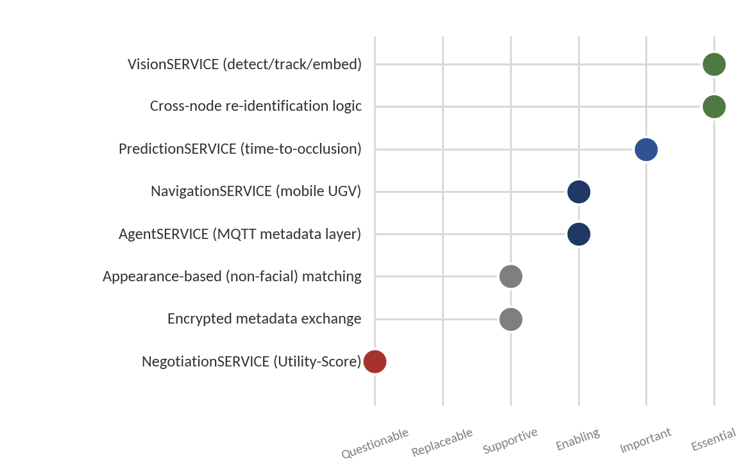
Figure 3 — Necessity classification of each capability, from Questionable to Essential.

7. Simpler-Solution Test

Full decentralized peer negotiation vs. a simple 'nearest node' or 'broadcast' rule
Simple alternative: a fixed rule (hand off to whichever neighboring node is geometrically nearest, or broadcast the description to all neighbors and let the first successful match win). What it achieves: in a controlled study of multi-robot patrol coordination, loosely coordinated or even uncoordinated strategies were found to regularly match or beat tightly coordinated ones in practice. What it fails to achieve: a rule this simple cannot account for line-of-sight probability, interception time, or node availability the way a Utility-Score negotiation is designed to. Additional value of the proposed capability: potentially better handoff accuracy in dense, complex node layouts, but this has not been demonstrated for target-handoff specifically, as distinct from patrol. Verdict: the added complexity is not currently justified by the available evidence and is the single most important simplicity challenge identified in this program's research; it should be empirically benchmarked against a simple baseline before being treated as a settled design choice.

Mobile UGV nodes vs. more fixed cameras
Simple alternative: add more fixed cameras to shrink coverage gaps. What it achieves: for sites with fixed building geometry (a warehouse or campus), this is a well-understood, lower-complexity approach many facilities already partially pursue, with no navigation stack, no battery constraint, and no moving-robot safety consideration. What it fails to achieve: it cannot follow a blind spot that itself moves (a container yard) or extend coverage where power/backhaul, not camera count, is the binding constraint (a remote perimeter). Additional value of the proposed capability: concentrated specifically in N7/N8. Verdict: fixed cameras are very plausibly the better choice for the two use cases the program's evidence identifies as strongest (warehouse, campus); mobility's advantage is real but concentrated in exactly the two use cases (port, critical infrastructure) with the weakest deployment-readiness evidence in the entire program.

Custom decentralized Re-ID vs. existing centralized VMS analytics
Simple alternative: an existing, commercially available cross-camera appearance-search product integrated into a video management system (documented examples integrate with major VMS platforms and are already deployed at scale for fixed-camera sites). What it achieves: much of the 'who is this person, where did they go' function today, for fixed-camera sites, without any decentralized negotiation protocol or mobile robots. What it fails to achieve: it is retrospective/forensic in its most mature commercial form, is typically face-based, and does not extend to genuinely mobile or occlusion-shifting environments. Verdict: for fixed-camera-friendly sites, this is a materially simpler, already-commercial substitute that narrows — without eliminating — the incremental case for the full proposed architecture.

8. Market Need vs Technical Complexity
Quadrant | Where It Applies | Assessment
High Need + High Complexity | N7/N8 in port and critical-infrastructure environments | Potentially justified — no simpler alternative fully closes these gaps — but this is also where deployment-readiness evidence (RF reliability, power, regulatory clearance) is weakest across the entire program.
High Need + Low Complexity | General coverage-gap awareness in fixed-geometry sites | Attractive, and largely already served by the simpler alternative of more fixed cameras plus existing VMS appearance search — the two highest-value use cases identified in the operational-value analysis sit here.
Low Need + High Complexity | Full Utility-Score peer negotiation in fixed-geometry, low-node-count sites | Weak position: the complexity is not clearly earning its value where a simpler coordination rule is plausibly sufficient.
Low Need + Low Complexity | Not materially represented in the evidence reviewed | No significant capability in the defined system falls cleanly into this quadrant.
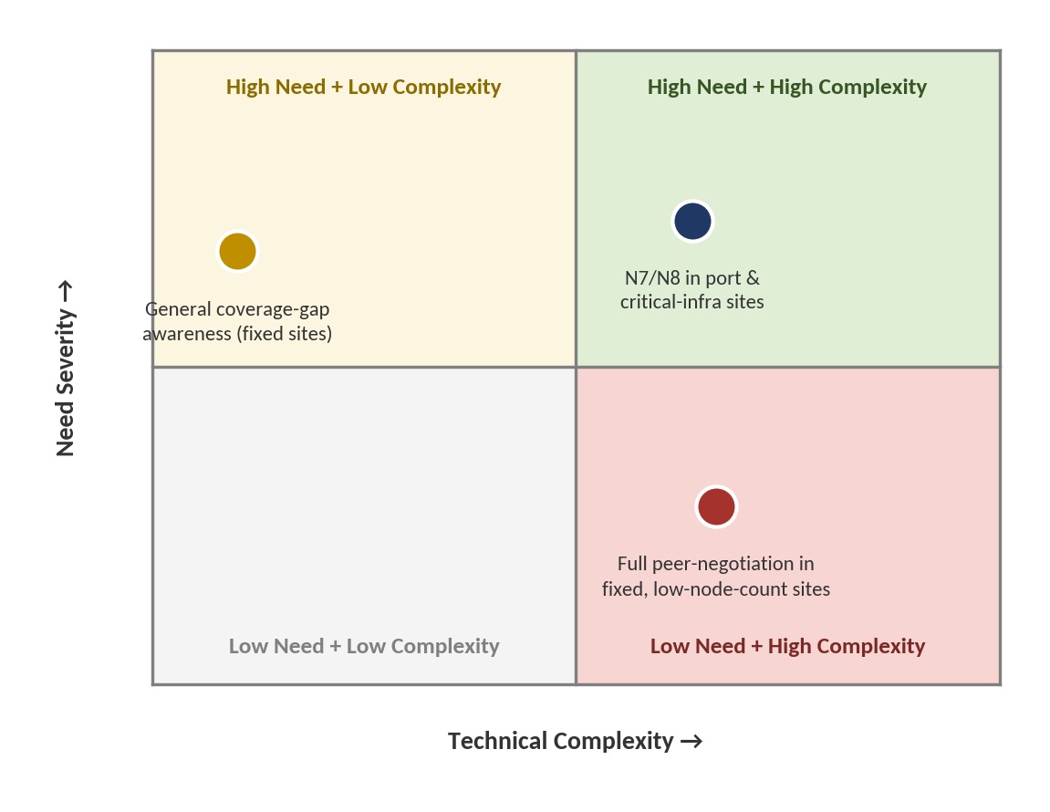
Figure 4 — Need severity vs. technical complexity, with representative items plotted.

9. Capability-to-Value Traceability
Two chains are traceable with reasonable rigor from the evidence base; a third, commonly asserted chain is explicitly not, and is flagged as such rather than assumed.
Traceable chain 1: Local inference (VisionSERVICE) → only a compact description needs to cross the network (AgentSERVICE) → a calculable, order-of-magnitude reduction in per-handoff payload size relative to continuous raw video → a real reduction in bandwidth/infrastructure requirement, conditional on the deploying site's link actually being bandwidth-constrained (not established as universal).
Traceable chain 2: Occlusion prediction (PredictionSERVICE) → handoff negotiation begins before the target is lost → a shorter gap between loss and reacquisition, provided negotiation completes before the target also leaves the receiving node's view — a timing race the program's evidence base does not size for this specific system.
Chain explicitly not established: 'Automation of handoff' → 'reduced operator workload,' asserted without qualification, is exactly the kind of unsupported jump the analytical brief warns against. The program's own operational-value analysis concludes the more defensible claim is a shift in the nature of the operator's task — from actively watching and comparing feeds to supervising and confirming system-proposed matches — not an unconditional reduction in workload, since a nonzero share of matches will need human correction given documented Re-ID domain-shift failure rates.

10. Core vs Supporting Needs
- Core: N1 (identity continuity), N2 (timely, proactive reconnection) — without these the central problem remains unresolved.
- Important: N3 (reduced vigilance dependency), N7 (dynamic-occlusion coverage) — materially improve the outcome and, for N7 specifically, have no simpler substitute.
- Supporting: N5 (bandwidth efficiency), N6 (privacy/regulatory exposure) — enable practical, compliant deployment rather than resolving the core problem themselves.
- Marginal: N4 (headcount-independent scaling) as a standalone claim — plausible but not independently measured anywhere in the program; it is largely a restated consequence of solving N1 automatically rather than a distinct need.
- Unvalidated: N8 (power/connectivity-constrained perimeter coverage) — theoretically the strongest structural rationale in the entire needs list, and simultaneously the least evidenced by any located deployment, anywhere, in this or comparable systems.

11. Core vs Supporting Capabilities
- Core: VisionSERVICE (detection, tracking, embedding) and the cross-node matching logic it feeds.
- Enabling: PredictionSERVICE (makes proactivity possible); AgentSERVICE (makes the edge/decentralized design possible).
- Supporting: appearance-based (non-facial) matching; encrypted metadata exchange.
- Replaceable: NegotiationSERVICE's full Utility-Score logic (by a simpler coordination rule, pending benchmarking); NavigationSERVICE/mobility itself, specifically in fixed-geometry sites where fixed cameras are a plausible substitute.
- Unjustified/Unclear on current evidence: none of the defined capabilities is wholly unjustified, but NegotiationSERVICE's specific design is the one capability the program's own evidence base most directly calls into question.

12. Misalignment Analysis
Capability without a clearly established need: The full Utility-Score negotiation protocol in fixed-geometry sites (warehouse, campus), where the program's own operational-value analysis identifies a simpler fixed-camera-plus-existing-VMS-analytics approach as a plausible substitute for comparable outcomes.
Need without a demonstrated capability: Direct confirmation that operators actually experience continuity loss as a frequent, costly, specifically painful failure — as opposed to a structurally plausible but field-unconfirmed problem — was not established anywhere in this program. Every phase of the program's research, including the regional field-readiness assessment, explicitly flags this as unresolved rather than assumed.
Partial alignment: The bandwidth-reduction claim (N5) is real only where a site's link is actually the bottleneck; it does not universally apply, and no evidence in the program establishes what share of realistic target sites meet that condition.
Complexity mismatch: A five-service-per-node architecture is considerably more complex than the two highest-value use cases identified in the program's own operational analysis appear to require, on the evidence available.
Hidden dependency: The entire proactive-handoff value proposition (N2) depends on completing negotiation before the target also exits the receiving node's field of view — a timing budget that documented MQTT latency growth under higher concurrent-node counts puts genuinely at risk at scale, and that the program's evidence base does not size for this specific system.
Weak value link: "Encrypted metadata" is repeatedly treated in the source material as addressing privacy risk, but encryption alone resolves confidentiality, not the separate and still-open question of whether an appearance embedding constitutes biometric data under regimes like GDPR Article 9, nor the authentication/integrity of which node may legitimately claim a handoff.

13. Requirement Traceability Matrix
ID | Market Need | Technical Requirement | System Capability | Necessity | Evidence
T1 | N1 — Continuity across a gap | Retain + re-apply identity across nodes | VisionSERVICE + Re-ID matching | Essential | Strong (components); moderate (Re-ID accuracy)
T2 | N2 — Timely reconnection | Anticipate loss before it occurs | PredictionSERVICE | Important | Moderate; no field measurement located
T3 | N1/N2/N4 — Accurate, efficient handoff target selection | Select best receiving node | NegotiationSERVICE | Questionable | Weak; direct counter-evidence exists
T4 | N5/N6 — Efficient, minimized data exchange | Compact metadata, not raw video | AgentSERVICE (MQTT) | Enabling / conditional | Moderate; conditional on bottleneck
T5 | N7/N8 — Reconfigurable coverage | Mobile or reassignable nodes | NavigationSERVICE | Essential for N7/N8 only | Strong (tech); unproven as best choice elsewhere
T6 | N6 — Reduced biometric exposure | Non-facial matching + data minimization | Appearance-based Re-ID design | Supportive | Legal question open, not resolved
T7 | N3/N4 — Reduced vigilance dependency, scalable coverage | Automate the noticing-and-searching step | Full pipeline (T1+T2 together) | Core outcome, not a separate capability | Indirect; follows from T1/T2 if they work as specified
Table 13.1 — Forward (need→capability) and backward (capability→need) traceability converge on the same conclusion: T1 and T2 are solidly grounded; T3 is the weakest link in the chain.

14. Part I Findings
Strongest market/operational needs: N1 (identity continuity across a coverage gap) and N2 (timely, proactive rather than reactive reconnection) are the two needs with the most independent, well-documented evidentiary support across the program's research.
Capabilities most directly connected to those needs: VisionSERVICE and the cross-node matching logic (for N1); PredictionSERVICE (for N2).
Enabling/supportive capabilities: AgentSERVICE, appearance-based matching, and encrypted metadata exchange all serve real but conditional or partial needs (N5, N6).
Capabilities that appear replaceable: NavigationSERVICE (mobility) in fixed-geometry sites, and NegotiationSERVICE's specific coordination design in general — both have plausible simpler substitutes the evidence base does not rule out.
Capability whose practical value remains most uncertain: NegotiationSERVICE. It is the one component the program's own evidence base directly, not just speculatively, calls into question.
Strongest need-to-technology relationship: N1 → VisionSERVICE/Re-ID matching, and N7 → NavigationSERVICE (mobility has no real substitute specifically for a moving blind spot).
Weakest need-to-technology relationship: N4 (headcount-independent scalability) → the system as a whole; this relationship is plausible but not independently measured anywhere in the program, and risks being asserted rather than demonstrated.
Most important simplicity challenge: For the two use cases the program's own evidence identifies as strongest (warehouse, campus), a materially simpler combination — more fixed cameras plus an existing, commercially available VMS Re-ID product — has not been ruled out as delivering a comparable operational outcome at lower complexity and cost.
Most important unresolved assumption: That the specific decentralized, peer-negotiating multi-robot architecture is necessary to solve N1/N2, as opposed to being one possible architecture among several — including centralized alternatives already in wide commercial and institutional use — capable of addressing the same underlying needs.

Part II — Final Market Validation

15. Evidence Consolidation
Problem Evidence: Strong and multi-domain. Vigilance decrement, appearance-matching fragility, and bandwidth-constrained centralized processing are each independently documented in peer-reviewed and institutional sources across physical security, transportation, critical infrastructure, and search-and-rescue contexts.
User / Market Evidence: Moderate. Personas and jobs-to-be-done are derived from the operational literature underlying each segment, not from direct interviews; no primary user research exists anywhere in the program.
Competitive Evidence: Strong. An extensive review of commercial products and published research found no system combining the full target architecture, but substantial, in several cases very recent, precedent for nearly every individual component.
Research Evidence: Strong on component maturity; weak on combined, field-validated demonstration of the specific proactive multi-robot handoff mechanism.
Regional / Field Evidence: Moderate on infrastructure and regulatory description; weak-to-absent on direct operator or stakeholder confirmation of the problem's severity, since no primary interviews were conducted in Egypt, the Gulf states, or Morocco.
Operational Value Evidence: Moderate. A rigorous, self-critical use-case analysis found real value concentrated in two-to-four candidate environments, with explicit, evidence-based downgrades of others (most notably search and rescue, despite its presence on the original candidate list).
Adoption Evidence: Mixed. Individual technology components (edge AI, ROS2/Nav2, MQTT) are commercially mature and widely deployed; the specific combination is not; regulatory, institutional, and RF/connectivity barriers are concrete and, in Egypt's case, very recently introduced and untested.
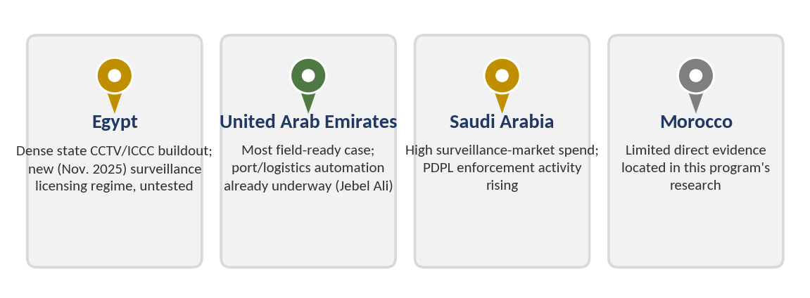
Figure 5 — Regional evidence footprint across the four markets examined in the program's field-readiness research.

16. Final Validation Dimensions
Problem Severity: Moderate–High — High in security/ITS/critical-infrastructure and search-and-rescue contexts by the nature of the consequences (safety, survival probability); moderate in the specific industrial/logistics segment, where tagging already resolves continuity for most tracked entities.
Problem Frequency: High in security/ITS, Low-but-consequential in SAR/critical-infrastructure — Frequency and severity do not move together across segments — a documented, not assumed, pattern in the problem-foundation analysis.
User Need: Moderate — Strongly implied by structural and vigilance-research evidence; not directly confirmed by any user or operator.
Market Relevance: Moderate–Strong — Real, verifiable money is already being spent on adjacent solutions (VMS appearance search, patrol robots, perimeter-protection systems) across the segments and regions examined.
Existing Alternatives: Moderate–Strong, Fragmented — No single alternative solves the full problem, but centralized VMS analytics, tag-based RTLS, and additional staffing each solve a meaningful share of it in specific contexts.
Competitive Density: Crowded at the component level, sparse at the combination level — Per the competitive-intelligence review: fixed-camera appearance search and single-robot patrol are both crowded; the specific proactive multi-robot handoff combination has almost no direct competitors.
Differentiation: See Section 20 (multi-part) — Varies sharply by architectural element; not a single answer.
Technical Relevance: Strong for core capabilities (T1/T2), weak for NegotiationSERVICE specifically — Per the necessity and simpler-solution tests in Part I.
Operational Value: Moderate, concentrated and conditional — Meaningful in 2–4 of 7 evaluated use cases; theoretical value elsewhere unconfirmed.
Adoption Feasibility: Low–Moderate near term, uneven by region and sector — Regulatory, institutional, and infrastructure barriers are concrete and, in several cases, more restrictive than favorable.
Adoption Barrier: Significant — Regulatory (biometric/surveillance licensing), institutional (centralization as the regional default), and technical (RF reliability, MQTT scaling) barriers all independently documented.
Evidence Strength (overall): Moderate-to-Strong on desk research; Weak on primary/field validation — Consistent across all four source analyses: extensive, well-sourced desk research; zero primary stakeholder confirmation anywhere in the program.
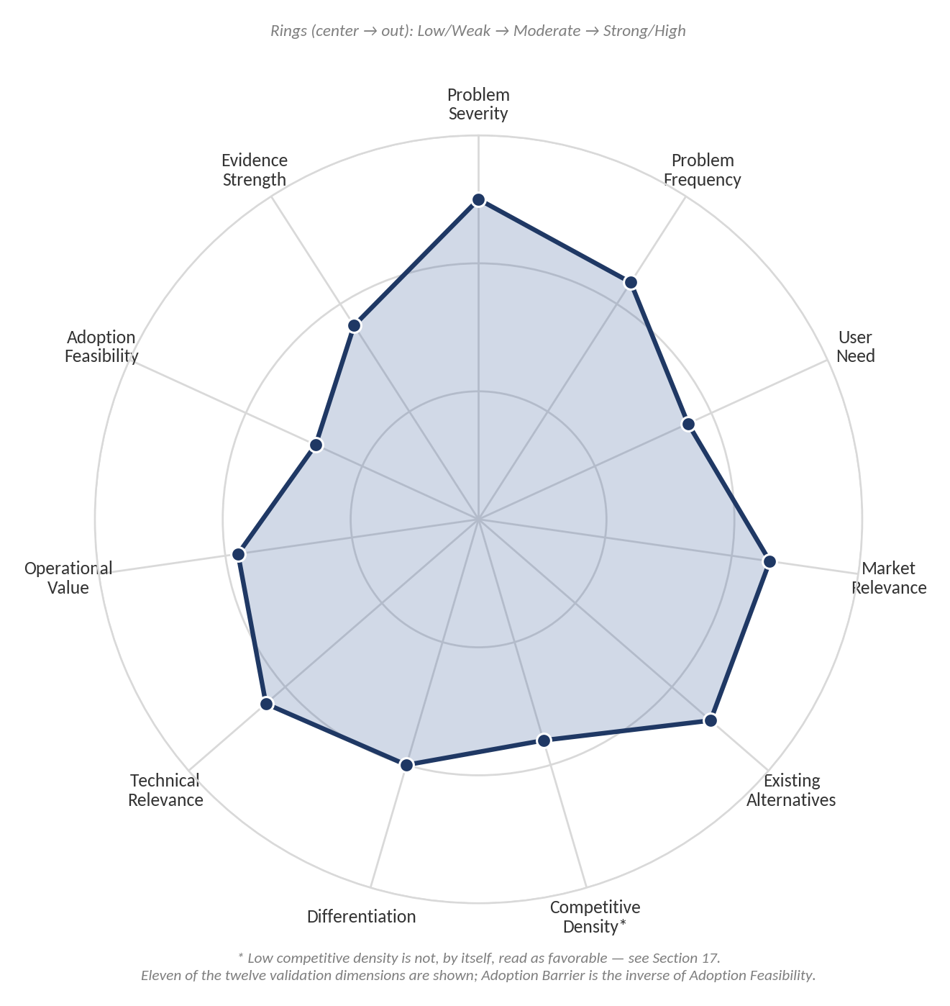
Figure 6 — Summary shape of eleven validation dimensions on a common Low/Moderate/Strong scale.

17. Final Validation Matrix
Dimension | Assessment | Supporting Evidence | Counter-Evidence | Confidence
Problem Severity | Moderate–High | Vigilance decrement, appearance-matching fragility, and bandwidth constraints independently documented | Severity concentrated unevenly; industrial/logistics segment structurally weaker (tagging already solves most of it) | Moderate
Problem Frequency | High (security/ITS); Low (SAR/critical-infra) | High-frequency segments have strong volume evidence (camera counts, incident volumes) | Frequency figures for several sub-sectors (e.g., SCZone, ports) not independently located | Moderate
User Need | Moderate | Structural/vigilance research strongly implies need | Zero direct operator confirmation anywhere in the program | Low–Moderate
Market Relevance | Moderate–Strong | Real capital already committed to adjacent solutions across regions (Honeywell/New Capital, DP World automation, Saudi surveillance-market spend) | Adjacent spend evidences the broader problem category, not this specific architecture | Moderate
Existing Alternatives | Moderate–Strong, fragmented | VMS appearance search, RTLS/tagging, and staffing each address a real share of the problem | No single alternative is comprehensive, which favors the opportunity somewhat | Moderate
Competitive Density | Crowded (components) / Sparse (combination) | No direct competitor combines the full architecture | Component crowding means much of the perceived novelty is integration, not invention | Moderate–Strong
Differentiation | Mixed — see Section 20 | Genuine whitespace in the specific end-to-end combination | Most individual pieces are not novel; some (NegotiationSERVICE) are actively contested | Moderate
Technical Relevance | Strong (core) / Weak (Negotiation) | T1/T2 map cleanly to N1/N2 | NegotiationSERVICE's necessity is directly challenged by prior coordination research | Moderate
Operational Value | Moderate, concentrated | 2 of 7 evaluated use cases rated high-value; 2 more conditional | 3 of 7 downgraded to weak, including one from the original candidate list (SAR) | Moderate
Adoption Feasibility | Low–Moderate | Individual technology components are commercially mature | Regional institutional default is centralization; new/untested regulatory regimes; RF/power constraints concentrated in the highest-value-differentiation use cases | Moderate
Adoption Barrier | Significant | Barriers are specific and documented, not speculative | Some barriers (e.g., Egypt's Nov. 2025 licensing regime) may resolve favorably or unfavorably — genuinely unknown | Moderate
Evidence Strength (overall) | Moderate-to-Strong (desk) / Weak (field) | Four independent, extensively sourced analytical passes, each self-critical and internally consistent | No primary research anywhere in the program; several load-bearing legal questions explicitly unresolved | Moderate

18. Evidence Conflict Analysis
Strong problem, weak differentiation: The underlying continuity problem is well evidenced; the specific decentralized multi-robot solution to it is not established as necessary rather than merely sufficient — simpler, already-commercial alternatives are not ruled out for the two highest-value use cases.
Strong component technology, weak integrated evidence: Edge AI, Nav2, and MQTT are each commercially mature; their specific five-service combination for live, proactive, appearance-based multi-agent handoff has not been demonstrated at commercial scale by this system or, per the competitive review, by any other identified system.
Strong global/structural relevance, weak regional field evidence: The problem recurs across Egypt, Saudi Arabia, the UAE, Qatar, and Morocco in desk research, but zero primary interviews were conducted in any of them, and the region's dominant institutional answer to this class of problem is more centralization, not decentralization — running against the architecture's own core premise.
Strong academic precedent for individual pieces, weak field deployment: The closest research precedents for proactive handoff are validated only in simulation or a single fixed-camera campus deployment, not in a live multi-robot field setting.
Strong operational value in principle, high adoption barriers concentrated in the same places: The two use cases with the clearest non-substitutable technical rationale (port, critical infrastructure) are also the two with the weakest infrastructure, RF, power, and regulatory readiness evidence — value and deployability point in opposite directions.
Strong original vision, contradicted by dedicated analysis: Search and rescue appears on the system's own originating list of candidate environments, but a dedicated causal-chain analysis found it to be the weakest fit of any use case examined, because the system's core mechanic (preserving continuity of an already-detected target) does not address SAR's actual bottleneck (initial detection with no existing sensor coverage).
High technical feasibility of components, direct empirical caution on the coordination design: A controlled study of multi-robot coordination found tightly coordinated strategies often impractical relative to looser ones — direct, if dated, evidence against assuming the system's central coordination mechanism (NegotiationSERVICE) automatically justifies its complexity.

19. Assumption Audit
Assumption | Supporting Evidence | Contradicting Evidence | Consequence if False | Status
Operators experience continuity loss as a frequent, costly failure | Strong indirect evidence: documented vigilance decrement, camera-to-operator ratios, and false-alarm rates | No direct confirmation anywhere in the program; explicitly flagged as untested by the program's own field-validation-framework section | Willingness to adopt an unfamiliar architecture drops sharply | Partially Validated
A decentralized, peer-negotiating architecture is necessary, not just one option, to solve the problem | No simpler alternative fully closes N7/N8 (dynamic occlusion, remote perimeters) | Region's dominant institutional pattern is more centralization; a coordination-literature finding that loose coordination often matches tight coordination; commercial centralized VMS Re-ID is a plausible substitute for the two highest-value use cases | The core architectural differentiator, not just an implementation detail, would need to be reconsidered for fixed-geometry sites | Unvalidated / Partially Contradicted
Bandwidth reduction is a materially important value driver | Large, real, calculated payload reduction (raw video vs. compact metadata) | Only decision-relevant where the link is actually bandwidth-constrained, which is not established for the two highest-value use cases (plausibly on wired LAN) | The infrastructure-efficiency value proposition narrows to a subset of deployments | Partially Validated
Appearance-based matching meaningfully reduces legal/biometric exposure vs. facial recognition | Avoids statutes specifically targeting facial geometry | Broader 'unique identification' tests (e.g., GDPR Art. 9) may still capture a sufficiently distinctive appearance embedding — an open legal question | A claimed compliance advantage could not hold in some jurisdictions | Unvalidated
The system is deployable in its theoretically strongest-fit environments (critical infrastructure, SAR) | Strong structural rationale for critical infrastructure (N8); SAR appears on the system's own candidate list | SAR shown to be a mechanic mismatch, not just an adoption gap; critical infrastructure faces the least-evidenced infrastructure and regulatory readiness of any segment examined | Two of the theoretically most compelling use cases would need to be deprioritized or substantially reframed | Contradicted (SAR) / Unvalidated (critical infrastructure)
Regional (Egypt/MENA) infrastructure and institutional environment support this architecture | Camera and sensor density is genuinely high in priority environments (New Capital, Jebel Ali) | That density was built around centralized, not decentralized, command-and-control; Egypt's Nov. 2025 visual-surveillance licensing regime is new and untested; no UGV-specific legal framework located for Egypt | Regional go-to-market would need an explicit centralized-compatibility or hybrid story, not an assumed clean deployment | Partially Validated / Partially Contradicted

20. Differentiation Validation
This section applies the five-way classification directly, drawing on the competitive-intelligence review's own novelty assessment rather than restating it in full.
- Already Commercially Available: fixed-camera cross-camera appearance search (multiple VMS-integrated products); single-robot autonomous patrol (multiple vendors with multi-year track records).
- Already Demonstrated in Research: appearance-based re-identification generally; market-based/auction multi-robot task allocation; edge inference for re-identification; metadata/feature-level (rather than raw-video) inter-agent information sharing, particularly in the adjacent V2X collaborative-perception literature.
- Emerging (demonstrated but not mature): proactive/predictive handoff for fixed cameras specifically — the closest and most recent research precedents are, in every case located, less than two years old and validated only in simulation or a single fixed-camera deployment; privacy-preserving, topology-aware descriptor exchange for decentralized camera networks.
- Integration Opportunity: combining edge re-identification, proactive occlusion prediction, and peer-to-peer coordination into a single mobile-robot pipeline — no component here is individually unprecedented; the combination, if executed and field-validated, would be a genuine engineering integration achievement.
- Genuine Unresolved Gap: proactive exit/occlusion prediction driven by a mobile robot's own onboard perception of the target (as opposed to a wearable device on the subject or simulator ground truth, both of which are how the closest research precedents actually work), combined with a peer-to-peer negotiation protocol specifically for target-custody handoff and validated in a real, non-simulated multi-robot field deployment.
The system's defensible differentiation is therefore best described as an integration opportunity with one genuinely unresolved technical sub-problem at its center (real-time, robot-perspective, non-cooperative occlusion prediction), not as novelty at the level of any single named component, and not as a proven commercial gap — the absence of a shipping competitor product is evidence consistent with a genuine gap, but is not, on its own, proof of one, since it is equally consistent with the market not yet having prioritized this specific combination.

21. Use-Case Validation
Use Case | Classification | Reasoning
Distribution / logistics warehouse yard | Conditionally Supported | Real, costed problem (documented cargo-theft losses) and strong structural fit, but a simpler fixed-camera-plus-VMS-analytics alternative was not ruled out as delivering comparable value at lower complexity.
University / corporate campus security | Conditionally Supported | Real workload problem with existing patrol-robot precedent, but the coordinated-handoff element specifically remains unproven, and night-time Re-ID accuracy — precisely the condition of most incidents — is the largest single open technical risk.
Port / container terminal yard | Conditionally Supported (strongest technical rationale) | The one environment where fixed cameras structurally cannot solve the problem (shifting occlusion from container stacking), but wireless reliability among steel stacks is unverified and the single largest infrastructure risk identified for this case.
Critical-infrastructure perimeter | Conditionally Supported (theoretically strongest, least evidenced) | Strong structural logic (unmanned by design), but connectivity, power, and regulatory certification — the three preconditions it needs most — are also the three most likely to be absent or slow at a genuinely remote, regulated site.
Search and rescue | Unsupported | A dedicated causal-chain analysis found the system's core mechanic (preserving continuity of an already-detected target) does not address SAR's actual bottleneck (initial wide-area detection with no existing coverage) — a fit problem, not merely a readiness problem.
Airport (airside/landside) | Weakly Supported | The underlying problem is plausible, but the environment is already among the most camera-dense examined, and near-term deployment is blocked by certification/vendor-vetting timelines independent of the technology's own readiness.
Generic industrial facility | Unsupported as a distinct case | Either off-target (fixed-route equipment inspection, which does not exercise the system's re-identification/handoff capability at all) or a restatement of the warehouse/critical-infrastructure security case, not an independent application.
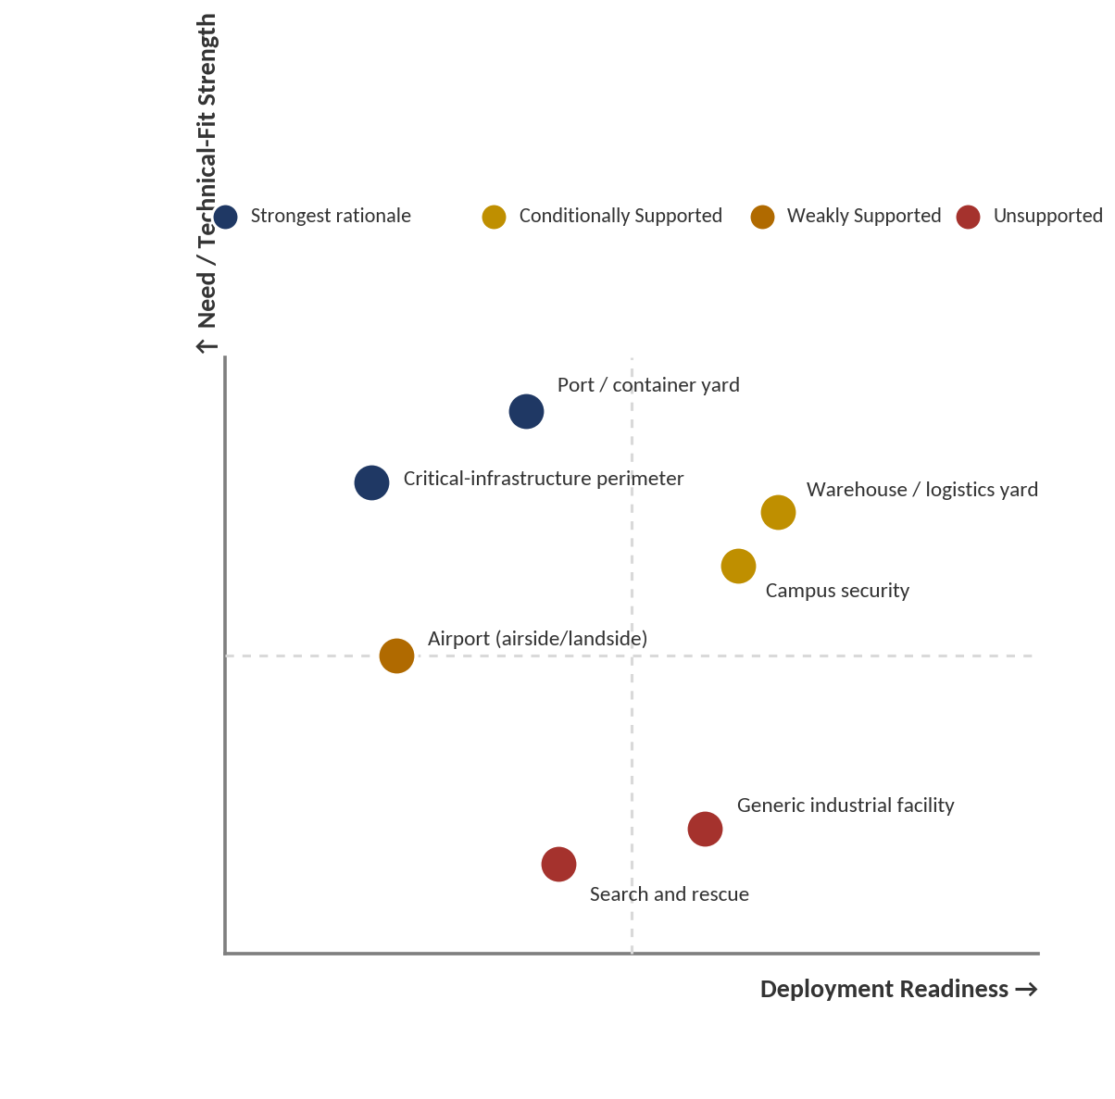
Figure 7 — Use cases positioned by deployment readiness and need/technical-fit strength.

22. Value Validation
Network load reduction: Demonstrated as a calculation (compact metadata vs. raw-video bitrate figures), not as a measured result from an actual deployment. Baseline: continuous raw-stream transmission (roughly 2–4 Mbps per 1080p stream). Change: a payload of a few kilobytes at the moment of handoff. Why it matters: potentially large where the link is the bottleneck. Could a simpler solution provide the same benefit? Yes, trivially, by not transmitting continuous raw video in the first place, which several existing commercial systems already avoid through motion-triggered or event-based recording — this is Potential Value, not Expected or Demonstrated Value.
Faster reacquisition / continuity: Theoretical/calculated only; no field measurement of this architecture's actual reacquisition time was located anywhere in the program. The benefit depends entirely on Re-ID accuracy under the deployment site's actual lighting and viewpoint conditions, which cannot be quantified without an on-site pilot. This is Potential Value at best.
Reduced operator workload: Not established, and explicitly cautioned against in the source evidence: automation creates a new supervisory task (validating system-proposed matches) rather than simply subtracting the old one, particularly given a non-trivial expected rate of false or missed matches under real-world domain shift. This is, at most, a plausible qualitative shift in the nature of the task, not a demonstrated or even confidently Expected net reduction.
Reduced legal/compliance exposure: Plausible relative to facial-recognition-specific statutes, but resting on an unresolved legal question (whether a sufficiently distinctive appearance embedding meets a broader biometric/unique-identification threshold). This is a Hypothesis, not even clearly a Potential Value claim, until that question is resolved by counsel or precedent.

23. Adoption Validation
Use Case | Technically Possible | Operationally Plausible | Deployable Under Conditions | Practically Adoptable Today
Warehouse / logistics yard | Yes | Yes | Yes — night Re-ID validation, wireless coverage | Not yet — unvalidated against the simpler alternative
Campus security | Yes | Yes | Yes — night Re-ID validation, legal clearance | Not yet — same caveat, plus risk-averse campus procurement norms
Port / container yard | Yes | Plausible | Conditional — RF-resilient mesh among steel stacks unverified | No — infrastructure precondition unverified
Critical-infrastructure perimeter | Yes | Plausible | Conditional — site power/connectivity and sector certification | No — the two hardest preconditions are also the two most likely absent
Egypt (state-security channel) | Yes | Uncertain | Conditional — institutional model is centralized; UGV legal status undefined | No — architectural and regulatory mismatch with current institutional norms
Egypt (commercial/industrial-zone channel) | Yes | Plausible | Conditional — new Nov. 2025 licensing regime untested for this technology category | Not yet — regulatory precedent does not yet exist
UAE (port/logistics channel) | Yes | Plausible, most favorable of regions examined | Conditional — integration with existing DP World/DGWorld automation stack unconfirmed | Not yet, but the most field-ready case identified in the program
Table 23.1 — No use case/region combination reaches 'Practically Adoptable Today' on the evidence available; the UAE port/logistics case comes closest.

24. Final Market Validation Logic
The interaction of the validation dimensions does not resolve to a simple sum. Problem severity and frequency are real and independently documented, which weighs meaningfully in favor of the opportunity — this is not a case of a solution in search of a problem, a conclusion the problem-foundation analysis itself reaches explicitly. But existing alternatives are not weak across the board: centralized VMS appearance search, tag-based RTLS, and additional staffing each already address a genuine share of the underlying need in specific, common contexts, which caps how much credit the opportunity can claim purely from problem severity. Differentiation is real only at the level of the full integrated combination and concentrated in one specific, still-open technical sub-problem (robot-perspective occlusion prediction); it is not real at the level of most individual components, several of which are commercially or academically well precedented. Adoption feasibility is the dimension doing the most work to pull the overall picture down: regulatory regimes relevant to this exact technology category are new and untested in the region with the greatest raw environmental scale (Egypt), the region's own institutional default runs counter to the architecture's central decentralization premise, and the two use cases with the clearest non-substitutable technical rationale (port, critical infrastructure) are also the two with the least favorable infrastructure evidence. Evidence strength is high for desk research and structural reasoning, and uniformly and explicitly weak for primary, field-level confirmation — a gap every phase of this program has flagged rather than papered over, which is itself informative: a genuinely strong, obviously validated opportunity would not need four independent analytical passes to keep surfacing the same open question.

25. FINAL MARKET VERDICT
Verdict: PARTIALLY VALIDATED


1. Strongest Evidence Supporting the Opportunity
The underlying operational problem — loss of target identity and continuity across the coverage gap between independently operating sensor or robot nodes — is real, structurally caused (not merely under-resourced), and independently documented across multiple domains (physical security, transportation, critical infrastructure, search and rescue) and multiple regions (Egypt, the Gulf states, Morocco). Organizations are already spending real, verifiable capital on adjacent solutions to this same underlying problem, evidencing genuine willingness to pay for a better answer to it.

2. Strongest Evidence Against the Opportunity
For the two use cases with the strongest near-term deployment evidence (a fixed-geometry warehouse or campus), a materially simpler and already-commercial alternative — more fixed cameras combined with existing VMS cross-camera appearance search — has not been ruled out as delivering a comparable operational outcome at meaningfully lower cost and complexity. Where the architecture's differentiation is genuinely strongest (dynamic-occlusion or power/connectivity-constrained environments), deployment-readiness evidence is weakest. And no primary stakeholder evidence exists anywhere in the program confirming that operators experience this problem as acutely as the structural evidence implies they should.

3. Strongest Real-World Use Case
A container-terminal or similarly structured port yard presents the clearest combination of a non-substitutable technical rationale (fixed cameras cannot track a blind spot that itself moves as containers are stacked) and an identifiable, resourced potential customer (evidenced concretely by DP World's own pattern of investing in automation at Jebel Ali). It remains conditional, not strongly supported outright, because the specific infrastructure precondition it depends on most — reliable wireless coordination among steel container stacks — is unverified.

4. Strongest Differentiation
The specific, integrated combination of proactive occlusion prediction driven by a mobile node's own onboard perception, peer-to-peer handoff negotiation, and privacy-minimized metadata exchange has not been found demonstrated end-to-end by any commercial product or published research system. This differentiation is real at the level of the combination and of one specific open technical sub-problem within it, not at the level of any individual named component.

5. Most Important Adoption Barrier
The combination of an untested, category-specific regulatory regime (Egypt's November 2025 visual-surveillance licensing requirement, and comparable biometric-data provisions across the Gulf states) with a regional institutional default that favors centralized, not decentralized, control architectures. This barrier is not primarily technical, and is not resolved by further engineering work on the system itself.

6. Most Important Unresolved Assumption
Whether the decentralized, peer-negotiating multi-robot architecture is actually necessary to solve the underlying continuity problem, or whether it is one credible architecture among several — including centralized alternatives already in wide commercial and institutional use — capable of addressing the same needs at lower complexity in the environments where deployment is nearest-term feasible.

7. Overall Reasoning
The evidence supports a real, well-documented, structurally-caused problem and a technically coherent, individually well-precedented set of components, but does not yet support the conclusion that this specific architecture is the necessary or best-justified answer to that problem in the environments where deployment is most feasible in the near term — nor does it include any direct confirmation, from an actual operator or stakeholder, that the problem is felt with the severity the structural evidence implies. The opportunity is not weak: the problem is genuine, meaningful differentiation exists at the level of the full combination, and at least one use case (port/container yard) presents a non-substitutable technical rationale. But it is not yet validated: the strongest differentiation and the strongest deployment readiness point at different use cases rather than the same ones, at least one contested design component (NegotiationSERVICE) lacks a clear necessity case against a simpler alternative, and the single most important open question — whether operators actually experience this as an acute, costly problem — has not been tested anywhere in the program. This is precisely the evidentiary shape the validation framework defines as Partially Validated: meaningful evidence supports the opportunity, but important uncertainties remain regarding necessity, differentiation-in-context, value, deployment, and direct stakeholder confirmation.

26. Decision Confidence
Confidence: Moderate
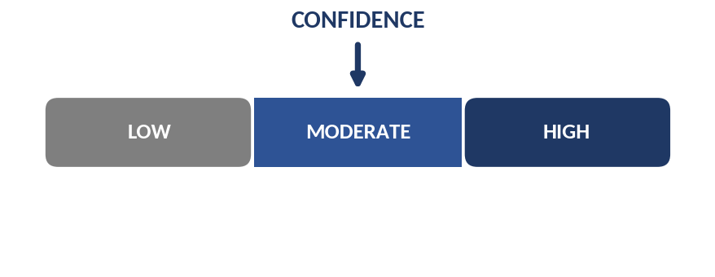
The evidence base is unusually extensive and, notably, consistently self-critical: four independent analytical passes (problem/market, competitive/research, regional/field, and operational/adoption) each explicitly flagged their own limitations, distinguished verified findings from inference, and in several cases reversed or narrowed an earlier, more favorable framing (for example, the operational-value analysis's revision of an original 'zero visual data breaches' claim to the more defensible 'minimizes exposure of raw visual data,' and its own explicit downgrade of search and rescue despite that use case's presence on the system's originating candidate list). This internal consistency and willingness to self-correct raises confidence in the reasoning process itself. Confidence is capped below High, however, by three specific, load-bearing gaps that recur across every phase of the program: the complete absence of primary stakeholder or field evidence anywhere in the research; the genuinely unresolved legal status of appearance-based re-identification under biometric-data regimes; and the lack of any direct empirical test, for this specific system, of whether its central coordination mechanism (NegotiationSERVICE) outperforms a simpler alternative. None of these three gaps is resolved by more desk research; each requires either primary field work, legal counsel, or a controlled benchmark that has not yet been conducted.

27. Sources
This synthesis draws on the fully sourced evidence bases of the four constituent analyses developed across this research program. Rather than reproduce every citation from each underlying document, the entries below identify the source document for each evidentiary category and highlight the individual sources most load-bearing for the conclusions in this document. Full citation detail (author, publication, year, and specific finding) is maintained in the Sources section of each respective underlying report.

Problem & Market Foundation (source document)
- Vigilance-decrement and CCTV-operator performance research (Donald & Donald, Applied Ergonomics, 2011; Sandia National Laboratories, SAND2014-17929, 2014)
- Multi-camera/person re-identification and non-overlapping-camera-network research surveys (multiple, 2018–2025)
- Bandwidth/edge-video-analytics measurements (arXiv 1905.13536; arXiv 2312.15740)
- Search-and-rescue mission volume and survival-probability research (U.S. National Park Service-derived analyses; PMC8990012)
- Perimeter-protection market and false-alarm-rate data (CORDIS/WARDIAM project 783977)
- Facial-recognition and biometric-surveillance regulatory sources (CSIS; Congress.gov CRS Report R48935; EU AI Act analysis, 2026)

Competitive & Research Intelligence Report (source document)
- Commercial cross-camera appearance-search products (Avigilon, BriefCam/Milestone, Genetec, Axxon One)
- Autonomous patrol robot vendors (Knightscope, Cobalt AI)
- Proactive/predictive fixed-camera handoff research (CamTrack, Neural Computing and Applications, 2026; SPOT!, preprint, 2025–2026; TRACER/SPATULA, 2025/2020)
- Privacy-preserving decentralized identity-search research (CityGuard, preprint, 2026)
- Multi-robot cooperative tracking and V2X collaborative-perception surveys (ACM Computing Surveys, 2019; Robin & Lacroix, Autonomous Robots, 2016; multiple 2024–2026 V2X surveys)

Egypt/MENA + Field Validation Report (source document)
- Egyptian national CCTV and Security Operations Center reporting (Rosa Luxemburg Stiftung, 2023; 3arabawy, 2026)
- New Administrative Capital ICCC contract and scale (Egyptian Streets, 2019; Context/Thomson Reuters Foundation, 2023)
- Suez Canal Economic Zone investment and factory-count data (Daily News Egypt, 2025–2026)
- DP World Jebel Ali automation and Khalifa University/KUCARS, MBZUAI research infrastructure (The National, 2021; Port Technology International, 2020; MBZUAI, 2026)
- Egyptian Personal Data Protection Law executive regulations and visual-surveillance licensing requirement (Shand Partners, 2026; Record of Law, 2026)
- Saudi NEOM spend-versus-announcement analysis (Vision2030.ai; Britannica, 2026); Saudi PDPL/SDAIA enforcement data (SGC Consulting, 2026)

Real-World Use Cases, Operational Value & Technology Adoption Analysis (source document)
- Cargo-theft cost and Knightscope deployment scale (Knightscope, Inc., 2022; National Insurance Crime Bureau estimate)
- Multi-robot coordination practicality (Agmon, Fok, Emaliah, Stone, Julien & Vishwanath, ICRA 2012)
- ROS2/Nav2 production deployment scale (Open Navigation, 2025–2026; AWS Robotics Blog)
- Re-identification domain-shift accuracy research (Huaman et al.; Asperti, Naldi & Fiorilla, Sensors, 2025)
- MQTT latency and scaling behavior (Ali & Zafar, Alexandria Engineering Journal, 2023; ECTI-EEC empirical study)
- GDPR Article 9 biometric-data classification guidance (GDPRLocal, 2026; UK ICO guidance via babl.ai, 2024/2026)
- UGV/legged-platform pricing estimates and video-bitrate technical references (Boston Dynamics Spot-class pricing estimates; Fortinet/Hikvision bandwidth technical bulletins)

